 | MUNICIPALITY OF ANCHORAGE  Project Management and Engineering Department | 
MEMORANDUM
DATE: 5/26/2023
TO: Requestor
SUBJECT: PM&E ‘Collection’ Special Provisions for Project Manual Document
Attached is a collection of special provisions that have been compiled from PM&E’s projects over the past few years. The intent is to include ‘special provisions’ that have the potential for re-use and may require some modifications.
These special provisions are to be used with the 2015 M.A.S.S. only.
This collection of special provisions are not ‘standard’ special provisions and should not be used as such.
Not all of these special provisions are applicable on all projects. Not all of these special provisions are applicable in their current wording.
It is the engineer’s responsibility to determine the applicability of the special provision(s) used, as well as final wording. Most of these special provisions were developed based on project-specific requirements. Please re-read the second paragraph, above.
Should you have questions, comments, or suggested revisions, please feel free to contact Brandon Telford at 343-8145 or email massupdate@muni.org.
Summary of Modifications
Date | Modification
3/22/12 | Updated to Rev 2 language – removed everything inserted into Rev 2.
5/31/2012 | Added Glass Cullet specials to 20.21 and 20.22; updated insurance form & 10.6.9 language
6/5/12 | Modified Minimum Rates of Pay language
6/6/12 | Added Sample Bid Proposal pages to show how the column spacing should be set up so the pages are actually usable.
9/10/12 | Added Recycled Concrete as an alternative to Leveling Course
3/21/13 | Updated for Rev 3
4/1/13 | Updated Contact information
5/10/13 | Updated DOL language and Bid Proposal Signature information
7/9/13 | Updated Project Information Sign information & Day Labor Article #
2/21/14 | Updated Contract dates and Bid Proposal Signature Page
3/28/14 | Added language re: Profit & Overhead markup on Sub invoices
7/10/14 | Added Line in Footer (left side) of BP pages for Contractor Name
8/12/14 | Updated Utility Contact info in 10.4.17 Utilities
2/27/15 | Updated for the 2015 MASS release. Removed SPs that were inserted into MASS.
3/25/15 | Updated ML&P contact info. Fixed typos in the BPs.
1/6/16 | Fixed years in boilerplate contract; Updated Contact info in 10.4.17
2/22/16 | Deleted PW; PM&E Div to Dept; Updated 10.4.7 again; Submittal List
3/21/16 | Added CEA and ENSTAR construction requirement links to 4.17
6/27/16 | Added Final Rule for PHMSA link for ENSTAR requirements
7/8/16 | Deleted Spenard Fence & other extra crap at the end.
3/29/17 | Updated 2016 to 2017 & misc other mods to Sample Contract; published BP Excel samples (get them from the website)
4/14/17 | Added “bird window” language to 20.04, 20.05, 20.06
1/31/18 | Updated 2017 to 2018; added delineators to 10.4.8 and 10.5.31; changed “partially” to “fully” deteriorated pipe in 55.26; AASHTO MP-21 to AASHTO M330 in Div 55; updated Trail Clearing spec 20.05.
4/9/18 | Updated OEO language and Bid Bond sheet
1/24/19 | Updated to 2019 and added new Sample Contract
1/8/21 | Updated Contact Information, 2021, added language to 10.04, modified Pavement Disposal note to reflect St. Maint wanting pavement.
4/1/22 | Updated Contact Information; Fixed formatting issues; Modified 95.01; Updated project sign requirements in 10.4.22; Added 20.09 Removal of Pavement; Modified 20.04 and 20.06; Added 75.04 Seeding, 75.05 Sod, and 75.12 Moose Protection Fence.
5/26/23 | Updated Contact Information; Fixed formatting issues; Added 30.01, 30.02, 30.03, 30.04, 30.09, 40.07 and Details 30-8A, 30-8B, 30-9, 30-16, 40-4, 40-5, and 40-6.

PROJECT NAME
PROJECT LIMITS

XX-XX
Invitation to Bid No.
PROJECT MANUAL

Municipality of Anchorage
Project Management and Engineering Department
4700 Elmore Road
Anchorage, Alaska 99507

MUNICIPALITY OF ANCHORAGE
PROJECT MANAGEMENT AND ENGINEERING DEPARTMENT
PROJECT NAME
XX-XX
MASTER INDEX
I. |  | INVITATION TO BID
II. |  | SPECIAL PROVISIONS
III. |  | SUBMITTAL LIST
IV. |  | SPECIAL DETAILS
V. |  | SOILS INFORMATION
VI. |  | TEMPORARY CONSTRUCTION PERMITS AND EASEMENTS
VII. |  | EQUAL EMPLOYMENT OPPORTUNITY SPECIAL PROVISIONS
VIII. |  | MINIMUM RATES OF PAY
IX. |  | CONTRACT
X. |  | CONTRACT PERFORMANCE AND PAYMENT BOND
XI. |  | CERTIFICATE OF INSURANCE
XII. |  | BID BOND
XIII. |  | BIDDER’S CHECKLIST & RESPONSIBLE BIDDER QUESTIONNAIRE
XIV. |  | BID PROPOSAL
XV. |  | PLANS (___ SHEETS)

MUNICIPALITY OF ANCHORAGE
PROJECT MANAGEMENT AND ENGINEERING DEPARTMENT

PROJECT NAME
PROJECT LIMITS

XX-XX
I
INVITATION TO BID
MUNICIPALITY OF ANCHORAGE
PURCHASING DEPARTMENT
Invitation to Bid
No. 2023C
Sealed bids will be received in accordance with the time schedule shown below by the Municipality of Anchorage at the Purchasing Department, 632 W. 6th Avenue, Suite 520; Anchorage, Alaska, 99501, for:
Project name
consisting of approximately _____ S.Y. of Sidewalk and Concrete Apron Removal and Replacement; _____ S.Y. of Curb Ramps; _____ L.F. of Curb and Gutter Removal and Replacement; _____ Tons of A.C. Pavement; _____ S.Y. of Pavement Removal; _____ Catch Basins; _____ Storm Drain Manhole; _____ L.F. of Storm Pipe Removal and Replacement; and other related work.
ESTIMATED CONSTRUCTION COST: Between $1,000,000 and $3,000,000
Site Visit(s) at
Pre-Bid Conference at
REQUEST ANY QUESTIONS BE SUBMITTED IN WRITING TO WWPUR@MUNI.ORG., BEFORE THE PRE-BID CONFERENCE. Please reference the Project Title and Invitation to Bid No. 2017C0

Bids Opened at
Post-Bid Conference at
An electronic (.pdf) copy of the Invitation to Bid is available at Municipality of Anchorage, Purchasing Office’s website; (http://purchasing.muni.org). Should you choose to obtain a copy of the Invitation to Bid from the website; it is your responsibility to periodically check the website for addenda.
At the above-indicated time, the bids will be opened publicly and read. Bids must be received by the Purchasing Officer prior to the time fixed for opening of the bids to be considered. Time of receipt will be as determined by the time stamp in the Purchasing Office, Suite 520.
Drawings, specifications, and contract documents may be examined and will be available for pickup at 632 W. 6th Avenue, Suite 520; Anchorage, Alaska; Monday through Friday, 8 a.m. until 12 noon and 1 p.m. until 5 p.m. These documents are available for sale on a non-refundable basis at $ per set (cash or check only).
Fees stated above include parcel post charges (1st class mail). Should expedited handling be desired, Federal Express or equivalent service will be utilized on a reverse billing basis only.
The Municipality of Anchorage reserves the right to reject any and all bids and to waive any informalities in the bids. No bidder may withdraw his bid after the hour set for the opening of bids or before the Award of Contract unless said award is delayed for a period exceeding forty-five (45) days from the time of the opening.
The Municipality shall not be responsible for bid preparation costs, nor for costs, including attorney fees, associated with any (administrative, judicial, or otherwise) challenge to the determination of the lowest responsive and responsible bidder and/or award of contract, and/or rejection of bids. By submitting a bid, each bidder agrees to be bound in this respect and waives all claims to such costs and fees.
Contracts shall be awarded by written notice issued by the Purchasing Officer to the lowest responsive and responsible bidder; however, preference will be given to local bidders in compliance with Anchorage Municipal Code, Section 7.20.040.
A pre-bid conference will be held at the above-indicated time in the Purchasing Office for the purpose of answering any questions bidders may have and to consider any suggestions they may wish to make. Any changes resulting from this conference will be made by Addendum immediately following the conference. This conference is held for the benefit of the bidders. It is requested that some person of authority from the office of the prospective bidder attend this meeting.
The Municipality of Anchorage assumes no responsibility for any interpretations or presentations made by any of its officers or agents unless such interpretations or presentations are made by written addendum to this Invitation to Bid.
Bonding requirements are per M.A.S.S.B./M.A.S.S. or as per Special Provisions.
PUBLISH ONE TIME
Date

Rachelle Alger
Purchasing Director

MUNICIPALITY OF ANCHORAGE
PROJECT MANAGEMENT AND ENGINEERING DEPARTMENT

PROJECT NAME
PROJECT LIMITS

XX-XX
II
SPECIAL PROVISIONS

MUNICIPALITY OF ANCHORAGE
PROJECT MANAGEMENT AND ENGINEERING DEPARTMENT

PROJECT NAME
PROJECT LIMITS
XX-XX
INDEX TO SPECIAL PROVISIONS
PAGE
SECTION 95.01 LOCATION AND SCOPE 1
SECTION 95.02 REFERENCE TO MUNICIPALITY OF ANCHORAGE STANDARD SPECIFICATIONS 1
SECTION 95.03 TIME OF COMPLETION 2
SECTION 95.04 MODIFICATIONS AND/OR ADDITIONS TO MUNICIPALITY OF ANCHORAGE standard SPECIFICATIONS 2
A. DIVISION 10 STANDARD GENERAL PROVISIONS 2
SECTION 10.00 ALL APPLICABLE M.A.S.S. ARTICLES 2
SECTION 10.04 SCOPE OF WORK 2
Article 4.8 Work Incidental to the Contract 2
Article 4.17 Utilities 2
Article 4.22 Project Information Signs 4
Article 4.23 Work Order Issued Under “Day Labor” Type Contracts 4
SECTION 10.05 CONTROL OF WORK 4
Article 5.27 Liquidated Damages 5
Article 5.31 Winter Suspension 5
SECTION 10.06 LEGAL RELATIONS AND RESPONSIBILITIES 5
Article 6.1 Laws to be Observed 5
SECTION 10.07 MEASUREMENT AND PAYMENT 5
Article 7.0 Payments to Contractors and Subcontractors 5
B. DIVISION 20 STANDARD CONSTRUCTION SPECIFICATIONS FOR EARTHWORK 5
SECTION 20.04 CLEARING AND GRUBBING 6
Article 4.2 Construction 6
SECTION 20.06 REMOVAL OF TREES 6
Article 6.2 Construction 6
SECTION 20.05 CLEARING 6
Article 5.2 Construction 6
SECTION 20.09 REMOVAL OF PAVEMENT 6
Article 9.2 Construction 6
SECTION 20.21 CLASSIFIED FILL AND BACKFILL 7
Article 21.2 Material 7
Article 21.3 Construction 8
Article 21.4 Measurement 8
SECTION 20.22 LEVELING COURSE 8
Article 22.2 Material 8
Article 22.3 Construction 10
Article 22.4 Measurement 10
C. DIVISION 30 STANDARD CONSTRUCTION SPECIFICATIONS FOR PORTLAND CEMENT CONCRETE 11
SECTION 30.01 GENERAL 11
Article 1.6 Mix Requirements for Classes of Concrete 11
Article 1.9 Weather Limitations 11
Article 1.10 Protection of Work 12
SECTION 30.02 PORTLAND CEMENT CONCRETE, CURB AND GUTTER AND VALLEY GUTTER 12
Article 2.2 Materials 12
SECTION 30.03 PORTLAND CEMENT CONCRETE SIDEWALKS 12
Article 3.2 Materials 12
SECTION 30.04 PORTLAND CEMENT CONCRETE CURB RAMPS 12
Article 4.2 Materials 12
SECTION 30.09 CONCRETE PARKING BUMPERS 13
Article 9.2 Material 13
D. DIVISION 40 STANDARD CONSTRUCTION SPECIFICATIONS FOR ASPHALT SURFACING 13
SECTION 40.01 GENERAL 13
Article 1.7 Asphalt Price Adjustment 13
SECTION 40.07 PERMANENT ASPHALT SPEED HUMPS 15
Article 7.1 General 15
Article 7.2 Cross Section Template 15
Article 7.3 Material 15
Article 7.4 Construction 15
Article 7.5 Measurement 16
Article 7.6 Basis of Payment 16
E. DIVISION 50 STANDARD CONSTRUCTION SPECIFICATIONS FOR Sanitary Sewers 16
F. DIVISION 55 STANDARD CONSTRUCTION SPECIFICATIONS FOR STORM DRAIN SYSTEMS 16
SECTION 55.02 FURNISH AND INSTALL PIPE 16
Article 2.2 Material 16
SECTION 55.26 CURED IN PLACE PIPE (CIPP) LINING 17
Article 26.3 Materials 17
G. DIVISION 60 STANDARD CONSTRUCTION SPECIFICATIONS FOR WATER SYSTEMS 17
H. Division 65 Standard Construction Specifications for Construction Survey 17
I. DIVISION 70 STANDARD CONSTRUCTION SPECIFICATIONS MISCELLANEOUS 17
SECTION 70.12 TRAFFIC MAINTENANCE 17
Article 12.6 Public Notice 17
J. DIVISION 75 STANDARD CONSTRUCTION SPECIFICATIONS FOR LANDSCAPING IMPROVEMENTS 18
SECTION 75.04 SEEDING 18
Article 4.3 Application 18
SECTION 75.05 SOD 18
Article 5.5 Measurement 18
Article 5.6 Basis of Payment 18
SECTION 75.12 MOOSE PROTECTION FENCE 19
Article 12.1 General 19
Article 12.2 Materials 19
Article 12.3 Construction 19
Article 12.4 Measurement 20
Article 12.5 Basis of Payment 20
K. DIVISION 80 STANDARD CONSTRUCTION SPECIFICATIONS FOR INSTALLATION AND REMOVAL OF TRAFFIC SIGNALS AND ILLUMINATION 20

MUNICIPALITY OF ANCHORAGE
PROJECT MANAGEMENT AND ENGINEERING DEPARTMENT

PROJECT NAME
PROJECT LIMITS
XX-XX
SPECIAL PROVISIONS

SECTION 95.01 LOCATION AND SCOPE
All proposed Work is located within the Municipality of Anchorage corporate limits and is more particularly located on the design drawings. The Work included under this Contract consists of furnishing all labor, materials, equipment, supervision, and other facilities necessary to successfully complete the Work set forth in the Drawings and Specifications. The Work included under this Contract consists of, but is not limited to:

It is the responsibility of the bidder to prepare the bid so that all materials and/or fittings shall harmoniously conform to the intent of the Contract Drawings, Specifications, and Special Provisions.
Below are the schedules of Work that are presented in the Bid Proposal of this Contract:
SCHEDULE | DESCRIPTION
A
B
C

SECTION 95.02 REFERENCE TO MUNICIPALITY OF ANCHORAGE STANDARD SPECIFICATIONS
This Contract is subject to and hereby incorporates by reference the Municipality of Anchorage Standard Specifications, dated 2015, hereinafter referred to as M.A.S.S.; the Alaska Sign Design Specifications (ASDS) as adopted and amended by the Municipality; the Municipality of Anchorage Sign Manual; the Alaska Traffic Manual (ATM); the Manual on Uniform Traffic Control Devices (MUTCD) 2009 Edition, with the Alaska supplement, dated 1/13/12; the National Electrical Safety Code (NESC) as amended and adopted by the Municipality; the National Electrical Code as amended and adopted by the Municipality of Anchorage; and the Edition of the Standard Specifications for Structural Supports for Highway Sign, Luminaires and Traffic Signals provided in the appropriate divisions. When conflicts exist between M.A.S.S. and MUTCD, the requirements of M.A.S.S. and these Special Provisions shall govern.

SECTION 95.03 TIME OF COMPLETION
This Project shall be completed within thirty (XX) calendar days after the Notice-to-Proceed is issued.

SECTION 95.04 MODIFICATIONS AND/OR ADDITIONS TO MUNICIPALITY OF ANCHORAGE standard SPECIFICATIONS
The following listed provisions of M.A.S.S. are amended as hereinafter stated:

A. DIVISION 10 STANDARD GENERAL PROVISIONS
Add the following Section:

SECTION 10.00 ALL APPLICABLE M.A.S.S. ARTICLES
{Section 10.00 is required for ALL contracts unless federal money is involved in the construction project. If federal money is involved, delete this Section.}
Delete all references to and requirements for compliance with Anchorage Municipal Code Chapter 7.60 the Disadvantaged/Women Owned Business (DBE/WBE) program and specifications.

SECTION 10.04 SCOPE OF WORK

Article 4.8 Work Incidental to the Contract
Add the following item:
14. Installation of flexible delineators at the end of culverts, ends of retaining walls, field inlets, and other locations that may be hazardous or should be delineated for snow removal operations as determined by the Engineer.

Article 4.17 Utilities
C. Gas
Add the following paragraphs:
The Contractor shall download and follow the most current construction guidelines published by ENSTAR. Those guidelines can be downloaded from:
https://www.enstarnaturalgas.com/safety-education/natural-gas-safety/safety-for-excavators-contractors/
Click on the link in the last sentence of the first paragraph.
The Final Rule from the PHMSA website can be obtained from:
https://www.phmsa.dot.gov/pipeline/excavator-final-rule/about-excavation-enforcement-final-rule
Click on the “Final Rule on Excavation Damage 80 FR 43836” link under Related Links.
D. Electrical and Telecommunications
Add the following paragraphs:
The Contractor shall download and follow the most current construction guidelines published by Chugach Electric Association. Those guidelines can be downloaded from:
https://www.chugachelectric.com/member-services/regulations-requirements
Click on the link titled “Electrical Facility Clearance Requirements”.
The following contact information is provided as a courtesy to the Contractor and is the most currently available.
Alaska Communication Systems (ACS) – Duilio Guerrero, 564-1522 or 230-8268
Anchorage Water & Wastewater Utility (AWWU) – Shawn Dooley, 564-2786
AT&T – Mike Barsalou, 264-7325
Chugach Electric Association (CEA) – Victor Willis, 230-7536
ENSTAR Natural Gas – Stan Staples, 334-7777
GCI – Steven Cranford, 868-6769
Municipal Street and Storm Drain Maintenance – Eric Hodgson, 343-8100
Municipal Street Light Maintenance – Steve Parkinson, 343-8290
Municipal Traffic Signals Section – Levi Piehl, 343-8363
Solid Waste Services (SWS) – Evalu Filitaula, 343-6258 or 317-6863
Matanuska Electric Association (MEA) – John Foutz, 761-9265
Matanuska Telephone Assoc. (MTA) – Robbie Nash, 761-2704 or 355-1687
Eagle River Street & Storm Drain Maintenance – Anthony Winsor, 343-1512
Alaska Waste – Josh James, 688-4446
Add the following Articles:

Article 4.22 Project Information Signs
Prior to beginning of any work on the project, Contractor shall install ___ (XX) project information sign(s) (combination owner and contractor supplied materials), in accordance with Section 70.12, Article 12.7 - Traffic Control Devices, in a location directed by the Engineer. The Owner supplied project information signs shall be available for pick up at 5701 Northwood Drive, Monday thru Thursday from 8:00 a.m. to 4:00 p.m. Contact Paul VanLandingham at 343-8372 (office) or 317-7054 (cell) to coordinate pickup.
Owner-supplied materials are as follows:
- Project Information Sign - ___ (XX) 4’x8’x¾” MDO wood sign Project Name, Project No. XX-XX.
Contractor provided materials are as follows:
- Sign Frame - ___ (XX) 2”x4” lumber pre-assembled in a rectangular shape measuring 4-foot by 8-foot.
- Post Skids – assembled, two (2) EA 4”x6” lumber standing vertical 8-foot in height, with 8-foot base attached with a ¾” plywood gusset between the 2 vertical pieces.
Assembly shall be constructed per Appendix XX Project Information Sign(s) detail. Once assembled and positioned as directed by the Engineer, the Contractor shall supply and secure each post skid with two (2) each 60-pound sand bags, or provide equivalent anchoring system as approved by the Engineer. The Contractor shall be responsible for maintaining placement and possible location adjustment if required per the Engineer, and for overall maintenance of the signs.
Following final completion of the project, Contractor shall disassemble the signs and return the owner-provided materials to 5701 Northwood Drive. Contact Paul VanLandingham at 343-8372 (office) or 317-7054 (cell) to coordinate drop-off.
All Work in this Article shall be considered incidental to the project.

Article 4.23 Work Order Issued Under “Day Labor” Type Contracts
{Should be deleted for non Day Labor Contract projects}
THE CONTRACTOR SHALL NOT ACCEPT ANY INDIVIDUAL PROJECT OR WORK ORDER UNDER THIS CONTRACT IN EXCESS OF $50,000 WITHOUT THE PRIOR CONSENT OF THE PURCHASING OFFICER, OR HIS/HER DESIGNEE. THIS CONDITION IS A MATERIAL ASPECT OF THE CONTRACT. Notwithstanding the notice requirements of M.A.S.S. Section 10.05, Article 5.28 - Termination of Contract by Owner violations of this provision constitute an immediate and material breach of the contract terms and may result in the termination of this contract for default by the Contractor without further administrative action.

SECTION 10.05 CONTROL OF WORK

Article 5.27 Liquidated Damages
Add the following paragraph:
{Amount of liquidated damages is project specific.}
The Owner may withhold from any progress payment the sum of $_____ per day as Liquidated Damages for each and every calendar day that the Substantial Completion Date is delayed beyond the Contract Completion Date. The Owner may withhold out of any progress payment the sum of $____ per day as Liquidated Damages for each and every calendar day that the Final Acceptance Date is delayed beyond the Contract Completion Date. If no money is due Contractor, the Owner will have the right to recover said sums from Contractor, the Surety, or both.

Article 5.31 Winter Suspension
C. Suitable Conditions for Winter Maintenance
Add the following paragraph:
8. Contractor shall install temporary flexible delineators at the end of culverts, end of retaining walls, field inlets, and other locations as determined by the Engineer.

SECTION 10.06 LEGAL RELATIONS AND RESPONSIBILITIES

Article 6.1 Laws to be Observed
Add the following paragraph:
Owner is not aware of any contaminated material within the project limits. If such material is encountered, Contractor shall notify the Engineer immediately for direction. This will be treated as a changed condition, unless the contamination was caused by Contractor’s operation.
Verify that Section 10.07 applies, if not remove Section 10.07.

SECTION 10.07 MEASUREMENT AND PAYMENT
Add the following Article:

Article 7.0 Payments to Contractors and Subcontractors
{May be deleted for non-state-funded projects.}
This Contract is funded (in part or in its entirety) by the State of Alaska; therefore, the Provisions of Alaska Statute 36, Section 36.90, Article 3, entitled “Public Construction Contract Payment,” apply.

B. DIVISION 20 STANDARD CONSTRUCTION SPECIFICATIONS FOR EARTHWORK

SECTION 20.04 CLEARING AND GRUBBING

Article 4.2 Construction
Add the following paragraph:
The Contractor shall protect migratory bird habitat in compliance with the Migratory Bird Treaty Act of 1918 located at https://www.fws.gov/law/migratory-bird-treaty-act-1918. Additionally, Contractor shall notify the Engineer immediately if any active nests are found at any time during construction of the project.

SECTION 20.06 REMOVAL OF TREES

Article 6.2 Construction
Add the following paragraph:
The Contractor shall protect migratory bird habitat in compliance with the Migratory Bird Treaty Act of 1918 located at https://www.fws.gov/law/migratory-bird-treaty-act-1918. Additionally, Contractor shall notify the Engineer immediately if any active nests are found at any time during construction of the project.

SECTION 20.05 CLEARING

Article 5.2 Construction
Replace the first sentence of A. Clearing for Multi Use Paths with the following:
Overhanging limbs shall be pruned to provide a four-foot (4’) clear corridor on both sides of the pathway with a twenty foot (20’) clearance above the finished trail.
Add the following paragraph:
The Contractor shall protect migratory bird habitat in compliance with the Migratory Bird Treaty Act of 1918 located at https://www.fws.gov/law/migratory-bird-treaty-act-1918. Additionally, Contractor shall notify the Engineer immediately if any active nests are found at any time during construction of the project.

SECTION 20.09 REMOVAL OF PAVEMENT
The following change to Article 9.2 is only to be used for projects within ARDSA that include medium to large quantities of pavement removal.

Article 9.2 Construction
Replace the second paragraph with the following:
Contractor shall keep all asphalt surfacing designated for removal free from objectionable material (concrete, steel, etc.). Contractor shall deliver all asphalt surfacing that does not contain objectionable material to Street Maintenance. Contractor shall coordinate exact location and time of delivery with the Maintenance & Operations Department, Street Maintenance Division, at 343-8277. If the removed asphalt surfacing, under this Section, contains objectionable material, as identified by the Engineer, Contractor shall dispose of this asphalt surfacing in accordance with Division 10, Section 10.04, Article 4.9 – Disposal Sites.

SECTION 20.21 CLASSIFIED FILL AND BACKFILL

Article 21.2 Material
Add the following paragraph after the second paragraph:
Crushed waste glass (cullet) may be combined with soil-aggregate material and used in Type II or Type II-A classified fill and backfill. If glass cullet is incorporated, classified fill and backfill shall contain not more than ten percent (10%) by weight glass cullet smaller than three-eights-inch (3/8”). Contractor shall ensure that glass cullet is uniformly blended with natural soil aggregate material prior to project delivery and placement. Glass cullet must conform to the specifications in Subarticle G – Glass Cullet of this Article. In addition to the normal gradation documentation for classified fill or backfill, when glass cullet is used the Contractor shall provide documentation certifying that the glass cullet (1) is comprised only of eligible types of glass, (2) does not contain prohibited materials, (3) meets debris content requirement, and (4) meets blending percentage requirement to the Engineer prior to placement of the material.
Add the following Subarticle:
G. Crushed Waste Glass (Cullet)
Glass cullet shall be free of prohibited or hazardous substances and the cullet shall contain no more than two percent (2.0%) debris as determined in AASHTO M318.
Eligible glass products from which glass cullet may be produced include:
- food and beverage container glass;
- plain ceramic or china dinnerware; and
- building window glass.
Prohibited glass products include:
- automobile windshields or other glass from automobiles;
- light bulbs of any type;
- porcelain products;
- laboratory glass; or
- television, computer, or other cathode ray monitor tubes.

Article 21.3 Construction
Add the following after the last paragraph:
Contractor shall not use classified fill and backfill incorporating glass cullet:
- within four feet (4’) from the face of any embankment slope;
- within one hundred and fifty feet (150’) of any surface water body;
- in embankment areas where culvert placement is required;
- in contact with any geotextile or geosynthetic material; or
- in any soil-aggregate base or subbase courses that are not covered by surfacing material.

Article 21.4 Measurement
Add the following after the last paragraph:
Use of glass cullet is incidental to the bid item Classified Fill and Backfill and no additional payments shall be made.

SECTION 20.22 LEVELING COURSE

Article 22.2 Material
Add the following paragraphs after the second paragraph:
Crushed waste glass (cullet) may be combined with soil-aggregate material and used in leveling course. If glass cullet is incorporated, leveling course shall contain not more than ten percent (10%) by weight glass cullet smaller than three-eights-inch (3/8”). Contractor shall ensure that glass cullet is uniformly blended with natural soil aggregate material prior to project delivery and placement. Glass cullet must conform to the specifications in Subarticle D – Glass Cullet of this Article. In addition to the normal gradation documentation for classified fill or backfill, when glass cullet is used the Contractor shall provide documentation certifying that the glass cullet (1) is comprised only of eligible types of glass, (2) does not contain prohibited materials, (3) meets debris content requirement, and (4) meets blending percentage requirement to the Engineer prior to placement of the material.
Upon written approval by the Engineer, recycled concrete aggregate (RCA) may be substituted for leveling course, on an inch for inch basis. RCA shall conform to this specification.
Add the following Subarticles:
D. Crushed Waste Glass (Cullet)
Glass cullet shall be free of prohibited or hazardous substances and the cullet shall contain no more than two percent (2.0%) debris as determined in AASHTO M318.
Eligible glass products from which glass cullet may be produced include:
- food and beverage container glass;
- plain ceramic or china dinnerware; and
- building window glass.
Prohibited glass products include:
- automobile windshields or other glass from automobiles;
- light bulbs of any type;
- porcelain products;
- laboratory glass; or
- television, computer, or other cathode ray monitor tubes.
E. Recycled Concrete Aggregate
RCA shall consist of a manufactured aggregate material and natural aggregate particles derived from the crushing, processing and classification of Portland cement concrete construction debris recovered from roadways, sidewalks, building, bridges and other sources, which conforms to AASHTO M-319 - Reclaimed Concrete Aggregate for Unbound Soil-Aggregate Base Course, and this specification. This material shall not contain deleterious substances in excess of the following amounts by mass-weight:
%,
Deleterious Material By weight
Bituminous concrete materials 5%
Brick or concrete masonry unit block 5%
Solid waste or hazardous materials 0%
Wood, metal, plaster, gypsum 0.1%
Both Coarse and Fine Aggregate shall conform to this specification and the quality requirements from AASHTO M-147 - Materials for Aggregate and Soil-Aggregate Subbase, Base, and Surface Courses. Additionally RCA shall have a minimum of seventy percent (70%) of particles with one or more mechanically fractured faces when the RCA is tested in accordance with AASHTO TP-61.
The Maximum Moisture Content is four percent (4.0%) for RCA.
The RCA Liquid Limit shall not exceed 35 when tested in accordance with AASHTO T-89 and the Plasticity Index of the fraction of RCA passing the No. 40 sieve shall not exceed 6 when tested in accordance with AASHTO T-90.
In accordance with ASTM 306, the percent of flat and elongated pieces in RCA shall not exceed eight percent (8%).
Restrictions to Use of Recycled Concrete Aggregate: RCA shall not be placed over a geotextile layer, gravel drain fields, drain field piping, subdrains, or open soil-lined stormwater retention or detention facilities, because soluble minerals rich in calcium salts and calcium hydroxide can be hydraulically transported from the recycled concrete aggregate. RCA is not approved for use within five feet (5’) of metal culverts due to its high alkalinity and because recycled concrete aggregate in contact with aluminum or galvanized steel pipes can cause corrosion in the presence of moisture.

Article 22.3 Construction
Add the following paragraph at the end of Subarticle C. Placing:
If used, any portion of the RCA which becomes segregated and/or develops zones of paste or crushed conglomerates during the distribution/compaction process shall be corrected by the Contractor. This correction process shall be conducted full depth and continue until the on-grade RCA meets this specification. The Engineer reserves the right to sample (or resample) the RCA for acceptance after it has been placed, watered and compacted.
Add the following Subarticle:
F. Crushed Waste Glass (Cullet)
Contractor shall not use leveling course incorporating glass cullet:
- within four feet (4’) from the face of any embankment slope;
- within one hundred and fifty feet (150’) of any surface water body;
- in embankment areas where culvert placement is required;
- in contact with any geotextile or geosynthetic material; or
- in any soil-aggregate base or subbase courses that are not covered by surfacing material.

Article 22.4 Measurement
Remove the first sentence and replace with the following:
The leveling course shall be measured in tons of materials delivered and placed in accordance with these Specifications and adjusted for excess moisture as provided.
Add the following after the last paragraph:
Use of glass cullet and/or RCA is incidental to the bid item Leveling Course and no additional payments shall be made.

C. DIVISION 30 STANDARD CONSTRUCTION SPECIFICATIONS FOR PORTLAND CEMENT CONCRETE

SECTION 30.01 GENERAL

Article 1.6 Mix Requirements for Classes of Concrete
Remove CLASS OF CONCRETE table and replace with the following:
CLASS OF CONCRETE
 | C-6 | B-3 | B-6 | A-3 | A-6 | AA-3 | AA-6
Minimum Cement Content in Sacks/Cu. Yd. | 4.5 | 5.0 | 5.0 | 5.5 | 5.5 | 6.0 | 6.0
Maximum Water Content Ratio in Gal./Sack | 6.5 | 6.5 | 6.5 | 6.5 | 6.5 | 5.0 | 5.5
Slump Range in Inches | 1-5 | 2-4 | 1-3.5 | 2-4 | 1-3.5 | 2-4 | 1-2
Entrained Air Range in Percentage | 3-6 | 4-7 | 3-6 | 4-7 | 3-6 | 5-8 | 3-6
Coarse Aggregate (AASHTO Gradation) | No. 4 and No. 67 | No. 67 | No. 4* and No. 67 | No. 67 | No. 4* and No. 67 | No. 67 | No. 4* and No. 67
Fine Aggregate Shall Conform to AASHTO M-6 Gradation
Minimum Design Strength (f’c), psi | 2000 | 2500 | 2500 | 3000 | 3000 | 4000 | 3500

Article 1.9 Weather Limitations
Delete the second to last paragraph and replace with the following two paragraphs:
Ensure the concrete temperature is between fifty degrees (50°) Fahrenheit and ninety degrees (90°) Fahrenheit when placed. If ambient air temperature falls below forty degrees (40°) Fahrenheit at any time during the cure period defined in Article 1.10 Protection of Work, concrete shall be protected by the placement of insulating blankets over the surface area and/or application of heat as necessary to maintain a surface temperature greater than fifty degrees (50°) Fahrenheit.
Placement of concrete shall be prohibited at an ambient air temperature above ninety degrees (90°) Fahrenheit and below forty degrees (40°) Fahrenheit or where the foundation material is frozen, except in special situations where authorized by the Engineer in writing. Exemption from the ambient temperature clause of these Specifications shall be considered only under the following conditions:

Article 1.10 Protection of Work
Remove the second and third paragraphs and replace with the following:
Type I/II/III Portland Cement Concrete shall be placed, finished, cured at a minimum temperature of fifty degrees (50°) Fahrenheit. The concrete shall be protected until lab testing of field-cured specimens indicate a minimum compressive strength of 3,000 psi has been achieved prior to material being distributed against, or vibrated (compaction) adjacent to the structure. In the event where concrete samples are misplaced or stolen in the field or lab testing is unavailable, a minimum of seven (7) days protection period shall be provided.

SECTION 30.02 PORTLAND CEMENT CONCRETE, CURB AND GUTTER AND VALLEY GUTTER

Article 2.2 Materials
Remove the first paragraph and replace with the following:
Portland Cement Concrete, joint filler, reinforcing steel and curing materials shall conform to Section 30.01, Article 1.3 – Materials. Concrete mix for curb and gutter and valley gutter shall conform to the requirements for Class AA-3 unless otherwise specified.

SECTION 30.03 PORTLAND CEMENT CONCRETE SIDEWALKS

Article 3.2 Materials
Remove entirely and replace with the following:
Portland Cement Concrete, joint filler, reinforcing steel and curing materials shall conform to Section 30.01, Article 1.3 – Materials. Concrete mix for sidewalks shall conform to the requirements for Class AA-3 unless otherwise specified.

SECTION 30.04 PORTLAND CEMENT CONCRETE CURB RAMPS

Article 4.2 Materials
Remove Subarticle A. General and replace with the following:
- General
Portland Cement Concrete, joint filler, reinforcing steel and curing materials shall conform to Section 30.01, Article 1.3 – Materials. Concrete mix for curb ramps shall conform to the requirements for Class AA-3 unless otherwise specified.
The Contract shall not apply a troweled pattern to the curb ramps. Contractor shall provide a coarse broom finish for the ramps perpendicular to direction of pedestrian traffic.

SECTION 30.09 CONCRETE PARKING BUMPERS

Article 9.2 Material
Remove second sentence and replace with the following:
Concrete class shall be AA-3.

D. DIVISION 40 STANDARD CONSTRUCTION SPECIFICATIONS FOR ASPHALT SURFACING

SECTION 40.01 GENERAL
Add the following Article:

Article 1.7 Asphalt Price Adjustment
This provision provides a price adjustment for asphalt cement material by:
- an increase to the contract amount, or
- a deduction from the contract amount.
The provision shall apply to asphalt concrete pavement which:
- is a major bid item as defined in M.A.S.S. Division 10, Section 10.04, Article 4.5 – Increased Quantities;
- is placed in the second or later year of the contract;
- conforms to M.A.S.S. Division 40, Section 40.06 – Asphalt Concrete Pavement; and
- is paid pursuant to M.A.S.S. Division 40, Section 40.06 – Asphalt Concrete Pavement.
This provision shall only apply to cost changes in the asphalt cement material that occurs between the date of bid opening and the date the asphalt material is incorporated into the project.
The asphalt price adjustment shall only apply when there is more than a seven and one-half percent (7.5%) increase or decrease in the Alaska Asphalt Material Price Index from the date of the bid opening to the date the asphalt material is incorporated into the project.
As used in this Article, the Alaska Asphalt Material Price Index is calculated bi-monthly on the first and third Friday of each month, and will remain in effect from the day of calculation until the next bi-monthly calculation. The Alaska Asphalt Material Price Index is posted on the ADOT&PF’s Statewide Materials website, and is calculated according to the formula posted therein.
The Asphalt Price Adjustment (APA) payment is cumulative and is calculated with each progress payment. Asphalt material price index in effect on the last day of the pay period is used to calculate the price adjustment for asphalt cement material incorporated into the project during that pay period. The Municipality will increase or decrease payment under this contract by the amount determined with the following asphalt cement material price adjustment formula:
APA {price ^{increase}/_{decrease}}* = [( IPP IB) - (0.075 IB)] Q % AC
Where,
Q = quantity of asphalt concrete pavement incorporated into the project during the pay period, in tons, and documented by weight tickets;
IB = Index at bid: the bi-monthly Alaska asphalt material price index in effect on date of bid, in dollars per ton;
IPP = Index at Pay Periods: the bi-monthly Alaska asphalt material price index in effect on the last day of the pay period, in dollars per ton; and
%AC = percentage asphalt cement content in the asphalt concrete pavement, as determined by the average asphalt cement content in project’s asphalt concrete quality control testing.
* Note: a negative price adjustment (APA) results in a price reduction to the Contract.
Method of measurement for determining quantity, Q, is the weight of asphalt concrete pavement material that conforms to M.A.S.S. Division 40, Section 40.06 – Asphalt Concrete Pavement and is incorporated into the project.
No asphalt price adjustment will be paid based on estimated quantities.
Contingent Sum payment shall be made on the following basis:
The final asphalt price adjustment on a project is the aggregate of the price adjustments paid on a project’s respective progress pay estimates, i.e.,
APA = APA₁ + APA₂ + …. + APA_{n}
Where n = partial payment estimate number.

SECTION 40.07 PERMANENT ASPHALT SPEED HUMPS
Delete entire section and add the following:

Article 7.1 General
The work under this section shall consist of furnishing all materials and performing all operations necessary to construct permanent asphalt speed humps, asphalt flat top speed humps, and asphalt speed cushions (traffic calming devices) on paved surfaces.

Article 7.2 Cross Section Template
Prior to construction, the Contractor shall submit (2) cross-section templates for each type of asphalt speed hump or asphalt speed cushion necessary to complete the construction for approval by the Engineer. One template shall be for the Contractor’s quality assurance use, and the other shall be utilized by the Inspector. Should the cross-section templates be rejected, the Contractor shall resubmit new templates within five (5) working days. The Contractor shall construct templates of rigid materials such as wood or steel to match the cross-section per Standard Details 40-3, 40-4, and 40-5. The template will be used for checking the asphalt speed hump, asphalt flat top speed hump, and asphalt speed cushion for compliance during construction and for final acceptance upon completion. The template shall be manually moved laterally down the length of the asphalt speed hump, asphalt flat top speed hump, or asphalt speed cushion to verify that the specified traffic calming device matches the specified cross-section. Because the template will be used manually, it must be light weight but rigid enough to retain the specified cross-section shape during transport and use.

Article 7.3 Material
The asphalt speed humps, asphalt flat top speed humps, and asphalt speed cushions shall be constructed of Class D asphalt pavement material as specified in M.A.S.S. Section 40.06 – Asphalt Concrete Pavement.

Article 7.4 Construction
Construct asphalt speed humps, asphalt flat top speed humps, and asphalt speed cushions in accordance with M.A.S.S Section 40.06 – Asphalt Concrete Pavement and the dimensions as detailed in the drawings.
Equipment used in the construction shall conform to M.A.S.S. Section 40.06 – Asphalt Concrete Pavement.
Density and surface requirements shall conform to M.A.S.S. Section 40.06 – Asphalt Concrete Pavement.
Prior to constructing the traffic calming device, Contractor shall apply a layer of Tack Coat to the paved surface in accordance with M.A.S.S Section 40.04 – Tack Coat.
The compacted pavement surface shall be within plus or minus one-fourth inch (±1/4”) as shown in the Standard Details 40-4 and 40-5. Non-conforming surfaces shall be subject to rejection by the Engineer.

Article 7.5 Measurement
The asphalt speed humps, asphalt flat top speed humps, and asphalt speed cushions shall be measured per each complete traffic calming device accepted in place, in accordance with M.A.S.S Division 10, Section 10.07 – Measurement and Payment, and shall include full payment for all Work described in this Section. No separate measurement or payment will be made for asphalt, tack coat, pavement symbol markings, templates, or other material required to construct each asphalt speed hump, asphalt flat top speed hump, or asphalt speed cushion as they are incidental to this work item.

Article 7.6 Basis of Payment
Payment for this Work shall be in accordance with M.A.S.S. Division 10, Section 10.07 – Measurement and Payment, and shall include full payment for all Work described in this Section.
Payment shall be made under the following units:
ITEM UNIT
Asphalt Speed Hump Each
Asphalt Flat Top Speed Hump Each
Asphalt Speed Cushion Each

E. DIVISION 50 STANDARD CONSTRUCTION SPECIFICATIONS FOR Sanitary Sewers

F. DIVISION 55 STANDARD CONSTRUCTION SPECIFICATIONS FOR STORM DRAIN SYSTEMS

SECTION 55.02 FURNISH AND INSTALL PIPE

Article 2.2 Material
Replace the second sentence of E. Polypropylene Pipe (PP) with the following:
The pipe shall meet AASHTO M330.

SECTION 55.26 CURED IN PLACE PIPE (CIPP) LINING

Article 26.3 Materials
Replace #1 of C. Structural Requirements with the following:
- All pipes shall be considered fully deteriorated.

G. DIVISION 60 STANDARD CONSTRUCTION SPECIFICATIONS FOR WATER SYSTEMS

H. Division 65 Standard Construction Specifications for Construction Survey

I. DIVISION 70 STANDARD CONSTRUCTION SPECIFICATIONS MISCELLANEOUS

SECTION 70.12 TRAFFIC MAINTENANCE

Article 12.6 Public Notice
Delete the first paragraph, inclusive of the list of local officials and transportation organizations, and replace with the following:
The Work Site Traffic Supervisor shall give notices of changes, delays, or lane/road closures to the following local officials and transportation organizations including, but not limited to:
{If necessary, insert ‘Page Break’ here to have table on single page.}
{Engineer to verify current name and telephone number.}
1. | Anchorage Chamber of Commerce | 272-2401
2. | Alaska Travel Industry Association | 929-2842
3. | Alaska Trucking Association | 276-1149
4. | Alaska State Troopers | 428-7200
5. | Alaska Court System | 264-8232
6. | Anchorage Police Department | 786-8500
7. | Anchorage Fire Department | 267-4950
8. | Local Emergency Medical Services | 267-4950
9. | Anchorage Public Transportation | 343-8253/8386
10. | ASD Pupil Transportation | 742-1207
11. | U.S. Postal Service | 266-3261
12. | MOA Parks and Recreation
13. | Local Schools and Universities
14. | Volunteer Fire Departments (applicable if operating in the project area)
15. | Local Solid Waste Utilities
16. | Commercial Vehicle Enforcement | 365-1203

J. DIVISION 75 STANDARD CONSTRUCTION SPECIFICATIONS FOR LANDSCAPING IMPROVEMENTS

SECTION 75.04 SEEDING

Article 4.3 Application
Remove the first paragraph of A. Soil Preparation and replace with the following:
After grading of areas has been completed in conformity with the lines and grades shown on the Drawings, and before beginning seeding operations, the areas to be seeded shall be cultivated to provide a reasonably firm but friable seedbed. Cultivation shall be carried to a depth of two inches (2”). On slopes steeper than 3:1, depth of cultivation may be reduced as directed by the Engineer. All areas to be cultivated shall be raked or cleared of stones (one inch [1”] in diameter and larger), weeds, plant growth, sticks, stumps, and other debris or irregularities which might interfere with the seeding operation, germination of seed, or subsequent maintenance of the seed-covered areas. Cultivation shall include the entire ground surface, regardless of existing ground cover. Contractor may be required to track-walk slopes 2:1 or over as directed in the Drawings or by the Engineer. Prior to seeding application, site inspection by the Engineer is required to confirm that preparation conditions are satisfactory for the seeding work to proceed.

SECTION 75.05 SOD

Article 5.5 Measurement
Remove the first paragraph and replace with the following:
Sod shall be measured per 1,000 square feet and shall be placed in all areas disturbed by construction, or as directed by the Engineer. The sod bid item shall include all labor and material, including all cultivating, materials, limestone, if required, and fertilizer. Seventy percent (70%) of sod bid item shall be measured as quantity of sod installed as specified. The remaining thirty percent (30%) of sod shall be measured as maintenance performed during the Plant Establishment Period and Landscaping Acceptance in the condition identified in Article 5.4 of this Section. Payment process and exceptions are identified in Article 5.6 below and in Division 10, Section 10.07, Article 7.7-Final Payment.

Article 5.6 Basis of Payment
Remove the first paragraph and replace with the following:
Payment of this Work shall be in accordance with Division 10, Section 10.07- Measurement and Payment, and shall include full payment for all Work described in this Section.
Payment for sod includes payment for maintenance during the Plant Establishment Period. Owner will pay the accepted quantity of sod after the Acceptance of Initial Planting Operations, based on seventy percent (70%) of the Contract unit price for sod. The remaining thirty percent (30%) for the maintenance of sod during the Plant Establishment Period shall be paid upon Landscaping Acceptance except as noted below.
If Contractor did not perform maintenance in accordance with Article 5.4-Maintenance, the remaining thirty percent (30%) shall not be paid.
If damaged sod areas are not repaired or replaced as required within fourteen (14) days of written notice, the Engineer may replace or have replaced the damaged items and deduct the cost of said repair or replacement work from the remaining payments. The cost of said repair or replacement work is based on receipts for replacement sod and ten percent (10%) administrative markup.
Add the following Section:

SECTION 75.12 MOOSE PROTECTION FENCE

Article 12.1 General
Work under this Section includes all equipment, labor, and transportation necessary to furnish, install, and remove Moose Protection Fencing as specified herein. Moose Protection Fencing is required around all new individual deciduous trees and/or deciduous tree groupings. Moose Protection Fences are to be removed at the completion of the plant establishment period, unless otherwise directed by the Engineer. The Engineer may notify the Contractor about damages to the Moose Protection Fencing, in which case the repairs shall be made within two (2) working days. The Contractor shall repair and replace all materials damaged or destroyed within the scope of the Work, regardless of cause.
Tree Protection Zone (TPZ): Tree Protection Zones shall be per Section 75.02

Article 12.2 Materials
- Fabric: 1”x2” welded wire mesh. Min. 14-gauge wire diameter.
- Steel T-Posts: 9’ height, green steel T-posts with pointing.

Article 12.3 Construction
Workmanship and Procedure: Moose protection fencing shall be erected immediately following the tree installation. The moose protection fencing shall be placed at the outside edges of individual deciduous trees and/or deciduous tree groupings. All deciduous trees shall be enclosed within the fencing without damaging branches or allowing branches to protrude. The fencing shall remain in place during the duration of the Work and shall be removed at the end of the Plant Establishment Period.

Article 12.4 Measurement
Measurement for Moose Protection Fencing shall be by the linear foot.

Article 12.5 Basis of Payment
Payment for this Work shall be in accordance with Division10, Section 10.07 – Measurement and Payment, and shall include full payment for all Work described in this Section.
Payment shall be made under the following unit:
ITEM UNIT
Moose Protection Fencing Linear Foot

K. DIVISION 80 STANDARD CONSTRUCTION SPECIFICATIONS FOR INSTALLATION AND REMOVAL OF TRAFFIC SIGNALS AND ILLUMINATION
END OF SPECIAL PROVISIONS
MUNICIPALITY OF ANCHORAGE
PROJECT MANAGEMENT AND ENGINEERING DEPARTMENT

PROJECT NAME
PROJECT LIMITS

XX-XX
III
SUBMITTAL LIST
PROJECT NAME
PROJECT LIMITS
XX-XX
SUBMITTAL LIST
Job #: ____________________________ Contractor: ______________________
Submittal Number | Rev. | Description
10.04.9 |  | Private Property Disposal Site Permission; Fill Permit
10.04.12 |  | Property Owner 48-Hour Closure Notice
10.04.13 |  | Street Closures; Traffic Control Plan
10.04.15 |  | Temporary Erosion and Sediment Control Plan
10.04.17 |  | Utility Notification Verification
10.04.17 |  | Pre-Construction Utility Inspection Report
10.04.17 |  | Post-Construction Utility Inspection Report
10.04.19 |  | Record Drawings
10.04.20 |  | Operating and Maintenance Manuals
10.05.3 |  | Construction Progress Schedule
10.05.3 |  | Schedule of Values
10.05.4 |  | Notice of Unusual Working Hours
10.05.7 |  | Proposed Substitutions
10.05.9 |  | Contractor’s Authorized Representatives and Employees
10.05.10 |  | Subcontractor’s List
10.05.31 |  | Winter Suspension Plan
10.06.6 |  | Contractor Obtained Permits (ROW, Noise, Electrical, Dewatering, etc.)
10.06.9 |  | Certificate of Insurance
10.06.12 |  | Certified Payroll
10.07.1 |  | Material Weight Tickets
10.07.7 |  | ADOL Notification of Compliance
10.07.7 |  | Notarized Certificate of Compliance
20.02.4 |  | Storm Water Pollution Prevention Plan (SWPPP)
20.02.4 |  | eNOI
20.02.14 |  | eNOT and Final SWPPP
20.02.16 |  | SWPPP Inspection Reports
20.10.7 |  | Survey Cross-Section Measurement - Usable and Unusable Excavation
20.12.2 |  | Dewatering Plan
20.27.4 |  | Survey Cross-Section Measurement - Trench Excavation Disposal of Unusable or Surplus Material
20.13.2 |  | Trench Excavation Notice to Engineer and AWWU.
20.29 |  | Work Plan for Pipe Casing Installation
20.30 |  | Trench Sheeting/Shoring Submittal
30.01.9 |  | Concrete Temperature Maintenance Procedure Proposal
40.02.2 |  | Certified Analysis of Asphalt for Seal Coat from Refining Laboratory
40.04.2 |  | Certified Analysis of Asphalt for Tack Coat from Refining Laboratory
40.04.3 |  | Tack Coat Test Strip and Notification
40.05.2 |  | Certified Analysis of Asphalt for Crack and Joint Sealant from Laboratory
40.06.2 |  | Certified Analysis of Asphalt for A.C. Pavement from Refining Laboratory
40.06.3 |  | Asphalt Job Mix Formula for A.C. Pavement
40.06.4 |  | Contractor’s Certificate of Compliance for bituminous paver segregation mechanism installation
40.06.5 |  | Paving Plan
40.07.2 |  | Permanent Asphalt Speed Hump Cross Section Template
40.09.2 |  | Certified Analysis of Asphalt for Bituminous Surface Treatment from Refining Laboratory
50.02.2 |  | Sanitary Sewer Pipe and Fittings Submittal
50.03.2 |  | Sanitary Sewer Concrete Structures Submittal
50.04.2 |  | Sanitary Sewer Pipe Connections and Extensions Submittal
50.05.2 |  | Sanitary Sewer Flow Control Submittal
50.06.2 |  | Sanitary Sewer Existing Manhole Modifications Submittal
50.07.2 |  | Sanitary Sewer CCTV Inspection Submittal
50.08.2 |  | Work Plan for Removal and Disposal of Existing Cesspools or Septic Tanks
55.02.3 |  | Storm Drain Watertight Pipe Low Pressure Air Test
55.02.3 |  | Storm Drain New Pipe CCTV Inspection Submittal
55.23.3 |  | Heat Trace System Submittal
55.23.4 |  | Heat Trace System Warranties, Guarantees, and Inspection Sheets
55.24.2 |  | Storm Drain Pipe Pre-lining CCTV Inspection Submittal
55.25.2 |  | Cured In Place Pipe (CIPP) Lining Submittal
55.24.4 |  | Storm Drain Pipe Post-lining CCTV Inspection Submittal
60.02.2 |  | Water Pipe Submittals
60.02.5 |  | Flushing and Testing Work Plan and Schedule
60.03.2 |  | Water Valve Submittals
60.04.2 |  | Fire Hydrant Submittals
60.05.2 |  | Water Service Line Submittals
60.06.2 |  | Galvanic Anode Submittals
60.07.2 |  | Temporary Water Plan
60.08.2 |  | Decommissioning Water System Plan
65.02.2 |  | Survey Field Notes
65.02.3 |  | Party Chief's Daily Diary
65.02.5 |  | Survey Cross Sections
65.02.5 |  | Notification Prior to Cross Section Work
65.02.13 |  | Survey Electronic Data
65.02.16 |  | Survey Quantity Measurements (Clearing, Clearing & Grubbing, Pavement Removal, Pavement Rotomilling, Pavement Reclamation, Road Excavation, Trench Excavation, Topsoil, Seeding, and other areas of misc. final surfacing application such as asphalt, concrete, RAP, etc. which are measured in SF or SY)
70.10.3 |  | Manufacturer’s Recommendations for Application of Methyl Methacrylate Traffic Markings
70.12.2 |  | Traffic Control Plan (TCP)
70.12.4 |  | Identify Work Site Traffic Supervisor/Telephone Number
70.12.6 |  | Proof of Public Notice
75.02.2 |  | Plant Schedule
75.02.3 |  | Notification 5 Working Days Prior to Plant Delivery
75.02.3 |  | Identify Tree Protection Zone
75.02.4 |  | Landscape Maintenance Schedule
75.02.4 |  | Landscaping Watering Schedule
75.03.2 |  | Topsoil Analysis Test Reports
75.04.2 |  | Seed Certification Tag
75.05.1 |  | Sod Submittal
80.01.3 |  | Electrical Equipment and Materials Submittal
80.01.3 |  | Record Drawings
80.01.4 |  | Manufacturers’ Warranties, Guarantees and Instruction Sheets
80.01.5 |  | Traffic Signal Maintenance Name and Telephone Number
80.05.1 |  | Wind Stress Certification Submittal
80.17.2 |  | Controller Unit Documentation
80.17.7 |  | Controller Unit, Aux. Equipment, and Cabinet Submittal
80.18 |  | Loop Detector Test Reports
80.23.2 |  | Luminaire Lens Certified Compliance
80.25 |  | Falsework Lighting Submittal

NOTE: The above list of submittals is not all inclusive. In addition to the above, the Contractor is required to comply with all submittal requirements as required or identified in the plans, specifications, M.A.S.S., or as directed by the Engineer.

PROJECT NAME
PROJECT LIMITS
XX-XX

SUBMITTAL LIST
Job #: ____________________________ Contractor: ______________________
Submittal Number | Rev. | Description
NOTE: The above list of submittals is not all-inclusive. In addition to the above, the Contractor is required to comply with all submittal requirements as required or identified in the plans, specifications, M.A.S.S., or as directed by the Engineer.
MUNICIPALITY OF ANCHORAGE
PROJECT MANAGEMENT AND ENGINEERING DEPARTMENT

PROJECT NAME
PROJECT LIMITS

XX-XX
IV
special details

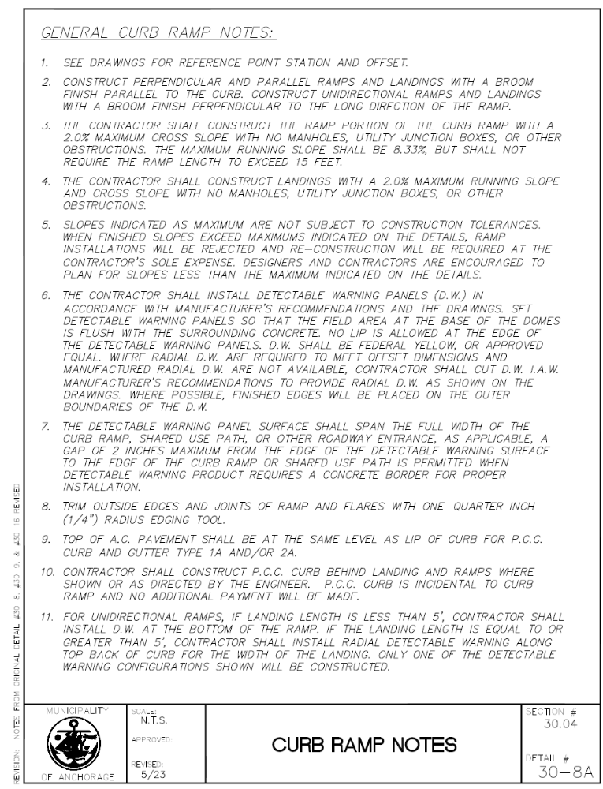
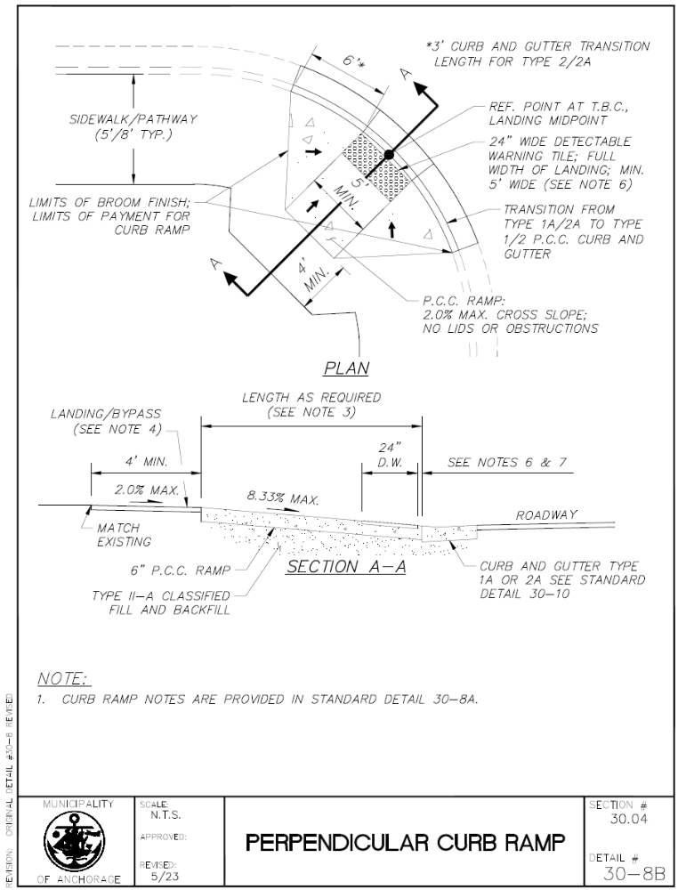
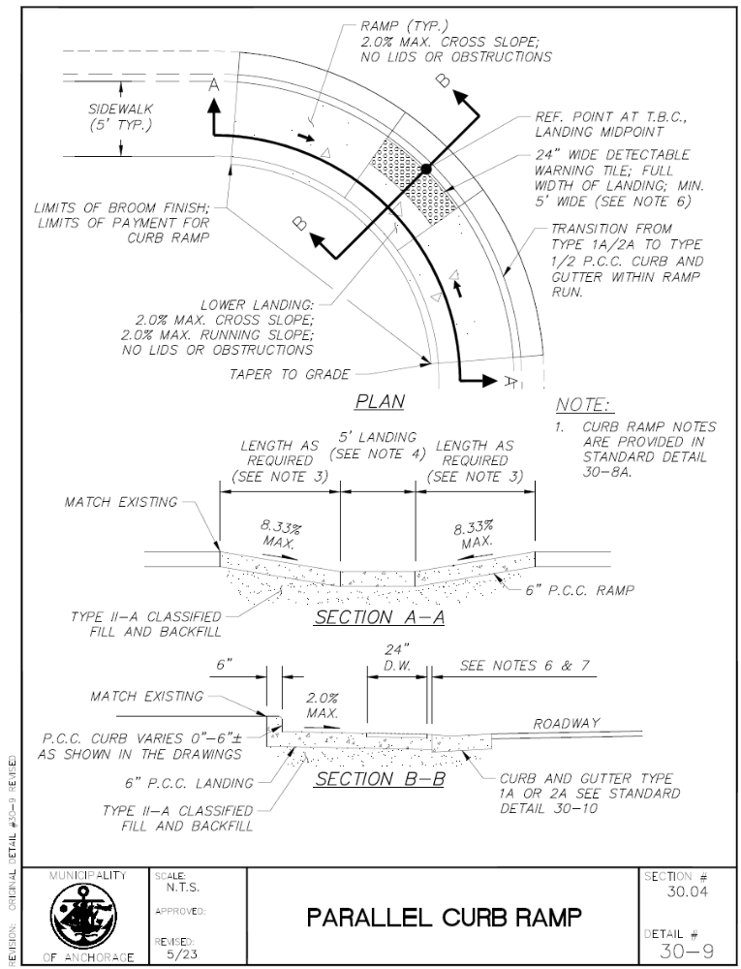
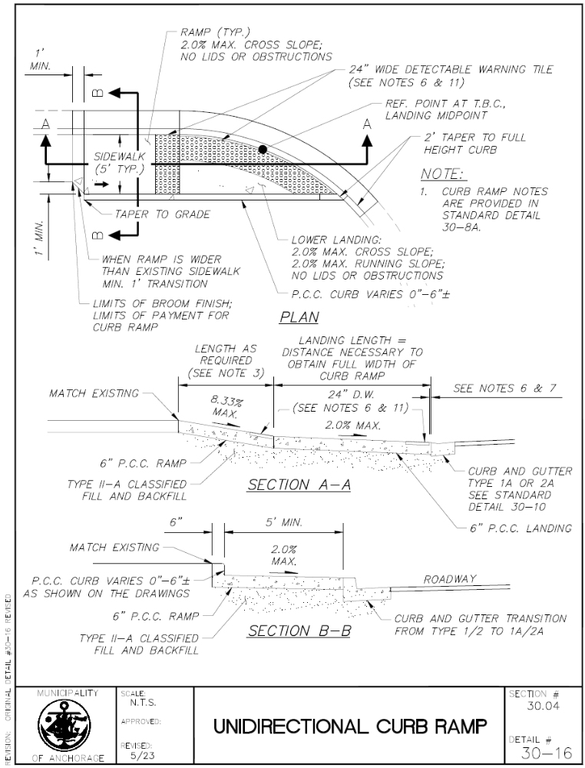
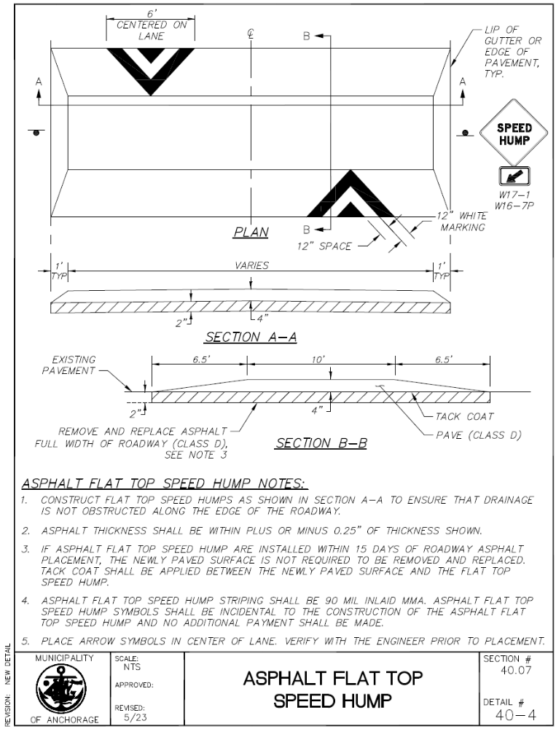
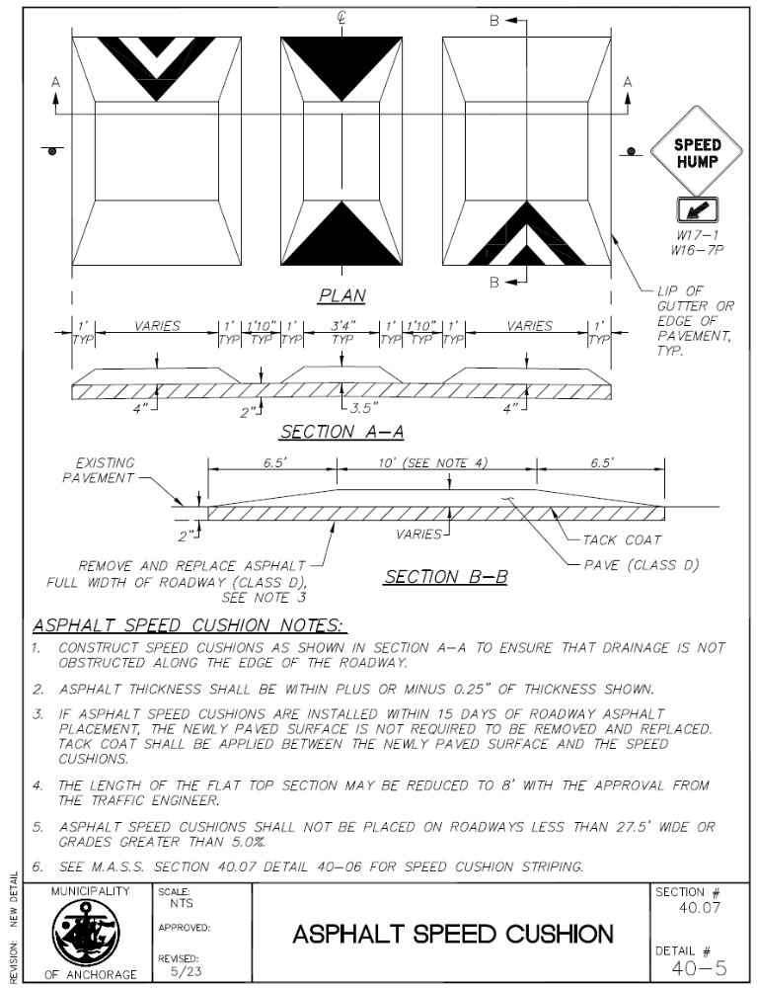
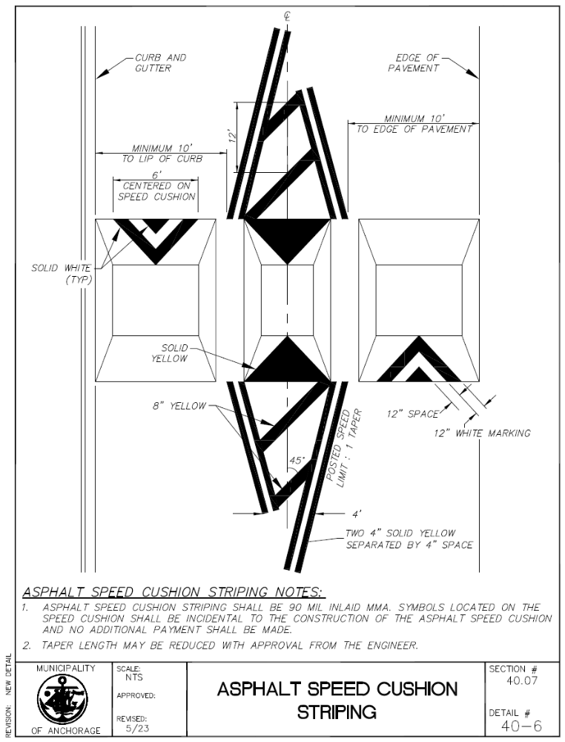
MUNICIPALITY OF ANCHORAGE
PROJECT MANAGEMENT AND ENGINEERING DEPARTMENT

PROJECT NAME
PROJECT LIMITS

XX-XX
V
SOILS INFORMATION

MUNICIPALITY OF ANCHORAGE
PROJECT MANAGEMENT AND ENGINEERING DEPARTMENT

PROJECT NAME
PROJECT LIMITS

XX-XX
VI
TEMPORARY CONSTRUCTION PERMITS AND EASEMENTS

MUNICIPALITY OF ANCHORAGE
PROJECT MANAGEMENT AND ENGINEERING DEPARTMENT

PROJECT NAME
PROJECT LIMITS

XX-XX
VII
EQUAL EMPLOYMENT OPPORTUNITY SPECIAL PROVISIONS

CONTRACT COMPLIANCE SPECIFICATIONS

EQUAL EMPLOYMENT OPPORTUNITY
SPECIAL PROVISIONS
Every municipal contract shall include language substantially the same as the following: The contractor will not discriminate against any employee or applicant for employment because of race, color, religion, national origin, ancestry, age, sex, sexual orientation, gender identity, marital status, or physical or mental disability. The contract will comply with all laws concerning the prohibition of discrimination including, but not limited to, Title 5 and Title 7 of the Anchorage Municipal Code.
Every municipal contract shall state, in all solicitations or advertisements for employees to work under the contract, that all qualified applicants will receive consideration for employment without regard to race, color, religion, national origin, ancestry, age, sex, sexual orientation, gender identity, marital status, or physical or mental disability.

MUNICIPALITY OF ANCHORAGE
PROJECT MANAGEMENT AND ENGINEERING DEPARTMENT

PROJECT NAME
PROJECT LIMITS

XX-XX
VIII
MINIMUM RATES OF PAY

Laborers’ & Mechanics’ Minimum Rates of Pay

Title 36. Public Contracts AS 36.05 & AS 36.10 Wage & Hour Administration Pamphlet No. 600 (Pamphlet 600) is hereby incorporated in its entirety. Pamphlet 600 is available for free download at http://labor.state.ak.us/lss/pamp600.htm.

The Municipality of Anchorage will include a paper copy of the wage rates in the signed Contract.

MUNICIPALITY OF ANCHORAGE
PROJECT MANAGEMENT AND ENGINEERING DEPARTMENT

PROJECT NAME
PROJECT LIMITS

XX-XX
IX
CONTRACT
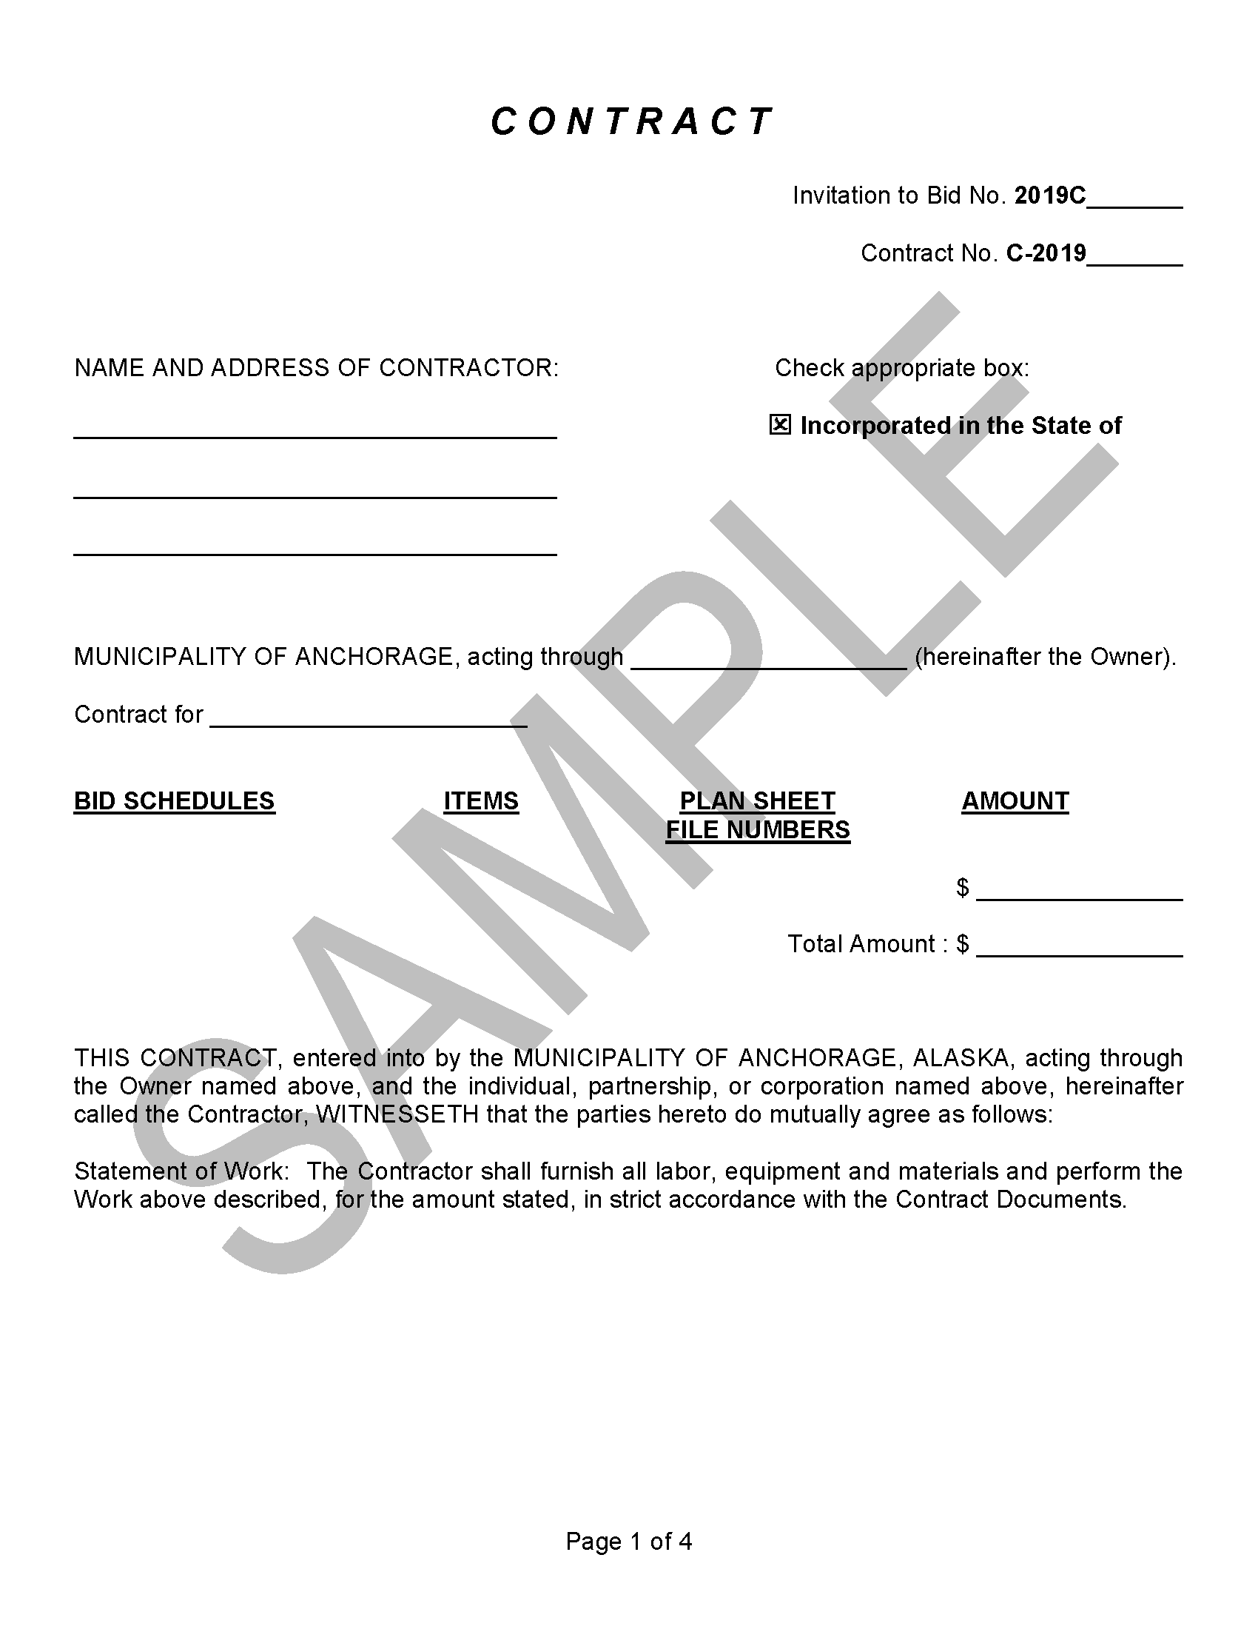

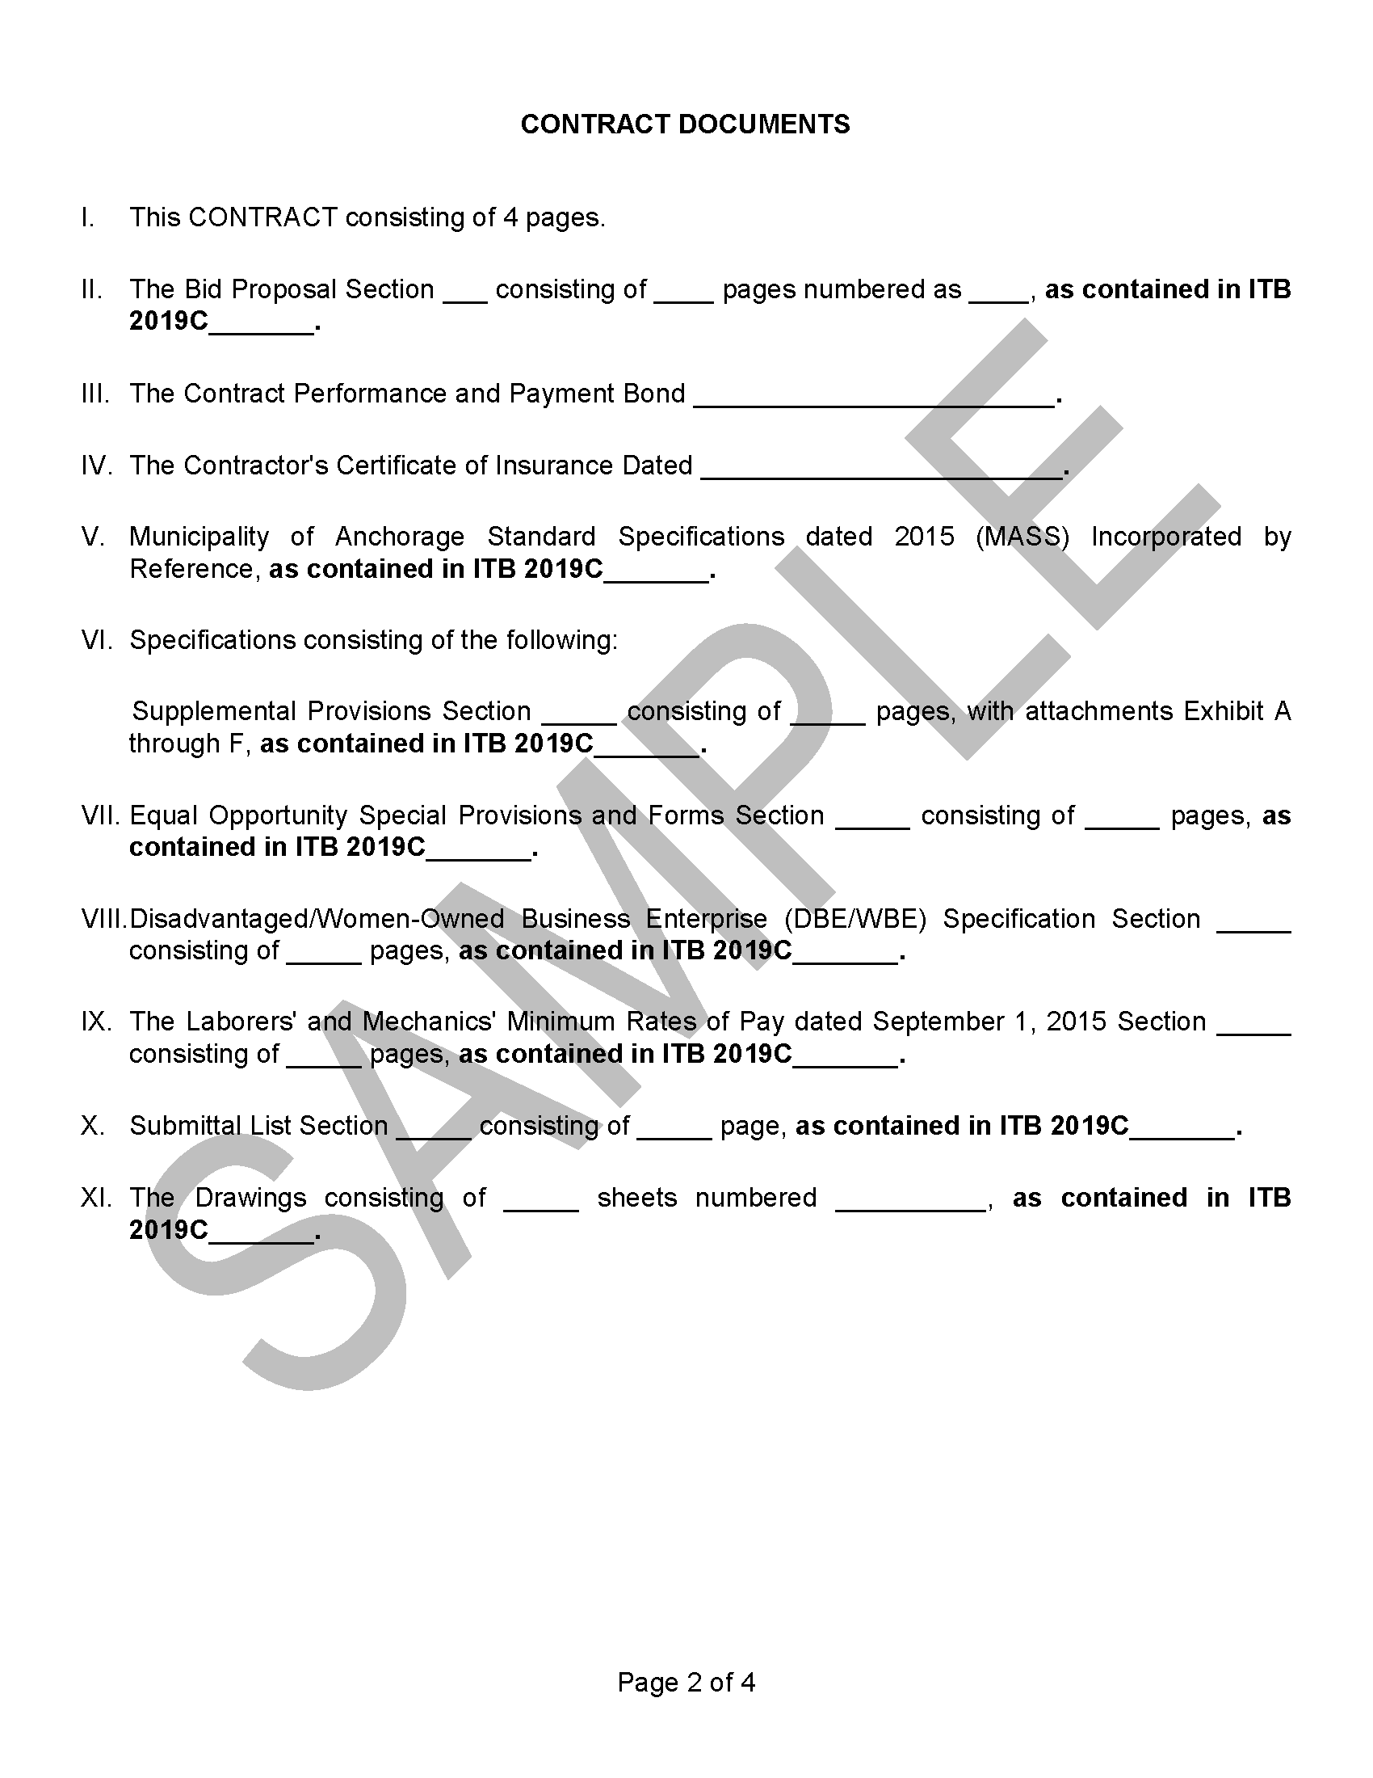
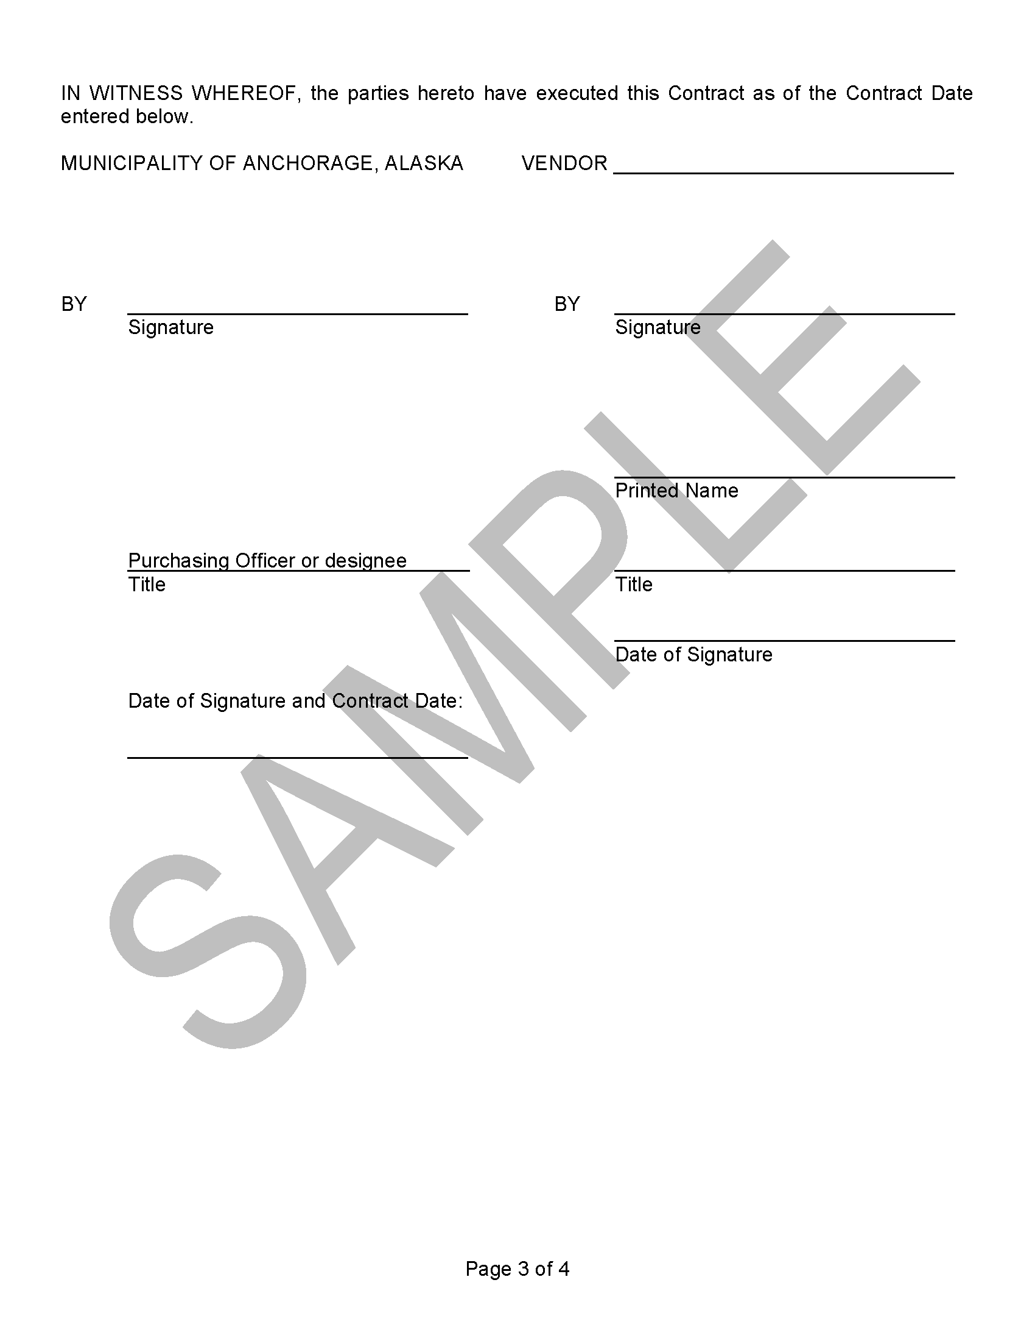
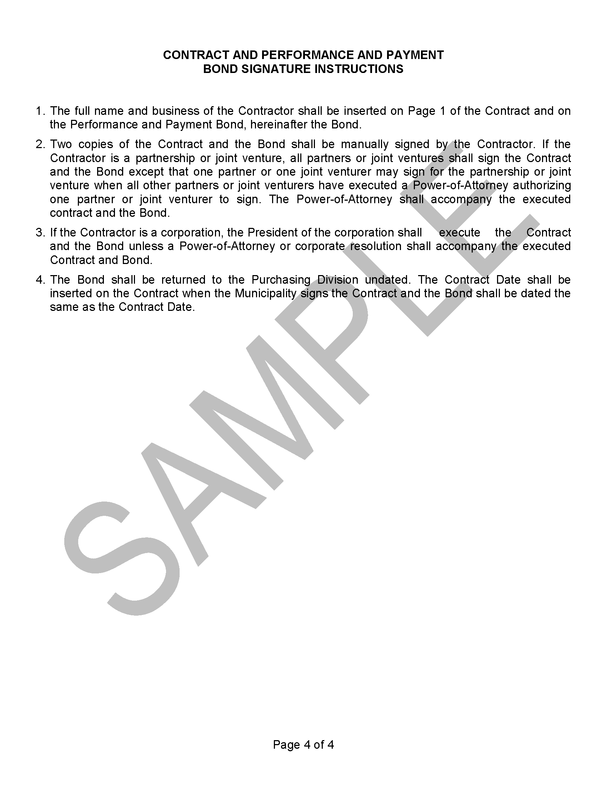
MUNICIPALITY OF ANCHORAGE
PROJECT MANAGEMENT AND ENGINEERING DEPARTMENT

PROJECT NAME
PROJECT LIMITS

XX-XX
X
CONTRACT PERFORMANCE AND PAYMENT BOND

CONTRACT PERFORMANCE AND PAYMENT BOND

KNOW ALL MEN BY THESE PRESENTS, That we ___________________________________
________________________________ of __________________________________________
as Principal, and _______________________________________________________________
a corporation organized under the laws of the ________________________________________
________________________________________ and authorized to transact surety business in the State of Alaska, of ___________________________________________________________
as Surety, are held and firmly bound unto the MUNICIPALITY OF ANCHORAGE, as Obligee, in the full and just sum of __________________________________________________________
($___________________________________) Dollars, lawful money of the UNITED STATES, for the payment which, well and truly to be made, we bind ourselves, our heirs, executors, administrators, successors and assigns, jointly and severally, firmly by these presents.
THE CONDITIONS OF THIS OBLIGATION IS SUCH, that whereas the principal has entered into a certain contract dated the ______________________ date of ____________ 20____________, with the Obligee for the construction of _______________________________
_____________________________________________________________________________
which contract is hereby referred to and made a part hereof as fully and to the same extent as if copied at length herein.

NOW THEREFORE, if the Principal shall well and truly perform and fulfill all the undertakings, covenants, terms, conditions, and agreements of said contract, and shall promptly make payments to all persons supplying labor and material in the prosecution of the work provided for in said contract, during the original term of said contract and any extensions or modifications thereof that may be granted by the Municipality, with or without notice to the Surety, then this obligation to be void; otherwise to remain in full force and effect.
This obligation is made for the use of said Obligee and also for use and benefit of all persons who may perform any work or labor or furnish any material in the execution of said Contract and may be sued on thereby in the name of said Obligee.
The said Surety, for the value received, hereby stipulates and agrees that no change, extension of time, alteration or addition to the terms of the contract or to the work to be performed thereunder or the specifications accompanying the same, shall in anywise affect its obligations on this bond, and it does hereby waive notice of any such change, extension of time, alteration or addition to the terms of the contract or to the work or to the specifications.
Whenever Principal shall be, and declared by Obligee to be in default under the Contract the Obligee having performed Obligee’s obligations thereunder, the Surety may promptly remedy the default or shall promptly:
1. Complete the Contract in accordance with its terms and conditions, or
2. Obtain a bid or bids for submission to Obligee for completing the Contract in accordance with its terms and conditions and upon determination by Surety of the lowest responsible bidder, or, if the Obligee elects, upon determination by Obligee and the Surety jointly of the lowest responsible bidder, arrange for a contract between such bidder and Obligee and make available as Work progresses (even though there should be a default or a succession of defaults under the contract or contracts of completion arranged under this paragraph) sufficient funds to pay the cost of completion less the balance of the contract price but not exceeding, including other costs and damages for which the Surety may be liable hereunder the amount set forth in the first paragraph hereof. The term “balance of the contract price” as used in this paragraph, shall mean the total amount payable by Obligee to Principal under the Contract and any amendments thereto, less the amount properly paid by Obligee to Principal.

IN TESTIMONY WHEREOF, the parties hereunto have caused the execution hereof in ________
________________ original counterparts as of the __________________ day of ____________,
20_________.

WITNESS AS TO PRINCIPAL:
_________________________________ ________________________________
Principal Name

___________________________
Principal Signature

___________________________
Corporate Surety
(AFFIX CORPORATE SEAL)
___________________________

___________________________
Surety Business Address

BY: ___________________________
(Attorney-In-Fact)

(AFFIX SURETY SEAL)
MUNICIPALITY OF ANCHORAGE
PROJECT MANAGEMENT AND ENGINEERING DEPARTMENT

PROJECT NAME
PROJECT LIMITS

XX-XX
XI
CERTIFICATE OF INSURANCE

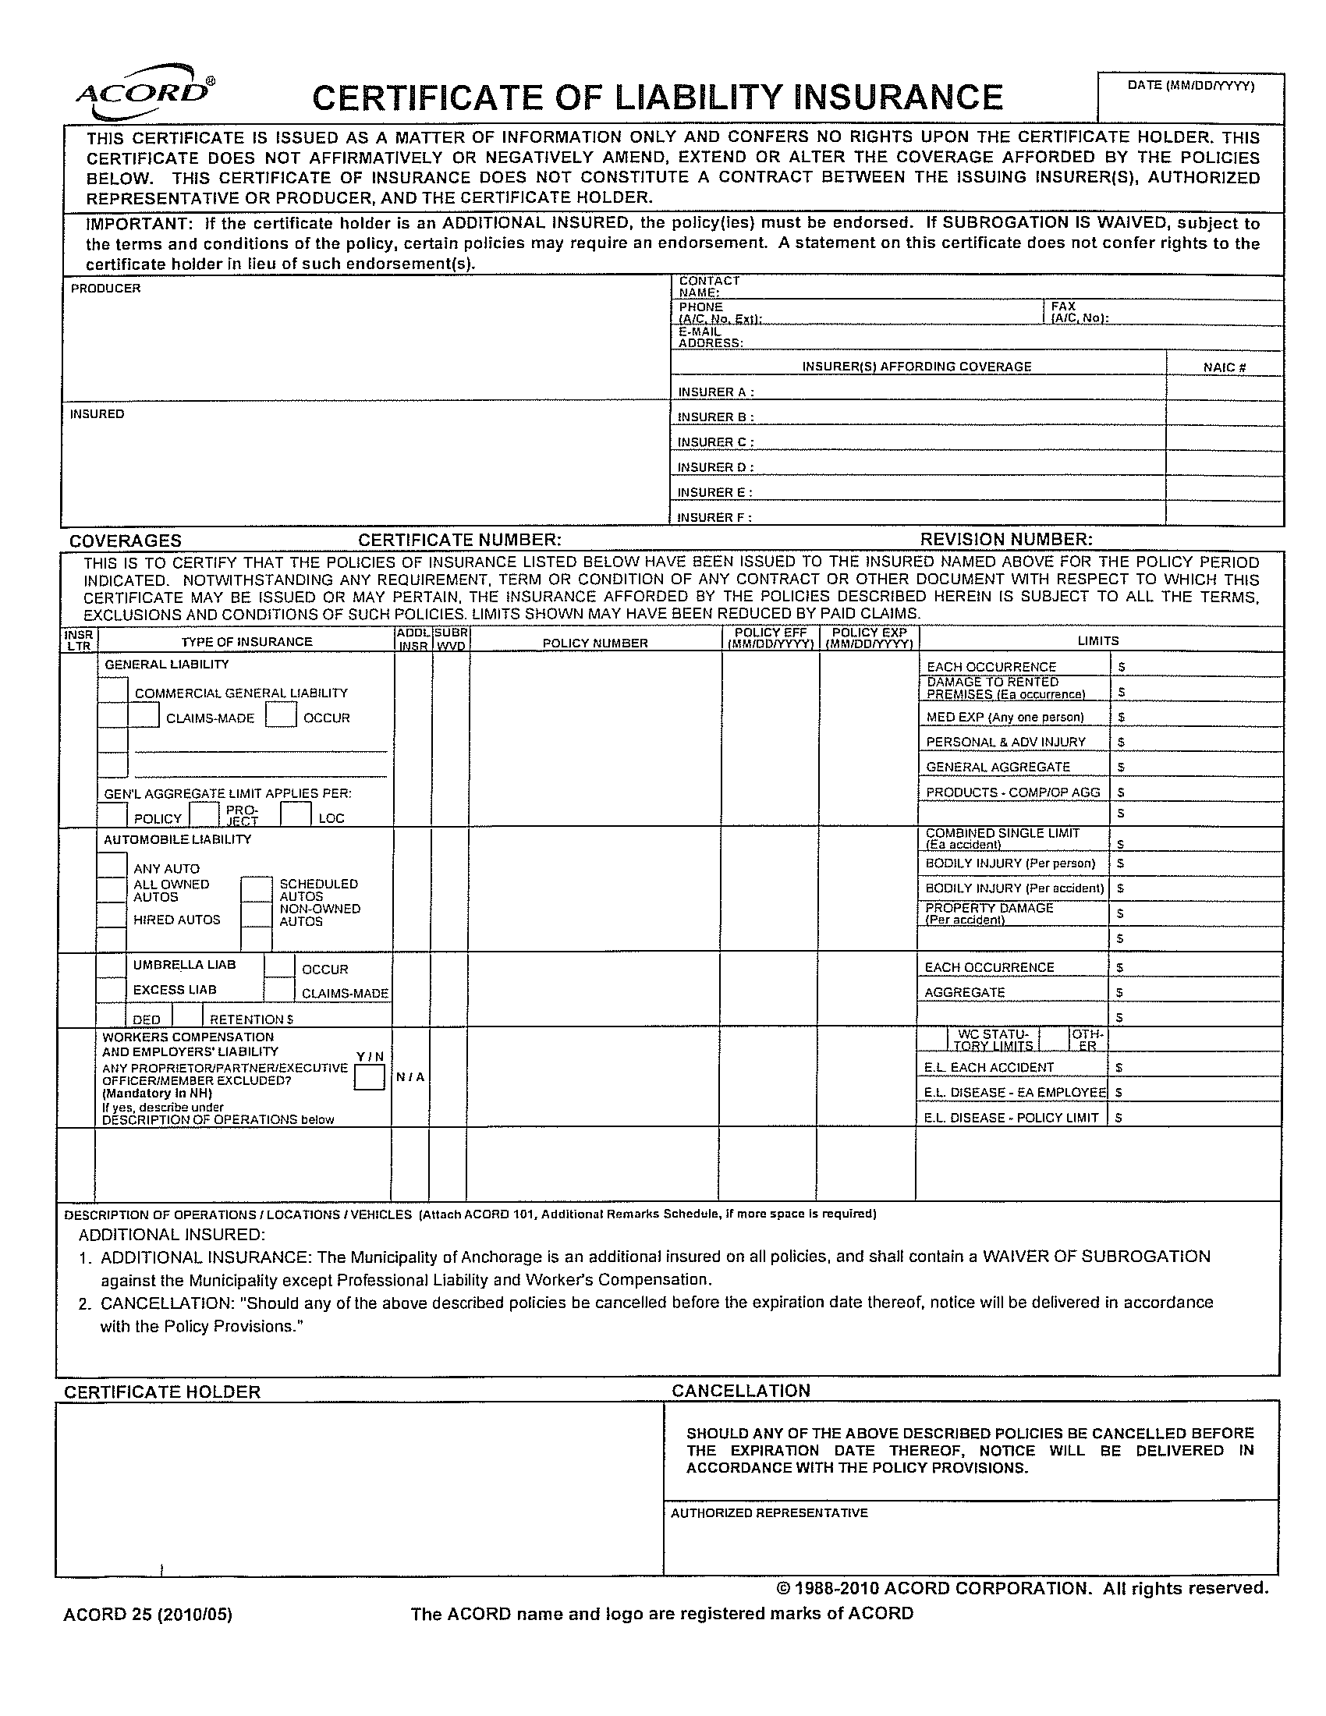
MUNICIPALITY OF ANCHORAGE
PROJECT MANAGEMENT AND ENGINEERING DEPARTMENT

PROJECT NAME
PROJECT LIMITS

XX-XX
XII
BID BOND

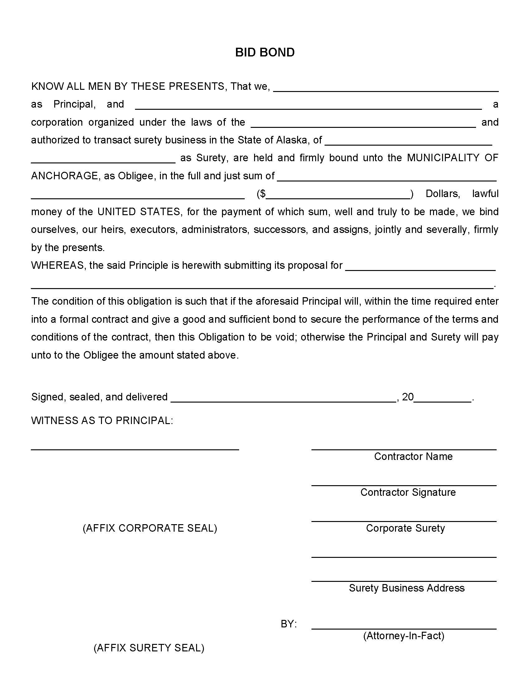
MUNICIPALITY OF ANCHORAGE
PROJECT MANAGEMENT AND ENGINEERING DEPARTMENT

PROJECT NAME
PROJECT LIMITS

XX-XX
XIII
BIDDER’S CHECKLIST & RESPONSIBLE BIDDER QUESTIONNAIRE

BIDDER’S CHECKLIST
INSTRUCTIONS TO BIDDER
I. General
Bidders are advised that, notwithstanding any instructions or implications elsewhere in this Invitation to Bid, only the documents shown and detailed on this sheet need be submitted with and made part of their bid. Other documents may be required to be submitted after bid time, but prior to award. Bidders are hereby advised that failure to submit the documents shown and detailed on this sheet shall be justification for rendering the bid nonresponsive. Evaluation of bids for responsiveness shall be accomplished in accordance with Anchorage Municipal Code, Title 7.

II. REQUIRED DOCUMENTS FOR BID:
NOTE: Only the following listed items as marked with an “X” are required to be completely filled out and submitted with the bid.
X Bid proposal consisting of pages BP- through BP- . BP- of BP- must be manually signed.
X Erasures or other changes made to the Bid Proposal Sheet must be initialed by the person signing the bid.
Two identical sets of descriptive literature, brochures, and/or data must accompany the bid where specifically requested or when in support of an “or equal” offer.
X Bid bond, certified check, cashiers check, money order or cash shall be submitted with the bid in the amount indicated.
X All Addenda issued shall be acknowledged in the space provided on the Bid Proposal sheet or by manually signing the Addenda sheet and submitting it prior to the bid opening in accordance with Anchorage Municipal Code 7.20.020C.
Disadvantaged and Women-Owned Business Enterprises, Form 10-029
Others
MUNICIPALITY OF ANCHORAGE
PROJECT MANAGEMENT AND ENGINEERING DEPARTMENT

PROJECT NAME
PROJECT LIMITS

XX-XX
XIV
BID PROPOSAL

BID PROPOSAL
(CERTIFICATION)

TO: MUNICIPALITY OF ANCHORAGE , 2023
PURCHASING DEPARTMENT
632 W. 6TH AVENUE, SUITE 520
ANCHORAGE, ALASKA 99501

SUBJECT: Invitation to Bid No. 2023C
PROJECT TITLE:

Pursuant to and in compliance with subject Invitation to Bid, and other bid documents relating thereto, the bidder hereby proposes to furnish all labor and materials and to perform all work for the construction of the above referenced project in strict accordance with the bid documents at the prices established in the Bid Proposal, pages BP-XX of YY through BP-ZZ of YY submitted herewith.

The bidder agrees, if awarded the contract, to commence and complete the work within the time specified in the bid documents.

The bidder acknowledges receipt of the following addenda:

Addenda No. Date of Addenda
Addenda No. Date of Addenda
Addenda No. Date of Addenda

Enclosed is a Bid Bond in the amount of .
(Dollar Amount or Percentage of Bid)

Type of Business Organization
The bidder, by checking the applicable box, represents that it operates as ( ) a corporation incorporated under the laws of the State of , ( ) an individual, ( ) an LLC, ( ) a partnership, ( ) a nonprofit organization, or ( ) a joint venture. If a partnership or joint venture, identify all parties on a separate page.

Company Name
BID PROPOSAL
(CERTIFICATION)
Continued

SUBJECT: Invitation to Bid No.

PROJECT TITLE:

Date Alaska Contractor’s License Number

Company Name (Printed) Employer’s Tax Identification Number

Authorized Representative Signature Printed Name & Title

Company Mailing Address Company Phone Number

City, State, Zip Code Company Fax Number

Company Email Address

Company Physical Address
(if different from mailing address)

City, State, Zip Code

SCHEDULE A – Basic Bid SAMPLE
ITEM | SPEC. | WORK DESCRIPTION |  | EST | UNIT BID | TOTAL BID
NO. | NO. | (UNIT PRICE IN WORDS) |  | QTY | PRICE | PRICE
A-1 | 20.02 | Storm Water Pollution Prevention Plan (Type 3) | per S.Y. | 1
A-2 | 95.04 20.09 | Remove Speed Hump | per Each | 2
A-3 | 20.10 | Unusable Excavation | per C.Y. | 2,550
A-4 | 95.04 70.12 | Traffic Maintenance | per L.S. | 1
A-5 | 75.03 | Topsoil (4") | per MSF | 5.2
A-6 | 75.04 | Seed (Schedule A) | per MSF | 5.2
 |  |  | Schedule A Total:
 |  | Contractor |  |  | Date

MUNICIPALITY OF ANCHORAGE
PROJECT MANAGEMENT AND ENGINEERING DEPARTMENT

PROJECT NAME
PROJECT LIMITS

XX-XX
XV
PLANS (XX SHEETS)
Suggested organization of Plan Set}
Sheet 1 | Cover Sheet
Sheet 2 | Key Map and Legend
Sheet 3 | Survey Control Sheet
Sheet 4 | Demolition Plan
Sheet 5 | Street Improvement Plan
Sheet 6 | Street Improvement Plan
Sheet 7 | Storm Drain Improvements
Sheet 8 | Sanitary Sewer Improvements
Sheet 9 | Water Improvements
Sheet 10 | Details
Sheet 11 | Curb Ramp Details
Sheet 12 | Illumination Plan
Sheet 13 | Striping Plan
Sheet 14 | Signing Plan
Sheet 15 | Sign Installation and Pavement Marking Detail Sheet
Sheet 16 | ML&P Vault and Duct System
Sheet 17
Sheet 18
Sheet 19
Sheet 20
Sheet 21
Sheet 22

