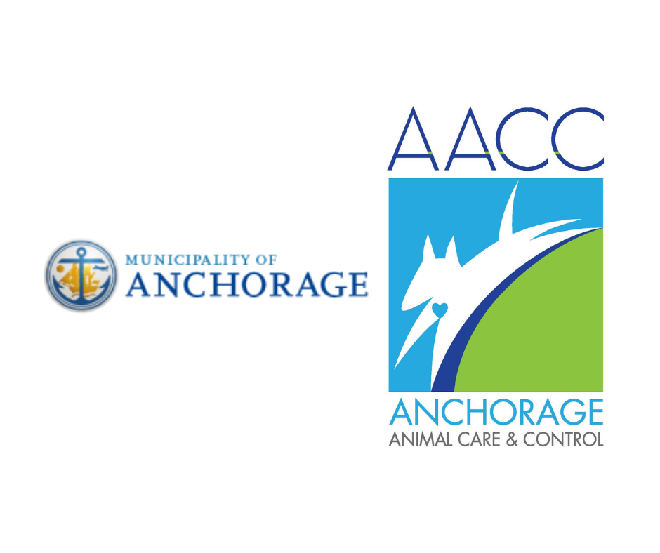Municipality of Anchorage Animal Care and Control
Adoption. Education. Assistance.
4711 Elmore Road, Anchorage, AK 99507
907-343-8122
www.muni.org/animal

The Municipality of Anchorage Animal Care and Control (AACC) provides care for companion cats, dogs, and a variety of small mammals. Volunteers assist with improving the emotional and physical well being of animals, along with helping them find new forever homes.

Volunteers need to possess the following physical, mental, and emotional capacities to effectively and safely perform the essential functions of the volunteer position(s) and serve as a MOA volunteer.

Volunteers must:
- Be at least 18 years of age.
- Commit to a regularly scheduled weekly shift, or two events per year for events and community outreach volunteers.
- Commit to at least six consecutive months of service.
- Be willing and able to pass a background check.
- Be willing and able to abide by the MOA Drug Free Workplace Policy.
- Be able to successfully complete a volunteer health and safety assessment.
- Successfully complete orientation, required training classes, and periodic skills evaluations.

Essential physical capabilities to perform the essential functions of all position(s):
- Quick reflexes and ability to use both hands simultaneously (example: open kennel door while handling animal).
- High level of manual dexterity to collar, leash, and/or harness animals.
- Ability to bend and squat in order to collar, leash, harness, or pick up an animal.
- Ability to stand for significant periods of time while walking dogs, socializing cats in their kennels, or assisting the public with visits.
- Average vision with or without correction to move safely without assistance, to observe animal body language without difficulty, and to read notes on animals’ paperwork.
- Ability to speak, write, and effectively communicate in English.
- Ability to maneuver well, react, and move quickly (example: ability to quickly pursue and retrieve cats or dogs who have escaped from a kennel, cage, or play area).
- Ability to handle and restrain animals of all sizes (up to 140 pounds) with extreme caution and care. This requires average vision, hearing, steadiness of hands and body, quick reflexes, physical strength, and mental alertness.
- Must not have strong allergies to dogs, cats or other companion animals that cannot be managed by medication, or to chemicals used in grooming or cleaning.
- Ability to deal with strong and unpleasant odors.
- Ability to cope with a very loud environment.

Essential physical capabilities required for cat adoption counselors to perform the essential functions of the position:
- Ability to reach into kennels at least six feet in height, using a step stool as needed.

Essential physical capabilities required for dog adoption counselors to perform the essential functions of the position:
- Ability to walk unaided on all types of terrain in all types of weather.

Essential physical capabilities required for grooming dogs to perform the essential functions of the position:
- Average strength to assist with lifting animals to shoulder height to place into bathtub, which is approximately three and a half feet high.
- Ability to bend over a bathtub for extended periods of time to complete grooming/washing procedures as needed.
- High level of manual dexterity to handle small tools to properly groom animals.

Essential mental capabilities required to perform the essential functions of all position(s):
- Ability to understand, remember, and follow instructions and procedures given in English.
- High level reading, writing, spelling and communication skills (example: understand words such as quarantine, euthanize, and other common industry-related terms), and mastery of the English language.
- Possess problem-solving capability.
- Must be able to recognize potentially dangerous situations when working with animals. Must be able to remain calm with animals who are upset. Must behave sensitively and confidently; show good judgment and act appropriately in these situations.

Essential emotional capabilities required to perform the essential functions of all position(s):
- Ability to cope with unexpected animal behavior without assistance.
- Ability to cope with an emotionally charged environment with animals that are homeless, neglected, and/or abandoned, as well as the reality that some of the animals in our care may be euthanized.
- Ability to understand the shelter’s policies and procedures regarding companion animals, animal control, and other key animal welfare issues and an ability and willingness to appropriately and accurately represent those policies when interacting with the public or otherwise representing the shelter.

Level of supervision:
- Once trained, volunteers must be self-motivated and able to work with minimal supervision; yet must recognize limitations in knowledge and abilities and ask for help when needed.
- Should be able to work independently for long periods of time, as well as work within a team atmosphere with other volunteers or staff.

Risks/Hazard exposure:
- Understand and recognize volunteer services might include exposure to hazardous cleaning agents, personal injuries, accidents, animal bites, and personal property damage.

At this time AACC is unable to accept applications from those wishing to fulfill court ordered community service requests.
If you would like to join the volunteer team, possess the required physical, mental and emotional capabilities, and are willing to fulfill training requirements, you are encouraged to complete and sign the remainder of the application. Please direct any questions you may have to the volunteer coordinator. The information in this application will help us find the most appropriate position(s) for you. Please print your responses.
For Office Use Only Date Contacted______________
Date Contacted______________
Orientation______________

1. Applicant Information:
Last Name First Name Middle Initial
Address City State Zip
Contact Phone Birth Date (MM/DD/YYYY)
Email

2. In Case of Emergency, please contact:
Name
Address City State Zip
Relationship
Phone

3. Why would you like to volunteer with Anchorage Animal Care and Control? _____________________________________________________________________________________________
_____________________________________________________________________________________________

- What do you hope to gain from your volunteer experience? _________________________________________
_____________________________________________________________________________________________

- Do you currently have pets? Yes ____ No ____
a. If yes, what kind? Cat_____ Dog_____ Other (please list) _____________________________________
b. Are they spayed or neutered? Yes_____ No_____ Not applicable ____

- Have you ever been bitten by a cat or dog? Yes_____ No_____
a. Did the bite require medical attention? Yes_____ No_____
b. If yes, please explain ___________________________________________________________________

7. Please list present and past volunteer position(s): _____________________________________________________________________________________________
_____________________________________________________________________________________________
a. What did you like best about the work? ____________________________________________________
b. What did you like least? ________________________________________________________________
c. How long did you volunteer? ____________________________________________________________
d. What were your reasons for leaving? ______________________________________________________
______________________________________________________________________________________

8. Please indicate any special skills/interests you have:
Clerical/Data Entry _____ Writing/Editing _____ Graphic Design _____
Photography/Videotaping _____ Event Planning/Coordination ______
Admin/Customer Service ______ Grooming _____
Animal Behavior/Training (please describe) _________________________________________________________
Other (please describe – new ideas are welcome!) ____________________________________________________

- From the following volunteer positions, please indicate the first two for which you would like to be considered.

___ Cat Adoption Counselor
___ Small Animal Adoption Counselor
___ Administrative Volunteer
___ Dog Adoption Counselor
___ Events and Community Outreach Volunteer
___ Volunteer Photographer

- Availability.
Please check the days and times you plan to volunteer.
Shift times | Sunday | Monday | Tuesday | Wednesday | Thursday | Friday | Saturday
10 – 11 AM |  | closed | closed | closed | closed | closed
11 – 12 PM
12 – 1 PM
1 – 2 PM
2 – 3 PM
3 – 4 PM
4 – 5 PM
5 – 6 PM
6 – 7 PM | closed |  |  |  |  |  | closed
Volunteers are expected to volunteer in regularly scheduled 1-2 hour shifts. Two unexcused absences will result in immediate termination from the volunteer program.

- Health and safety assessment: Can you perform all the essential functions of the volunteer position listed on pages 1-2 of this application? If no, which ones can you not perform?
_____________________________________________________________________________________________
_____________________________________________________________________________________________
_____________________________________________________________________________________________

- By signing this form, I acknowledge that I meet the requirements to serve as a volunteer at the MOA, including but not limited to, possessing the physical, mental and emotional capabilities required to perform the essential functions of the position(s). I further understand that I will be required to pass a background check as part of the application process and give my consent to MOA and its Contractor to check CourtView for convictions related to cruelty/mistreatment of animals, violence, stalking, harassment, workplace violence and/or illegal drug use.

Printed Name: __________________________________________________

Signature: ______________________________________________________ Date__________________________

