What is Anchored Home:2018-2021? 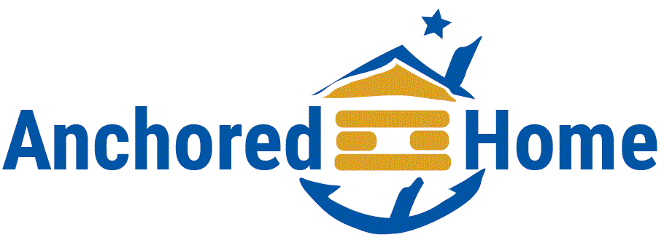
The Anchored Home plan is an update of the 2015 Anchorage Community Plan to End Homelessness. This plan will address communication and representation within the Anchorage community regarding homelessness and housing. The Anchored Home plan, officially launching in October, will work with the new Anchorage Homeless Leadership Council (HLC) to provide timelines for activities, ensure assignment responsibility and accountability, and further guide the work in addressing homelessness and housing issues in our community. Anchored Home is a collaborative effort between the Municipality of Anchorage, the Anchorage Coalition to End Homelessness (ACEH), community leaders such as the Rasmuson Foundation, United Way, and many other key stakeholders - housing partners, social service agencies, residents and funding partners.

Why are we releasing an updated strategic plan?
The Anchored Home plan is a strategic update that will build on existing work to extend the strategies to new partners, deepen the commitment to align resources and incorporate more community stakeholders. With this strategic plan update, we will inform the community stakeholders of new developments and encourage a stronger understanding of what each person can do to help further the Anchored Home plan and our goal to end homelessness.

Who will support the plan?
A primary workgroup with three main leaders provides the core staffing to the plan: Nancy Burke, from the Municipality of Anchorage; Jasmine Khan, from the Anchorage Coalition to End Homelessness; and Dr. Dick Mandsager, a Rasmuson Foundation Senior Fellow. These three entities will provide staffing and guidance for the work under the plan, however, there are many other organizations committed to outcomes, including Providence Alaska Health & Services, United Way of Anchorage, and Cook Inlet Housing Authority, Alaska Mental Health Trust Authority, and many community social service and housing partners.
To see the list of supporting entities, click here: (Link to the list of partners here) – see list on p3

Who will oversee the plan?
The Anchorage Homelessness Leadership Council (HLC): This group of prominent Anchorage leaders will oversee the plan as it is put into action. The council will leverage resources, monitor data, hold service providers and other stakeholders accountable, inform the public on results, and provide overall direction on next steps.

Why select an oversight board with so many partners involved?
The oversight board, Anchorage Homeless Leadership Council will be involved in monitoring data, providing advocacy and working to develop needed resources to implement Anchored Home priorities. This neutral role allows the partners doing the work to have a focus on each of their respective areas of expertise while an overarching group will monitor the system outcomes and needed resources. Having these levels of supporting partners allows multiple facets of the action plan to be addressed at once, while still working to achieve a common goal.

Where else has a plan like this been used? Why is it effective for our community?
Cities with high homelessness rates, such as Houston, Texas, and Salt Lake City, Utah, have utilized action plans and community leadership councils similar to Anchored Home with positive results. Anchored Home will be tailored to fit the needs of Anchorage, while using the model of a core group that works together under a common goal.
Using tools such as these, Anchorage will make homelessness a rare, brief and one-time event. We will also improve communication within the community while creating an environment where outcomes and resources needed can be highlighted for everyone.

How will community input be taken?
There will be a community stakeholder input process that begins on August 23, with the initial phase ending on or before October 4. Ongoing input will be taken through the Anchorage Homeless Leadership Council (HLC) meetings and additional community gatherings throughout the year. Please see the link below for dates of community meetings on the plan (link here). There will be a general public meeting on Sept 18th at 5:30 – 7:30 PM at the Anchorage Loussac Library, Wilda Marston Theatre.

Why now? What has changed with the new plan?
It is our desire for all Anchorage communities to have equal access to information on the plan to end homelessness in our city. The updated Anchored Home strategic plan will allow for broader communication and a more inclusive representation of the community experience of homelessness impacts and solutions. By encouraging representation through community stakeholders, the Anchored Home plan will be enabled to grow and develop as the community does.

Collaboration and Inputs
Everyone in the community has a role to play in ensuring that homelessness for people in Anchorage is a rare, brief and one-time experience. Many partners have contributed to Anchored Home and have committed to working together to achieve its goals. Many voices came to the conversation and provided inputs.

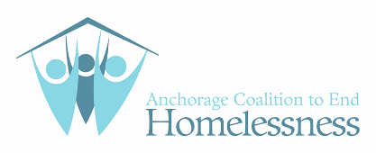
Anchored Home Developers and Funders

