All Hazards
Mitigation Plan Update

Anchorage, Alaska

Municipality of Anchorage Project Management & Engineering
PO Box 196650
Anchorage, AK 99519-6650

July 2016

EXECUTIVE SUMMARY

The Municipality of Anchorage (MOA) is vulnerable to a wide range of natural, technological, and human/societal hazards including earthquakes, avalanches, and hazardous material accidents. These hazards can affect the safety of residents, damage or destroy public and private property, disrupt the local economy, and negatively impact the quality of life.

Typically, we cannot eliminate these hazards altogether but we can lessen their impact by undertaking hazard mitigation activities. Hazard mitigation activities are those that reduce or eliminate the long-term risk to property and human life from hazards. Examples of hazard mitigation activities include elevating a structure out of a floodplain, bolting a structure to its foundation and developing a hazard mitigation plan.

The Disaster Mitigation Act of 2000 (DMA 2000) requires that local governments have a local mitigation plan approved by the Federal Emergency Management Agency (FEMA) as a condition for receiving future FEMA mitigation funds. This hazard mitigation plan was developed to fulfill federal and state hazard mitigation planning requirements.

Development and implementation of this plan has been directed by the Anchorage Hazard Mitigation Planning Team consisting of representatives from a variety of municipal departments including the Office of Emergency Management, Project Management & Engineering, Maintenance & Operations, Anchorage School District, Anchorage Water & Wastewater Utility, the Port of Anchorage, Anchorage Police Department and Anchorage Fire Department.

Upon approval by FEMA, this plan will be formally adopted by the MOA Assembly.

FEMA REQUIREMENTS
According to the FEMA regulations, a mitigation plan must identify the hazards that occur in Anchorage, contain a strategy to mitigate those hazards and a method of monitoring and updating the plan.

HAZARDS IN ANCHORAGE

The hazards that may occur in Anchorage include:
Natural | Technological | Human/Societal
Earthquake | Dam Failure | Civil Disturbance
Wildfire | Energy Emergency | Terrorism
Extreme Weather | Urban Fire | Weapons of Mass Destruction (Chemical, Biological, Radiological, Nuclear, or Explosive Agents)
Flooding | Hazardous Materials Release
Avalanche | Radiation Accident
Ground Failure/Landslide | Transportation Accident
Volcanic Ash Fall | Air Pollution
Severe Erosion | Communications Failure
Infectious Disease | Dock Failure
Food/Water Contamination

The 2005 plan focused on natural hazards. In this update, the plan was expanded to include technological hazards. Human/societal hazards will be addressed in future updates of the plan.

For each hazard, there is a description of the hazard’s characteristics, the location where the hazard can occur, previous occurrences of the hazard, and what is vulnerable to the hazard. Where possible, the location of the hazard area has been mapped.

MITIGATION STRATEGY
The mitigation strategy includes goals, objectives and action items that, when implemented, will make the MOA safer. The goals and objectives are:
Goal 1: Education/Coordination: Develop coordinated and proactive public policies, emergency plans and procedures, and educational programs that minimize the risk to the community from natural, technological, and human/societal hazards and disasters.
(From Anchorage 2020, LRTP, Housing & Community Development Consolidated Plan, Work Force & Economic Development Plan)
Objective 1.1 Increase coordination among Municipal departments.
Objective 1.2 Educate individuals and businesses about hazards, disaster preparedness, and mitigation.
Objective 1.3 Increase coordination between hazard mitigation goals and existing and future plans, including the incorporation of effective hazard mitigation strategies into the Capital Improvement Program.
Objective 1.4 Coordinate with the Alaska Division of Insurance, as well as the AK DOT&PF and the State’s Department of Homeland Security and Emergency Management.
Objective 1.5 Educate public officials, developers, realtors, contractors, building owners, and the general public about hazard risks and disaster mitigation requirements.
Objective 1.6 Partner with Municipal Departments and other agencies serving vulnerable populations to minimize harm in the event of an emergency.

Goal 2: Land Use/Planning: Develop an urban place that functions in harmony with its natural setting and is mindful of its natural technological and human/societal hazards.
(From Anchorage 2020, LRTP, Housing & Community Development Consolidated Plan)
Objective 2.1 Continue to provide for floodplain management to protect residents and property from the hazards of development in floodplains.
Objective 2.2 Land use regulations shall include new design requirements that are responsive to Anchorage’s climate and natural setting.
Objective 2.3 Use environmentally and conservation-friendly materials in mitigation projects whenever possible and economically feasible.
Objective 2.4 Adopt and enforce public policies to minimize impacts of development and enhance safe construction in high hazard areas.
Objective 2.5 Integrate new hazards and risk information into building codes and land use planning mechanisms, to ensure resilience.

Goal 3: Emergency Management: Create and maintain a community where people and property are safe.
(From Anchorage 2020, LRTP, Housing & Community Development Consolidated Plan, Work Force & Economic Development Plan)
Objective 3.1 Develop mechanisms in advance of a major emergency to cope with subsequent rebuilding and recovery phases.
Objective 3.2 Consider the secondary effects of disasters, such as hazardous waste and hazardous materials spills, when planning and developing mitigation projects.
Objective 3.3 Minimize increases in hazard vulnerability.
Objective 3.4 Ensure compliance with the Emergency Planning and Community Right-to- Know Act of 1986
Objective 3.5 Improve road connectivity for evacuation purposes.
Objective 3.6 Promote disaster contingency planning and facility safety among institutions that provide essential services such as food, clothing, shelter, and health care.
Objective 3.7 Improve disaster warning systems.
Objective 3.8 Promote appropriate hazard mitigation of all public and privately owned property within the Municipality of Anchorage including, but not limited to, residential units, commercial structures, educational institutions, health care facilities, public gathering places, other and infrastructure systems.
Objective 3.9 Promote mitigation of historic buildings.
Objective 3.10 Promote post-disaster mitigation as part of repair and recovery.

Goal 4: Protection of Public/Critical Facilities: Make MOA-owned facilities as resilient as feasible.
Objective 4.1 Encourage a structural review of new facilities.
Objective 4.2 Consider known hazards when siting new facilities and systems. Objective 4.3 Perform structural retrofitting of existing structures.
Objective 4.4 All public facilities should have a pollution prevention plan. Objective 4.5 Incorporate non-structural mitigation into existing buildings.
Objective 4.6 Implement mitigation programs that protect critical Municipal facilities and services and promote reliability of lifeline systems, e.g., the Port of Anchorage, to minimize impacts from hazards, to maintain operations, and to expedite recovery in an emergency.
Objective 4.7 Create redundancies for critical networks such as water, sewer, digital data, power, and communications.
Objective 4.8 Formalize best practices for protecting systems and networks.

Goal 5: Support Wildfire Mitigation.
Objective 5.1 Support the AFD Wildfire Strategic Plan.
Objective 5.2 Promote FireWise homes through the concepts in Firewise Alaska; landscaping and vegetation management; structure protection through preparedness; building design, siting, and construction material; and homeowner awareness.
Objective 5.3 Promote vegetation management in greenbelts and parks to limit fire spread.
Objective 5.4 Maintain the wildfire risk model.
Objective 5.5 Maintain and develop additional water resources.

Goal 6: Information: Ensure information is easy to access and up to date.
Objective 6.1 Convert all hazard maps to GIS format. Objective 6.2 Identify hazards not already mapped.
Objective 6.3 Map all currently unmapped regulated flood-prone areas. Objective 6.4 Update drainage studies.

Goal 7: Economy/Business: Maintain Anchorage’s (and the State’s) economic vitality
Objective 7.1 Partner with private sector, including small businesses, to promote structural and non-structural hazard mitigation as part of standard business practice.
Objective 7.2 Educate businesses about contingency planning citywide, targeting small businesses and those located in high-risk areas.
Objective 7.3 Partner with private sector to promote employee education about disaster preparedness while on the job and at home.
Objective 7.4 Minimize economic loss.

ACTION ITEMS
Action 1. Identify department responsible for coordinating hazard mitigation activities.
Action 2. Review composition of departments represented on the hazard mitigation planning committee.
Action 3. Review and update prioritization strategy (in Appendix G). Upon completion, prioritize action items.
Action 4. Hold semi-annual meetings of the hazard mitigation committee.
Action 5. The MOA shall develop a program to educate the community on the various methods of making structures and their contents more disaster- resistant, which would include workshops, literature, and public safety announcements.
Action 6. Continue the Emergency Watch Program.
Action 7. Develop a recovery plan.
Action 8. Acquire updated air photos or LiDAR information for the entire MOA.
Action 9. Identify necessary warning system improvements.
Action 10. Utilize essential strategies to implement public safety policies 98, 99, and 100 of Anchorage 2020 – Anchorage Bowl Comprehensive Plan (9-10-02 public safety amendments; AO 2002-119). Essential strategies include emergency management plan, public safety plan, design for public safety, public facilities site selection criteria, and geohazards management.
Action 11. Continue to require new and renovated MOA infrastructure to go through the FM Global Engineering Review.
Action 12 Develop siting requirements for facilities built with Municipal funds.
Action 13. Replace, retrofit, or construct new fire stations as listed in the AFD’s 2009-2015 Strategic Plan.
Action 14. Replace, retrofit, or construct new police stations as listed in the APD’s Strategic Plan.
Action 15. Complete the Anchorage Port Modernization Project.
Action 16. Prepare 1 or 2 grant applications that can be submitted to DHS&EM when funds are available.
Action 17. Create a volcanic ash recovery plan.
Action 18. Obtain GIS data used to create the seismic landslide hazards maps from the USGS Report titled “Maps showing Seismic Landslide Hazards in Anchorage, Alaska.”
Action 19. Pursue funding to seismically retrofit MOA-owned facilities that will be needed during and after a hazard.
Action 20. Install gas shut-off valves in MOA-owned public facilities used in response/recovery efforts.
Action 21. Repair the Port of Anchorage pilings under Terminal I as necessary.
Action 22. Continue to identify municipal fire stations, police stations, emergency facilities, and other facilities that need to be seismically retrofitted or rebuilt to current seismic standards.
Action 23. Continue and expand seismic monitoring instrumentation of buildings, other major structures, and free field sites throughout the Municipality, and establish funding support for locally based monitoring and data analysis from these instruments.
Action 24. Incorporate the action items identified in the Downtown Seismic Risk Assessment into the All-Hazards Mitigation Plan.
Action 25. Review existing zoning to determine if additional wildfire mitigation measures could be incorporated.
Action 26. Conduct fire-wise home assessment.
Action 27. Maintain the wildfire risk model.
Action 28. Continue and maintain vegetation management.
Action 29. Develop additional water resources for wildfire response purposes.
Action 30. The MOA shall continue to apply floodplain management regulations for development in the flood plain and floodway.
Action 31. The MOA shall continue to utilize the FEMA Flood Insurance Rate Map to define the special flood hazard area, the floodway, and the floodplain.
Action 32. Annually review and amend, as appropriate, a list of potential flood mitigation projects such as culvert replacement, channel rehabilitation and property acquisition.
Action 33. Annually identify and prioritize FIRMs that need to be updated.
Action 34. Update the Flood Insurance Study.
Action 35. Convert the local vertical datum to a national standard vertical datum.
Action 36. Annually review the list of drainage studies that need updating.
Action 37. Update snow avalanche mapping for Chugiak/Eagle River, Anchorage Bowl, and Turnagain Arm/Girdwood.
Action 38. Map estimated dam inundation areas within the Municipality and evaluate alternative methods to mitigate the potential risk of a dam failure in these areas.
Action 39. Retrofit the Lake O’ the Hills Dam.
Action 40. Identify all MOA facilities that need an industrial storm water pollution prevention plan (SWPPP).
Action 41. Continue to comply with Right to Know Act.
Action 42. Continue to support DHHS’s air pollution monitoring, prevention, and education programs.
Action 43. Create an inventory of respite centers to be used during an air quality emergency.
Action 44. Continue the Communicable Disease Reporting and Screening program.
Action 45. Identify ways to have information on reportable infectious diseases reported to DHSS in a timelier manner.
Action 46. Continue the Tuberculosis Control Program.
Action 47. Continue the Immunization Clinic.
Action 48. Continue to support DHHS’s food safety & sanitation program.

Plan Maintenance
This plan will be maintained through a series of annual evaluations, evaluations after major hazard events, and a formal re-adoption every five years. On an annual basis, the plan will be evaluated to:
- monitor progress made on plan recommendations during the previous 12 months.
- identify mitigation accomplishments in projects, programs and policies.
- update the status of mitigation projects included on the city’s Capital Improvement Program list, and elsewhere.
- ensure new mitigation needs are identified.
- identify new mitigation projects.
- review project prioritization to ensure it reflects current conditions.
- modify or remove existing initiatives, and the justification for doing so.
- incorporate changes in membership to the MOA Hazard Mitigation Planning Committee.
Table of Contents

EXECUTIVE SUMMARY 2
CHAPTER 1 - INTRODUCTION 12
1.1 BACKGROUND 12
1.2 PURPOSE 13
1.3 HOW THIS PLAN WILL BE USED 13
1.4 SUMMARY OF HAZARDS IN THE MUNICIPALITY OF ANCHORAGE 13
1.5 SCOPE 15
1.6 ORGANIZATION OF THE PLAN 16
1.7 PLANNING PROCESS 16
1.8 PUBLIC INVOLVEMENT 18
CHAPTER 2 COMMUNITY PROFILE 19
2.1 LOCATION 19
2.2 NATURAL SETTING 19
2.3 HISTORY 20
2.4 DEMOGRAPHICS 21
2.5 ECONOMY 23
CHAPTER 3 ASSET INVENTORY 25
3.1 INFRASTRUCTURE 25
3.2 EXISTING DEVELOPMENT IN MOA 35
3.3 FUTURE DEVELOPMENT 36
CHAPTER 4 – HAZARDS IN THE MUNICIPALITY OF ANCHORAGE 39
4.1 NATURAL HAZARDS 40
4.2 TECHNOLOGICAL HAZARDS 95
4.3 HUMAN/SOCIETAL 115
CHAPTER 5 MITIGATION STRATEGY 116
5.1 GOALS AND OBJECTIVES 116
5.2 IMPLEMENTATION 119
5.3 ACTION PLAN 121
CHAPTER 6 PLAN MAINTENANCE 136
6.1 PLAN ADOPTION 136
6 .2 MONITORING AND EVALUATION 136
6.3 UPDATING 136
6.4 CONTINUED PUBLIC INVOLVEMENT 138

REFERENCES 139

List of Tables On or Following Page

A. Table 1.1 Hazards in Anchorage 13
B. Table 1.2 Hazard Rating Matrix 14
C. Table 1.3 Vulnerability Summary 15
D. Table 2.1 Historic Population of the Municipality of Anchorage 22
E. Table 2.2 Profile of General Demographic Characteristics for the Municipality of Anchorage (July 2014 Estimate) 22
F. Table 2.3 Employment, Population, and Housing Demand in Chugiak/Eagle River 23
G. Table 2.4 Employment, Population, and Housing Demand in Chugiak/Eagle River 23
H. Table 3.1 National Register of Historic Places 34
I. Table 3.2 Number of Parcels by Land Use 35
J. Table 3.3 Total Parcels and Taxable Value for MOA 36
K. Table 3.4 MOA Publications, Studies, and Adopted Plans 38
L. Table 4.1 Earthquake Vulnerability 43
M. Table 4.2 Wildfires in the MOA, 2001 – 2006 46
N. Table 4.3 Wildfire Vulnerability 47
O. Table 4.4 Heavy Snow Vulnerability 50
P. Table 4.5 Precipitation in the MOA 52
Q. Table 4.6 Heavy Rain Vulnerability 52
R. Table 4.7 Temperatures 55
S. Table 4.8 Extreme Cold Vulnerability 56
T. Table 4.9 Ice Storm Vulnerability 57
U. Table 4.10 Wind Speeds 60
V. Table 4.11 Area of Wind Speed Zones 61
W. Table 4.12 100 mph “Three Second Gust” Vulnerability in the Anchorage Building Service Area 62
X. Table 4.13 110 mph “Three Second Gust” Vulnerability in the Anchorage Building Service Area 62
Y. Table 4.14 120 mph “Three Second Gust” Vulnerability in the Anchorage Building Service Area 62
Z. Table 4.15 125 mph “Three Second Gust” Vulnerability in the Anchorage Building Service Area 63
AA. Table 4.16 Fog Vulnerability 64
BB. Table 4.17 Historic Flooding 69
CC. Table 4.18 100-YearFloodplain Vulnerability 70
DD. Table 4.19 500-Year Floodplain Vulnerability 70
EE. Table 4.20 Known Historic Avalanche Events 77
FF. Table 4.21 High Avalanche Hazard Area Vulnerability 79
GG. Table 4.22 Moderate Avalanche Hazard Area Vulnerability 80
HH. Table 4.23 Deep, Translational Landslide Vulnerability 85
II. Table 4.24 Deformation in Adjacent Areas Vulnerability 85
JJ. Table 4.25 Volcanic Ash Vulnerability 90
KK. Table 4.26 Dams Located Within the MOA 96
LL. Table 4.27 Dam Failures in Anchorage Since 1962 97
MM. Table 4.28 Parcels Vulnerable to Energy Emergencies 99
NN. Table 4.29 Parcels Vulnerable to Urban Fire in the Anchorage Bowl 102
OO. Table 4.30 Parcels Vulnerable to a Hazardous Material Incident 104
PP. Table 4.31 Parcels Vulnerable to Radiation Releases 105
QQ. Table 4.32 Parcels Vulnerable to Transportation Accidents 109
RR. Table 4.33 Parcels Vulnerable to Air Pollution 111

List of Figures On or Following Page

A. Figure 1.1 The Planning Process 18
B. Figure 2.1 Municipality of Anchorage 20
C. Figure 2.2 Employment by Industry: Municipality of Anchorage 24
D. Figure 3.1 Schools 28
E. Figure 3.2 Hospitals and Major Medical Facilities 29
F. Figure 3.3 Fire Stations 30
G. Figure 3.4 Law Enforcement Facilities 31
H. Figure 3.5 The Fire Triangle. Image from Northern & Intermountain Regions of the U.S. Forest Service 43
I. Figure 4.1 Average Annual Snowfall 49
J. Figure 4.2 Average Annual Rainfall 51
K. Figure 4.3 Extreme Minimum Temperatures 54
L. Figure 4.4 50-Year Wind Speed 59
M. Figure 4.5 Flood-Prone Areas in the MOA 67
N. Figure 4.6 Flood Insurance Zones 71
O. Figure 4.7 Known Avalanche Risk Areas 75
P. Figure 4.8 Seismic Landslide Hazards 83
Q. Figure 4.9 Volcanoes 86
R. Figure 4.10 Flight Routes 87
S. Figure 4.11 Map of Dams in the MOA 97
T. Figure 4.12 Approximate Daily Gas Demand 99
U. Figure 4.13 Map of Urbanized Area from Anchorage 2020 101
V. Figure 4.14 Map of the Distribution of Hazardous Materials 103
W. Figure 4.15 Map of Major Transportation Facilities 107

Appendices
A. Summary of Changes
B. Public Involvement
C. Critical Facility Matrix
D. Flooding
E. Dam Inundation Areas
F. Prioritization

CHAPTER 1 - INTRODUCTION

1.1 BACKGROUND
The Municipality of Anchorage (MOA) is vulnerable to a wide range of natural, technological, and human/societal hazards including earthquakes, avalanches, and hazardous material accidents. These hazards can affect the safety of residents, damage or destroy public and private property, disrupt the local economy, and negatively impact the quality of life.

Typically, we cannot eliminate these hazards altogether, but we can lessen their impact by participating in hazard mitigation. Hazard mitigation is any action taken to reduce or eliminate the long-term risk to property and human life from hazards.
Benefits of hazard mitigation include…
- Reduced loss of life, property, essential services, critical facilities, and economic hardship
- Reduced short-term and long-term recovery and reconstruction costs
- Increased cooperation and communication within the community through the planning process
- Expedited pre-disaster and post-disaster grant funding
- Increased disaster resilience
- Improved environmental quality
- Improved economic vitality
- Improved quality of life

There is a wide variety of hazard mitigation activities available.
They can be structural in nature, such as reinforcing a building’s
foundation or constructing a levee, or they can be non-structural, such as rezoning a flood- prone area or securing a water heater to a wall. Mitigation activities can focus on preventing the damage from occurring in the first place (by limiting development in hazard-prone areas), or by protecting against damage (strengthening existing or future development so that it is not damaged by a hazard event). More information about hazard mitigation activities can be found in Chapter 6.

One of the most effective tools to reduce vulnerability to hazards is a local hazard mitigation plan. A hazard mitigation plan identifies what hazards exist in the community and establishes goals and specific mitigation activities to be undertaken.

To encourage communities to develop hazard mitigation plans, the United States Congress passed the Disaster Mitigation Act of 2000 (DMA 2000). This Act requires local governments to have a Federal Emergency Management Agency (FEMA)-approved mitigation plan by November 2004 to remain eligible for FEMA Hazard Mitigation Grant Program (HMGP) funding and Pre-Disaster Mitigation (PDM) grants.

This plan for the MOA has been prepared in coordination with the State of Alaska (SOA) Division of Homeland Security and Emergency Management (DHS&EM) to ensure it meets all applicable DMA 2000 requirements. FEMA’s Local Mitigation Plan Crosswalk, found in Appendix A, provides a summary of federal and state minimum standards and documents where each requirement is met within the plan.

1.2 PURPOSE
The purpose of this plan is to:
- Identify hazards, mitigation goals and objectives, and potential mitigation projects within the MOA.
- Fulfill the DMA 2000 Local Hazard Mitigation Plan requirements.
- Serve as a qualifying document for hazard mitigation programs coordinated through the DHS&EM.

1.3 HOW THIS PLAN WILL BE USED
A hazard mitigation plan is not intended to be developed and forgotten, because it is the implementation of the plan that is essential. To be effective, the goals of the plan need to be incorporated into the everyday activities of the Municipality. As a result, this plan should be used to modify existing MOA plans and policies so that they support the Municipality’s hazard mitigation goals. Issues related to emergency response are not included in this plan; these issues should be addressed in the MOA’s Emergency Operations Plan (EOP).

1.4 SUMMARY OF HAZARDS IN THE MUNICIPALITY OF ANCHORAGE
According to the MOA’s 2007 EOP, Anchorage is vulnerable to three main types of hazards: natural, technological, and human/societal hazards. Table 1.1 shows the types of potential hazards in the MOA. More information about natural and technological hazards can be found in Chapter 4. Human/Societal hazards will be addressed in a future update.

A. Table 1.1 Hazards in Anchorage

Natural | Technological | Human/Societal
Earthquake | Dam Failure | Civil Disturbance
Wildfire | Energy Emergency | Terrorism
Extreme Weather | Urban Fire | Weapons of Mass Destruction (Chemical, Biological, Radiological, Nuclear, or Explosive Agents)
Flooding | Hazardous Materials Release
Avalanche | Radiation Accident
Ground Failure/Landslide | Transportation Accident
Volcanic Ash Fall | Air Pollution
Severe Erosion | Communications Failure
Infectious Disease | Dock Failure
Food Contamination

Source: 2007 MOA Emergency Operations Plan
Hazards can be measured in terms of their frequency and severity. Frequency is the number of times the hazard has occurred. Severity measures how bad the situation can be and is based on several factors, including the number of deaths/injuries; how long critical facilities are shut down; extent of property damage; effect on economy; and the effect on response systems. Table 1.2 shows the frequency and severity of Anchorage’s potential hazards.

B. Table 1.2 Hazard Rating Matrix
Frequency

 | Has not occurred yet | Low (11-100  years) | Medium (5-10 years) | High (1-4 years)
Catastrophic (Deaths or Injuries: 50 or more) | Pandemic Infectious Disease  Food/Water Contamination  Terrorism Weapons of Mass  Destruction | Severe Earthquake
Critical | Radiation Release |  | Wildfire | Communications Failure
Limited | Energy Emergency | Civil  Disturbance | Ground Failure/Landslide | Avalanche Extreme Weather Urban Fire Transportation  Accident
Negligible | Dam Failure Severe Erosion |  | Volcano Ash Fall | Minor Infectious Disease  Minor Earthquake Flooding  Air Pollution Hazardous  Materials Release
Catastrophic: More than 50 deaths/injuries; complete shutdown of critical facilities for 20 days or more; more than 50% property damage; severe long-term effects on economy; severely affects state/local/private sectors’ capabilities to begin or sustain recovery activities; overwhelms local and state response resources.
Critical: 10-50 deaths/injuries; shutdown of critical facilities for 8-30 days; 25-50% property damage; short-term effect on economy; temporarily (24-48 hours) overwhelms response resources.
Limited: Fewer than 10 deaths/injuries; shutdown of critical facilities for 3-7 days; 10-25% property damage; temporary effect on economy; no effect on response system.
Negligible: Minor injuries; no deaths; shutdown of critical facilities for fewer than 3 days; less than 10% property damage; no effect on economy; no effect on response system.
Source: 2007 EOP
After the hazards are identified, the potential consequences of the hazard are considered. One potential consequence is property damage. Potential property damage was estimated using Geographical Information System (GIS) analysis. Table 1.3 summarizes the number of parcels and the taxable value (land and structure) that are vulnerable to each hazard. These values represent the parcels that could be vulnerable to a hazard event, the actual number and location of parcels impacted will vary depending on the size and location of the event.

C. Table 1.3 Vulnerability Summary

Hazard | Number of Parcels | Taxable Value
Earthquake | 84,219 | $39,974,839,600
Wildfire | 84,219 | $39,974,839,600
Extreme Weather | 84,219 | $39,974,839,600
Flooding | 4,652 | $3,355,324,850
Avalanche | 969 | $30,4008,700
Ground Failure/Landslide | 5,120 | $4,016,899,000
Volcanic Ash Fall | 84,219 | $39,974,839,600
Severe Erosion | N/A | N/A
Infectious Disease | N/A | N/A
Food/Water Contamination | N/A | N/A
Dam Failure | N/A | N/A
Energy Emergency | 84,219 | $39,974,839,600
Urban Fire | 66,945 | $132,357,638,300
Hazardous Materials Release | 84,219 | $39,974,839,600
Power Failure | 84,219 | $39,974,839,600
Radiation Accident | 84,219 | $39,974,839,600
Air Pollution | 84,219 | $39,974,839,600
Communications Failure | 84,219 | $39,974,839,600
Source: MOA 2016

Additional information about the property, infrastructure, and populations vulnerable to each hazard can be found in Chapter 4.

1.5 SCOPE
This plan is an update of the 2011 Anchorage All Hazard Mitigation Plan. Chapter 2 (Community Profile) and Chapter 3 (Asset Inventory) were updated to reflect the current conditions. Chapter 4 was expanded to include technological hazards. Other changes to Chapter 4 involved updating the natural hazards information, including the vulnerability tables. The volcano section was revised to focus more on volcanic ash, as this is the biggest threat to the MOA compared to other aspects of a volcanic event. Selected ongoing and completed mitigation success stories were also included. In Chapter 5 only minor updates to the plan’s goals and objectives were required. Review by MOA staff determined that most were still valid. All action items were updated to reflect their current status, and additional action items were identified. Minor modifications were also made to Chapter 6 (plan maintenance) to better document the process. In addition, modifications to the plan were made to improve readability and ease of use whenever possible. A more detailed summary of changes can be found in Appendix A.

1.6 ORGANIZATION OF THE PLAN
The plan is organized as follows:

Chapter 1
Chapter 1 is an introduction to the plan and includes the purpose, scope, and organization of the plan, as well as a description of the planning process.

Chapter 2
Chapter 2 is a community profile providing an overview of the MOA’s:
  - Location,
  - Natural Setting,
  - History,
  - Demographics, and
  - Economy.

Chapter 3
Chapter 3 is an asset inventory identifying what development could be vulnerable to a hazard event.

Chapter 4
Chapter 4 provides details about the hazards that can occur in Anchorage. For each hazard, there is a description of the hazard’s characteristics, the location where the hazard can occur, previous occurrences of the hazard, and what is vulnerable to the hazard. Where possible, the location of the hazard area has been mapped.

Chapter 5
Chapter 5 contains the MOA’s mitigation strategy, including mitigation goals, objectives, and action items. This chapter also contains information about how the mitigation measures will be implemented.

Chapter 6
This chapter is devoted to the maintenance, evaluation, and updating of the plan.

Chapter 7
This chapter lists the references used in the development of the plan.

Appendices
The appendices contain the plan’s supporting documentation.

1.7 PLANNING PROCESS
The planning process was led by the MOA’s Project Management and Engineering (PM&E) department. A consulting firm, HDR Alaska, Inc., was retained to assist with the planning process and update of the plan.

The planning process began with an invitation to MOA departments to participate in the process as part of the MOA Hazard Mitigation Planning Committee. As work on the plan developed, additional departments were added to the committee. The following departments (and roles where available) were involved in the development of the updated all-hazards mitigation plan:
  - PM&E
    - Watershed Manager
    - Flood Hazard Administrator
  - Maintenance & Operations (M&O)
  - Anchorage Fire Department (AFD)
    - Deputy Chief
    - Wildfire Program Manager
  - Anchorage Police Department (APD)
  - Office of Emergency Management (OEM)
    - Director
    - Special Administration Assistant
  - Planning & Development Services (P&DS)
    - Senior Planner/Geotechnical Advisory Committee Liaison
  - Anchorage School District (ASD)
  - Mayor’s Office
  - Building Safety
  - Department of Health and Human Services (DHHS)

The all-hazards mitigation plan update process began with a MOA planning committee meeting to introduce the process, to inform representatives about the process, and to identify what would be expected from them. This meeting was held on November 16, 2015.

The next step was to review the asset inventory to determine if there were any changes to be made to the list of critical facilities. Each department was responsible for reviewing the list of facilities and identifying the hazards to which the facility was exposed.

Simultaneously, the hazard section was updated. The natural hazard section was updated and the technological hazard section was drafted based on a review of existing literature, consultation with state and federal agencies and MOA departments, and interviews with MOA staff.

The next step was to review the existing goals, objectives, and action items to identify any changes that might be necessary. First, the existing goals and objectives were reviewed by the planning committee and changes were identified. Each department was also asked to review the list of action items to identify the current status of each action item and to identify new action items for their department. Based on input from the planning committee, additional goals and objectives were then added and a list of action items was developed.

The next task was to develop a draft of the updated all-hazards mitigation plan. The draft was circulated internally within the MOA for review. The plan was made available for review by the public and other interested parties. Based on the comments provided on the public review draft, the plan was revised and submitted to DHS&EM and FEMA for approval. After FEMA approved the plan, it went the MOA Assembly for adoption. This process is summarized in Figure 1.1.

A. Figure 1.1 The Planning Process

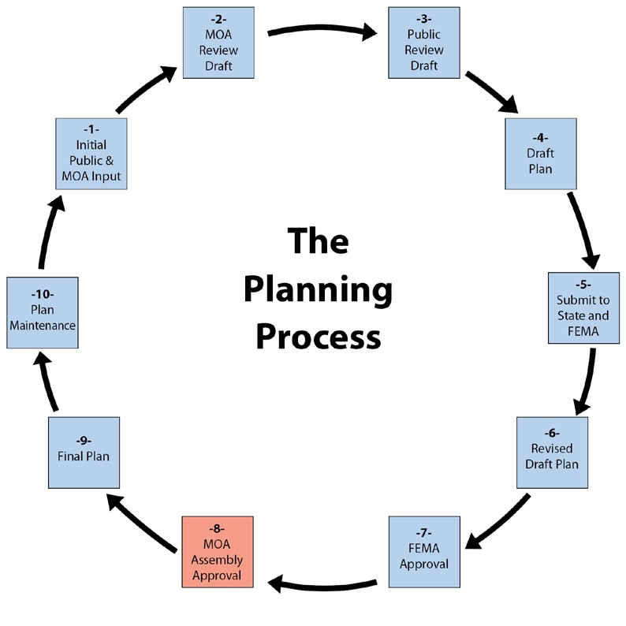

1.8 PUBLIC INVOLVEMENT
The plan update process, announcement was placed on the home page of MOA’s website (www.muni.org). A public meeting was held in January, 2016. The draft plan is available for review and comments on the MOA web page

CHAPTER 2 COMMUNITY PROFILE

This chapter is a brief community profile for Anchorage. It contains information about Anchorage’s location, history, demographics, economy, and natural setting. This information provides an overview of the MOA’s physical and socioeconomic characteristics. A community profile is important because it provides an overview of the community and can be used in conjunction with the asset inventory as a reference when identifying the potential impacts of a hazard event.

2.1 LOCATION
The MOA is located in Southcentral Alaska at the head of Cook Inlet. It is a 1,955-square-mile area between northern Prince William Sound and upper Cook Inlet. The area consists of mostly rugged mountainous terrain, 84 percent of which is taken up by national forest or state parklands and tidelands. Six percent is occupied by military reservations. Only the remaining 10 percent of the entire MOA is inhabited.

The Anchorage Bowl is the most urbanized area of the MOA. It occupies approximately 100 square miles, bounded by Chugach State Park, Turnagain and Knik Arms, and Joint Base Elmendorf - Richardson (JBER) (see Figure 2.1). Settlements north of the Fort Richardson Military Reservation include Eagle River, Chugiak, Birchwood, Peters Creek, and Eklutna. Most of this lowland area is between the Chugach Mountains and Knik Arm. South of the Anchorage Bowl are the Turnagain Arm communities of Girdwood, Indian, Rainbow, Bird, and Portage.

2.2 NATURAL SETTING
Anchorage has a unique natural setting, as it is an urban area surrounded by wilderness and water. Several thousand acres of municipal greenbelts and parklands link developed areas with surrounding natural open space and wildlife habitat in Chugach State Park (the second largest state park in the country), the Chugach National Forest, and the 50-square-mile Anchorage Coastal Wildlife Refuge. Anchorage has five salmon species and 52 mammal species, including wolf, bear, lynx, and moose.

B. Figure 2.1 Municipality of Anchorage
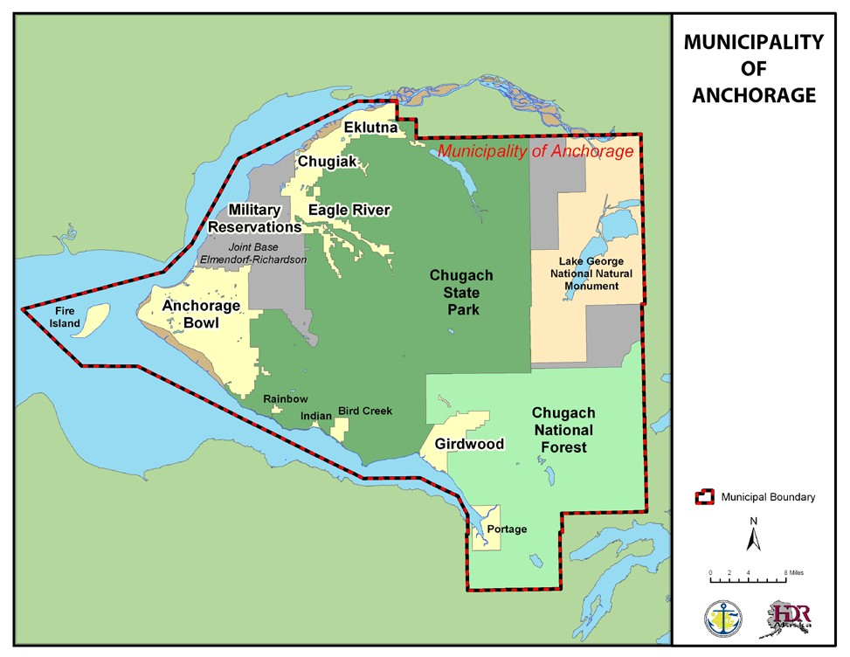

2.3 HISTORY
The Anchorage area was originally inhabited by the Dena’ina Athabascan Indians. The Native Village of Eklutna was one of eight winter settlements and is the last occupied Dena’ina village in the MOA.

2.3.1 ANCHORAGE BOWL
Anchorage was founded in 1914 when the government established the field headquarters for the construction of the Alaska Railroad at Ship Creek. Soon after, in 1920, Anchorage was incorporated as a city.

Between 1940 and 1990, Anchorage grew in spurts. Military build-ups, post-1964 earthquake reconstruction, the Trans Alaska Pipeline construction in the mid-1970s, and the early 1980s petroleum boom each pumped up the economy and spurred rapid community growth.
Often, the aftermath was recession. By the 1990s, Anchorage had a much more diverse and stable economy, resulting in modest and steady community growth.

2.3.2 CHUGIAK/EAGLE RIVER
The area north of the Anchorage Bowl saw additional development after 1900 when traders and prospectors began to arrive in the area looking for minerals and routes to the gold fields. As a result of federal involvement (home for Native Children and the Eklutna hydroelectric project), Eklutna was the dominant settlement in the area in the 1920s. However, growth occurred closer to Anchorage, with the creation of Fort Richardson Army Reservation and Elmendorf Air Force Base. Many military personnel and civilians associated with military construction jobs moved into the area. The Chugiak/Eagle River area continued to grow as people looked for a more rural lifestyle than that offered in the Anchorage Bowl. Commercial enterprises subsequently followed the population to the area.

2.3.3 GIRDWOOD
Girdwood was founded just before the turn of the century as a supply and transport center for the area’s placer and lode gold mines. The mining claims operated through the 1930s, when they stopped due either to the exhaustion of lode deposits or to lawsuits and presidential orders to stop environmentally destructive hydro-mining. In the 1920s, the construction of the Alaska Railroad benefited Girdwood, because the town was a source of timber for rail ties.

Development in the Girdwood area was revived in 1949 because of the construction of the Seward Highway. Much of the growth and development in Girdwood since the 1950s has been associated with skiing and other recreational opportunities.

2.4 DEMOGRAPHICS
For most of its history, Anchorage grew as a community of immigrants and newcomers from outside the state, and Alaska Natives from rural areas within the state. For decades, a seasonal boom-bust economy and military personnel rotations made Anchorage a fast-growing town of transient residents without a strong stake in the community. Those who stayed as permanent residents lived in Anchorage by personal choice, not by chance of birth. They were rooted by their liking for the place and for the distinctive lifestyle it offered. At the time of the 1990 census, barely a quarter of Anchorage residents were born in Alaska.

In the 1990s, economic stability and military cutbacks dramatically slowed immigration and reduced annual population turnover by half. As a result, Anchorage’s population has become much less transient and more committed to long-term community betterment.

The majority of the MOA’s population lives in the Anchorage Bowl (see Table 2.1), although the number preferring the lifestyle offered by the smaller outlying communities is increasing. The population residing on the military bases is declining.

D. Table 2.1 Historic Population of the Municipality of Anchorage

Year | Anchorage  Bowl | Chugiak/Eagle  River | Turnagain  Arm | Military  Bases | Total
1980 | 143,351 | 12,858 | 876 | 17,346 | 174,431
1990 | 184,557 | 25,324 | 1,360 | 15,097 | 226,338
1998 | 213,919 | 31,654 | 2,108 | 11,117 | 258,798
*2006 | 233,844 | 34,139 | 2,243 | 12,587 | 282,813
**2015 | 268,915 | 38,066 | 2,760 | 10,226 | 319,967
Source: Anchorage 2020. *Source: MOA, 2007. **Source: 2015 LUPM Technical Forecast Report

Today, Anchorage’s population is diverse. Racial and ethnic minorities are the fastest-growing segment of the population and account for about 28 percent of the total population. Alaska Natives make up about seven percent of the total population and are the largest minority group. There are also substantial African American, Asian/Pacific Islander, and Hispanic communities, each making up about six percent of the total population. Table 2.2 is a profile of the general demographic characteristics for the MOA.

E. Table 2.2 Profile of General Demographic Characteristics for the Municipality of Anchorage (July 2014 Estimate)

 | Number | Male | Female
Total population | 300,549 | 152,124 | 148,425
AGE
0 to 4 years | 21,629 | 11,161 | 10,468
5 to 9 years | 21,321 | 11,020 | 10,301
10 to 14 years | 20,331 | 10,482 | 9,849
15 to 19 years | 19,461 | 9,913 | 9,548
20 to 24 years | 24,708 | 13,324 | 11,474
25 to 29 years | 25,735 | 13,310 | 14,425
30 to 34 years | 24,249 | 12,194 | 12,055
35 to 39 years | 19,445 | 9,734 | 9,711
40 to 44 years | 18,879 | 9,517 | 9,362
45 to 49 years | 18,770 | 9,282 | 9,488
50 to 54 years | 21,746 | 10,932 | 10,814
55 to 59 years | 20,548 | 10,175 | 10,373
60 to 64 years | 16,462 | 8,330 | 8,132
65 to 69 years | 11,277 | 5,702 | 5,575
70 to 74 years | 6,566 | 3,213 | 3,353
75 to 79 years | 4,196 | 1,885 | 2,311
80 to 84 years | 2,763 | 1,180 | 1,583
85 to 89 years | 1,519 | 561 | 958
90+ | 944 | 299 | 645
Median age (years) | 33.5 | 32.8 | 34.2
Source: 2014 American Community Survey/Alaska Dept. of Labor

2.4.1 FUTURE POPULATION
Population increases are expected throughout the MOA. A recent study by the Institute of Social and Economic Research (ISER) at the University of Alaska Anchorage (UAA) projects that in 2015, the MOA will have approximately 110,300 households and a population of 288,800 and (ISER, 2009). By 2035, this number is expected to increase to 136,600 households and a population of 351,300 (ISER, 2009). Most of the population growth will occur in the Anchorage Bowl. The ISER projection of total employment in the MOA is 151,400 in 2015 and will increase to 177,600 in 2035 (ISER, 2009).

Table 2.3 shows employment, population, and housing demand in Chugiak/Eagle River in 2005 and 2025. Table 2.4 shows employment, population, and housing demand in Girdwood in 1993 and 2013.

F. Table 2.3 Employment, Population, and Housing Demand in Chugiak/Eagle River

 | 2015 | 2025 | 2035
Total Employment | 5,082 | 5,974 | 6,227
Total Population | 38,066 | 44,748 | 51,042
Total New Housing Demand | 13,178 | 15,698 | 18,130
Source: 2015 LUPM Technical Forecast Report

G. Table 2.4 Employment, Population, and Housing Demand in Chugiak/Eagle River
 | 2015 | 2025 | 2035
Total Employment | 1,220 | 1,323 | 1,400
Total Population | 2,760 | 2,965 | 3,107
Total New Housing Demand | 1,289 | 1,384 | 1,451

Source: 2015 LUMP Technical Forecast Report

The figures from the 1995 Girdwood Area Plan, shown in Table 2.4, represent the most recent population and employment growth forecasts for Girdwood published in a municipal plan.
The Planning Department, in a 2006 growth forecasting analysis, updated the Girdwood population estimate, forecasting approximately 5,900 residents in the year 2030. This number represents a slower growth rate for Girdwood than was predicted in 1995. The population of Girdwood is expected to remain at less than 1 percent of the total Municipality population.

The Planning Department is preparing updates to its long-range forecasts of population, housing, and employment in Anchorage Bowl and Girdwood. Forecasts for Chugiak-Eagle River are also being reviewed for the update to the municipal Long-Range Transportation Plan (LRTP). These updated data are anticipated to be available later in 2010.

2.5 ECONOMY
At first glance, Anchorage appears off the beaten path, lying as far north as Helsinki, Finland, and almost as far west as Honolulu, Hawaii. However, its location, together with air, road, port, and rail transportation facilities, is the city’s prime economic asset. Anchorage has capitalized on its location and versatile transportation assets to build a solid economic base. The community is firmly established as the statewide trade, finance, service, transportation, and administrative center and is the distribution gateway for central, western, and northern Alaska. Federal Express and the United Postal Service have made Anchorage a major hub and other firms have expanded their air cargo operations. With over 15 billion pounds of landed cargo, Ted Stevens Anchorage International Airport (TSAIA) is one of the nation’s busiest air cargo airports (Federal Aviation Administration, 2010). Figure 2.2 shows employment by industry in the MOA.

C. Figure 2.2 Employment by Industry: Municipality of Anchorage
10.2%
3.4%
7.6%
Agriculture, forestry, fishing and hunting, and mining
5.0%
1.9%
2.8%
Construction

Manufacturing
8.9%
Wholesale trade
10.6%
Retail trade
Transportation and warehousing, and utilities Information
8.2%
Finance and insurance, and real estate and rental and leasing
21.2%
2.9%
Professional, scientific, and management, and administrative
and waste management services
Educational services, and health care and social assistance
6.2%
Arts, entertainment, and recreation, and accommodation,
and food services
Other services, except public administration
11.1%
Source: 2006-2008 American Community Survey

The educational services, and health care services, and social assistance industry are the largest in the MOA. The growth in the health care sector is due largely to the expansion of hospitals and more local provision of services. Residents from outside Anchorage often receive treatment in Anchorage, and Anchorage residents can stay in Anchorage for more of their medical care instead of having to go to the “Lower 48.”

Tourism is a growing part of the economy (Anchorage Visitor and Convention Bureau, undated). Anchorage has received an increasing number of visitors due to the increase in conventions being held in Anchorage and visits associated with the cruise ship facilities in Seward. In 2010, Holland America brought a cruise ship directly to the Port of Anchorage and has more stops scheduled for 2011 (Anchorage Convention and Visitor Bureau, 2010).

In the Chugiak/Eagle River area, local retail growth in response to the increasing population has made retail trade the area’s largest employment sector. Services are second, and the third-largest employment sector is government. Many government jobs are associated with education, although some are with the U.S. Postal Service and the Alaska Department of Corrections. Many residents commute to the Anchorage Bowl for employment (MOA, 2006). Approximately 85% of all workers in the Chugiak/Eagle River area work in the Anchorage Bowl (Department of Transportation and Public Facilities, 2009).

Girdwood’s biggest economic sector is services, and the largest employer is the Alyeska Resort. The service industry has more than triple the amount of employment than the next closest category—construction. The third-largest employment sector is trade, mostly associated with tourism. There is seasonality to employment in Girdwood, as many of the jobs are associated with skiing in the winter or with the summer tourists. Many Girdwood residents who are not employed in the tourism sector commute into the Anchorage Bowl.

CHAPTER 3 ASSET INVENTORY

Before a community can develop its mitigation strategy, it needs to know what should be protected. The purpose of this chapter is to identify what needs to be protected, including Anchorage’s critical facilities. Anchorage has many other assets that should be protected, including its infrastructure and existing development. This information will be used in Chapter 4 to describe Anchorage’s vulnerability to each hazard.

3.1 INFRASTRUCTURE
Infrastructure is the basic facilities and services needed for a community. Anchorage’s infrastructure includes roads, water supplies, wastewater treatment plants, water and wastewater pipes, power plants, electrical lines, bridges, ports, airports, railroads, telecommunications equipment, schools, etc. The critical facilities matrix in Appendix D lists the hazards to which each facility is exposed.

3.1.1 SCHOOLS
The following is a list of public schools in Anchorage. In addition to those listed below, there are several private schools. Schools identified with an asterisk (*) after their name may be used as a shelter. School locations are shown in Figure 3.1.

Charter

- Alaska Native Cultural  - Aquarian  - Eagle Academy  - Family Partnership | - Frontier Charter School  - Highland Tech High School  - Rilke Schule  - Winterberry

Elementary

- Abbott Loop Elementary  - Airport Heights Elementary  - Alpenglow Elementary*  - Aurora Elementary  - Baxter Elementary  - Bayshore Elementary  - Bear Valley Elementary*  - Birchwood ABC  - Bowman Willard Elementary*  - Campbell Elementary*  - Chester Valley Elementary  - Chinook Elementary  - Chugach Optional Elementary  - Chugiak Elementary  - College Gate Elementary  - Creekside Park Elementary  - Denali Montessori Elementary  - Eagle River Elementary  - Fairview Elementary  - Fire Lake Elementary*  - Girdwood Elementary*  - Gladys Wood Elementary  - Government Hill Elementary  - Homestead Elementary  - Huffman Elementary  - Inlet View Elementary  - Kasuun Elementary*  - Kincaid Elementary*  - Klatt Elementary*  - Lake Hood Elementary* | - Lake Otis Elementary  - Mountain View Elementary*  - Mt. Iliamna Elementary  - Mt. Spurr Elementary  - Muldoon Elementary  - North Star Elementary  - Northern Lights ABC  - Northwood Elementary  - Nunaka Valley Elementary  - O'Malley Elementary  - Ocean View Elementary*  - Orion Elementary  - Ptarmigan Elementary  - Rabbit Creek Elementary  - Ravenwood Elementary*  - Rogers Park Elementary  - Russian Jack Elementary*  - Sand Lake Elementary  - Scenic Park Elementary*  - Spring Hill Elementary*  - Susitna Elementary  - Taku Elementary*  - Trailside Elementary*  - Tudor Elementary  - Turnagain Elementary  - Tyson Elementary*  - Ursa Major Elementary  - Ursa Minor Elementary  - Williwaw Elementary*  - Willow Crest Elementary*  - Wonder Park Elementary

Middle

- Begich Middle School*  - Central Middle School of Science  - Clark Middle School*  - Goldenview Middle School*  - Gruening Middle School* | - Hanshew Middle School*  - Mears Middle School*  - Mirror Lake Middle School*  - Romig Middle School*  - Wendler Middle School*

High

- Bartlett High School*  - Chugiak High School*  - Dimond High School*  - Eagle River High School* | - East High School  - Service High School  - South Anchorage High School  - West High School
Other

- ACE/ACT Program  - Alaska State School for the Deaf and Hard of Hearing  - AVAIL Program  - Benson Secondary/SEARCH  - Bragaw Heights  - Crossroads  - Debarr Residential  - Humphrey Heights  - Jesse Lee  - King Career Center  - Maplewood | - McKinley Heights  - McLaughlin  - New Path  - PAIDEIA Cooperative  - Polaris K-12  - Providence Heights  - SAVE High  - Steller Secondary  - STrEam Academy  - Turning Point Heights  - Whaley School

D. Figure 3.1 Schools
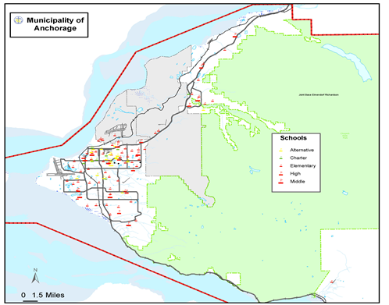

3.1.2 HOSPITALS AND MEDICAL FACILITIES

The main hospitals in Anchorage are:
- Joint Base Elmendorf/Richardson Hospital  - Alaska VA Health Care System  - Alaska Regional Hospital  - North Star Behavioral Health System  - First Care Medical Center  - Providence Alaska Medical Center | - Alaska Psychiatric Institute  - Alaska Native Medical Center  - Providence Extended Care Facility  - Medical Park Family Care  - St. Elias Specialty Hospital  - Anchorage Neighborhood Health Center

The locations of these facilities are shown in Figure 3.2.

E. Figure 3.2 Hospitals and Major Medical Facilities

3.1.3 FIRE DEPARTMENTS
Fire protection in MOA is provided by several sources. The AFD covers most of the Anchorage Bowl. Outside the Bowl, communities rely on volunteer fire departments. The fire stations in MOA are:

- AFD Communications Center  - AFD Fire Station #1  - AFD Fire Station #3  - AFD Fire Station #4  - AFD Fire Station #5  - AFD Fire Station #6  - AFD Fire Station #7  - AFD Fire Station #8  - AFD Fire Station #9  - AFD Fire Station #10  - AFD Fire Station #11  - AFD Fire Station #12  - AFD Fire Station #14 | - AFD Fire Station #15  - Ted Stevens Int’l Airport Aircraft/Rescue/Fire  - Joint Base Elmendorf/Richardson  - State of Alaska, Division of Forestry  - Bureau of Land Management  - Chugiak VFD Station #31  - Chugiak VFD Station #32  - Chugiak VFD Station #33  - Chugiak VFD Station #34  - Chugiak VFD Station #35  - Station 41 Girdwood VFD  - Municipal Emergency Preparedness Office
The locations of these stations are shown in Figure 3.3.

F. Figure 3.3 Fire Stations

3.1.4 LAW ENFORCEMENT
Police protection is provided by the APD and the Alaska State Troopers (AST). The Federal Bureau of Investigation (FBI) has an office in Anchorage. The law enforcement facilities in Anchorage include:
  - Airport Police and Fire
  - Alaska State Troopers Headquarters
  - Anchorage Police Department Headquarters
  - Anchorage Safety Center (Public Inebriate Title 47 Protective Custody Facility
  - Eagle River Police Substation
  - APD Training/Miscellaneous
  - Alaska State Court Building
  - Anchorage Correctional Complex
  - Department of Homeland Security Immigration & Customs Enforcement
  - Department of Justice
  - Federal Emergency Management Agency
  - FBI Building
  - Prosecutor’s Office
  - U.S. Coast Guard Marine Safety
  - U.S. Department of Homeland Security, U.S. Customs and Border Protection
  - U.S. Drug Enforcement Administration

The locations of these facilities are shown in Figure 3.4.

G. Figure 3.4 Law Enforcement Facilities

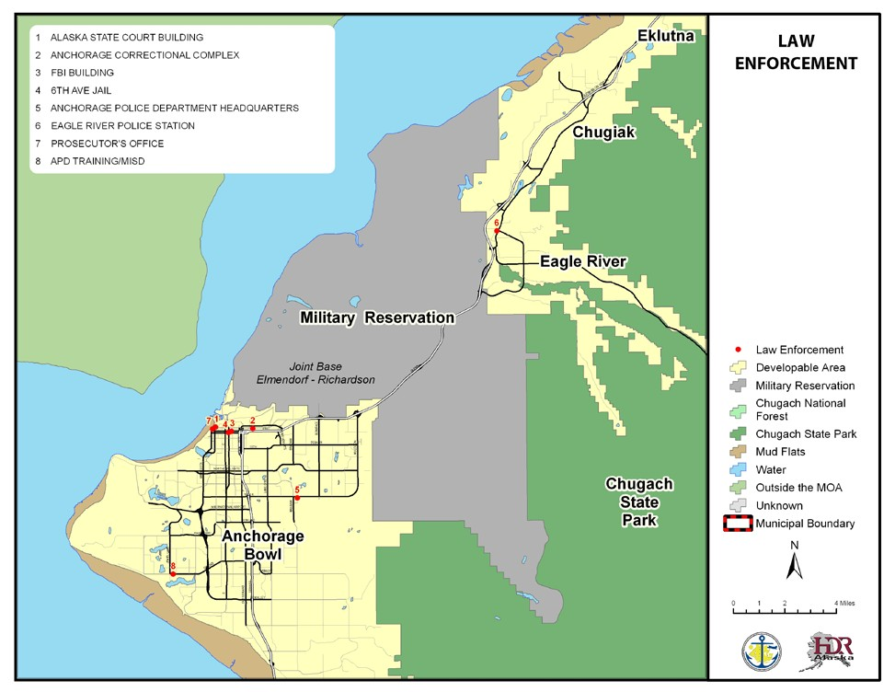

3.1.5 WATER SOURCES
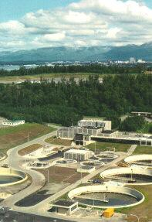
The MOA gets its potable water from three sources:
John M. Asplund Wastewater Treatment
  - Eklutna Water Treatment Plant (Eklutna Lake)
  - Ship Creek Water Treatment Plant
  - Wells

The Eagle River/Chugiak area relies on the Eklutna Water Treatment Plant; the Anchorage Bowl is supplied by the Eklutna Water Treatment Plant and the Ship Creek Water Treatment Plant, while Girdwood relies on wells.

3.1.6 WASTE WATER TREATMENT FACILITIES
The MOA has three wastewater treatment facilities:
  - John M. Asplund Wastewater Treatment Facility
  - Eagle River Wastewater Treatment Facility
  - Girdwood Wastewater Treatment Facility

3.1.7 ELECTRICITY
Within MOA, electricity is provided by three utilities:
  - Municipal Light & Power (MOA-owned)
  - Chugach Electric Association
  - Matanuska Electric Association

These utilities operate several power plants within MOA, including:
  - George M. Sullivan Plant 2
  - Generation Plant One (also known as Hank Nikkels Plant 1)
  - Eklutna Hydroelectric Power Plant

In addition to the power plants, each utility operates substations and electrical (transmission and distribution) lines.

3.1.8 AIRPORTS
The largest airport in MOA is TSAIA. It serves passenger and cargo travel. Merrill Field is one of the largest general aviation (limited to aircraft that weigh 12,500 pounds or less) airports in the United States. Lake Hood, Anchorage’s only seaplane base, is considered to be the largest and most active seaplane base in the world (Alaska Department of Transportation & Public Facilities, 2006). However, many local lakes are used for floatplanes in the summer months.
Other airports in the MOA are located in Birchwood and Girdwood.

3.1.9 RAIL
The Alaska Railroad (ARRC) is headquartered in Anchorage, near Ship Creek. The main ARRC depot is near the headquarters, and the Bill Sheffield Depot is located at the Ted Stevens Anchorage International Airport. Within MOA, the ARRC has more than 100 miles of track.

3.1.10 ROAD
Within the MOA, there are more than 1,000 lane miles of road, with numerous bridges, overpasses, etc. Most of the roads in the Anchorage Bowl are in the Anchorage Roads and Drainage Service Area (ARDSA). Other parts of Anchorage are in Limited Road Service Areas. One of the largest is the Chugiak, Birchwood, Eagle River Rural Road Service Area (CBERRRSA), which has more than 350 lane miles of roadway. Some roadways, including the Seward and Glenn Highways, are owned and maintained by the State.

3.1.11 PORT OF ANCHORAGE

The Port of Anchorage is located at the mouth of Ship Creek. Port facilities include three general cargo terminals, two petroleum terminals, a dry barge landing, bulk cement-handling, gantry cranes and roll-on/roll-off capability. Docks are maintained at a full seaway depth of 35 ft. Most products used in Alaska are transported into our state on container ships and barges. The Port of Anchorage handles three-quarters of all Southcentral Alaska/Railbelt-bound, waterborne, non-fuel, freight
3.1.12 OTHER UTILITIES
Natural Gas Utilities
  - ENSTAR

Telephone/Communication Utilities
  - GCI
  - Alaska Communications Systems (ACS)
  - Spark Wireless
  - AT&T
  - Alaska Telecom
  - Matanuska Telephone Association (MTA) Wireless
  - TelAlaska
  - ASTAC
  - Hughesnet
  - Verizon
  - Borealis Broadband
  - ASTAC
  - Alaska Fiber Star
  - TelAlaska Long Distance, Inc.
  - Level 3 Communications, LLC
  - EarthLink Business, LLC
  - France Telecom Corporate Solutions, LLC
  - Comtec Business Systems, Inc.
  - Mobilitie, LLC
  - Mitel NetSolutions, Inc.
  - Metropolitan Telecommunications of Alaska, Inc.
  - QuantumShift Communications, Inc.
  - Bowhead Communication Services, LLC
  - Wide Voice, LLC

3.1.2 HISTORICAL SITES
According to the National Register Information System, the MOA has the following sites listed on the National Register of Historic Places. The State Historic Preservation Office’s (SHPO) Alaska Heritage Resources Survey (AHRS) has many more sites considered historically significant within MOA. Because the AHRS has numerous entries and is not available to the general public, information about these sites is not listed here. For more information about these resources, please contact the SHPO. Several historic properties listed on the National Register of Historic Places were also adopted into the Four Original Neighborhoods Historic Preservation Plan as “Landmarks to Save”. This includes the Government Hill Wireless Station, Block 13-Army Housing Association Historic District, and the Government Hill Water Tower. Contact the Anchorage Historic Preservation Program Officer for additional information.

H. Table 3.1 National Register of Historic Places

Resource Name | Address | City | Listed
A. E. C. Cottage No. 23 | 618 Christensen Dr. | Anchorage | 1990-06-11
Alaska Engineering Commission Cottage No. 25 | 645 W. 3rd Ave. | Anchorage | 1996-02-16
Alex, Mike, Cabin | Off AK 1 | Eklutna | 1982-09-08
Anchorage Cemetery | 535 E. 9th Ave. | Anchorage | 1993-04-26
Anchorage City Hall | 524 W. 4th Ave. | Anchorage | 1980-12-02
Anchorage Depot | 411 W. 1st Ave. | Anchorage | 1999-08-27
Anchorage Hotel Annex | 330 E St. | Anchorage | 1999-04-15
Anderson, Oscar, House | 4th Ave. extended | Anchorage | 1978-06-13
Atwood Campus Center | University Drive | Anchorage | 1979-06-22
Beluga Point Site | Address Restricted | Anchorage | 1978-03-30
Block 13-Army Housing Association Historic District | Between A and Cordova Streets and 10th and 11th Avenues | Anchorage | Pending, locally eligible
Civil Works Residential Dwellings | 786 and 800 Delaney St. | Anchorage | 2004-07-21
Crow Creek Consolidated Gold Mining Company | NE of Girdwood | Girdwood | 1978-09-13
David, Leopold, House | 605 W. 2nd Ave. | Anchorage | 1986-07-24
Eklutna Power Plant | NE of Anchorage | Anchorage | 1980-06-20
Federal Building-U.S. Courthouse | 601 W. 4th Ave. | Anchorage | 1978-06-23
Fourth Avenue Theatre (AHRS Site No. ANC-284) | 630 W. 4th Ave. | Anchorage | 1982-10-05
Gill, Oscar, House | 1344 W. 10th Ave. | Anchorage | 2001-02-02
Government Hill Federal Housing  Historic District |  | Anchorage | 2015-14-01
Government Hill Water Tower | West Harvard Avenue | Anchorage | Pending, locally eligible
Government Hill Wireless Station | 123 West Manor | Anchorage | Pending, locally eligible
Historic Pioneer School House | 3rd Ave. and Eagle St. | Anchorage | 1980-12-03
Indian Valley Mine | Address Restricted | Indian | 1989-10-25
KENI Radio Building | 1777 Forest Park Dr. | Anchorage | 1988-04-18
Kimball's Store | 500 and 504 W. 5th Ave. | Anchorage | 1986-07-24
Loussac-Sogn Building | 425 D St. | Anchorage | 1998-05-20
McKinley Tower Apartments | 337 E. 4th Ave. | Anchorage | 2008-09-12
Mt. Alyeska Roundhouse | Approx. 2 mi. W of Alyeska | Girdwood | 2003-11-05
Nike Site Summit | Off Arctic Valley Rd., 12.5 mi. E of Anchorage | Anchorage | 1996-07-11
Old St. Nicholas Russian Orthodox Church | Eklutna Village Rd. | Eklutna | 1972-03-24
Pilgram 100B Aircraft | Anchorage Aviation Heritage Museum | Anchorage | 1986-07-08
Potter Section House | Off AK 1 | Anchorage | 1985-12-06
Spring Creek Lodge | 18939 Old Glenn Hwy. | Chugiak | 2001-09-09
Wendler Building | 400 D St. | Anchorage | 1988-06-24
Source: National Register of Historic Places

3.2 EXISTING DEVELOPMENT IN MOA
Anchorage’s history has shaped its development patterns, making the Anchorage Bowl the dominant area locale in terms of developed areas in the region. Table 3.2 shows the number of parcels (by land use) in the Anchorage Bowl, the Turnagain Arm area (including Girdwood), and the Chugiak/Eagle River area. Table 3.3 shows the taxable value of the land and buildings in the MOA by land use. The number of parcels was used as a substitute for the number of structures, as it is assumed that the non-vacant parcels include existing structures (which determine the land use).

I. Table 3.2 Number of Parcels by Land Use

Type of Parcels | In Turnagain Communities | In Chugiak/Eagle River | In Anchorage Bowl
Residential |  | 10,137 | 53,600
Commercial |  | 195 | 3,370
Industrial |  | 109 | 1,642
Institutional |  | 129 | 594
Parks, Open Space, and |  | 354 | 1,204
Recreation
Transportation-Related |  | 137 | 584
Other Land Uses |  | 97 | 95
Vacant Land |  | 2,093 | 4,750
Unidentified | 1,965 | 695 | 1,825
Total | 1,965 | 13,946 | 67,664
Source: MOA GIS, 2009

J. Table 3.3 Total Parcels and Taxable Value for MOA

Land Use |  | # of Parcels | Taxable Value (Land) | Taxable Value (Buildings) | Total
Residential |  | 75024 | 8526159300 | 17756156200 | 26282315500
Commercial |  | 4065 | 2568664400 | 4512337400 | 7081001800
Industrial |  | 2597 | 1494944600 | 1907337000 | 3402281600
Institutional |  | 1035 | 1215398400 | 1554183700 | 2769582100
Open Space |  | 44 | 24995700 | 503000 | 25498700
Transportation |  | 664 | 0 | 0 | 0
Other |  | 562 | 377462100 | 36697800 | 414159900
Vacant |  | 228 | 0 | 0 | 0
Total |  | 84219 | 14207624500 | 25767215100 | 39974839600

3.3 FUTURE DEVELOPMENT
Like many areas of the United States, Anchorage is expecting increased growth and development in the future. As shown in Tables 3.2 and 3.3, there are more than 5,000 parcels that could still be developed. In addition, the other parcels may be redeveloped. These activities may increase Anchorage’s vulnerability to hazardous events in the future.

Anchorage 2020, the Chugiak Eagle River Comprehensive Plan Update, the Girdwood Area Plan, and numerous other plans all describe future development in the MOA. A few items are highlighted below because they could have a strong influence in the MOA’s future vulnerability. It is important to know and track where and what will be developed in the future to plan for its protection and to mitigate hazards during development.

3.3.1 HOUSING

According to the March 2012 Anchorage Housing Market Analysis, by McDowell Group and ECONorthwest, there is not enough buildable land to accommodate future housing demand under historical development patterns, current land use policies, and development options. The study forecasts a demand for about 18,200 new dwellings in the Anchorage Bowl and 3,300 new dwellings in Chugiak-Eagle River over the next 20 years. However, the study predicts that without increasing the current level of housing density and increasing the rate of redevelopment, the Anchorage Bowl will lack land for about half of the expected demand. While Chugiak-Eagle River has enough land to meet its own projected demand for all housing types, the study finds it cannot accommodate all of the Bowl’s projected demand as well.

3.3.2 INFRASTRUCTURE
It is expected that MOA will experience more utility development, including:
  - Electrical infrastructure improvements and a new electrical substation to serve southeast Anchorage. The location for the substation has yet to be identified. For more information on potential improvements, please contact Chugach Electric or Municipal Light & Power.
  - New water and sewer lines (locations to be determined during the Water Master Plan and the Wastewater Master Plan updates). For more details about this process, please visit http://www.awwu.biz

3.3.3 TRANSPORTATION
Population forecasts of more than 500,000 residents in the Mat-Su Borough and the Municipality of Anchorage by 2035 drive a multi-faceted approach toward meeting area transportation needs. The expectation is that there will be greater total vehicle miles traveled throughout the region as greater shares of the population move to more suburban locations, and employment grows predominantly in the Anchorage Bowl. Increased population densities in the Downtown, Midtown, and U-Med District will provide demand and opportunities for increased access by public transportation and non-motorized transportation. Specific recommendations are contained in the 2035 Metropolitan Transportation Plan and the Interim 2035 Metropolitan Transportation Plan (June 26, 2015 public review draft).

3.3.4 OTHER PLANS
Table 3.4 lists several plans that help guide where future development in the MOA will occur.
Below are most of the comp plan elements in code. Only a few were listed in the All Hazards Mitigation Plan, but here are the ones not included on the list. Note that Anchorage 2020 is not on the list but is mentioned throughout their plan. Girdwood Area Plan and Chugiak-Eagle River Comp Plan are noted elsewhere in plan also but not specifically listed either.

K. Table 3.4 MOA Publications, Studies, and Adopted Plans

Name of Plan | Year of Adoption or Publication
Anchorage 2020 – Anchorage Bowl Comprehensive Plan | 2001
Anchorage Wetlands Management Plan | 2014
Chugiak-Eagle River Comprehensive Plan
Crow Creek Neighborhood Land Use Plan | 2006
East Anchorage District Plan | 2014
Eagle River Greenbelt Plan | 1985
Fairview Neighborhood Plan | 2014
Girdwood Commercial Area and Transportation Master Plan | 2001
Girdwood Area Plan | 1995
Girdwood-Iditarod Trail Route Study | 1997
Glacier-Winner Creek Access Corridor Study | 1997
Government Hill Neighborhood Plan | 2013
Historic Preservation Plan for Anchorage’s Four Original Neighborhoods | 2013
Potter Valley Land Use Analysis | 1999
Section 36 Land Use Study | 1992
Ship Creek/Waterfront Land Use Plan | 1991
Ship Creek Framework Plan | 2014
Spenard Community District Development Plan | 1986
3500 Tudor Road Master Plan | 2007
Tudor Road Public Lands and Institutions Plan | 1986
Utility Corridor Plan | 1990
Downtown Anchorage Seismic Risk Assessment and Land Use Regulations to Mitigate Seismic Risk | 2010
Geotechnical Hazards Assessment Study (Harding-Lawson Associates) | 1979
Snow Avalanche and Mass-wasting Hazard Analysis – Glacier/Winner Creek Areas, Alaska | 1993
Anchorage Commercial Land Assessment | 2012
Anchorage Housing Market Study | 2012

CHAPTER 4 – HAZARDS IN THE MUNICIPALITY OF ANCHORAGE

One of the requirements of a hazard mitigation plan is that it describes the hazards that affect a jurisdiction. This chapter profiles the hazards that occur in the MOA by identifying each hazard’s location, extent, previous occurrences, and the likelihood of future events.

Hazard mitigation plans are also required to summarize the vulnerability to the hazards. The vulnerability information was calculated by identifying the parcels that intersect each of the hazard zones. Some notes about this method are:
  - Not all the hazard GIS layers used to perform this analysis cover the entire MOA. Most include only a portion of the Municipality. (Parcels could be at risk but the risk area has not been mapped and included in the GIS yet.)
  - The taxable value is based on 2016 MOA tax assessor data.
  - Using the taxable value underestimates the vulnerability because:

- Some parcels, such as schools, religious facilities, and military land, are not taxed and therefore do not have a taxable value.
- Some parcels are treated as economic units (separate parcels that are treated as one for tax purposes) and do not have taxable values listed.
- Taxable value does not consider the value of the contents.
- The taxable value is the sum of the land and building taxable values. This is different from the total taxable value listed in the tax assessor’s file because tax exemptions have been applied to those totals.
- If a parcel was in multiple risk areas, the entire parcel was considered to be in the highest risk area (i.e., no partial parcels). However, depending on how much of the parcel is in the hazard zone and site specific factors, existing or future structures may not be at risk.
- The number of unidentified parcels could be wrong due to data issues (i.e., extra polygons in the GIS file, not all tax records associated with a parcel, etc.).

It is important to remember that the information listed in this chapter is meant to provide an overview of each hazard. While based on the best available information, the information is for planning purposes and should not be used for purposes which it was not intended such as securing permits, or for construction.
As part of this update, MOA departments, along with several state and federal agencies, were contacted to find out if new information was available. When available, the additional information was incorporated into the plan. The tables showing the number of parcels vulnerable to each hazard have been updated. The section on volcanoes was revised to focus more on volcanic ash as this is the biggest threat to the MOA compared to other aspects of a volcanic event. Tsunami section was removed. The technological hazards section (Section 4.2) was also added to this update. Throughout this chapter, text boxes highlighting completed or on-going mitigation success stories have also been included.

After consultation with the National Weather Service (NWS), winter storms were removed from the extreme weather section because it is too generic. The types of extreme weather events experienced in the MOA are better reflected by the other types of events in this section.

Future plan updates should continue to make the hazard descriptions and vulnerabilities more MOA-specific.

4.1 NATURAL HAZARDS
Natural hazards are unexpected or uncontrollable events caused by nature, such as earthquakes, floods, or volcanic eruptions. In some cases, although rare, they can be human- triggered, such as a human-triggered avalanche. The impacts of a natural hazard can also be worse based on human development and changes to the landscape.

The majority of the following information describing these hazards is from the October 2010 State Hazard Mitigation Plan and is used by permission from the DHS&EM.

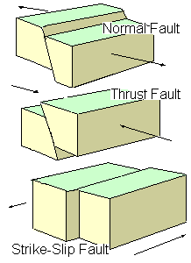
4.1.1 EARTHQUAKES
Three types of faults. Image courtesy of USGS
An earthquake is the shaking of the earth’s surface. Most large earthquakes are caused by the sudden release of accumulated stresses as the Earth’s crustal plates move against each other. Other earthquakes occur along faults that lie within these plates. The dangers associated with earthquakes include ground shaking, ground failure, and surface faulting as well as secondary hazards, such as avalanches or landslides.

Ground shaking is responsible for most of the damage. Ground shaking is the result of the three classes of seismic waves generated by an earthquake. Primary waves (P waves) are the first waves, often felt as a sharp jolt. Secondary, or shear, waves (S waves) are slower and usually have a side-to-side movement. They can be very damaging because structures are more vulnerable to horizontal than vertical motion. Surface waves are the slowest waves, but they can carry the bulk of the energy in a large earthquake.

The intensity of the shaking is dependent on many factors, including the magnitude of the quake, the geology of the area, distance from the epicenter, building design, and local construction practices. The amount of damage to buildings depends on how the specific characteristics of each incoming wave interact with the buildings’ height, shape, and construction materials.

Surface faulting is the differential movement of the two sides of a fault. There are three general types of faulting: strike-slip, normal, and thrust (reverse). Strike-slip faults are where each side of the fault moves horizontally. Normal faults have one side dropping down relative to the other side. Thrust (or reverse) faults have one side moving up and over the fault relative to the other side.

Secondary Hazards
Secondary effects from an earthquake include seismically induced ground failure, snow avalanches, tsunamis, landslides, and infrastructure failure. These will be discussed in greater detail in other sections of the plan.
Richter Scale
On the Richter scale, magnitude is expressed in whole numbers and decimals. A 5.0 earthquake is a moderate event; a 6.0 characterizes a strong event; a
7.0 is a major earthquake; and a great earthquake exceeds 8.0. The scale is logarithmic and open-ended.

Magnitude and Intensity
Earthquakes are usually measured in terms of their magnitude and intensity. Magnitude is related to the amount of energy released during an event, while intensity refers to the effects on
Peak Ground Acceleration
Peak ground acceleration (PGA) in percent of g with 10% probability of exceedance in 50 years represents the ground motions that can be reasonably expected in a 50-year period.
The acceleration values are the peak or maximum values expected during the earthquake. The "10% probability of exceedance in 50 years" refers to the fact that earthquakes are somewhat random in occurrence. One cannot predict exactly whether an earthquake of a given size will or will not occur in the next 50 years.

people and structures at a particular place. Each earthquake will have only one magnitude but may have many intensities. Earthquake magnitude is usually reported according to the standard Richter scale (ML) for small to moderate earthquakes. Large earthquakes are reported according to the moment-magnitude scale (MW) because the standard Richter scale does not adequately represent the energy released by these large events.

Intensity is usually reported using the Modified Mercalli Intensity Scale (MMI). This scale has 12 categories ranging from not felt to total
destruction. Different MMI values can be recorded at different locations for the same event, depending on local circumstances such as distance from the epicenter or building construction practices. Soil conditions in Anchorage are a major factor in determining an earthquake’s intensity, as areas with unconsolidated fill, liquefiable soils, or that are susceptible to lateral spread will sustain more damage than areas with shallow bedrock.
Seismic landslide hazard is a key local issue and is discussed in more detail in see section 4.1.6 Landslide/Ground Failure.

Location
The entire MOA faces a significant threat from earthquakes. Earthquakes that result from the Pacific Plate subducting beneath the North American Plate are most likely to impact the MOA (Haeussler, 2010).

Likelihood of Occurrence
While it is impossible to know when the next earthquake will affect MOA, given the MOA’s seismic history, earthquakes will continue to occur. An event similar to the 1964 earthquake usually occurs every 300 to 900 years so the MOA is less likely to experience one in the near future. (Haeussler, 2010). However, given Anchorage’s geologic situation, a dangerous damaging earthquake with a lower magnitude of 7 or
8 could occur at any time in the MOA.

Peak ground acceleration with a 10% probability of exceedance in 50 years represents events that are reasonably expected to occur. Peak ground acceleration (PGA) is one method to measure the strength of ground movements. The MOA has a peak ground acceleration of 40%g (Westin et al, 2007). This can be considered a high seismic hazard.

Historic Events
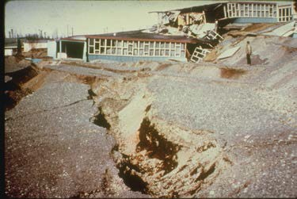
1964 Good Friday Earthquake
The Government Hill School after the 1964 Good Friday earthquake.
The best known earthquake in Anchorage’s history is the March 27, 1964 Good Friday earthquake. This
9.2 MW earthquake is the largest ever recorded in North America and the second largest in the world. The shaking lasted between four and five minutes and was felt over an area of approximately seven million square miles.
This earthquake occurred at approximately 5:36 pm. The timing of the event may have saved many lives, as several structures with the most damage, such as the Government Hill School, were unoccupied at this time. In 1973, the National Research Council observed that this event could have had 50 times the number of deaths and 60 times as much property damage if it had affected a more densely populated area during work/school hours (Combellick 1985:6). The ground shaking caused a significant amount of ground deformation as well as triggering landslides and tsunamis. The Turnagain Heights landslide was the most damaging, with more than 100 homes destroyed.

Vulnerability
An earthquake could affect the entire Municipality. The exact number and location of impacted structures will depend on the size, location and frequency of the earthquake. The type of building also plays a role. For example, unreinforced masonry buildings tend to be more vulnerable to earthquake damage than wood framed buildings. Many of the MOA’s taller buildings are located in Downtown and Midtown. In addition, infrastructure, including roads and utilities, and other development is vulnerable to an earthquake. The disruptions to the transportation infrastructure including bridges can have an impact on emergency response activities.

L. Table 4.1 Earthquake Vulnerability

Land Use | # of Parcels | Taxable Value (Land) | Taxable Value (Buildings) | Total
Residential | 75024 | 8526159300 | 17756156200 | 26282315500
Commercial | 4065 | 2568664400 | 4512337400 | 7081001800
Industrial | 2597 | 1494944600 | 1907337000 | 3402281600
Institutional | 1035 | 1215398400 | 1554183700 | 2769582100
Open Space | 44 | 24995700 | 503000 | 25498700
Transportation | 664 | 0 | 0 | 0
Other | 562 | 377462100 | 36697800 | 414159900
Vacant | 228 | 0 | 0 | 0
Total | 84219 | 14207624500 | 25767215100 | 39974839600
Source: MOA GIS, 2016

Earthquakes have a higher potential for injuries and fatalities than many of the other hazards in the MOA. While everyone in the MOA could be impacted by an earthquake, some populations, such as those living in poorly constructed housing may be more vulnerable than other populations. People could be impacted by the loss of utilities and business closures. The MOA is also likely to experience a decrease in tourism.

4.1 2 WILDFIRE
The MOA’s location in the boreal forest makes wildfires (sometimes called a wildland urban interface fire) a concern. For the purposes of this plan, a wildfire is a fire that burns within the line, area, or zone where structures and other human development meet or intermingle with undeveloped wildland or vegetative fuels.

The creation and maintenance of the fire requires the interaction of heat, fuel, and oxygen. This is often referred to as the fire triangle.

Fire Behavior
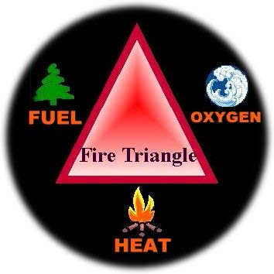
Fuel, weather, and topography influence wildland fire behavior. Wildland fire behavior can be erratic and extreme, causing fire whirls and firestorms that can endanger the lives of firefighters trying to suppress the blaze. The danger increases when the fire involves developed areas with structures, property and populations. The additional fuel load, high value property, life safety risk, and the need for simultaneous evacuation and suppression add significant wildfires firefighting challenges.
H. Figure 3.5 The Fire Triangle. Image from Northern & Intermountain Regions of the U.S. Forest Service

Fuel
According to the AFD, the factors contributing to Anchorage’s wildfire risk include:
- Mixed hardwood and conifer forests that burn readily in high fire danger conditions. White spruce trees have persistent branches that contribute to ladder fuels. Black spruce trees have a very low moisture content that allows them to burn easily when ambient weather conditions provide for low relative humidity, high temperatures, and dry duff layers in the soil.
- Residential and rural neighborhoods exist throughout forested stands that have been affected by the spruce bark beetle. In the MOA, this area extends over 85,000 acres. Dead trees resulting from beetle attacks contribute to forest fuel accumulations that create high risk for wildfire.
- Mutual aid resources to help the AFD may take an hour or more to arrive on site. Suppression resources from the SOA Division of Forestry must travel to Anchorage from Palmer and other locations outside the MOA.
- On the south Anchorage Hillside, Eagle River Valley, South Fork, and other sites around the MOA, there are limited water resources to help fight a wildland fire.
- Many neighborhoods in the MOA have limited ingress and egress routes for suppression apparatus to enter and for residents to evacuate.
- The hilly topography throughout the area contributes to increased rate of fire spread. Where the Miller’s Reach Fire of 1996 spread across mostly flat terrain and still burned more than 400 structures, a wildfire in South Anchorage would spread even faster because fire spread rates increase with slope.
- The spring fire season is a dry time in Southcentral Alaska. Dry foliage on trees and dead bluejoint grass burn readily soon after snow melts

Fuel determines how much energy the fire releases, how quickly the fire spreads, and how much effort is needed to contain the fire. The primary fuels in wildland fires are living and dead vegetation. Fuels differ in how readily they ignite and how hot or long they burn. This depends on the following characteristics:
  - Moisture content
  - Size and shape
  - Fuel loading
  - Horizontal continuity of fuels
  - Vertical arrangement of fuels

Weather
Weather is the most variable and uncontrollable factor in wildland fire fighting. Weather includes temperature, relative humidity, wind, and precipitation. High temperatures and low humidity encourage fire activity, while low temperatures and high humidity help retard fire behavior. Wind dramatically effects fire behavior and is a critical factor in fire spread and control.

Topography
Topography directs the movement of air, which can also affect fire behavior. When the terrain funnels air, as in a canyon, it can lead to faster spreading. Fire can also travel up-slope quicker than it goes down.
Burning material can roll down the slope and ignite fires below. Certain areas in the MOA with glaciers, including the Eagle River and Eklutna Valleys, may experience local glacial wind effects dramatically influencing fire behavior.

Slope orientation also influences fire behavior. Forests on southern or southwestern slopes (those exposed to the sun) generally have lower humidity and higher temperatures than those on northern or northeast slopes.
Consequently, fire hazard is often higher on south- and southwest-facing hills.
Location
The AFD Wildfire Home Assessment
The AFD will provide home assessments to provide homeowners with specific recommendations for vegetation management and home maintenance activities to reduce a home’s potential to ignite during a wildfire. The AFD is also able to provide financial assistance to remove dead, beetle killed spruce trees and densely growing coniferous trees.
The entire MOA has the potential for wildfires. The AFD has identified a 345,309- acre study area for wildfire exposure.
Approximately 17,088 acres of this study area are exposed to hazardous wildfire conditions (MOA, 2010b). The exact location of the wildfire hazard changes because it depends on a combination of factors, including availability of fuels, availability of ignition sources, and weather. Because of the changing conditions, the AFD has developed an Anchorage Fire Exposure Model to calculate wildfire exposure. For current information on wildfire exposure, please contact the Wildfire Mitigation Division of the AFD.
In addition, AFD has been conducting neighborhood wildfire assessments. These assessments are considered works in progress and are re-evaluated throughout the fire season. The assessments contain an evaluation of the hazard; potential hazards/complications, such as power lines; potential staging areas for equipment; water sources, potential safety zones (to wait out passing fire); and potential evacuation sites. They exist for the following areas:
  - Tudor Road to Abbott Road, including Far North Bicentennial Park
  - Eagle River
  - Hiland Road, South Fork
  - DeArmoun Road to Potter Creek Heights
  - Chugiak
Individual neighborhood assessments are available through the AFD.

Likelihood of Occurrence
The high fire danger months are typically May through August in the MOA; however, wildfires can occur in other months. Wildfires are more likely to occur during drought or low- precipitation times and are less likely to occur during high-precipitation times and when snow is on the ground.

Wildfires in the MOA are more likely to be caused by humans than by other sources. As development increases in areas with high wildfire potential, the chances of wildfire also increase. The AFD is taking measures to reduce the risk of fires by controlling the amount of fuel available. The AFD does this through controlled burns, homeowner education, and the development of firebreaks.

Historic Events
No declared wildfire disasters have been identified to date in the MOA. However, the potential exists. Every year, the AFD puts out dozens of fires that could be disastrous if not contained early. Between 2010 and 2015, the number of wild fires per year in the MOA ranged from 58 fires in 2012 to 102 fires in 2011. Between 2007 and 2015, the MOA had 773 wildfire calls that burned approximately 152 acres (Table 4.2).

M. Table 4.2 Wildfires in the MOA, 2001 – 2006

Cause |  | Number | Percent | Acres
Undetermined |  | 354 | 45.80% | 72.11
Misuse of Fire/Unintentional |  | 98 | 12.68% | 15.96
Intentional/Incendiary |  | 86 | 11.13% | 14.31
Open/Outdoor Fire |  | 77 | 9.96% | 23.61
Smoking |  | 73 | 9.44% | 7.93
Debris/Vegetation Fire |  | 24 | 3.10% | 3.85
Other |  | 21 | 2.72% | 4.81
Act of Nature/Natural |  | 20 | 2.59% | 2.64
Equipment |  | 19 | 2.46% | 6.53
Structure/Exposure |  | 1 | 0.13% | .1
Totals |  | 773 | 100% | 151.85

Other Wildfire Events
O'Malley/Hillside Fire, 1973
In May 1973, a small brush fire at a private home, fanned by 40 mile per hour (mph) winds, burned out of control in the foothills of the Chugach range. The fire threatened 25 homes and forced several families to evacuate. By the time firefighters contained the blaze, 300 acres of brush and timber were destroyed.

Dowling Road Fire, 2003
A wildfire near the east end of Dowling Road was ignited by a homeless person’s fire. This fire burned approximately 2.5 acres.

Otter Lake Fire, 2006
The Otter Lake Fire began in an approximately five-mile area near the ARRC tracks on Fort Richardson. The fire quickly expanded to approximately 50 acres before it was extinguished.

Piper Fire, 2008
On July 2, 2008, a wildfire burned 10 acres of Municipal park land. This fire was ignited by a homeless person. The AFD was able to extinguish the fire before it reached nearby subdivisions.

Eklutna Lake fires 1999, 2010
There have been two wildfires over 100 acres in the MOA’s Eklutna Lake Valley in the last twenty years. In 1999 a landowner ignited a fire to clear brush on a windy day and the fire escaped control and burned over 200 acres. The fire threatened homes and potentially the MOA’s Eklutna Lake water treatment facility. In May of 2010 there was a wildfire that burned over 1000 acres at the far end of the lake that threatened Eklutna State Park developments and homes near the lake.

Vulnerability
In 2001, Anchorage was declared a community-at-risk for wildfire by the U.S. Department of Agriculture (USDA) Forest Service (USFS). According to the AFD, a wildfire could occur anywhere in the MOA, so the entire MOA is represented in Table 4.3. Only a portion of these properties are likely to be affected by a given event. The number and location of the impacted parcels depend on the size and location of the wildfire event.

Wildfires have the potential to destroy property and vegetation. Without vegetation, these areas may experience soil erosion which can have an impact on water quality. Wildfires may reduce the amount of animal habitat. Wildfires may also cause injuries or loss of life. Fire response systems are well prepared to deal with wildfires so large numbers of injuries or fatalities are not expected. Additional research would be required to identify the number of people who could be injured or killed as the result of a wildfire.
N. Table 4.3 Wildfire Vulnerability

Land Use | # of Parcels | Taxable Value (Land) | Taxable Value (Buildings) | Total
Residential | 75024 | 8526159300 | 17756156200 | 26282315500
Commercial | 4065 | 2568664400 | 4512337400 | 7081001800
Industrial | 2597 | 1494944600 | 1907337000 | 3402281600
Institutional | 1035 | 1215398400 | 1554183700 | 2769582100
Open Space | 44 | 24995700 | 503000 | 25498700
Transportation | 664 | 0 | 0 | 0
Other | 562 | 377462100 | 36697800 | 414159900
Vacant | 228 | 0 | 0 | 0
Total | 84219 | 14207624500 | 25767215100 | 39974839600
Source: MOA GIS, 2016

More detailed information has not been calculated because the information will change depending on current conditions. For the latest vulnerability information, please contact the Wildfire Mitigation division of the AFD.

4.1.3 EXTREME WEATHER
Extreme weather is a broad category that includes heavy snow, extreme cold, ice storms (freezing rain), high wind, thunder & lightning, hail, coastal storms, and storm surge. High winds, ice storms, and heavy snow are the most likely types of extreme weather in the MOA.

Heavy Snow
Heavy snow is generally considered to be more than six inches of accumulation in less than 12 hours. (Albanese, 2010b). Heavy snow can have a significant impact on an area.
Until the snow can be removed, airports and roadways experience delay, or are closed completely, stopping the flow of traffic, supplies and disrupting emergency and medical services. Heavy snow loads can damage light aircraft and sink small boats. It can also cause roofs to collapse and knock down trees and power lines.
Snow Terminology
A heavy snow is considered to be 6 or more inches of snow in 12 hours. The NWS criteria for a heavy snow advisory is 6 to 11 inches in 12 hours or 12 to 23 inches in 24 hours. A heavy snow warning may be issues for 12 or more inches of snow in 12 hours or 24 or more inches of snow in 24 hours.
Snow Squalls are periods of moderate to heavy snowfall, intense, but of limited duration, accompanied by strong, gusty surface winds, and possibly lightning.
A Snow Shower is a short duration of moderate snowfall.
Snow Flurries are an intermittent light snowfall of short duration with no measurable accumulation.
Blowing Snow is wind-driven snow that reduces surface visibility. Blowing snow can be falling snow or snow that already has accumulated but is picked up and blown by strong winds.
Drifting Snow is an uneven distribution of snowfall and snow depth caused by strong surface winds. Drifting snow may occur during or after a snowfall.
Heavy snowfalls can cause secondary hazards. In the mountains, heavy snow can lead to avalanches. A quick thaw can cause flooding, especially along small streams and in urban areas. The cost of snow removal, repairing damages, and the loss of business can have severe economic impacts.
Snowfall Records

Normal snowfall – 74.5’
Top 5 Highest Winter Snowfalls

134.5……….2011-2012
132.6……….1954-1955
128.8……….1955-1956
121.5……….1994-1995
113.9……....2003-2004

Top 5 Lowest Winter Snowfall

25.1……….2014-2015
30.4……….1957-1958
32.9……….1980-1981
36.8……….2002-2003
38.5……….1960-1961

Source: National Weather Service Anchorage Forecast Office’s Climate Records List, (1917 – current) Available at http://pafc.arh.noaa.gov/misc.php?p

Location
The entire Municipality can get heavy snow but Girdwood tends to receive more snow than other areas.
In general, the location of heavy snowfall depends on the weather system involved. The typical storm is a low pressure system originating in Prince William Sound that moves in from the East. This results in heavier snow on the hillside, and less as you get further from the mountains. When the storm is out of the south, the snowfall is heavier in West Anchorage (Vonderheide, 2003). Occasionally, air comes up Cook Inlet and hits the mountains. This may lead to heavy snow on the upper hillside and less in the bowl area (Vonderheide, 2003). Blizzards are rare events in the MOA but could occur along the Turnagain Arm. See Figure 4.1 for the average annual snowfall pattern in MOA.

Likeliness of Occurrence
While snow falls frequently in Anchorage during the winter, most snowfalls are not usually heavy.
Anchorage tends to experience one or two heavy snowfalls each winter (Albanese, 2010). However, these tend not to result in disaster declarations. The occurrence of heavy snowfall events depends on the weather conditions.
I. Figure 4.1 Average Annual Snowfall
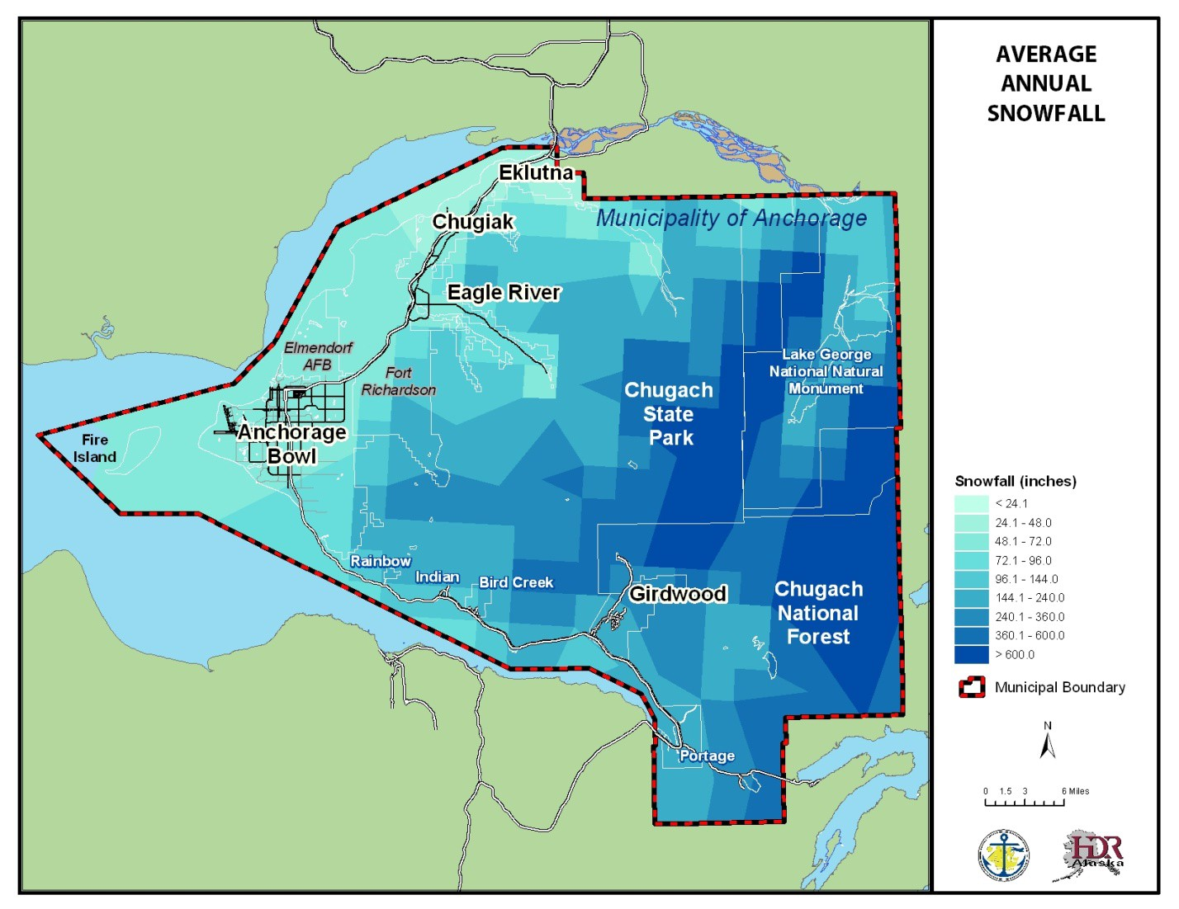

Historic Events
2002 Heavy Snow Fall
Record heavy snow occurred in MOA on March 17, 2002 when two to three feet of snow fell in less than 24 hours. TSAIA recorded a total of 28.7 inches while an observer near Lake Hood measured over 33 inches. The Municipality was essentially shut down because of the accumulating snow. Fortunately, the storm occurred on a Sunday morning when fewer businesses are open. The following day, both military bases, both universities, and many businesses remained closed, while Anchorage schools remained closed for two days. It took four days for snowplows to reach all areas of the city.

Other Snow Events
On March 20, 2001, 8-12 inches of snow fell in the Anchorage Bowl-Eagle River area.

Vulnerability
As a heavy snowfall could affect the entire Municipality, the entire MOA is represented in Table 4.4. Heavy snowfall can also damage infrastructure and critical facilities. Heavy snowfalls make transportation difficult, especially by road, and result in more money spent on snow plow services. Transportation may be distributed more in steeper areas such as the Hillside and parts of Eagle River. High numbers of injuries and fatalities are not expected with a heavy snow event. Heavy snow can have a greater impact on people who need access to medical services, emergency services, pedestrians, and people who rely on public transportation. The cost of fuel to heat homes during times of heavy snow can be a financial burden on populations with low or fixed incomes. According to the 2005-2009 American Community Survey 5-Year Estimates, the MOA had approximately 10,506 households with a household income less than $25,000. Homeless populations are also vulnerable. According to the January 2009 single-night homeless count, there were 2,962 homeless people in Anchorage (UAA Justice Center, 2009). Heavy snows may also result in school and business closures which may result in some individuals having a loss of income.

O. Table 4.4 Heavy Snow Vulnerability

Land Use | # of Parcels | Taxable Value (Land) | Taxable Value (Buildings) | Total
Residential | 75024 | 8526159300 | 17756156200 | 26282315500
Commercial | 4065 | 2568664400 | 4512337400 | 7081001800
Industrial | 2597 | 1494944600 | 1907337000 | 3402281600
Institutional | 1035 | 1215398400 | 1554183700 | 2769582100
Open Space | 44 | 24995700 | 503000 | 25498700
Transportation | 664 | 0 | 0 | 0
Other | 562 | 377462100 | 36697800 | 414159900
Vacant | 228 | 0 | 0 | 0
Total | 84219 | 14207624500 | 25767215100 | 39974839600
Source: MOA GIS, 2016

Heavy Rain
Precipitation Records
Normal Precipitation: 16.08 inches Highest Annual Precipitation: 27.75
inches (1989)
Lowest Annual Precipitation: 8.08 inches (1969)
Longest Consecutive Days with Measurable Precipitation: 17 days (September 12 – 28, 1979)
Consecutive Days Without Precipitation:
47 (January 6 – February 21, 1939)
Source: National Weather Service Anchorage Forecast Office’s Climate Records List, (1917 – current)
There is no universal definition of heavy rain. Generally, when rainfall is sufficient to cause localized or widespread flooding, it is considered heavy. The NWS is most concerned about potential flooding with 10% of an area’s annual rainfall occurs in one day (Albanese, 2010b).

Heavy rains are sometimes associated with a weather system called the “Pineapple Express”. This weather system originates in Hawaii and usually brings heavy rain with it. This rain can lead to flooding. The “Pineapple Express” may also melt snow contributing to flooding.
Location
The Girdwood area receives the most rainfall in the MOA. See Figure 4.4 for the average annual rainfall pattern. Rainfall also varies with time of year with most precipitation occurring in late summer and fall. Table 4.5 summarizes precipitation in the MOA.

J. Figure 4.2 Average Annual Rainfall

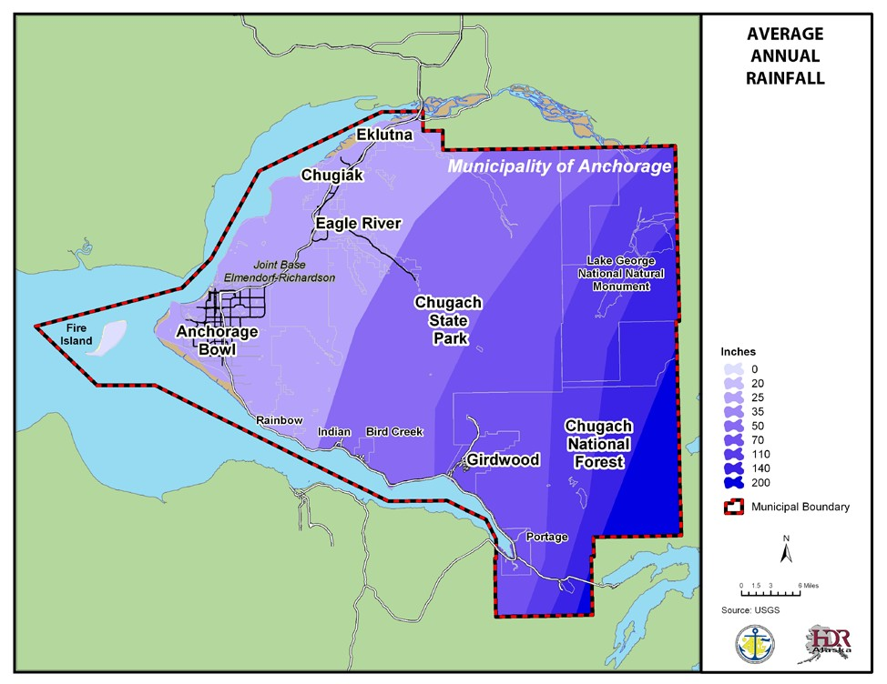

P. Table 4.5 Precipitation in the MOA
 | (a) | JAN | FEB | MAR | APR | MAY | JUN | JUL | AUG | SEP | OCT | NOV | DEC
PRECIPITATION (in.)  Water Equivalent  -Normal  -Maximum Monthly  -Year  -Minimum Monthly  -Year  -Maximum in 24 hrs  -Year  Snow, Ice Pellets, Hail  -Maximum Monthly  -Year  -Maximum in 24 hrs  -Year | 42  42  42  42  42 | 0.79  2.71  1987  0.02  1982  1.19  1961  27.5  1990  10.5  1955 | 0.7  3.07  1955  0.07  1958  1.16  1956  48.5  1955  12.4  1956 | 0.69  2.76  1979  T 1983  1.25  1986  31.0  1979  14.5  1959 | 0.67  1.91  1977  T 1969  0.78  1989  27.6  1963  9.1  1955 | 0.73  1.93  1989  0.02  1957  1.18  1980  3.9  1963  3.9  1963 | 1.14  3.40  1962  0.17  1993  1.84  1962  0.0  0.0 | 1.71  4.44  1958  0.42  1.72  2.06  1956  0.0  0.0 | 2.44  9.77  1989  0.33  1969  4.12  1989  0.0  0.0 | 2.70  6.64  1990  0.76  1973  1.92  1961  4.6  1965  3.5  1965 | 2.03  4.11  1986  0.35  1960  1.60  1986  27.1  1982  11.2  1991 | 1.11  2.84  1976  0.08  1985  1.66  1964  38.8  1994  16.4  1964 | 1.12  2.67  1955  0.09  1995  1.62  1955  41.6  1955  17.7  1955

Likelihood of Occurrence
The occurrence of heavy rain depends on the weather conditions.

Historic Events
No significant historic heavy rainfalls that have resulted in a declared disaster have been identified. However, heavy rainfalls have resulted in flood events. For more information, please see the flood section.

Vulnerability
As a heavy rain could affect the entire Municipality, the entire MOA is represented in Table
4.6. The flooding associated with a heavy rain is typically the greatest concern. For more information, please see the flood section. High numbers of injuries and fatalities are not anticipated with a heavy rain event.

Q. Table 4.6 Heavy Rain Vulnerability
Land Use | # of Parcels | Taxable Value (Land) | Taxable Value (Buildings) | Total
Residential | 75024 | 8526159300 | 17756156200 | 26282315500
Commercial | 4065 | 2568664400 | 4512337400 | 7081001800
Industrial | 2597 | 1494944600 | 1907337000 | 3402281600
Institutional | 1035 | 1215398400 | 1554183700 | 2769582100
Open Space | 44 | 24995700 | 503000 | 25498700
Transportation | 664 | 0 | 0 | 0
Other | 562 | 377462100 | 36697800 | 414159900
Vacant | 228 | 0 | 0 | 0
Total | 84219 | 14207624500 | 25767215100 | 39974839600
Source: MOA GIS, 2016

Extreme Cold
What is considered an excessively cold temperature varies according to the normal climate of a region. In areas unaccustomed to winter weather, near freezing temperatures are considered "extreme cold." In Alaska, extreme cold usually involves temperatures below –40º Fahrenheit (F). Excessive cold may accompany winter storms, be left in their wake, or can occur without storm activity.

Extreme cold can also bring transportation to a halt for days or weeks at a time. Aircraft may be grounded due to extreme cold and ice fog conditions. Long cold spells can cause rivers to freeze which increases the likelihood of ice jams and ice jam related flooding. If extreme cold conditions are combined with low or no snow cover, the ground’s frost depth can increase, and disturb buried utility pipes.
Frostbite is damage to body tissue caused by that tissue being frozen. Frostbite causes a loss of feeling and a white or pale appearance in the extremities.

Hypothermia is low body temperature. Normal body temperature is 98.6ºF. When body temperature drops to 95ºF, however, immediate medical help is needed. Hypothermia also can occur with prolonged exposure to temperatures above freezing.

The greatest danger from extreme cold is to people. Prolonged exposure to the cold can cause frostbite or hypothermia and become life threatening, especially for infants and the elderly. Carbon monoxide (CO) poisonings also increase as people use supplemental heating devices.

Location
In MOA, the official temperature is recorded at TSAIA. Due to its close proximity to open water, the airport tends to be warmer than the rest of Anchorage. For example, east Anchorage is generally 10 to 15 degrees cooler than at the airport (Vonderheide, 2003). The Chugiak/Eagle River area tends to get the coolest temperatures in the winter. See Figure 4.3 for the extreme minimum temperatures.
K. Figure 4.3 Extreme Minimum Temperatures

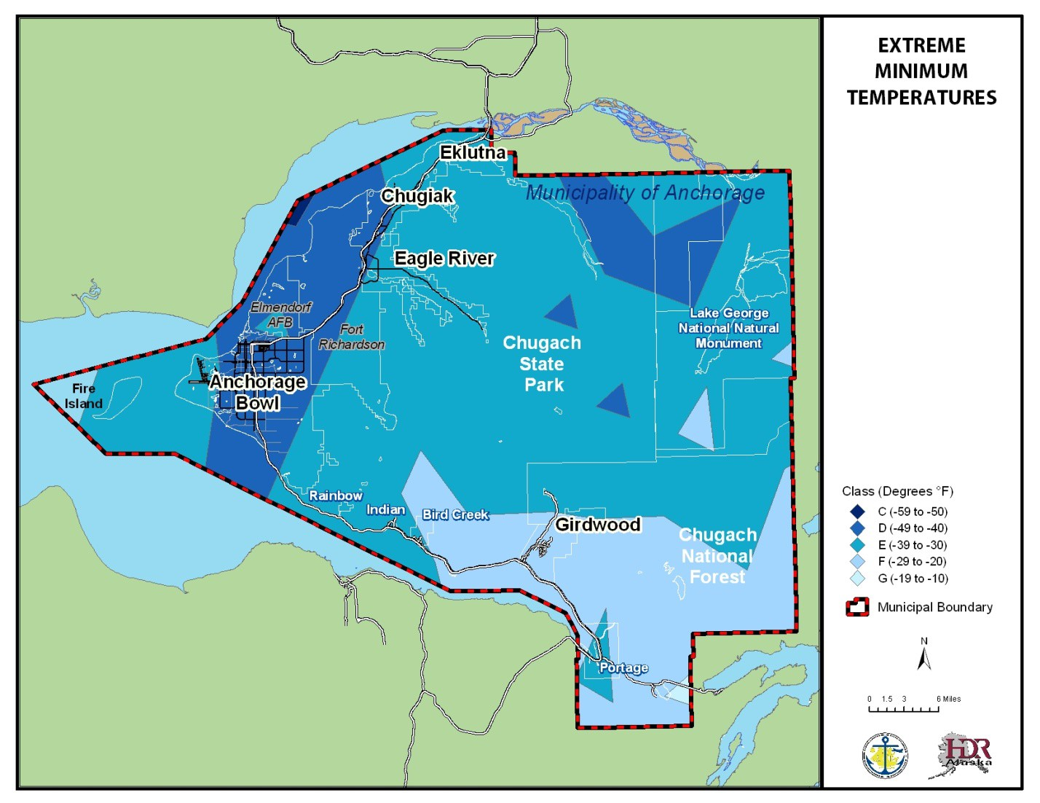

The coldest months in Anchorage are generally December, January, and February. The temperature tends to decrease, the further inland you are. Table 4.7 summarizes the temperature in the MOA.

R. Table 4.7 Temperatures

 | (a) | JAN | FEB | MAR | APR | MAY | JUN | JUL | AUG | SEP | OCT | NOV | DEC | YEAR
TEMPERATURE (Deg. F)  Normals  -Daily Maximum  -Daily Minimum  -Monthly Extremes  -Record Highest  -Year  -Record Lowest  -Year | 42  42 | 21.4  8.4  14.9  50  1961  -34  1975 | 25.8  11.5  18.7  48  1991  -26  1956 | 33.1  18.1  25.7  5.1  1984  -24  1971 | 42.8  28.6  35.8  65  1976  -4  1985 | 54.4  38.8  46.6  77  1969  17  1964 | 61.6  47.2  54.4  85  1969  33  1961 | 65.2  51.7  58.4  82  1989  38  1964 | 63.0  49.5  56.3  82  1978  31  1984 | 55.2  41.6  48.4  73  1957  19  1992 | 40.5  28.7  34.6  6.1  1993  -5  1956 | 27.2  15.1  21.2  53  1979  -21  1956 | 22.5  10.0  16.3  48  1992  -30  1964 | 42.7  29.1  35.9  85  JUN 1969  -34  JAN 1975
NORMAL DEGREE DAYS  Heating (base 65 Deg. F) Cooling (base 65 Deg. F) |  | 1553  0 | 1296  0 | 1218  0 | 876  0 | 570  0 | 318  0 | 205  0 | 70  0 | 498  0 | 942  0 | 1314  0 | 1510  0 | 10570  0
MEAN SKY COVER(tenths)  Sunrise - Sunset  MEAN NUMBER OF DAYS:  Sunrise to Sunset  -Clear  -Partly Cloudy  -Cloudy Precipitation  .01 inches or more Snow, Ice Pellets, Hail  1.0 inches or more Thunderstorms Heavy Fog Visibility 1/4 mile or less Temperature Deg. F  -Maximum  70 Deg. F and above 32 Deg. F and below  -Minimum  32 Deg. F and below 0 Deg. F and below | 42  42  42  42  31  31  42  42  31  31  31  31 | 7.1  7.0  4.6  19.4  7.8  2.8  0.0  6.0  0.0  24.7  30.5  9.5 | 7.0  6.7  3.6  18.0  7.8  3.1  0.0  4.4  0.0  19.7  27.2  7.2 | 6.7  7.6  5.4  17.9  7.4  2.7  0.0  1.5  0.0  11.7  28.3  2.3 | 7.2  5.6  6.1  18.3  6.0  1.5  0.0  0.7  0.0  2.0  20.3  0.* | 7.7  4.0  6.5  20.6  7.2  0.0  0.1  0.3  0.5  0.0  2.7  0.0 | 7.9  2.7  6.9  20.4  7.9  0.0  0.1  0.1  3.3  0.0  0.0  0.0 | 7.9  3.4  5.8  21.8  11.5  0.0  0.4  0.2  6.5  0.0  0.0  0.0 | 7.9  3.3  6.1  21.6  13.4  0.0  0.2  0.9  3.4  0.0  0.1  0.0 | 7.9  3.7  5.4  20.9  14.5  0.2  0.1  1.3  0.1  0.0  3.2  0.0 | 7.7  5.0  4.6  21.3  12.2  2.3  0.0  2.1  0.0  4.6  19.8  0.1 | 7.3  5.7  4.7  19.6  9.6  3.5  0.0  3.7  0.0  20.8  28.2  3.2 | 7.5  5.8  4.0  21.2  11.0  4.6  0.0  5.0  0.0  24.5  30.2  7.2 | 7.5  60.5  63.7  241.0  116.3  20.8  1.0  26.2  13.9  108.1  190.5  29.5
Source: Alaska Climate Research Center, 2010

Likelihood of Occurrence
Extreme cold temperatures could happen every winter, depending on weather conditions. However, it is rare for temperatures in the MOA to be colder than -50°F (Albanese, 2010).

Historic Events
Extreme cold temperatures can be especially problematic if they are associated with low snow levels as happened in the winter of 1995-1996. The combination of these two factors resulted in the ground freezing to a greater depth than usual (more than 10 feet compared to the usual three of four feet). As utility pipes, including water and wastewater, are buried to a depth of 10 feet, some pipes froze and subsequently broke. Repairing the broken pipes was a massive undertaking as the ground had to be thawed before work could commence (Vonderheide, 2003).

Vulnerability
As extreme cold could affect the entire Municipality, the entire MOA is represented in Table
4.8. An extreme cold event is likely to result less property damage than other hazards such as an earthquake. In the MOA, typically buried pipes are most vulnerable to an extreme cold event. Homeless populations and people who have difficultly heating their homes (due to poor insulation, unable to afford heating costs, etc.) also tend to be more vulnerable. According to the January 2009 single-night homeless count, there were 2,962 homeless people in Anchorage (UAA Justice Center, 2009). While the exact number of people is unavailable, several homeless people have died in Anchorage due to hypothermia in recent years. According to the 2005-2009 American Community Survey 5-Year Estimates, the MOA had approximately 10,506 households with a household income less than $25,000.

S. Table 4.8 Extreme Cold Vulnerability

Land Use | # of Parcels | Taxable Value (Land) | Taxable Value (Buildings) | Total
Residential | 75024 | 8526159300 | 17756156200 | 26282315500
Commercial | 4065 | 2568664400 | 4512337400 | 7081001800
Industrial | 2597 | 1494944600 | 1907337000 | 3402281600
Institutional | 1035 | 1215398400 | 1554183700 | 2769582100
Open Space | 44 | 24995700 | 503000 | 25498700
Transportation | 664 | 0 | 0 | 0
Other | 562 | 377462100 | 36697800 | 414159900
Vacant | 228 | 0 | 0 | 0
Total | 84219 | 14207624500 | 25767215100 | 39974839600
Source: MOA GIS, 2016

Ice Storms
Ice storm is the term used to describe occasions when damaging accumulations of ice are expected during freezing rain situations. Ice storms result from the accumulation of freezing rain (rain that becomes super cooled and freezes upon impact with cold surfaces). Freezing rain most commonly occurs in a narrow band within a winter storm that is also producing heavy amounts of snow and sleet in other locations. Ice storms can be devastating and are often the cause of automobile accidents, power outages and personal injuries.

Glace ice, also known as black ice, which occurs when rains hits the cold ground and turns into ice, is possible in the MOA. It is responsible for multiple traffic accidents every winter.

Location
Ice storms can occur anywhere but the atmospheric conditions that can lead to ice storms occur most frequently around Cook Inlet. Freezing rains often approach from the west as storms from the Bering Sea move westward and mix with the pre-existing cold air in the MOA area.

Likelihood of Occurrence
The future occurrence of ice storms in the MOA depends on the weather conditions. Typically, there are a few episodes of light freezing rain each winter. The NWS will issue a freezing rain advisory which is for freezing rain up to 0.24 inches accumulation of ice. In the MOA, most events have an accumulation less than a tenth of an inch (Albanese, 2010b).
More commonly, rain will fall on ice or snow pack covered roads which result in difficult driving conditions. This can occur when there is a storm in the Bering Sea/Bristol Bay area that has ample warm air advecting over the region and is accompanied by a strong southeast Chinook wind.

Historic Events
No significant historic ice storms have been identified. In November 2010, there were several days of freezing rain that made the roads slick and resulted in school closures. There was also an ice event in the mid-1990s (Albanese, 2010).

Vulnerability
As an ice storm could affect the entire Municipality, the entire MOA is represented in Table 4.9. An ice storm is likely to result in less building and property damage than other hazards. An ice storm has the potential to damage power lines. Infrastructure, especially above ground power lines are also vulnerable to ice. Ice storms can also increase the number of traffic accidents. Large numbers of injuries and fatalities are not anticipated with an ice storm. Ice storm related power outages can affect people who rely on electricity for life-safety items such as respirators, monitoring equipment or medication that needs to be kept refrigerated.

T. Table 4.9 Ice Storm Vulnerability

Land Use | # of Parcels | Taxable Value (Land) | Taxable Value (Buildings) | Total
Residential | 75024 | 8526159300 | 17756156200 | 26282315500
Commercial | 4065 | 2568664400 | 4512337400 | 7081001800
Industrial | 2597 | 1494944600 | 1907337000 | 3402281600
Institutional | 1035 | 1215398400 | 1554183700 | 2769582100
Open Space | 44 | 24995700 | 503000 | 25498700
Transportation | 664 | 0 | 0 | 0
Other | 562 | 377462100 | 36697800 | 414159900
Vacant | 228 | 0 | 0 | 0
Total | 84219 | 14207624500 | 25767215100 | 39974839600
Source: MOA GIS, 2016

High Winds
High winds are generally considered to be winds in excess of 73 mph (Albanese, 2010b). A strong wind can be considered to be between 45 and 72 mph (Albenese, 2010b). They can lead to dangerous wind chill temperatures or combine with loose snow to produce blinding
blizzard conditions. High winds have the potential to cause serious damage to a community’s infrastructure, especially above ground utility lines. With early season high wind events, like the events in September 2010 and September 2012, high winds can cause trees to be blow over and uprooted. Later in the year, when trees are free of leaves and the ground is frozen, trees are more likely to break or have limbs broken off than being uprooted (Albanese, 2010b).

In mountainous areas, down slope windstorms created by temperature and pressure differences across the terrain can produce winds in excess of 100 mph. These windstorms can be particularly damaging as they are gusty in character and may seem to come from several directions.

Location
Typically, high wind warnings are for the Hillside and along Turnagain Arm. These areas common get high winds but the impacts is not that great until the winds are above 85 mph (Albanese, 2010b). When winds exceed 85 mph, it is not unusual for there to be damage. The damage is more widespread (especially along the Hillside and in East Anchorage), when the winds exceed 100 mph. Weaker winds (in the 50 to 60 mph range) will have more of an impact in the downtown area (Albanese, 2010b).

In the MOA, the basic wind speed, for the determination of the wind loads is determined in accordance with the Anchorage “Three Second Gust” wind zone map. This Anchorage Area- Wide Wind Speed Study noted that Anchorage gets strong winds from the southerly direction in the summer and northerly directions during the winter (RWDI, 1998).
L. Figure 4.4 50-Year Wind Speed
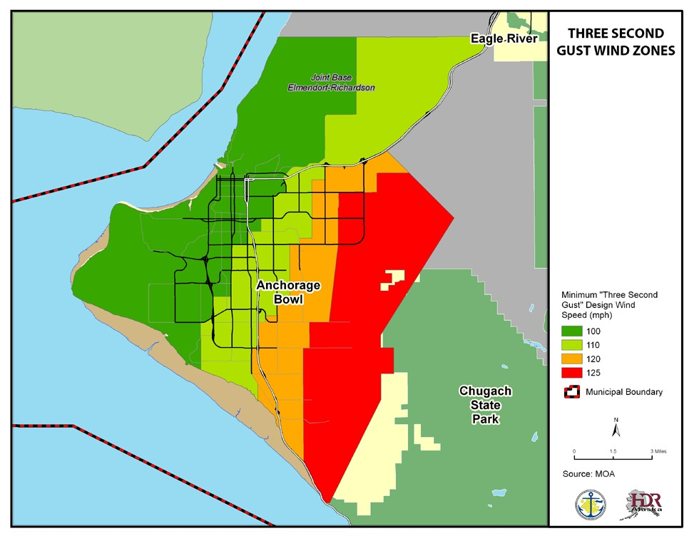

Localized high winds can also occur (see Table 4.10). The most well known local wind is the Chugach wind which blows off the Chugach Mountains. These Chugach winds are really Chinook winds (a strong warm wind) and mostly affect the eastern side of the Anchorage Bowl. There can be winds just in the Turnagain Arm area, which affects traffic on the New Seward Highway (Vonderheide, 2003). Winds near McHugh Creek can get in the 80-90 mph range (Vonderheide, 2003). There is a Knik Valley wind, which brings warm air from Prince William Sound. The hillside area can experience a Chinook/Chugach wind. Eagle River can get winds from the Southeast. Localized winds in Bear Valley can reach 125 mph.

U. Table 4.10 Wind Speeds

 | (a) | JAN | FEB | MAR | APR | MAY | JUN | JUL | AUG | SEP | OCT | NOV | DEC | YEAR
WIND  Mean Speed (mph) Prevailing Direction through 1964 Fastest Mile | 42  38 | 6.4  NNE 03  61 | 6.9  N 04  52 | 7.0  N 03  51 | 73  N 15  35 | 8.4  S 35  33 | 8.4  S 17  30 | 7.3  S 16  29 | 6.9  S 02  31 | 6.7  NNE 22  35 | 6.7  N 03  40 | 6.5  NNE 04  41 | 6.3  NNE 05  41 | 7.1  N 03  61
-Direction(!!) | 16 | 1971 | 1979 | 1989 | 1964 | 1964 | 1971 | 1957 | 1987 | 1993 | 1966 | 1978 | 1964 | JAN
-Speed(mph) |  |  |  |  |  |  |  |  |  |  |  |  |  | 1971
-Year |  | E | NE | NE | SE | S | SE | SE | N | S | S | NE | SE
Peak Gust | 16 | 64 | 61 | 75 | 43 | 43 | 46 | 40 | 44 | 48 | 55 | 55 | 55 | NE
-Direction(!!) |  | 1986 | 1994 | 1989 | 1987 | 1988 | 1985 | 1980 | 1987 | 1985 | 1987 | 1990 | 1992 | 75
-Speed(mph) |  |  |  |  |  |  |  |  |  |  |  |  |  | MAR
-Date |  |  |  |  |  |  |  |  |  |  |  |  |  | 1989

Likelihood of Occurrence
High wind advisories, watches, and warnings are frequently issued by the National Weather Service (NWS) for different parts of Anchorage.

Historic Events
2003 Winter Storm – Federal Disaster 1461
In March 2003, a winter storm brought high winds and freezing temperatures to Anchorage and surrounding communities for several days. This event involved a Bora wind, which is a very cold northerly wind (sometimes called the Matanuska wind). Bora winds are rare in Anchorage, and usually only occur every 10 to 15 years (Vonderheide, 2003). Prior to this event, the last one occurred in 1989.

Within the Municipality, the worst effects occurred in the west Anchorage area. Ted Stevens Anchorage International Airport had record high winds, sustained winds around 92-94 mph and a peak gust of 109 mph (Scott, Baines, and Papineau, 2003). Damage for the event in MOA alone exceeded $3.5 Million. MOA conducted a voluntary on-line survey about the damage caused by storm. The survey results are displayed in Figure 4.5.

2000 Central Gulf Coast Storm - Federal Disaster 1316
In December 1999 and January 2000, there was series of severe winter storms (involving high winds and avalanches) that caused damage throughout Southcentral Alaska. Anchorage was one of many jurisdictions included in a Federal Disaster Declaration. In Anchorage, damage from this event included one fatality, property damage, disruption of electrical service, and interruption of rail and road access south of the Potter Weigh Station.

April 1980 Windstorm
On April 1, 1980, a Chinook wind with maximum gust speeds estimated at 134 mph caused approximately $25 million in damages.

Other Wind Events (From RWDI 1998a and b)
    - December 3, 1994 - southeasterly downslope wind storm
    - February 20, 1994 – northeasterly wind storm
    - November 22, 1993 - southeasterly downslope wind storm
    - February 3, 1993 – northeasterly wind storm
    - December 1, 1992 windstorm - southeasterly downslope wind storm
        - Had maximum gust speeds estimated at 112mph
    - December 26, 1991 - southeasterly downslope wind storm
    - March 4, 1989 – northeasterly wind storm
    - November 9, 1986 – southeasterly downslope wind storm
    - February 14, 1979 – northeasterly windstorm

Vulnerability
The entire MOA was not included in the Anchorage Area-Wide Wind Speed Study. The area included in the study is shown on Figure 4.4. The size of each wind speed zone is shown in Table 4.11. The vulnerability tables for each wind speed zone (Tables 4.12 – 4.15) only reflect the area included in the study.

V. Table 4.11 Area of Wind Speed Zones

Minimum “Three Second Gust”  Design Wind Speed (mph) | Fastest Mile | Acres
100 | 85 | 31,489
110 | 95 | 21,545
120 | 104 | 12,120
125 | 109 | 22,372

W. Table 4.12 100 mph “Three Second Gust” Vulnerability in the Anchorage Building Service Area

Land Use | # of Parcels | Taxable Value (Land) | Taxable Value (Buildings) | Total
Residential | 21338 | 2597575600 | 5253931000 | 7851506600
Commercial | 2442 | 1520269900 | 3143414100 | 4663684000
Industrial | 1004 | 488792600 | 744528000 | 1233320600
Institutional | 240 | 455801100 | 316954300 | 772755400
Open Space | 34 | 20163000 | 476700 | 20639700
Transportation | 104 | 2392100 | 227800 | 2619900
Other | 127 | 117746600 | 13342700 | 131089300
Vacant | 397 | 0 | 0 | 0
Total | 25686 | 5202740900 | 9472874600 | 14675615500
Source: MOA GIS, 2016

X. Table 4.13 110 mph “Three Second Gust” Vulnerability in the Anchorage Building Service Area

Land Use | # of Parcels | Taxable Value (Land) | Taxable Value (Buildings) | Total
Residential | 12705 | 1345616400 | 2849712300 | 4195328700
Commercial | 673 | 579464500 | 881644400 | 1461108900
Industrial | 1415 | 906007900 | 1044356700 | 1950364600
Institutional | 122 | 269195800 | 813039000 | 1082234800
Open Space | 1 | 254600 | 0 | 254600
Transportation | 20 | 0 | 0 | 0
Other | 13 | 19226800 | 11192100 | 30418900
Vacant | 15 | 0 | 0 | 0
Total | 14964 | 3119766000 | 5599944500 | 8719710500
Source: MOA GIS, 2016

Y. Table 4.14 120 mph “Three Second Gust” Vulnerability in the Anchorage Building Service Area

Land Use | # of Parcels | Taxable Value (Land) | Taxable Value (Buildings) | Total
Residential | 14606 | 1521998100 | 3460575500 | 4982573600
Commercial | 220 | 183366800 | 298402000 | 481768800
Industrial | 71 | 57714000 | 83264100 | 140978100
Institutional | 241 | 259074200 | 187242200 | 446316400
Open Space | 1 | 254600 | 0 | 254600
Transportation | 4 | 0 | 0 | 0
Other | 4 | 6955400 | 11452000 | 18407400
Vacant | 42 | 0 | 0 | 0
Total | 15189 | 2029363100 | 4040935800 | 6070298900
Source: MOA GIS, 2016

Z. Table 4.15 125 mph “Three Second Gust” Vulnerability in the Anchorage Building Service Area

Land Use | # of Parcels | Taxable Value (Land) | Taxable Value (Buildings) | Total
Residential | 11242 | 1448168400 | 3085166200 | 4533334600
Commercial | 39 | 34156200 | 39603400 | 73759600
Industrial | 1 | 0 | 0 | 0
Institutional | 146 | 169233900 | 117153000 | 286386900
Open Space | 4 | 1503900 | 0 | 1503900
Transportation | 5 | 0 | 0 | 0
Other | 0 | 0 | 0 | 0
Vacant | 16 | 0 | 0 | 0
Total | 11453 | 1653062400 | 3241922600 | 4894985000
Source: MOA GIS, 2016
In general, a windstorm is more likely to cause property damage than injuries and fatalities. High winds can cause falling trees and branches which can bring down utility lines and cause property damage. Windstorms can lead to power failures which can affect people who rely on electricity for life-safety items such as respirators, monitoring equipment or medication that needs to be kept refrigerated. Power failures can also cause school and business closures.
Fallen trees and branches can block roads making it difficult to travel around town. Areas that are near forested areas such as the Hillside may be more vulnerable.

Fog
Fog is basically a cloud on the ground. When the air is saturated with water vapor, a drop in temperature will cause the excess water vapor to condense into water droplets. These droplets, if thick enough, will turn into fog.

When it is foggy, ice can be deposited on the roadways, causing black ice conditions (Vonderheide, 2003).
Location
Fog is more frequent in West Anchorage. In the fall and early winter, a northerly wind comes from the north and reduces visibility. In East Anchorage, the drainage winds from the mountains mix the air to help keep the area relatively fog free.

Fog can also occur in the lower parts of Eagle River, but it is rare in the higher elevations.

Likelihood of Occurrence
Fog is likely to occur when the climatic conditions are right. Fog events are usually short-term with no lasting effects.

Historic Events
No significant historic fog events have been identified to date.

Vulnerability
As fog could affect the entire Municipality, the entire MOA is represented in Table 4.16. Property damage does not typically occur during a dense fog event. Dense fog can reduce visibility leading to an increase in traffic accidents. Traffic accidents have the potential to result in injuries and fatalities. Large numbers of injuries and fatalities due to dense fog is not anticipated. Dense fog may result in closures at local airports.

AA. Table 4.16 Fog Vulnerability

Land Use | # of Parcels | Taxable Value (Land) | Taxable Value (Buildings) | Total
Residential | 75024 | 8526159300 | 17756156200 | 26282315500
Commercial | 4065 | 2568664400 | 4512337400 | 7081001800
Industrial | 2597 | 1494944600 | 1907337000 | 3402281600
Institutional | 1035 | 1215398400 | 1554183700 | 2769582100
Open Space | 44 | 24995700 | 503000 | 25498700
Transportation | 664 | 0 | 0 | 0
Other | 562 | 377462100 | 36697800 | 414159900
Vacant | 228 | 0 | 0 | 0
Total | 84219 | 14207624500 | 25767215100 | 39974839600
Source: MOA GIS, 2016

Other Weather Events
Other extreme weather events that are possible, but rare, in the MOA include:
    - Tornados
    - Coastal Storms
    - Storm Surges
    - Thunder and Lightning
    - Hail

4.1.4 FLOODING
Flooding occurs when weather, geology, and hydrology combine to create conditions where river and stream waters flow outside of their usual course and “spill” beyond their banks. In the MOA, these natural factors can be exacerbated by development and result in an increase in the frequency of flood events. The MOA spans a wide range of climatic and geologic regions, resulting in considerable variation in precipitation. Primary factors in the amount of precipitation and area will receive are elevation and slope aspect, or direction. Within the MOA, annual precipitation varies from less than 15 inches at TSAIA to over 70 inches in Girdwood and along Turnagain Arm. Snowmelt from the Chugach Mountains provides a continuous water source throughout the year, and can contribute significantly to the development of flooding.

Types of Flooding
Riverine, icing, and urban flooding are the three types of flooding that primarily affect the MOA. Riverine flooding is the overbank flooding of rivers and streams. The natural processes of flooding add sediment and nutrients to fertile floodplain areas. Riverine flooding can be the result of rainfall runoff or snowmelt and can occur on any of the rivers and streams within the MOA. Riverine flooding occurred on many rivers and creeks during the falls of 1995, 1997, 2002, and 2005.

Icing, also called aufeis, occurs when the growth of large bodies of ice on the streambed during freeze-up or breakup creates an obstruction to normal streamflow, causing river and streams to leave their banks. This can occur on many streams within the MOA. During the winters of 2003 and 2006, aufeis lead to overbank flooding on many creeks including Peters Creek and Rabbit Creek.

Urban flooding results from the conversion of land from wetlands or woodlands to parking lots and roads, through which the land loses its ability to absorb rainfall, causing runoff to overwhelm natural and manmade drainages.

Within the MOA, other types of flooding that may occur infrequently include:

Ice Jam Floods – the MOA tends not to have the typical ice jam flood like other parts of Alaska. In the MOA, when an ice jam flood occurs, it tends to be the result of ice collecting in a channel constriction such as a culvert. During a rain event or a sudden thaw, runoff enters a stream before the stream ice can melt, resulting in a flood. This type of flooding is more likely on larger creeks such as Campbell Creek.

Flash Floods - These floods are characterized by a rapid rise in water level and are often caused by heavy rain on small stream basins, ice jam formation, or by dam failure. Flash floods are usually swift moving and debris filled, which cause them to be very powerful and destructive. Steep coastal areas in general are subject to flash floods. A flash flood could occur downstream of a Lake o’ the Hills Dam. For more information, please see section 4.2.1, Dam Failure.
Fluctuating Lake Level Floods - Generally, lakes buffer downstream flooding due to the storage capacity of the lake. But when lake inflow is excessive, flooding of the lake shore area can occur.

Alluvial Fan Floods - Alluvial fans are areas of eroded rock and soil deposited by rivers. When various forms of debris fill the existing river channels on the alluvial fan, the water overflows and is forced to cut a new channel. Fast, debris-filled water causes erosion and flooding problems over large areas. The Girdwood area is prone to this type of flooding.

Glacial Outburst Floods - A glacial outburst flood, also known as a jökulhlaup, is a sudden release of water from a glacier or a glacier-dammed lake. They can fail by overtopping, earthquake activity, melting from volcanic activity, or draining through conduits in the glacier dam.

Subglacial releases occur when enough hydrostatic pressure occurs from accumulated water to “float” the glacial ice. Water then drains rapidly from the bottom of the lake.
This type of flooding can occur on Lake George.

Other problems related to flooding are deposition and stream bank erosion. Deposition is the accumulation of soil, silt, and other particles on a river bottom or delta. Deposition leads to the destruction of fish habitat and presents a challenge for navigational purposes. Deposition also reduces channel capacity, resulting in increased flooding or bank erosion. Stream bank erosion involves the removal of material from the stream bank. When bank erosion is excessive, it becomes a concern because it results in loss of streamside vegetation, fish habitat, and land and property.

A flood can injure or kill people as well as damage property. A flood may disrupt public utilities including water supplies and water treatment facilities. It can impact the transportation system by washing out roads or damaging bridges and culverts. This can make it difficult for emergency responders to get where they are needed.

Overflowing wastewater treatment systems can expose people to raw sewage which may make them ill. If a flooded building has not been treated properly, mold and mildew may develop which can become a health hazard especially for people with respiratory issues. The contents of a building such as household furnishing can be lost if they are washed away.
Important papers, photographs, and similar items may be damaged. Standing pools of water may become breeding grounds for mosquitoes.

Location
The MOA has many small streams and larger rivers that are susceptible to annual flooding events. Large rivers include the the Glacier Creek, Twentymile River, Portage Creek, Placer River, Ship Creek, and Eagle River. Smaller streams include California Creek, Virgin Creek, Alyeska Creek, Fire Creek, Chester Creek, Campbell Creek, Little Campbell Creek, Fish Creek, Furrow Creek, Rabbit Creek, Meadow Creek, Fire Creek, and Peters Creek. Additionally, the shorelines of many of the small lakes in Anchorage are subject to periodic flooding. Coastal areas may experience flooding associated with extreme high tides.
The flood hazard varies by location and type of flooding. The FEMA Flood Insurance Study from 2009 identifies potential areas of flooding. The study excluded Fire Island, Elmendorf Air Force Base, Fort Richardson Military Reservation, and Kincaid Park (referred to in the study as the Point Campbell Military Reservation). According to this report, most of the development land in MOA is “low, swampy, and subject to inundate from flooding” (FEMA, 2009). The MOA is currently in the process of updating their Flood Insurance Study. The update study is expected to be released in early mid-2011.

Figure 4.6 shows flood-prone areas in the MOA. This map is for illustrative purposes, as not all the floodplains identified on MOA’s Flood Insurance Rate Maps (FIRM) are on this map. The main flood-prone areas are near Glacier and California Creeks in Girdwood, near Eagle River Road in Eagle River, Potter’s Marsh, and along Campbell and Chester Creeks in Anchorage.
Please see the appropriate FIRM for more detailed flood information.

M. Figure 4.5 Flood-Prone Areas in the MOA

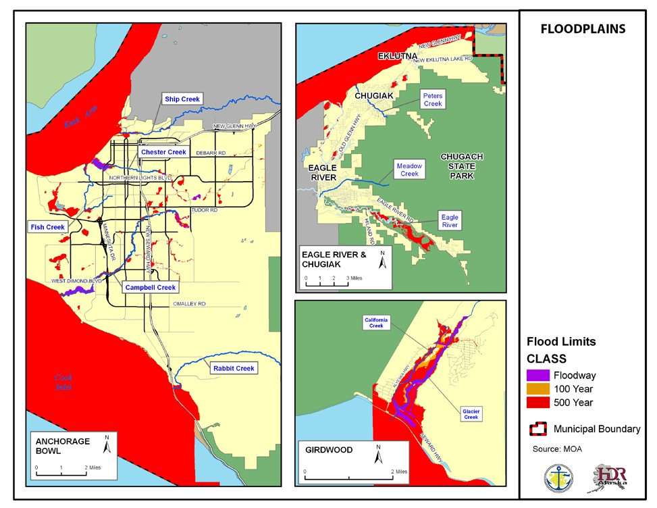

Much of Girdwood is subject to flooding because Girdwood valley occupies a fluvial valley drained by Glacier and California Creeks. The mouth of the valley is at sea level and gains elevation inland of the Seward Highway (MOA, 1996). The entire mouth of the Girdwood valley and the area adjacent to Glacier Creek to the airport is essentially within the 100-year floodplain. Other areas susceptible to flooding are California, Alyeska, and Virgin Creeks. The primary cause of flooding is runoff during
Property Owner Outreach
On an annual basis, the MOA sends an informational letter to people who own property located in a floodplain. The letter provides an overview of flooding sources within the MOA, the causes of flooding, recent flooding events, flood insurance, floodplain regulation, flood safety tips and a list of contacts where home owners can obtain additional information.
heavy rainfall or during rapid snowmelt during the spring (MOA, 1995).

Likelihood of Occurrence
Coastal areas are more likely to flood when there is a storm that causes storm surge, high waves, or intense rainfall. Riverine flooding is more likely to occur in the spring when the snowpack is melting. There is also more chance of flooding in heavy snow seasons. Riverine flooding can also occur in response to heavy rainfall in upstream areas. Glacier outburst floods are not very predictable.

Historic Events
Summer 2008
During the summer of 2008, an intense localized “cloudburst” caused flooding on the east side of the Anchorage Bowl. Stormwater runoff exceeded the capacity of the constructed and natural drainage system. Floodwaters flowed into the crawlspaces and lower floors of some local residences.
Peters Creek Flooding
In 2006, Peters Creek has some of the worst flooding local residents have seen in 50 years. The Anchorage Soil and Water Conservation District (ASWCD) had to blast a series of ice dams on Peters Creek to reopen the creek channel and stop the flooding. Since then, the ASWCD has been working on the Peters Creek Flooding and Erosion Control Project address the flooding issue.

Winter of 2003 and 2006
During the winters of 2003 and 2006, colder than normal temperatures, combined with later than normal snowfall, caused the formation of aufeis in local streams, leading to overbank flooding, particularly on Peters Creek.

Fall of 1995, 1997, 2002, and 2005
The “Pineapple Express” brought warm weather to Anchorage in the fall of 1995, 1997, 2002, and 2005. The warmer than average
temperatures, combined with prolonged precipitation, resulted in flooding throughout Southcentral Alaska, including the MOA. The 1995 event resulted in a federal disaster and is discussed below.

In September 1995, there was a federal disaster declaration (AK-1072-DR) due to flooding caused by heavy rainfall. Most of the damages were outside the MOA, but Girdwood was negatively impacted. Officials in Girdwood had to shut down the wastewater treatment plant when it was overwhelmed by large volumes of mud and water. This resulted in raw sewage being washed into local creeks.

Other Flood Events
August 30, 1989
In August 1989, more than 5 inches of rain fell in the Anchorage area, causing heavy flooding along drainage systems in the MOA. The flooding was concentrated at homes and businesses along Campbell, Chester, and Ship creeks. The flooding resulted in a State Disaster Declaration.

February 10, 1978
During February 1978, the south fork of Campbell Creek experienced flooding and glaciation. Glaciation is when a stream freezes to the bottom or a culvert freezes full. The water flowing on top of the ice also freezes, so more ice develops and spreads into the overbank areas.
The flooding affected an area bounded by East 80th Avenue, Spruce Avenue, Lake Otis Parkway, and Abbott Loop Road. Many residential structures were threatened with water, ice, and contamination of surface and subsurface water. The flooding resulted in a State Disaster Declaration.

June 1966
Glacial outburst flooding last occurred on Lake George in June 1966. Between 1914 and 1966, the lake flooded almost every June or July. Prior to 1914, however, flooding occurred irregularly. These flood events were caused by the Knik Glacier blocking the valley of Lake George, trapping glacier and snow meltwater. The lake enlarges and the water erodes the glacier until it breaks out. The released water can be flowing as fast as 150 million gallons per minute. The flooding threatened structures on the Knik River floodplain (Davis, 1980).

Other flooding events are listed in Table 4.17.

BB. Table 4.17 Historic Flooding

Flooding Source and Location | Maximum Discharge (cfs) | Date | Estimated Recurrence Interval (Years)
Ship Creek  Near Anchorage | 1,860 | June 1949 | 50.0
South Fork Campbell Creek at mouth | 891 | June 1949 | 100.0
Chester Creek | N/A | April 1963 | 5.0
Rabbit Creek | N/A | June 1964 | 100.0
Eagle River | 6,240 | September 1967 | N/A
Glacier Creek at Girdwood | 7,710 | September 1967 | 20.0
Ship Creek  Below Power Plant at Elmendorf Air Force Base | 1,600 | August 1971 | 20.0
Campbell Creek  Near Dimond Boulevard | 421 | August 1971 | 1.7
Chester Creek  At Arctic Boulevard At Anchorage | 95 | August 1971 | 1.1
Peters Creek | N/A | August 1971 | 50.0
Meadow Creek | N/A | August 1971 | 5.0
From: Flood Insurance Study, 2002

V u l n e r a b il it y
The MOA has almost 10,000 acres of floodplain and more than 3,500 parcels that are partially or wholly located within the floodplain. Ongoing development increases the developed area that is vulnerable to flooding as natural areas that have historically functioned as flood storage are displaced.
Parcels adjacent to waterbodies are the most vulnerable to flooding. The vulnerability shown in Tables 4.18 and 4.19 are based on the Municipality’s flood limit GIS file shown in Figure 4.7. The number and location of parcels impacted may be different during different events. Flood waters may cause road closures leading to a disruption of the transportation infrastructure.
While the exact number of people living in the 2,827 residential parcels in a known floodplain, based on the MOA average household size of 2.65, the number of people who could be affected by a flood event is approximately 7,492. Large numbers of injuries and fatalities are not anticipated with a flood event however people could be impacted by the need to evacuate their home, water damaged belongings, and the cost of clean-up activities. Proper clean-up after a flood event is important to prevent mold from developing.

CC. Table 4.18 100-YearFloodplain Vulnerability
Land Use | # of Parcels | Taxable Value (Land) | Taxable Value (Buildings) | Total
Residential | 2233 | 442489300 | 496510900 | 939000200
Commercial | 283 | 96818500 | 84792200 | 181610700
Industrial | 211 | 9717250 | 73592500 | 83309750
Institutional | 258 | 288382700 | 839591000 | 1127973700
Open Space | 315 | 146199700 | 58629200 | 204828900
Transportation | 29 | 0 | 0 | 0
Other | 241 | 250204600 | 12481500 | 262686100
Vacant | 17 | 71214500 | 0 | 71214500
Watershed | 6 | 612200 | 0 | 612200
Total | 3593 | 1305638750 | 1565597300 | 2871236050
Source: MOA GIS, 2016

DD. Table 4.19 500-Year Floodplain Vulnerability

Land Use | # of Parcels | Taxable Value (Land) | Taxable Value (Buildings) | Total
Residential | 802 | 98676700 | 190217500 | 288894200
Commercial | 60 | 11823300 | 5437300 | 17260600
Industrial | 71 | 13311600 | 15087700 | 28399300
Institutional | 35 | 10904000 | 111697800 | 122601800
Open Space | 66 | 22899500 | 4033400 | 26932900
Transportation | 2 | 0 | 0 | 0
Other | 22 | 0 | 0 | 0
Vacant | 1 | 0 | 0 | 0
Watershed | 0 | 0 | 0 | 0
Total | 1059 | 157615100 | 326473700 | 484088800
Source: MOA GIS, 2016

For more information about potential vulnerabilities, please see the 2009 Flood Insurance Study.

N. Figure 4.6 Flood Insurance Zones

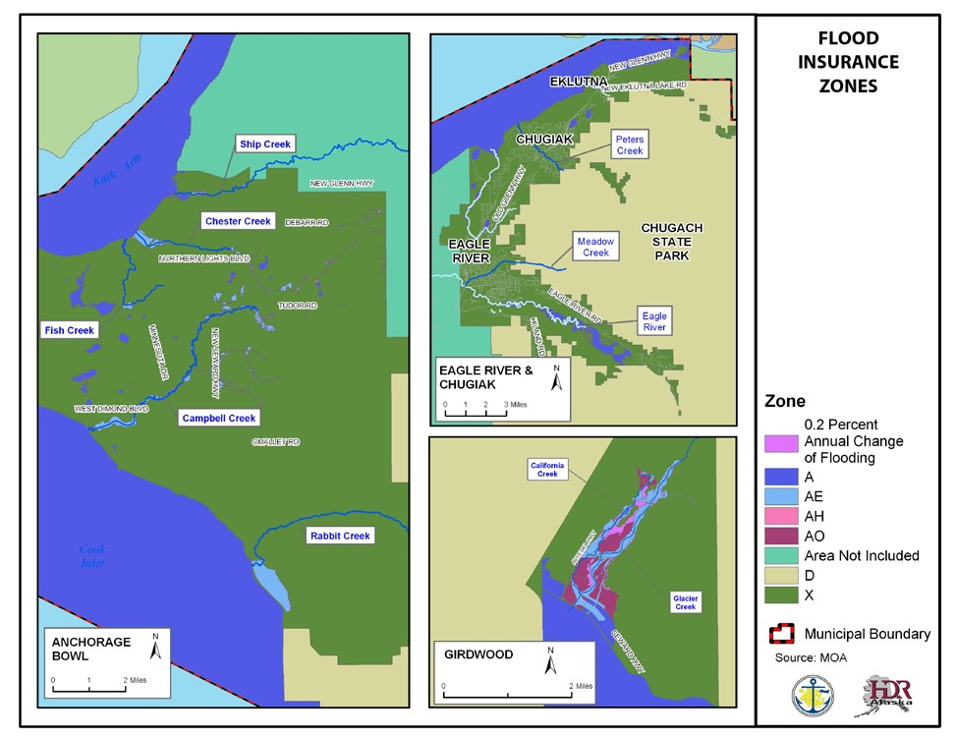

None of the above properties have been identified as a repetitive loss property. A repetitive loss property is defined in the Flood Insurance Manual as a National Flood Insurance Program (NFIP) “insured structure that has had at least two paid flood losses of more than $1,000 each in any 10-year period since 1978.”

Flood Insurance
The Municipality of Anchorage participates in the NFIP, which makes federally backed flood insurance available for all structures, whether or not they are located within the floodplain. Membership within NFIP —and the availability of flood insurance to municipal residents —requires the MOA to manage its floodplain in ways that meet or exceed standards set by FEMA. Federal financial assistance requires the purchase of flood insurance for buildings located within the Special Flood Hazard Area, a requirement that affects nearly all mortgages financed through commercial lending institutions. While the mandatory flood insurance purchase requirement has been in effect in the MOA since 1970, this requirement was often
overlooked by lending institutions. Today, however, all institutions are complying with the applicable flood insurance purchase requirements, and are reviewing all mortgage loans to determine whether flood insurance is required and should have been required in the past. Currently, the MOA has 474 NFIP policies, for a total premium of $320,234. There have been 14 closed paid losses.

The MOA has participated in the NFIP since 1979. The first FIRM became effective in 1979 and the current effective map date is September 25, 2009. The MOA makes PDF versions of the FIRM maps available through their Web site. The web site also has interactive flood maps that can be searched by address. Digital FIRMs are available through FEMA’s Map Service Center. The MOA’s floodplain ordinance exceeds the FEMA and state minimum requirements by having a 1-foot freeboard requirement, prohibiting critical facilities from being located in a floodplain, and prohibiting most types of floodway development. The floodplain permitting process is described in Appendix E.

The MOA has a dedicated floodplain manager, whose primary duty is floodplain management. Currently, the MOA has a Certified Floodplain Manager on staff. The MOA also currently provides the following administrative services: map and records depository, permit review, cooperative technical partners mapping, assistance with letters of map changes preparation, technical and design assistance, and agency coordination. The only change that would improve the effectiveness of the NFIP program would be the addition of more support from the development community and some sectors of the MOA.

The MOA is in good standing with the NFIP and there are no outstanding compliance issues. The most recent Community Assistance Visit or Community Assistance Contact was in 2007 and there are none scheduled or needed at this time.

Community Rating System
The MOA participated in the Community Rating System (CRS); the current CRS class ranking is
6. The CRS Verification Report included in Appendix E describes the categories and activities that provide CRS points. Activities that may improve the class, if any, are included in the mitigation strategy. Flood hazard policy holders within the Municipality receive a 20 percent discount on their premiums, due to MOA’s Flood Hazard Program rating.

4.1.5 AVALANCHE
A snow avalanche is a swift, downhill-moving snow mass. The amount of damage is related to the type of avalanche, the composition and consistency of the avalanche material, the force and velocity of the flow, and the avalanche path.

Avalanche Types
There are two main types of snow avalanches: loose snow and slab. Other types of avalanches include cornice collapse, ice, and slush.

Loose Snow Avalanches
Loose snow avalanches, sometimes called point releases, generally occur when a small amount of uncohesive snow slips and causes additional uncohesive snow to travel downhill. They occur frequently as small, local cold dry ”sluffs” that remove excess snow (involving just the upper layers of snow) and keep the slopes relatively safe. Loose avalanches are often small. Most dry loose snow avalanche do not have enough size to cause damage (American Avalanche Association, 2002). Wet loose snow avalanches, most commonly occurring in the spring, also tend to be small but are more likely to cause damage (American Avalanche Association, 2002). Loose snow avalanches can also trigger slab avalanches.

Loose snow avalanches typically occur on slopes above 35 degrees, and leave behind an inverted V-shaped scar. They are often caused by snow overloading (common during or just after a snowstorm), vibration, or warming (triggered by rain, rising temperatures or solar radiation).

Slab Avalanches
Slab avalanches are the most dangerous types of avalanches. They happen when a mass of cohesive snow breaks away and travels down the mountainside. As it moves, the slab breaks up into smaller cohesive blocks.

Slab avalanches usually require the presence of structural weaknesses within interfacing layers of the snowpack. The weakness exists when a relatively strong, cohesive snow layer overlies weaker snow or is not well bonded to the underlying layer. Weaknesses are caused by changes in the thickness and type of snow cover due to changes in temperature or multiple snowfalls. The interface fails for several reasons. It can fail naturally due to earthquakes, blizzards, temperature changes, or other seismic and climatic causes, or artificially by human activity. When a slab is released, it accelerates, gaining speed and mass as it travels downhill.

The slab is defined by fractures. The uppermost fracture delineating the top line of the slab is termed the “crown surface;” the area above that is called the crown. The slab sides are called the flanks. The lower fracture indicating the base of the slab is called the “stauchwall.” The surface over which the slab slides is called the “bed surface.” Slabs can range in thickness from less than an inch to 35 feet or greater.

Cornice Collapse
A cornice is an overhanging snow mass formed by wind blowing snow over a ridge crest or the sides of a gulley. The cornice can break off and trigger bigger snow avalanches when it hits the wind-loaded snow pillow.

Ice Fall Avalanche
Ice fall avalanches result from the sudden fall of broken glacier ice down a steep slope. They can be unpredictable. They are unrelated to temperature, time of day, or other typical avalanche factors.

Slush Avalanches
Slush avalanches occur mostly in high latitudes. One reason they are more common in high latitudes is because of the rapid onset of snowmelt in the spring. Slush avalanches can start on slopes from 5 to 40 degrees, but usually not above 25 to 30 degrees. The snowpack is totally or partially water-saturated. The release is associated with a bed surface that is nearly impermeable to water. It is also commonly associated with heavy rainfall or sudden intense snowmelt. Additionally, depth hoar is usually present at the base of the snow cover.

Slush avalanches can travel slowly or reach speeds up to more than 40 mph. Their depth is variable as well, ranging from 1 foot to more than 50 feet.

Avalanche Terrain Factors
There are several factors that influence avalanche conditions. The main factors are slope angle, slope aspect, and terrain roughness. Other factors include slope shape, vegetation cover, elevation, and path history. Avalanches usually occur on slopes above 25 degrees. Below 25 degrees, there usually is not enough stress on the snowpack to cause it to slide. Above 60 degrees, the snow tends to “sluff” off and does not accumulate. It is uncommon for avalanches to occur outside this slope angle range.

Slope aspect, also called orientation, describes the direction a slope faces with respect to the wind and sun. Leeward slopes loaded by wind-transported snow are problematic because the wind-deposited snow increases the stress and enhances slab formation. Intense direct sunlight, primarily during the spring months, can weaken and lubricate bonds between snow grains, weakening snowpack. Shaded slopes are potentially more unstable because weak layers are held for a longer time in an unstable state.

Terrain influences snow avalanches because trees, rocks, and general roughness act as anchors, holding snow in place. However, once an anchor is buried by snow, it loses its effectiveness. Anchors make avalanches less likely but do not prevent them unless the anchors are so close together that a person could not travel between them.
Avalanche Impact Pressures Related to Damage
Source Mears 1992.

Avalanche Path
Impact Pressures |  | Potential Damage
Kilopascals (kPa) | Pounds per square foot (Lbs/ft2)
2-4 | 40-80 | Break windows
3-6 | 60-100 | Push in doors, damage walls, roofs
10 | 200 | Severely damage wood frame structures
20-30 | 400-600 | Destroy wood frame structures, break trees
50-100 | 1000-2000 | Destroy mature forests
>300 | >6000 | Move large boulders

The local terrain features determine an avalanche’s path. The path has three parts: the starting zone, the track, and the run-out zone.

The starting zone is where the snow breaks loose and starts sliding. It is generally near the top of a canyon, bowl, ridge, etc., with steep slopes between 25 and 50 degrees. Snowfall is usually significant in this area.

The track is the actual path followed by an avalanche. The track has milder slopes, between 15 and 30 degrees. This is where the avalanche will reach maximum velocity and mass. Tracks can branch, creating successive runs that increase the threat, especially when multiple releases share a run-out zone.

The run-out zone is a flatter area—around 5 to 15 degrees. It is located at the path base where the avalanche slows down, resulting in snow and debris deposition.

The impact pressure determines the amount of damage caused by an avalanche. The impact pressure is related to the density, volume (mass), and velocity of the avalanche.

Location
Avalanches can occur anywhere, but gullies, steep snow-covered slopes, and areas below steep ridges are particularly susceptible. To identify avalanche-prone areas in Anchorage, the Anchorage Snow Avalanche Zoning Analysis was conducted in 1982 by Arthur Mears. This report identified moderate (blue) and high (red) hazard areas, as shown in Figure 4.8.

O. Figure 4.7 Known Avalanche Risk Areas

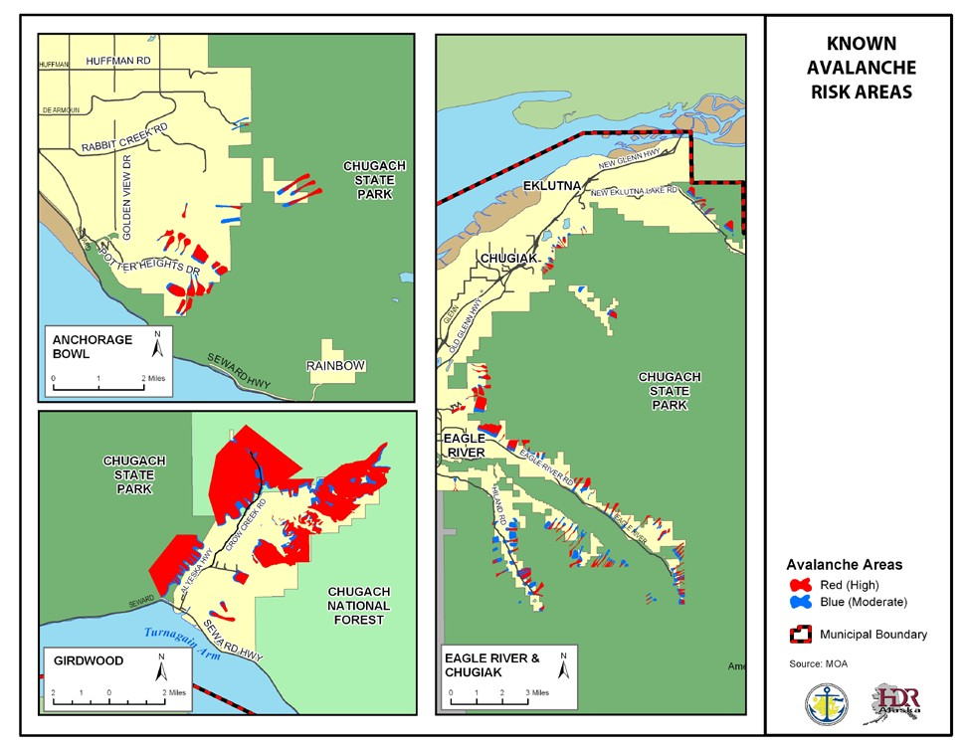
The report describes the red zone as subject to avalanches with a 10-year average return period and the blue zone as prone to avalanches with a 100-year average return period. This means that a 10-year avalanche has a 10% annual probability, while a 100-year event has a 1% probability. Because an average return period is used, a 10-year avalanche has a return period of 3 to 30 years, while a 100-year avalanche has a return period of approximately 30 to 300 years. Events greater than a 100-year avalanche will affect parcels outside the blue zone.

The area with the potential for the largest avalanches is the Girdwood/Crow Creek area. Evidence of snow avalanches is prominent along the mountainsides above the Girdwood valley. The western mountainside has high and moderate avalanche danger from Turnagain Arm to California Creek. Avalanche hazard is moderate to high on the eastern mountainside at the head of the valley, near the day lodge and resort area, and southeast of Virgin Creek. Alyeska’s daylodge and day parking are located partially in both the moderate and high avalanche hazard areas. Part of the original base area hotel and condos are in a moderate hazard area.

Other areas south of the Anchorage Bowl that may experience avalanches are Bird Creek, Indian, and Rainbow. North of the Anchorage Bowl, the areas near the South Fork of Eagle River, Eagle River, Peters Creek (especially near what is locally known as 4-mile), and Mirror Lake/N.W. Spur of Mt. Eklutna have avalanche potential. For more details, please refer to the Anchorage Snow Avalanche Zoning Analysis.

Another avalanche-prone area is the Seward Highway between the flats near Bird Point and the entrance to the Girdwood Valley (CSAC, 2004). This may be one of the most dangerous stretches of highway for avalanches due to traffic volume. In this area, avalanches have caused numerous accidents, killed at least five people, and caused other deaths from drowning by sweeping people into Turnagain Arm (CSAC, 2004).

Likelihood of Occurrence
Multiple avalanches occur every year, but they usually occur in more remote areas. The number and location depends on the conditions —the formation of weak layers in the snow, wind loading, terrain, etc. On a large scale, avalanches are hard to predict because winter conditions change and can vary from hour to hour.

Historic Events
The most remembered avalanches in recent history are those associated with the 2002 winter storms. Those avalanches resulted in road and rail access to Girdwood being blocked, disruption of electrical service, property damage, and the death of a heavy equipment operator who was clearing debris from an earlier avalanche off the Seward Highway.

2000 Central Gulf Coast Storm - Federal Disaster 1316
In December 1999 and January 2000, a series of severe winter storms triggered avalanches and flooding throughout Southcentral Alaska. Anchorage was one of many jurisdictions included in a Federal Disaster Declaration. In Anchorage, damage from this event included one fatality, property damage, disruption of electrical service, and interruption of rail and road access south of the Potter Weigh Station.

The section of New Seward Highway from Bird Point to Girdwood is very avalanche-prone. Between 1951 (when the Seward Highway opened, and 1998) avalanches have blocked the road at least 485 times and have been a factor in more than 60 accidents (CSAC, 2004). In 1998, a six-mile stretch of highway was relocated (from mountainside to a new sea-level route) and was expected to reduce avalanche danger by approximately 70 percent. See Table 4.20 for additional historic avalanche events.

EE. Table 4.20 Known Historic Avalanche Events

Date | Description
February 13, 2010 | An avalanche near Mile 7.3 of Hiland Road in Eagle River resulted in a cross- country skier being fatally injured.
March 25, 2009 | An avalanche hit an ARRC freight train approximately 5-20 miles south of Portage. Several of the rail cars were buried by the avalanche but there were no fatalities.
January 3, 2006 | An avalanche on Ragged Top Mountain near Girdwood, Resulted in fatal injuries to a skier.
February 9, 2006 | A snowshoer was fatally injured on Flat Top Mountain.
February 28, 2004 | A cornice gave way on Bryon Glacier Peak, near Portage, and triggered an avalanche resulting in the death of a mountain climber.
January 22, 2004 | A block of ice slide off the roof of a Forest Service warehouse near Portage and killed a Forest Service employee.
November 11, 2003 | A self-triggered slab avalanche occurred in the Chugach State Park on Triangle Peak near the head of the South Fork of the Eagle River Valley. One man was partially buried but his two companions were able to dig him out.
April 1, 2002 | An avalanche occurred on the south side of Mount Magnificent, killing two snowshoers. A third man was caught in the avalanche but was able to free himself. The avalanche triggered other slides in the area.
March 28, 2002 | Two backcountry skiers and two dogs triggered an avalanche in the south bowl of Three Bowl Path near Mile 6.6 of Hiland Road in Eagle River. One skier was buried under 4 feet of debris and was rescued by the other skier. The following day, while searching for the dogs, a rescuer triggered another slide that hit a house. The slide damaged the fence but not the house; however, there were several feet of debris against the back wall.
November 11, 2000 | On the North Gully of Flat Top Mountain, in Chugach State Park, one person was severely injured when he was caught by a small slab avalanche.
February 1, 2000 | Avalanche near Bird Flats on the Seward Highway. An Alaska Railroad employee who was helping clear previous slides from the highway was killed when the avalanche struck the bulldozer he was operating. Three avalanches occurred that day. This specific avalanche occurred at the Five Fingers chute, and was estimated to have crossed the highway at between 100 and 125 miles per hour. Slides also occurred at Mile 5.7 on the Eklutna Lake Road, Mile 7.5 of the Old Glenn Highway, and the Glenn Highway at Mile 95.
 | Late 1999 and early 2000 saw avalanches in Cordova, Valdez, Anchorage, Whittier, Cooper Landing, Moose Pass, Summit, Matanuska-Susitna Valley, and Eklutna from the Central Gulf Coast Storm.
January 25, 2000 | An avalanche occurred in the High Traverse area of Alyeska Resort. All skiers in the area were accounted for.
March 1999 | An avalanche at Alyeska Resort partially buried two skiers. This was the first time in 25 years that an avalanche hit skiers at the resort.
December 7,1997 | One woman was killed in a self-triggered soft slab avalanche while hiking on the Crow Pass Trail. Her companion was not caught by the avalanche but was unable to locate her.
April 1997 | There was a series of avalanches between April 5th and 11th that involved skiers, climbers, and snowmachiners. A snowmachiner was killed in one of those accidents.  http://www.sarinfo.bc.ca/Library/Rescues/girwood.AK
1987-88 | Several (34) avalanches reached the Seward Highway. Some of the avalanches resulted in temporary highway closures and downed power poles. One avalanche, near Super Scooper (MP 94), struck a vehicle on the highway.
January 1980 | Near MP 94, in a chute called Super Scooper, an avalanche hit a vehicle and derailed 4 locomotives and 13 cars of a freight train. Later that winter, avalanches blocked the road again, closing it for 4 days.
March 1979 | A series of storms near Bird Hill caused 24 avalanches over several weeks. One slide, with 33 separate tongues, buried 2 miles of highway, closing it for 3 days.
1978 | Seward Highway was blocked at least 17 times. One series of slides trapped 20 cars on Bird Hill. Another slide, near MP 99, hit one car and took high voltage lines off 13 poles.
1959-60 | The Seward Highway was blocked by avalanches at least 81 times because of frequent blizzards in the Bird Hill area.
1952 | On the Girdwood Flats near MP 91.8, an avalanche hit several cars on the highway. One person got out of their vehicle and was hit by a second slide and subsequently died.
1920 | Near MP 91, an avalanche buried an Alaska Railroad train. As the train’s occupants started to dig themselves out, the train was struck by a second slide. This slide buried 25 people and 4 killed others. It has been reported that several people were swept into Turnagain Arm and drowned.
1918 | An avalanche near the present Seward Highway MP 92 killed several draft horses and knocked a telegraph pole over.

Additional avalanche events are listed in Mears, 1993 and Mears, 1982.

Vulnerability
Avalanche vulnerability is calculated using the areas in the MOA’s avalanche GIS file (shown in Figure 4.10). The number of parcels in a high-risk avalanche area is shown in Table 4.21, while those in a moderate-risk area are shown in Table 4.22. Only a portion of these parcels are likely to be impacted by a given avalanche event. Other development including above ground utility lines can also be vulnerable to avalanches.

Avalanches have the ability to cause injury and death to people in the impacted area. With the average household size in the MOA being 2.65, the 24 residential parcels there is approximately 64 people living in an area with a known avalanche risk. Most avalanche related fatalities involve outdoor recreationalists such as back country skiers, snowboarders and snowmachiners but not exclusively. Many times, the victim triggers the avalanche. Other people such as passing motorists can also be at risk. Avalanches have the ability to destroy buildings, cover buildings and roads with snow and debris. They can also take down utility lines.

Historically, avalanches have caused the closure of the Seward Highway isolating Girdwood from the rest of the MOA. The avalanche hazard may increase road maintenance costs. Depending on the conditions, more avalanche mitigation measures may be needed.

FF. Table 4.21 High Avalanche Hazard Area Vulnerability

Land Use:  Anchorage | # of Parcels | Taxable Value (Land) | Taxable Value (Buildings) | Total
Residential | 1 | 48600 | 285600 | 334200
Commercial | 0 | 0 | 0 | 0
Industrial | 0 | 0 | 0 | 0
Institutional | 0 | 0 | 0 | 0
Parks | 0 | 0 | 0 | 0
Transportation | 0 | 0 | 0 | 0
Other | 0 | 0 | 0 | 0
Vacant | 25 | 4641600 |  | 4641600
Watershed | 10 | 0 | 0 | 0
Total | 36 | 4690200 | 285600 | 4975800
Land Use:  Chugiak/Eagle River | # of Parcels | Taxable Value (Land) | Taxable Value (Buildings) | Total
Residential | 97 | 11521400 | 25484800 | 37006200
Commercial | 0 | 0 | 0 | 0
Industrial | 0 | 0 | 0 | 0
Institutional | 4 | 0 | 0 | 0
Parks | 0 | 0 | 0 | 0
Transportation | 0 | 0 | 0 | 0
Other | 10 | 0 | 0 | 0
Vacant | 74 | 8475900 |  | 8475900
Watershed | 67 | 0 | 0 | 0
Total | 252 | 19997300 | 25484800 | 45482100
Total | 252
Land Use:  Girdwood | # of Parcels | Taxable Value (Land) | Taxable Value (Buildings) | Total
Residential | 31 | 1339400 | 3202500 | 4541900
Commercial | 12 | 5402700 | 1133400 | 6536100
Industrial | 1 | 459900 | 185000 | 644900
Institutional | 0 | 0 | 0 | 0
Parks | 0 | 0 | 0 | 0
Transportation | 0 | 0 | 0 | 0
Other | 11 | 0 | 0 | 0
Vacant | 15 | 861800 | 0 | 861800
Watershed | 2 | 0 | 0 | 0
Total | 72 | 8063800 | 4520900 | 12584700
Source: MOA GIS, 2016

GG. Table 4.22 Moderate Avalanche Hazard Area Vulnerability

Land Use:  Anchorage | # of Parcels | Taxable Value (Land) | Taxable Value (Buildings) | Total
Residential | 9 | 712,400 | 3,001,900 | 3,714,300
Commercial | 0 | 0 | 0 | 0
Industrial | 0 | 0 | 0 | 0
Institutional | 2 | 1981900 | 0 | 1981900
Parks | 0 | 0 | 0 | 0
Transportation | 0 | 0 | 0 | 0
Other | 0 | 0 | 0 | 0
Vacant (residential) | 34 | 5,500,500 | 0 | 5,500,500
Watershed | 8 | 3415700 | 0 | 3415700
Total |  | 11610500 | 3001900 | 14,612,400
Land Use:  Chugiak/Eagle River | # of Parcels | Taxable Value (Land) | Taxable Value (Buildings) | Total
Residential | 270 | 30,820,800 | 73,422,300 | 104,243,100
Commercial | 0 | 0 | 0
Industrial | 0 | 0 | 0 | 0
Institutional | 4 | 2901100 |  | 2901100
Parks | 3 | 7108500 | 0 | 7108500
Transportation | 0 | 0 | 0 | 0
Other | 19 | 38477300 |  | 38477300
Vacant | 137 | 20,188,100 |  | 20,188,100
Watershed | 74 | 26480200 | 2938500 | 29418700
Total | 507 | 125,976,000 | 76,360,800 | 202,336,800
Land Use:  Girdwood | # of Parcels | Taxable Value (Land) | Taxable Value (Buildings) | Total
Residential | 15 | 4461700 | 6363400 | 10825100
Commercial | 12 | 5781400 | 1458000 | 7239400
Industrial | 0 | 0 | 0 | 0
Institutional | 0 | 0 | 0 | 0
Parks | 0 | 0 | 0 | 0
Transportation | 0 | 0 | 0 | 0
Other | 3 | 0 | 0 | 0
Vacant | 18 | 1745000 |  | 1745000
Watershed | 1 | 0 | 0 | 0
Total | 49 | 11988100 | 7821400 | 19809500
Source: MOA GIS, 2016

4.1.6 LANDSLIDE/GROUND FAILURE
Ground failure is a general term used to describe hazards that affect the stability of the ground. It can occur in many different ways, including landslides, land subsidence, and failures related to seasonally frozen ground and permafrost. Frequently, ground failure occurs as the result of another hazard such as an earthquake or volcanic eruption. Seismically- induced ground failure is a major concern in the MOA.

Ground failure tends to cause more property damage than injuries or fatalities. Property damage can occur to buildings and infrastructure such as buried pipes. Ground failure can cause damage to the transportation system including roads, bridges, and railroads. Areas threatened by ground failure may have lower real estate values which can result in lower property tax revenue.

Landslides
Landslide is a generic term for a variety of downslope movements of earth material under the influence of gravity. Some landslides occur rapidly, in mere seconds, while others might take weeks or longer to develop.

It is hard to identify high and moderate zones of hazard intensity for different types of landslides. For example, hazard zones for rock falls can’t be identified because the risk depends on the size of the rocks involved. It is known that the bluff near Points Campbell and Woronzof is a “narrow zone of very unstable material with a strong risk of landslide” (Mason, 1997: 198-199). The area near Campbell Lake has a high risk of landslides (Mason, 1997). “Debris flows occur in small, steep drainage basins throughout the” Glacier/Winner Creek area (Mears, 1993:13).

Landslides can occur naturally or be triggered by human activities. They occur naturally when inherent weaknesses in the rock or soil combine with one or more triggering events such as heavy rain, snowmelt, changes in groundwater level, and seismic or volcanic activity. Landslides can be caused by long-term climate change that results in increased precipitation, ground saturation, and a rise in groundwater level, which reduces shear strength and increases the weight of the soil. Erosion that removes material from the base of a slope can also trigger landslides.

Human activities that trigger landslides are usually associated with construction, such as grading that removes material from the base, loads material at the top, or otherwise alters a slope. Changing drainage patterns, groundwater level, slope, and surface water (for example, the addition of water to a slope from agricultural or landscape irrigation, roof downspouts, septic-tank effluent, or broken water or sewer lines) can also cause landslides.

Three main factors that influence landslides are topography, geology, and precipitation. Topography and geology are associated with each other; the steeper the slope, the greater the gravitational influence. Rock strength is important, as certain bedrock formations or rock types appear to be more prone than others to landsliding. Precipitation may erode and undermine slope surfaces. When precipitation is absorbed into the ground, it increases the pore water pressure and lubricates weak zones of rock or soil.

Secondary Effects
Landslides are often associated with other hazards. For example, a landslide may occur during floods because both involve precipitation, runoff, and ground saturation. Landslides are often associated with seismic and volcanic events. It has been estimated that ground failure, not shaking, caused most of the damage in the Good Friday Earthquake in Alaska.

The secondary effects of landslides can extend the damage past the limits of the actual landslide. For example, a landslide that dams a river or creek can cause damage upstream due to flooding and downstream due to flooding that may result from a sudden break in the dammed river. Landslides can also trigger tsunamis and seiches.

Seismically Induced Ground Failure
In 1979, a Geotechnical Hazards Assessment Study was developed to “inventory all significant geotechnical data with respect to geologic hazards, to analyze the data to provide an indication of the degree of hazard, and to designate those areas of potential hazards upon a series of maps” (Harding-Lawson, 1979:3).

Most landslides caused by the 1964 earthquake fall into two categories: “(1) deep, translational block-type landslides on sub-horizontal shear surfaces, and (2) shallower, more disrupted slides and slumps, on more steeply dipping shear surfaces, along coastal and stream bluffs and other steep slopes” (USGS, 2009). The translational block slides occurred mostly in the downtown and Turnagain Heights areas. These areas tend to have thick (over 30 feet) layers of Bootlegger Cove Formation clay. The shallower slides generally occurred in coastal areas and stream bluffs. The following figures show the seismic landslide hazard for deep translational landslides associated with great subduction zone earthquakes with return periods between approximately 300 and 900 years, shallow landslides with a 2 percent probability of exceedance in 50 years, and shallow landslides with a 10 percent probability of exceedance in 50 years.
The United States Geologic Survey (USGS) recently completed a report on seismic landslide hazards in the Anchorage Bowl (Jobson and Michael, 2009). According to this report, a large portion of the Anchorage Bowl has a low hazard but areas with moderate, high, and very high potential exist.

P. Figure 4.8 Seismic Landslide Hazards

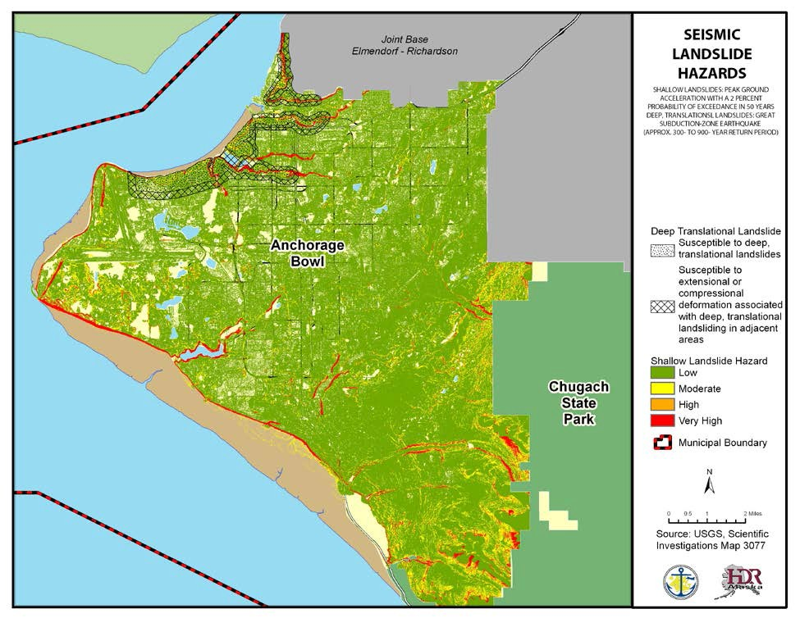
As Figure 4.9 shows, the areas most likely for a deep translational landslide are Turnagain Heights, Downtown, Government Hill, and along the western portion of Chester Creek and Ship Creek. The areas most likely for shallow landslides are “steeper slopes, principally along coastal and stream bluffs and steep slopes bounding some glacial hills” (Westin and others, 2007). Areas that have high and very high shallow landslide hazard include the Government Hill, along Chester Creek, along the Turnagain and Knik Arms, and Campbell Lake. For a map showing the shallow landslide hazard for an event with a 10 percent probability of exceedance in 50 years (a return period of 475 years), please see http://pubs.usgs.gov/sim/3077/downloads/3077_sheet2.pdf

The Chugiak/Eagle River and Turnagain Arm areas were not included in this report. While landslides are possible in these areas, additional research is needed

Land Subsidence

Land subsidence is any sinking or downward settling of the Earth's surface. Common causes of land subsidence in Alaska are sediment compaction and seismic or volcanic activity.

Based on previous experience, the Portage and Girdwood areas are susceptible to subsidence.

Seasonally Frozen Ground
Frost action is the seasonal freezing and thawing of water in the ground and its effect on the ground and development. Frost heave is when ice formation causes an upward displacement of the ground. When the ground ice thaws, the ground loses bearing strength and its ability to support structures is weakened. This is a widespread problem in Alaska.

Likelihood of Occurrence
Ground failure events are difficult to predict, as many of them are triggered by other events such as earthquakes.

Historic Events
The 1964 Good Friday earthquake triggered a wide variety of falls, slides, and flows through Southcentral Alaska. The Anchorage area was heavily impacted because of Bootlegger Cove clay failures. Some of the more significant events occurred at 4th Avenue, L Street, Government Hill, and Turnagain Heights. Several less-devastating slides occurred throughout town, including slides at Point Woronzof and Potter Hill.

The Government Hill slide was a complex movement. Government Hill Elementary School was severely damaged by the translational slide. The south wing of the school dropped about 30 feet, while the east wing split lengthwise and collapsed. Part of this slide became an earth flow that spread 150 feet across the flats into the Alaska Railroad yards. Anchorage All-Hazards Mitigation Plan Update
The Turnagain Heights landslide is also considered a complex movement. In fact, it was probably the most complex of all the Anchorage landslides associated with the Good Friday earthquake. The landslide likely began as a block slide, but evolved to include lateral spreading, slumping, and possibly other types of movement. This landslide caused serious damage to a housing development, in which three people died.

The earthquake caused at least one rock avalanche as a slab of rock became detached from the mountain peak overlooking Sherman Glacier. The rock slab disintegrated as it moved downhill, enabling it to reach high velocity and extend a great distance over the glacier.
Rockslides were also triggered, including “one relatively significant event in the Winner Creek drainage” (Mears, 1993:12).

Extensive subsidence also occurred as a result of the 1964 Good Friday earthquake. The zone of subsidence covered about 110,039 square miles, including the north and west parts of Prince William Sound, the west part of the Chugach Mountains, most of Kenai Peninsula, and almost all the Kodiak Island group. Some areas experienced subsidence that exceeded seven feet, but most areas subsided less. For example, part of the Seward area is about 3.5 feet
lower than before the earthquake and portions of Whittier subsided more than five feet. The village of Portage, at the head of Turnagain Arm of Cook Inlet, experienced six feet of tectonic subsidence during the earthquake.

Vulnerability
An earthquake could cause seismically induced landslide. For information about earthquakes, please see Section 4.1. The susceptibility for seismically induced ground failure has been determined only for the part of the Municipality shown in Figure 4.9. Table 4.23 shows the parcels that are susceptible to a deep, translational landslide while Table 4.24 shows the parcels that are susceptible to deformation associated with deep, translational landslides in adjacent areas. A similar calculation could not be conducted to identify the vulnerability to the shallow landslide hazard as the file format did not permit this analysis. Based on an average MOA household size of 2.65, there is approximately 5,955 people living areas that are vulnerability to deep, translational landslides and an additional 3,729 living in the adjacent areas. Infrastructure, including buried pipes, are vulnerable to ground failure.

HH. Table 4.23 Deep, Translational Landslide Vulnerability

Land Use | # of Parcels | Taxable Value (Land) | Taxable Value (Buildings) | Total
Residential | 2339 | 433511900 | 637984400 | 1071496300
Commercial | 419 | 223303600 | 451056700 | 674360300
Industrial | 48 | 49107700 | 44055800 | 93163500
Institutional | 43 | 74470000 | 77213700 | 151683700
Open Space | 12 | 3164300 | 271500 | 3435800
Transportation | 0 | 0 | 0 | 0
Other | 3 | 0 | 0 | 0
Vacant | 22 | 0 | 0 | 0
Total | 2886 | 783557500 | 1210582100 | 1994139600
Source: MOA GIS, 2016

II. Table 4.24 Deformation in Adjacent Areas Vulnerability

Land Use | # of Parcels | Taxable Value (Land) | Taxable Value (Buildings) | Total
Residential | 1350 | 189932800 | 320803700 | 510736500
Commercial | 700 | 362166700 | 879711300 | 1241878000
Industrial | 80 | 72405800 | 123638800 | 196044600
Institutional | 59 | 39055100 | 32231200 | 71286300
Open Space | 9 | 2814000 | 0 | 2814000
Transportation | 0 | 0 | 0 | 0
Other | 4 | 0 | 0 | 0
Vacant | 32 | 0 | 0 | 0
Total | 2234 | 666374400 | 1356385000 | 2022759400
Source: MOA GIS, 2016

4.1.7 VOLCANIC ASHFALL
According to the Alaska Volcano Observatory (AVO), a volcano is “a vent in the surface of the Earth through which magma and associated gases and ash erupt; also, the form or structure (usually conical) that is produced by the ejected material” (AVO www.avo.alaska.edu, undated). Alaska is home to over 130 volcanoes with 90 of them being active in the last 10,000 years and over 50 have been active since approximately 1760. None of these volcanoes are located within the MOA (see Figure 4.10). Because of the distance between any volcano and the MOA, the MOA will not be likely be directly affected by most elements of a volcanic eruption that occurs in Alaska; with the exception of ash fall.

Q. Figure 4.9 Volcanoes

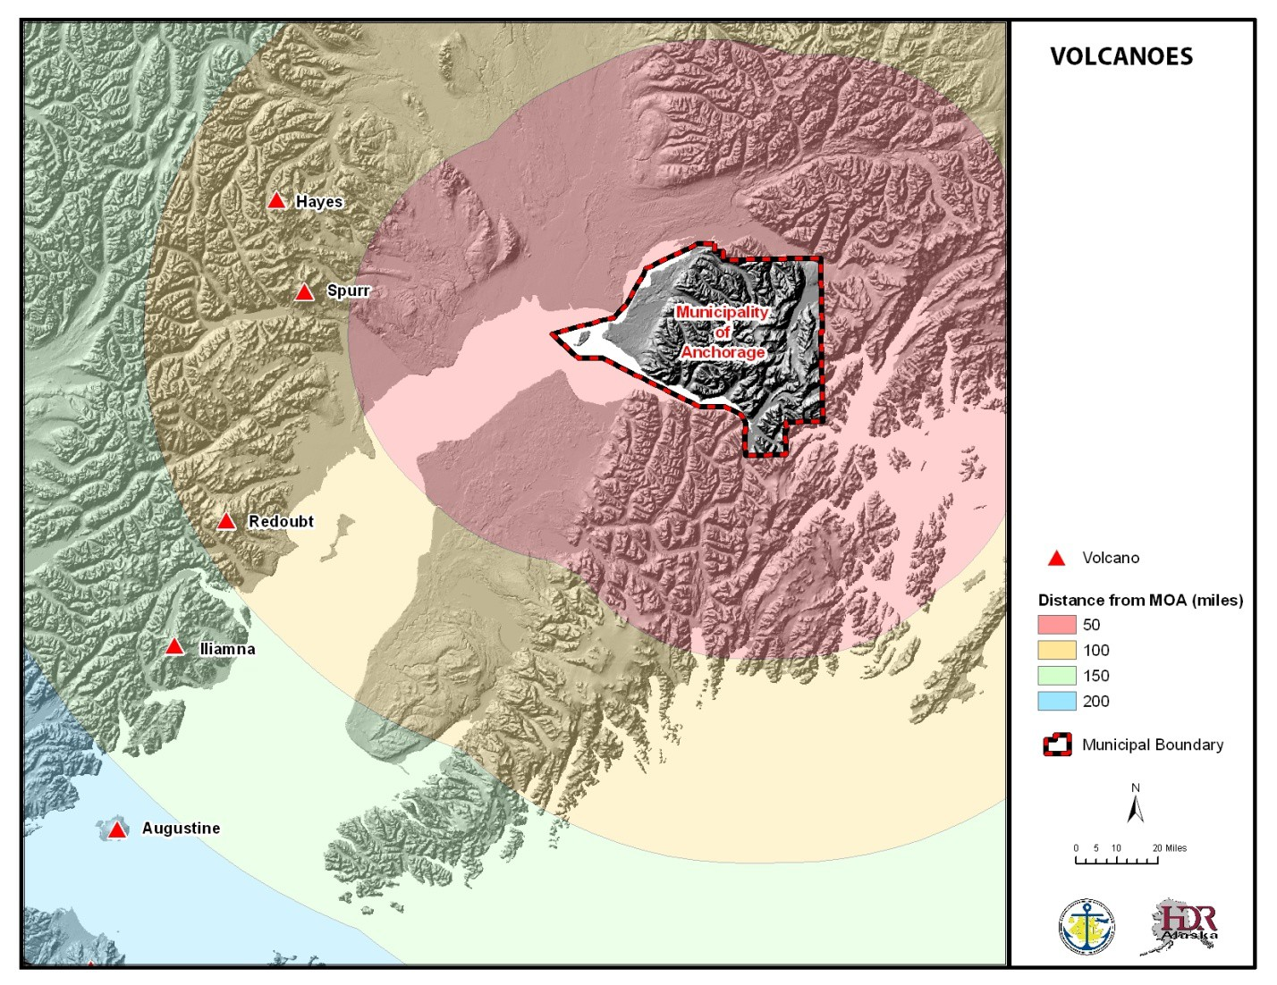

There are a variety of hazards associated with a volcanic eruption, but the primary hazard to the MOA is volcanic ash fall. Volcanic ash consists of small jagged pieces (less than 1/12 inch in diameter) of rocks, minerals, and volcanic glass sent into the air by a volcano (Kenedi and others, 2000). Volcanic ash is created during an explosive volcanic eruption. Alaska’s volcanic activity is dominated by explosive volcanism.

Volcanic ash can accumulate on roof tops, power lines or other structures causing them to collapse. Wet ash can conduct electricity and may cause short circuits or the failure of electrical components. Ash fall may interfere with telephone and radio communications. Ash can also interfere with the operation of mechanical equipment, including aircraft. In Alaska, this is a major problem, as many major flight routes are near historically active volcanoes; the main airport for the MOA and all of Alaska, the TSAIA along with Merrill Field, and JBER
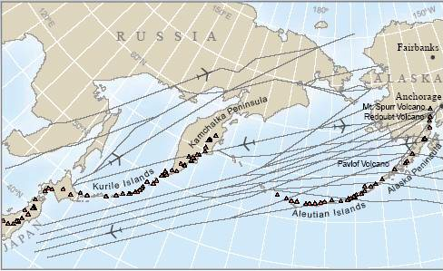
Elmendorf AFB air
R. Figure 4.10 Flight Routes

facilities, are all at risk from volcanic ash fall. Ash falling or resuspended can also reduce visibility and make roads and runways slippery making transportation difficult. Ash may be a health risk especially to people with cardiac or respiratory conditions, children and the elderly. Ash is abrasive and can
Alaska’s volcanoes and a schematic depiction of selected major North Pacific and Russian Far East air routes. SOURCE: AVO
injure eyes (Kenedi and others, 2000).

Based on proximity, the volcanoes that are most likely to result in ash fall in the MOA are the five Cook Inlet Volcanoes, Hayes, Spurr, Redoubt, Iliamna and Augustine (figure 4.11). Of these, Augustine is considered the most historically active volcano in the Cook Inlet region (Wallace and others, 2010). For more information about these volcanoes, please see the respective volcano hazard report available on the AVO website at http://www.avo.alaska.edu/downloads/classresults.php?pregen=haz

Location
The entire MOA could be impacted by a volcanic ash event. Different areas of the MOA may be impacted by any given event depending on which volcano erupts, wind direction, and duration of the eruption. Due to the prevailing winds, the MOA could receive ash fall from any Cook Inlet volcano depending on wind conditions at the time of the eruption (Waythomas and others, 1997; Waythomas and Waitt, 1998). Recent lake-core studies in the Anchorage area indicate that Mount Spurr volcano is the most prolific source of ash fall in the MOA over the last 12,000 years (Wallace and others, 2010). It is also possible that ash could reach the MOA from a large eruption outside of the Cook Inlet region.

Likelihood of Occurrence
Volcanic activity that poses a risk to aircraft or local populations in Alaska is infrequent. The AVO actively monitors Alaska’s volcanoes for signs of unrest. AVO is also responsible for issuing warnings of eruptions or activity that may lead to an eruption.

The MOA is more likely to experience ash fall from Spurr, Redoubt, and Augustine volcanoes because of the proximity of the MOA to these sources upwind. Based on geologic studies of the Cook Inlet volcanoes, Spurr, Redoubt, and Augustine are considered more frequently active than Hayes or Iliamna volcanoes, According to the USGS, “large-volume, explosive, ash-forming eruptions of Iliamna are probably unlikely in the future but significant disruptive small eruptions could occur (Waythomas and Miller, 1999). Hayes Volcano appears to be largely inactive in the past few thousand years and historical eruptions are unknown (USGS, 2002). However, the largest ash fall event in the MOA in the late Holocene occurred from Hayes Volcano (3,700–4,200 years ago).

Historic Events
In its nearly 100 years of existence, Anchorage has dealt with ash from historical eruptions of Spurr, Redoubt, and Augustine volcanoes. Additional information about these eruptions can be found in the respective Volcano-Hazard Assessments.

Spurr Volcano
In 1992, a series of three ash-producing eruptions occurred from Crater Peak, the active vent on Spurr Volcano. Ash fall from one of the three events occurred in the MOA (August 18) and triggered a disaster declaration. Approximately 0.12 inches (3 mm) of sand-sized ash fell in the MOA. The eruption caused health problems and property damage. Economic losses resulted from businesses, schools, and industrial facility closures. Cars, computers, and other electronic devices were damaged. TSAIA was closed for 20 hours. Two people had heart attacks while shoveling ash (Waythomas and Nye, 2002). Numerous air-quality alerts were issued for days following the ash-fall event due to resuspension of the ash deposit and air- quality was a concern until the first snow in the fall (Waythomas and Nye, 2002).

The only other historical eruption of Mount Spurr, was in July 1953. Ash from this eruption reached the MOA and deposited about twice as much ash as in 1992 (Waythomas and Nye, 2002).

Redoubt Volcano
The most recent eruption of Redoubt occurred in 2009 and produced at least 19 ash- producing explosions between March 22 and April 4 (Wallace and Schaefer, 2009). Only one such explosion on March 28 resulted in trace (< 0.8 mm or 0.031 in) ash fall in the MOA. Ash- fall impacts to the MOA were relatively minor due to the short duration (<1 hour) of ash fall and occurrence during winter months where the ash quickly mixed with snow on the ground preventing significant resuspension. Economic losses due to disruptions to airline travel were however, significant and the TSAIA was closed for 22 hours (March 28) and numerous flights were cancelled or rerouted throughout the eruption (Wallace and Schaefer, 2009).

Redoubt Volcano also erupted in 1989–1990 during which some 20 ash-producing explosions occurred (Scott and McGimsey, 1994). Ash fall in the MOA occurred on 3 occasions depositing trace amounts of ash (<0.8 mm or 0.031 in). The most serious impacts were economic losses due to disruptions to airline travel and the KLM Boeing 747-400 jet aircraft that temporarily lost power when it encounter the a diffuse volcanic ash plume causing millions of dollars in damage . The volcanic ash cloud affected flights from TSAIA, Merrill Field, and Elmendorf Air Force Base. As a result of eruption, the lost revenue to TSAIA is estimated at $2.6 million (Waythomas and others, 1997). The volcanic ash resulted in some school and business closures. Some people experienced respiratory problems from inhaling fine ash particles.

Augustine Volcano
The most recent eruption of Augustine occurred in 2006 when 13 major ash-producing explosions occurred between January 11 and mid-March. This was the fifth major eruption in 75 years (Power and others, 2010). Impacts from this event were considered minor with the biggest economic losses associated with cancelled, diverted, and rescheduled flights to avoid possible exposure to ash (Neal and others, 2010). The level of respirable particulate matter in the air within the MOA was reportedly elevated on several days during the eruption but did not exceed Environmental Protection Agency (EPA) standards (Wallace and others, 2010).
There is no known significant property damage or adverse health affects associated with this eruption (Neal and others, 2010).

The 1986 eruption of Augustine (March-April) deposited trace (<0.8 mm or 0.031 in) amounts of ash in the MOA and caused significant disruptions to air traffic. A dome formed in the crater and caused some to fear it would subsequently collapse and trigger a tsunami along the east shore of Cook Inlet, as occurred in 1883. This eruption caused flights to and from TSAIA to be cancelled and military aircraft were evacuated from Elmendorf Air Force Base. The level of respirable particulate matter in the air within the MOA was elevated for several days in late March but remained just below the health emergency threshold (EPA national standard), although some sensitive people experienced respiratory problems. Many schools and businesses were temporarily closed (Swanson and Kinele, 1988).

A significant eruption also occurred in 1976 and produced ash plumes during January, February, and April. Minor ash fall (0.6 in or 1.5 mm) occurred in the MOA on January 24–25 (Shackelford, 1978). Advisories to remain indoors were issued and many schools and businesses were closed in the MOA. Some people experienced respiratory problems and visibility in some locations was reduced to about 300 feet (100 meters or less) (Waythomas and Waitt, 1998). Ash was ingested by the equipment at the Beluga power plant, the primary power supply for Anchorage (Swanson and Kinele, 1988).

Vulnerability
Because the ash from a volcanic eruption could affect the entire Municipality, the entire MOA is represented in Table 4.32. In general, weather patterns and wind direction during an eruption will influence where ash fall occurs. Air transportation is particularly vulnerable to volcanic ash clouds as these clouds can travel great distances and cover broad areas. Ash may lead to increased traffic accidents as it reduces visibility and can make roadways slippery (IVHHN, unknown). Disruptions to the transportation system may cause delayed shipments of goods into the area.

Ashfall can disrupt power service. Power generation facilities may close to prevent equipment damage. As wet ash is conductive, equipment may need to be shut down to be properly cleaned or serviced (USGS, 2009a). Ash can contaminate water supplies making them unsafe to drink (IVHHN, unknown). Volcanic ash can cause changes in water quality (turbidity, acidity, and chemistry), increased wear on water delivery and treatment systems and high demand for water during cleanup activities (USGS 2009). Building roofs may collapse under the weight of the ash (IVHHN, unknown). In addition, volcanic ash also poses a health risk to people especially those cardiac or respiratory conditions such as asthma and emphysema (IVHHN, unknown). Volcanic ash can also cause eye irritation and skin irritation (IVHHN, unknown).

JJ. Table 4.25 Volcanic Ash Vulnerability

Land Use | # of Parcels | Taxable Value (Land) | Taxable Value (Buildings) | Total
Residential | 75024 | 8526159300 | 17756156200 | 26282315500
Commercial | 4065 | 2568664400 | 4512337400 | 7081001800
Industrial | 2597 | 1494944600 | 1907337000 | 3402281600
Institutional | 1035 | 1215398400 | 1554183700 | 2769582100
Open Space | 44 | 24995700 | 503000 | 25498700
Transportation | 664 | 0 | 0 | 0
Other | 562 | 377462100 | 36697800 | 414159900
Vacant | 228 | 0 | 0 | 0
Total | 84219 | 14207624500 | 25767215100 | 39974839600
Source: MOA GIS, 2016

4.1.8 EROSION
Erosion is a process that involves the wearing away, transportation, and movement of land. Erosion rates can vary significantly because erosion can occur quite quickly as the result of a flash flood, coastal storm, or other event. It can also
Bluff erosion occurs when water runs off the land, forming gullies. It is also caused by wave action at the toe of the bluff or when a bluff collapses under the weight of a heavy snow or rainfall.

Beach erosion occurs when wave action removes the light sand.
occur slowly, as the result of long-term environmental changes. Erosion is a natural process, but its effects can be exacerbated by human activity.

Erosion rarely causes death or injury. However, erosion causes the destruction of property, development, and infrastructure. In Alaska, coastal erosion is the most destructive, riverine erosion a close second, and wind erosion a distant third.

Classifying erosion can be difficult, as there are multiple terms used to refer to the same type of erosion. For example, riverine erosion may be called stream erosion, stream bank erosion, or riverbank erosion, among other terms. Coastal erosion is sometimes referred to as tidal erosion. Sometimes bluff erosion is included in coastal erosion; other times they are considered two separate processes. The same goes for beach erosion. For this plan, coastal erosion encompasses bluff and beach erosion, while riverine erosion will be considered synonymous with stream erosion, stream bank erosion, and riverbank erosion.

Coastal Erosion
Coastal erosion is the wearing away of land, through natural activity or human influences, that results in loss of beach, shoreline, or dune material. Coastal erosion occurs over the area roughly from the top of the bluff out into the near-shore region, to about the 30-foot water depth. It is measured as the rate of change in position or the horizontal displacement of a shoreline over a period of time. Bluff recession is the most visible aspect of coastal erosion because it causes dramatic in the landscape. As a result, this aspect of coastal erosion usually receives the most attention.

On the coast, the forces of erosion are embodied in waves, currents, and wind. Surface and ground water flow, and freeze-thaw cycles may also play a role. Not all of these forces may be present at any particular location.

Coastal erosion can occur from rapid, short-term daily, seasonal, or annual natural events such as waves, storm surge, wind, coastal storms, and flooding, or from human activities including boat wakes and dredging. The most dramatic erosion often occurs during storms, particularly because the highest-energy waves are generated under storm conditions. Coastal erosion also may be from multi-year impacts and long-term climatic change such as sea-level rise, lack of sediment supply, subsidence, or long-term human factors such as the construction of shore protection structures and dams or aquifer depletion. Studies are underway to determine the effects generated from global warming.
Definitions
Groin - A narrow, elongated coastal- engineering structure built on the beach perpendicular to the trend of the beach. Its purpose is to trap longshore drift to build up a section of beach.
Jetty - A narrow, elongated coastal- engineering structure built perpendicular to the shoreline at inlets to stabilize the position of a navigation channel, to shield vessels from wave forces, and to control the movement of sand along adjacent beaches to minimize the movement of sand into a channel.
Seawall - A vertical, wall-like coastal- engineering structure built parallel to the beach or duneline and usually located at the back of the beach or the seaward edge of the dune. It is designed to halt shoreline erosion by absorbing the impact of waves.
Revetment - An apron-like, sloped, coastal- engineering structure built on a dune face or fronting a seawall. It is designed to dissipate the force of storm waves and prevent undermining of a seawall, dune or placed fill.
Ironically, attempts to control erosion through shoreline protective measures such as groins, jetties, seawalls, or revetments can actually lead to increased erosion activity. This is because shoreline structures eliminate the natural wave run-up and sand deposition processes and can increase reflected wave action and currents at the waterline. The increased wave action can cause localized scour both in front of and behind structures and prevent the settlement of suspended sediment.

Fortunately, in Alaska, erosion is hindered by bottomfast ice, which is present on much of the Arctic coastline during the winter. These areas are fairly vulnerable while the ice is forming. The winds from a fall storm can push sea ice into the shorefast ice, driving it onto the beach. The ice will then gouge the beach and cause other damage.

Factors Influencing the Erosion Process
There are a variety of natural and human-induced factors that influence the erosion process. For example, shoreline orientation and exposure to prevailing winds, open ocean swells, and waves influence erosion rates. Beach composition influences erosion rates as well. For example, a beach composed of sand and silt, such as those near Shishmaref, is easily eroded, whereas beaches consisting primarily of boulders or large rocks are more resistant to erosion. Other factors may include:

  - Shoreline type
  - Geomorphology of the coast
  - Structure types along the shoreline
  - Density of development
  - Amount of encroachment into the high hazard zone
  - Proximity to erosion inducing coastal structures
  - Nature of the coastal topography
  - Elevation of coastal dunes and bluffs
  - Shoreline exposure to wind and waves.

Riverine Erosion
Rivers constantly alter their course, changing shape and depth, trying to find a balance between the sediment transport capacity of the water and the sediment supply. This process, called riverine erosion, is usually seen as the wearing away of riverbanks and riverbeds over a long period of time.

Riverine erosion is often initiated by failure of a riverbank, causing high sediment loads, or by heavy rainfall. This generates high volume and velocity run-off that will concentrate in the lower drainages within the river’s catchment area. When the stress applied by these river flows exceeds the resistance of the riverbank material, erosion will occur.
As the sediment load increases, fast-flowing rivers will erode their banks downstream. Eventually, the river becomes overloaded or velocity is reduced, leading to the deposition of sediment further downstream or in dams and reservoirs. The deposition may eventually lead to the river developing a new channel.

While all rivers change in the long-term, short-term rates of change vary significantly. In less- stable braided channel reaches, erosion and deposition of material are a constant issue. In more stable meandering channels, episodes of erosion may only occur occasionally. The erosion rate depends on the sediment supply and amount of run-off reaching the river. These variables are affected by many things including earthquakes, floods, climatic changes, loss of bank vegetation, urbanization, and the construction of civil works in the waterway.

Riverine erosion has many consequences, including the loss of land and development on that land. It can cause increased sedimentation of harbors and river deltas, hinder channel navigation, and affect marine transportation.

Other problems include reduction in water quality due to high sediment loads, loss of native aquatic habitats, damage to public utilities (roads, bridges and dams) and maintenance costs from trying to prevent erosion sites.

Location
Most of the MOA is not impacted by riverine erosion, although it may occur in some localized areas. For example, “Peters, Meadow, and Rabbit Creeks experience high-velocity flows that can lead to extensive erosion of banks and washouts at inadequate stream crossings” (FEMA, 2002:11).

Likelihood of Occurrence
Riverine erosion will always occur in Anchorage because rivers and other flowing water bodies are constantly altering their course.

Historic Events
No significant riverine erosion events have been identified.

Vulnerability
A recent GIS file showing the location of riverine erosion is not available. Only property adjacent to a river may be affected by riverine erosion. Property is considered more vulnerable to riverine erosion that people.

Wind Erosion
Wind erosion is when wind is responsible for the removal, movement, and redeposition of land. It occurs when soils are exposed to high-velocity wind, which picks up the soil and carries it away. The wind moves soil particles 0.0039 -0.0197 inch in size in a hopping or bouncing fashion (known as saltation) and those larger than 0.0197 inch by rolling (known as soil creep). The finest particles (less than 0.0039 inches) are carried in suspension. Wind erosion can increase during periods of drought.

Wind erosion can cause a loss of topsoil, which can hinder agricultural production. The dust can reduce visibility, which can cause automobile accidents, hinder machinery, and have a negative effect on air and water quality, creating animal and human health concerns. Wind erosion can also cause damage to public utilities and infrastructure.

Location
Every parcel in MOA could be affected by wind erosion. Those in higher wind areas are more likely to experience wind erosion.

Likelihood of Occurrence
In Anchorage, wind erosion is not a significant problem, but it can occur during a weather event with strong winds.

Historic Events
No significant wind erosion events have been identified.

Vulnerability
Every parcel in MOA could be vulnerable to wind erosion, but this is not a significant threat. Property is considered more vulnerable to wind erosion than people.

Coastal Erosion
Coastal erosion is the long-term landward movement of the shoreline. It is generally associated with high-energy events such as coastal storms, flooding, etc. Coastal erosion can result from a series of short-term events such as storms. Alternatively, it can result from long- term processes such as changes in sea level or subsidence.

Coastal erosion is a natural process, but can be influenced by human activity such as dredging and boat wakes. Coastal erosion rarely causes death or injuries, but it can destroy buildings and infrastructure.

According to NHIRA, the degree of exposure to coastal erosion may be related to:
  - Shoreline type
  - Geomorphology of the coast
  - Structure type along the shoreline
  - Development density
  - Amount of encroachment into the high-hazard zone
  - Shoreline exposure to waves and wind
  - Proximity to erosion-inducing coastal structures
  - Nature of the coastal topography
  - Elevation of coastal dunes and bluffs

Location
Coastal erosion is occurring west of TSAIA, as:
…several hundred yards of bluff have eroded in this century, much of it since 1949. The bluffs erode when high-energy storms enter Cook Inlet and generate large waves at their bases. Storms arriving in the fall are the most dangerous because the bluffs are not yet frozen and their sediment can be easily eroded (Mason, 1997: 193).
Coastal erosion is also occurring near the Tony Knowles Coastal Trail because “piles of construction or earthquake rubble plus a rock revetment built by the state to protect the bike path are increasing local rates of shoreline erosion by blocking lateral beach sand transport” (Mason, 1997:198).

Point Woronzof has a lack of vegetation, lack of a talus pile at the base, and lack of a protective mudflat, which indicate erosion about two feet per year (Mason, 1997). Point Campbell is also eroding but at a slightly slower rate (Mason, 1997).
Likelihood of Occurrence
Coastal erosion is a natural process that continually occurs. Unlike other parts of Alaska, it would be rare to have a single event in the MOA associated with a significant amount of coastal erosion.

Historic Events
No significant coastal erosion events have been identified.

Vulnerability
Only coastal areas are vulnerable to coastal erosion. Property is considered more vulnerable to coastal erosion than people.

4.2 TECHNOLOGICAL HAZARDS

Technological hazards are hazards originating from technological or industrial accidents, dangerous procedures, infrastructure failures, or human error or omission.

4.2.1 DAM FAILURE
Alaska Statute 46.17.900(3) defines a dam as an, “artificial barrier and its appurtenant works, which may impound or divert water.” Dam safety is regulated by Alaska Statute 46.17 and 11 Alaska Administrative Code 93 Article 3, Dam Safety, which became effective in May 1987.

Dam failures involve the unintended release of impounded water. A dam failure can destroy property and cause injury and death downstream. A dam failure does not always involve a total collapse of the dam. Dams may fail due to structural deficiencies, poor initial design or construction, lack of maintenance or repair, weakening of the dam through aging, debris blocking the spillway, other disasters such as earthquakes, improper operation, or vandalism.

The failure of a dam can be result in a major catastrophe with substantial economic impacts and loss of life. There are varying degrees of failure that can contribute to the uncontrolled release of water from the reservoir, ranging from improper gated spillway operation to the partial or full breach of the main structural component of the dam. Lesser degrees of failure often occur in advance of a catastrophic failure and are generally amenable to mitigation if detected and properly addressed. According to the State Hazard Mitigation Plan, there are several general causes of dam failure, including:
In Alaska, dams exist for
many purposes, some of which include:
•
•
•

•
•
•
•
Hydroelectric
Water supply Flood control and storm water management Recreation
Fish and wildlife habitat
Fire protection Mine tailings

- Inadequate spillway capacity, which results in dam overtopping during extreme rainfall events.
- Internal erosion or piping caused by seepage through the
embankment or foundation or along conduits.
- Improper or insufficient maintenance, leading to decay and deterioration.
- Inadequate design, improper construction materials, and poor workmanship.
- Operation issues.
- Failure of upstream dams on the same river system.
- Landslides into a dam’s reservoir, creating a wave that overtops the dam.
- Seismic instability.

Location
According to DNR, there are 10 dams in the MOA (Table 4.26 and Figure 4.15).

KK. Table 4.26 Dams Located Within the MOA
DAM ID | Name | Nearby Development | Hazard Potential Classification | Emergency Action Plan | Regulatory Jurisdiction
AK00033 | Eklutna | Eklutna Village | High | Yes | State
AK00034 | Lake “O” The Hills | Anchorage | High | Yes | State
AK00189 | Lower Fire Lake Dam | Eagle River | High | Yes | State
AK00028 | Campbell Lake Dam | Anchorage | Low | Not Required | State
AK00029 | Westchester Lagoon Dam | Anchorage | Significant | No | State
AK00093 | Lower Eklutna | Eklutna Village | Significant | No | State
AK00035 | Ship Creek Dam | Anchorage | Low | Not Required | Federal
AK00036 | Gregory Lake Dam | Elmendorf Air Force Base | Low | Not Required | Federal
AK00076 | Otter Lake Dam | Ft. Richardson Army Base | Low | Not Required | Federal
AK82401 | Explorer Glacier Pond Dam | Portage | Low | No | Federal
Source: State Hazard Mitigation Plan, 2010

Likelihood of Occurrence
Dam failures can occur wherever there is a dam. The risk increases as dams age and deteriorate from deferred maintenance and decay. Eighty percent of older dams designed and constructed before Alaska adopted dam safety regulations (1989) may have a higher risk due to design inadequacy. The State is especially concerned about those dams with known or suspected deficiencies because they pose a greater failure risk than properly designed and structurally sound dams. Currently, the only dam in the MOA that is being investigated for potential or known deficiencies is the Lake O’ the Hills dam.

S. Figure 4.11 Map of Dams in the MOA
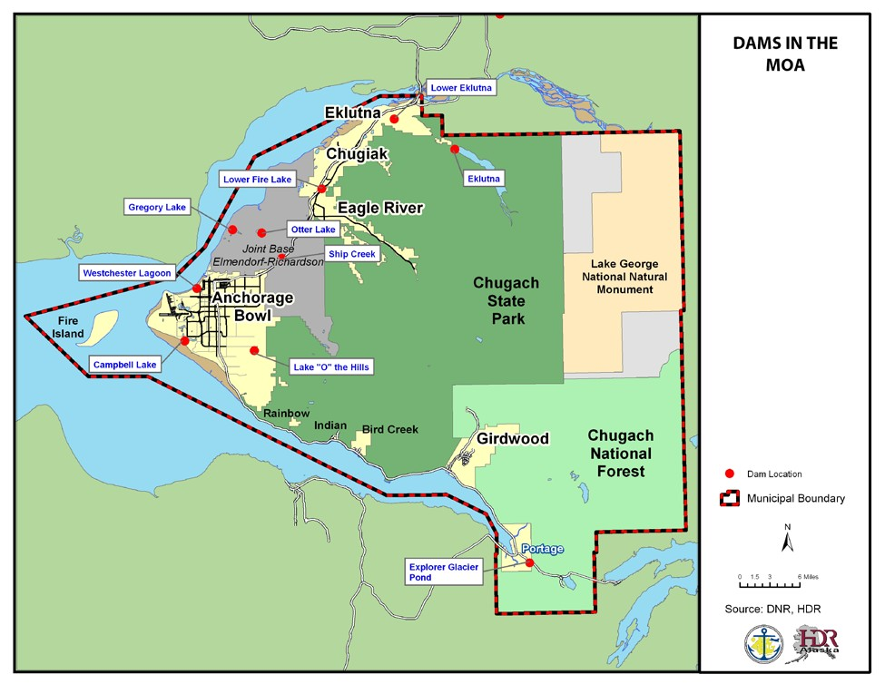

Historic Events
Only one dam failure in Alaska has resulted in a fatality. Anchorage’s Lake O’ the Hills dam failed in 1972, resulting in the downstream death of a child swept into a culvert by the floodwaters. The inundation map for this dam includes the grounds adjacent to O’Malley Elementary School, homes, and O’Malley Road. Table 4.27 lists the known dam failures in Anchorage since 1962.

LL. Table 4.27 Dam Failures in Anchorage Since 1962
Name | NID No. | Description | Class | Height | Date of Failure | Type of Failure | Consequences | Suspected Cause
Campbell Lake Dam | AK00028 | Earth embankment | Low | 11 | 1964 | Full breach | Repair costs | Foundation liquefaction, slope stability
Lake O’ the Hills | AK00034 | Earth embankment | High | 13 | 1964 | Unknown | Unknown | Seismic
Old Eklutna Dam | None | Earth and sheet pile | Low | NA | 1964 | Structural damage | Replacement costs | Seismic racking
Lake O’ the Hills | AK00034 | Earth embankment | High | 13 | 1972 | Full breach | One life lost | Inadequate low level outlet design, and construction, classic piping
Campbell Lake Dam | AK00028 | Earth embankment | Low | 11 | 1989 | Full breach | Repair costs | Insufficient spillway capacity
Source: State Hazard Mitigation Plan,2010

Vulnerability
Areas located within the inundation area of a dam are vulnerable to dam failure. However, most dams within the MOA have not had their inundation areas mapped. The exceptions are the Lake O’ the Hills dam and the Eklutna dam. The inundation mapping for these areas is several years old. The actual dam inundations areas may be different due to increased development in the area, changes in the amount of water being impounded, or other reasons. Maps are in Appendix F.

4.2.2. ENERGY MANAGEMENT
An energy emergency refers to the inability to produce and transmit sufficient quantities of energy to the public, businesses and industry. It can involve one or more energy resources such as heating oil, natural gas, gasoline, coal, or electricity.

An energy emergency can develop quickly. For example, a storm could cause a power line to break. It could also develop over days or weeks. For example, during the 1973 OPEC (Oil
Producing and Exporting Countries) embargo, gasoline, fuel oil, and other petroleum derivatives were in short supply. An energy emergency could even develop over years or decades. For example, increased development puts pressure on the amount of energy needed; if a utility company expands to meet that need but the revenue is not sufficient, the utility company could potentially close.
“Energy Watch” Campaign The MOA and regional utility organizations have worked together to create a public awareness campaign designed to ask residents to conserve energy use in the event of an energy emergency.

The type of energy emergency of greatest concern in the MOA is the deliverability of natural gas. Because there had been an abundant and affordable supply of natural gas in Cook Inlet, it has become the primary fuel for heating and electricity in the MOA. In recent years, the natural gas reserves in Cook Inlet have been declining. There is presently sufficient gas to meet customer demand; however, as demand increases, that may change. There is also growing concern about deliverability, which is the ability to supply gas when and where it is needed.

The gas fields no longer have adequate pressure to provide gas at peak periods, so producers use compressors on the pipeline system to obtain the necessary pressure. If a compressor fails, the system may not be able to supply enough gas to meet the demand (MOA, 2009).

Location
All areas of the MOA are susceptible to energy emergencies.

Likelihood of Occurrence
Typically, several small localized power outages occur every year. However, a large- scale, extended-duration power outage is not considered likely. An energy emergency caused by the unavailability of natural gas is most likely during the evening hours during a prolonged cold snap (MOA, 2009). As Figure 4.13 shows, the demand for gas in the MOA is greater during the winter months.

Historic Events
While power outages are not rare, they typically occur for a short duration and are limited to a small geographic area. There have been no known prolonged citywide power outages or other type of energy emergency recorded in Anchorage.

T. Figure 4.12 Approximate Daily Gas Demand
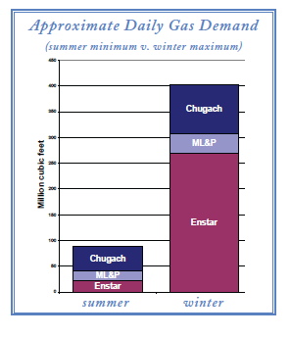
Source: MOA, 2009

Vulnerability
The MOA is vulnerable to localized short-term energy emergencies. Because an energy emergency could affect the entire Municipality, the entire MOA is represented in Table 4.28. Power failures are more likely to affect people than the built environment though. As the MOA continues to grow, the amount of energy demanded will increase. This has the potential of increasing the city’s vulnerability unless the energy supply also increases. Facilities that rely on electricity for life safety needs such as hospitals and nursing homes tend to be more vulnerable to an energy emergency. While these facilities tend to have back-up generators, they may not be able to meet the needs of the facility for an extended period of time.
Extended power outages will also have negative impact on the local economy as many businesses will be unable to functions. Businesses with perishable inventories, such as grocery stores and restaurants may suffer permanent losses.

MM. Table 4.28 Parcels Vulnerable to Energy Emergencies
Land Use | # of Parcels | Taxable Value (Land) | Taxable Value (Buildings) | Total
Residential | 75024 | 8526159300 | 17756156200 | 26282315500
Commercial | 4065 | 2568664400 | 4512337400 | 7081001800
Industrial | 2597 | 1494944600 | 1907337000 | 3402281600
Institutional | 1035 | 1215398400 | 1554183700 | 2769582100
Open Space | 44 | 24995700 | 503000 | 25498700
Transportation | 664 | 0 | 0 | 0
Other | 562 | 377462100 | 36697800 | 414159900
Vacant | 228 | 0 | 0 | 0
Total | 84219 | 14207624500 | 25767215100 | 39974839600
Source: MOA GIS, 2016

4.2.3 URBAN FIRE (CONFLAGRATION)
An urban fire is one involving a structure or property within an urban or developed area. For the purposes of this plan, urban fires are defined as major fires affecting (or with the potential to affect) multiple properties. These types of fires are rare in modern, developed cities but could happen if associated with another disaster such as an earthquake, second to a lary body aircraft crash, during civil unrest, where multiple ignitions could occur simultaneously, overwhelming the fire department’s ability to respond.

Location
Every parcel in the urbanized portion of the MOA, as identified in Anchorage 2020 (see Figure 4.15) has the potential for a major urban fire. In general, the potential for a conflagration is higher in high-density areas that have structures located close to each other.

Parts of the Chugiak/Eagle River area also have the potential for a conflagration but a specific geographic area has not been identified. The downtown area, which tends to have higher densities, is more likely than areas with lower densities.

Likelihood of Occurrence
In the MOA, there is not a significant likelihood of a major urban fire but the potential exists. Modern building codes, construction techniques, building materials have been developed to reduce the possibility of a major urban fire. A major urban fire is more likely to occur as the secondary effect of another hazard such as an earthquake as fire department resources may have to respond to multiple incidences simultaneously, water for fire fighting purposes may be unavailable, etc.

U. Figure 4.13 Map of Urbanized Area from Anchorage 2020
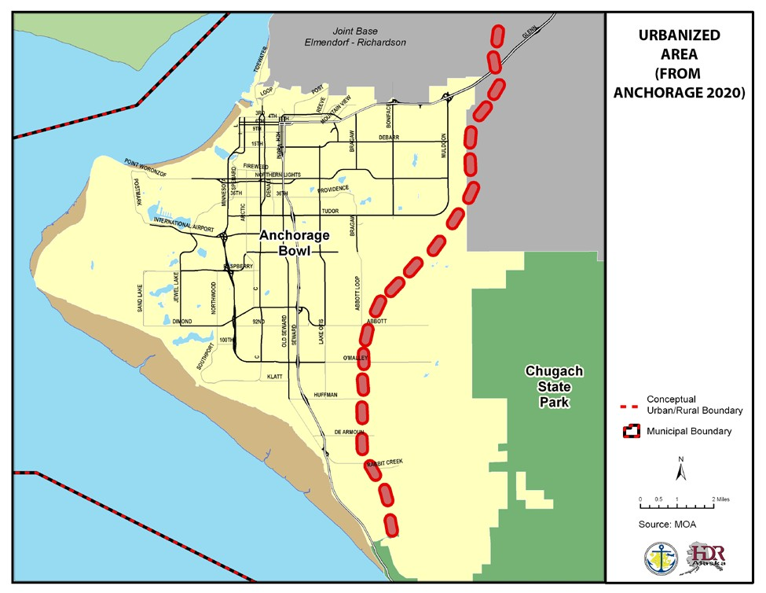

Historic Events
There have been no major urban fires in the MOA in recent years that have resulted in a disaster declaration. Fires within the urbanized portion of the MOA are usually quickly contained and are typically limited to one or two buildings.

One of the most significant urban fires in recent history occurred on June 5, 2007 at the Park Place Condominiums. This fire was accidentally started during plumbing maintenance.
Damages from the fire were estimated at $19 million: $14 million in property loss and $5 million in personal content loss.

Vulnerability
Every parcel in the urbanized portion of the Anchorage Bowl could be vulnerable to a major urban fire and is represented in Table 4.29. This is not considered a significant threat. Hotels, nursing homes, theaters, daycares, assisted living facilities, nightclubs and other places where large groups of people tend to gather tend to have a higher potential for injuries and fatalities.

NN. Table 4.29 Parcels Vulnerable to Urban Fire in the Anchorage Bowl
Land Use | # of Parcels | Taxable Value (Land) | Taxable Value (Buildings) | Total
Residential | 55,130 | 6,165,655,300 | 13,159,778,900 | 19,325,434,200
Commercial | 3,375 | 2383528500 | 4349166300 | 6732694800
Industrial | 2491 | 1452514500 | 1872148800 | 3324663300
Institutional | 368 | 650247000 | 1348498700 | 1998745700
Parks | 259 | 287975300 | 9803500 | 297778800
Transportation | 129 | 89869000 | 49512800 | 139381800
Other | 0 | 0 | 0 | 0
Vacant (residential) | 5,193 | 538,939,700 | 0 | 538,939,700
Watershed | 0 | 0 | 0 | 0
Total | 66945 | 11487847200 | 19575309000 | 31063156200
Source: MOA GIS, 2016

A geographic boundary has not been established for the Eagle River area so the number of parcels and their value that could be impacted has not been calculated as part of this update.

4.2.4. HAZARDOUS MATERIALS (HAZMAT) RELEASE
In general, a hazardous material is any substance or a material that has the potential to harm humans, animals, or the environment. A hazardous materials incident is the intentional or accidental release of toxic, combustible, illegal, or dangerous nuclear, biological, or chemical agents into the environment. The types of material that can cause a hazardous materials incident are wide ranging. Examples include materials such as chlorine, sulfuric acid, gasoline, medical/biological waste, etc. Many accidents happen at fixed sites (where hazardous materials are stored or handled), but incidents may also occur during transportation (by road, rail, pipeline or waterway). Terrorist incidents are not covered in this chapter.

Location
Hazardous materials incidents are more likely to occur where hazardous materials are located. Facilities that meet certain requirements are required to report information regarding the type and volume of hazardous materials to the State of Alaska and the AFD. According to the AFD records (as of April 22, 2010), zip code 99501 has the highest number (276) of reportable hazardous materials. This zip code includes the Ship Creek area which has a higher percentage of industrial land uses (see Figure 4.15).

V. Figure 4.14 Map of the Distribution of Hazardous Materials
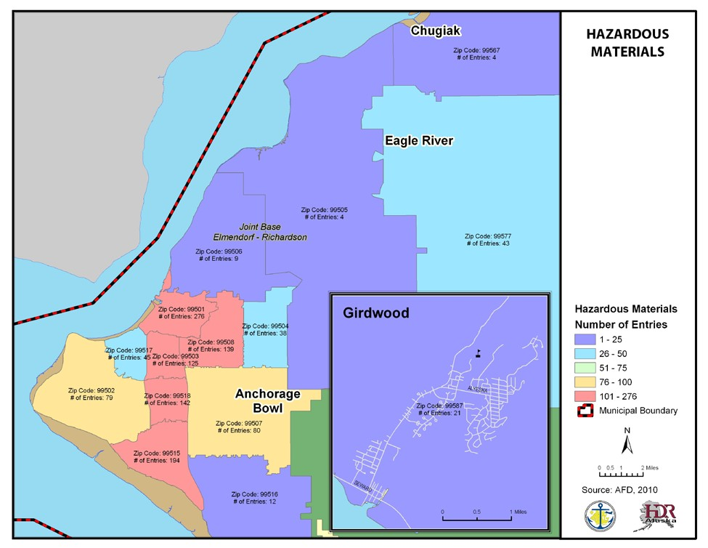

The MOA Solid Waste Services Division has two sites to collect hazardous wastes. The first Hazardous Waste Collector Center is located at the Anchorage Regional Landfill (near the intersection of the Glenn Highway and Hiland Road). The second Household Hazardous Waste Collection Facility is located at the Central Transfer Station near E. 54th and Juneau (east of the Old Seward Highway). These sites are for household use only.

Transportation related incidents are more likely on the main transportation routes such as the Seward and Glenn Highways and the Alaska Railroad. Materials enter the Port of Anchorage and are dispersed around the State. However, they can also occur on local roads or by air or marine vessel traffic.

Pipelines, such as the pipeline used to transport fuel from the Port of Anchorage to TSAIA, are another potential source of a hazardous materials incident.

Likelihood of Occurrence
Small-scale hazardous materials incidents occur every year although the exact number is unavailable. As the MOA continues to grow, it is likely that the number of facilities using hazardous materials will increase and so will the likelihood of a hazardous materials incident.
Additionally, as the State of Alaska itself grows, so too will the demand for Hazardous Materials needed statewide, more of which are brought through the Port of Anchorage. In the year 2015 there were a total of 417 HazMat calls requiring AFD response. 289 of these were fuel/chemicals. 137 were a release of CO and 144 pertained to a gas leak in nature.

Historic Events
There have been no events that resulted in a declared disaster. However, small scale hazardous materials incidents have occurred. For example, on June 9, 2009, there was a chemical spill at TSAIA that resulted in a cargo hanger being evacuated for an hour.

Vulnerability
As a hazardous material incident could occur at a facility or during transportation, the entire MOA is considered vulnerable to a hazardous materials incident (see Table 4.30).

OO. Table 4.30 Parcels Vulnerable to a Hazardous Material Incident
Land Use | # of Parcels | Taxable Value (Land) | Taxable Value (Buildings) | Total
Residential | 75024 | 8526159300 | 17756156200 | 26282315500
Commercial | 4065 | 2568664400 | 4512337400 | 7081001800
Industrial | 2597 | 1494944600 | 1907337000 | 3402281600
Institutional | 1035 | 1215398400 | 1554183700 | 2769582100
Open Space | 44 | 24995700 | 503000 | 25498700
Transportation | 664 | 0 | 0 | 0
Other | 562 | 377462100 | 36697800 | 414159900
Vacant | 228 | 0 | 0 | 0
Total | 84219 | 14207624500 | 25767215100 | 39974839600
Source: MOA GIS, 2016

Areas with higher concentrations of hazardous material usage, such as industrial areas, are more vulnerable. Zip code 99501 has the highest number of hazardous materials. People living in close proximity to a hazardous material incident are more vulnerable. The number of people vulnerable to a hazardous material incident will depend on the location of the event, the amount of material involved and the specific material involved.

4.2.5 RADIATION ACCIDENT
Radioactive materials are a type of hazardous material but are listed separately because radioactive material requires a specific and unique response. Radiological hazards exist, and accidents can occur whenever and wherever radioactive materials are stored, used, or transported. Hazards can range from relatively localized incidents involving small amounts of radioactive materials to large catastrophic events.

Location
Sources of radiation hazard are found in medical facilities and some industrial/laboratory facilities where radioactive materials and/or radiation-producing devices are found. Common places radioactive material is found are nuclear power plants, hospitals, universities, research laboratories, industries, major highways, railroads, and shipping yards. Some radiation (such
as radon) is naturally produced from decomposition of radioactive isotopes in soils and underlying strata.

There are no nuclear power plants in the MOA. The quantities of nuclear materials transported in Alaska are small compared to nuclear waste/cargo shipments in the contiguous United States. (Alaska Department of Environmental Conservation, 2009). According to the May 2009 Public Review Draft of the Alaska Federal/State Preparedness Plan for Response to Oil & Hazardous Substance Discharges/Releases, nuclear facilities (such as power plants, waste storage sites, and processing plants) in eastern Russia could impact Alaska because weather patterns have the potential to bring radioactive fallout to the state. Most Russian facilities are considered to have substandard construction and have had a history of reported and unreported releases (Alaska Department of Environmental Conservation, 2009).

Likelihood of Occurrence
No fatalities or serious injuries have been attributed to a radiological accident in the MOA, however there have been calls pertaining to and confirmed as radioactive materials. While an incident is possible, the likelihood is considered low.

Historic Events
In the MOA, there have been no declared disasters from a radiation accident. No other radiation events have been identified.

Vulnerability
Because radiological material can be airborne, the entire MOA is considered vulnerable and is represented in Table 4.31.

PP. Table 4.31 Parcels Vulnerable to Radiation Releases
Land Use | # of Parcels | Taxable Value (Land) | Taxable Value (Buildings) | Total
Residential | 75024 | 8526159300 | 17756156200 | 26282315500
Commercial | 4065 | 2568664400 | 4512337400 | 7081001800
Industrial | 2597 | 1494944600 | 1907337000 | 3402281600
Institutional | 1035 | 1215398400 | 1554183700 | 2769582100
Open Space | 44 | 24995700 | 503000 | 25498700
Transportation | 664 | 0 | 0 | 0
Other | 562 | 377462100 | 36697800 | 414159900
Vacant | 228 | 0 | 0 | 0
Total | 84219 | 14207624500 | 25767215100 | 39974839600
Source: MOA GIS, 2016

4.2.6 TRANSPORTATION ACCIDENT
The transportation system in the MOA consists of air, road, rail, and marine systems. All of these modes have the potential for accidents that could lead to a disaster. For this plan, a transportation accident is any large-scale aircraft, vehicular, railroad, or marine accident, i.e., one that is not handled on a day-to-day basis by emergency responders.

Anchorage is home to many public airports, the largest of which is TSAIA. TSAIA is the major passenger and cargo facility and is located on the western edge of the city. Merrill Field, one of the busiest general aviation airports in the country, is located just east of downtown.
Several of the flight paths of both airports pass over developed parts of the Municipality. Other airports located within the MOA include Birchwood Airport and Girdwood Airport. There are also two military air fields on JBER. In addition, the MOA has one seaplane base (Lake Hood), although several lakes are used by seaplanes, including Sand Lake, Campbell Lake, and Lower Fire Lake.

The MOA is vulnerable to two major types of air transportation accidents; a crash involving a large passenger aircraft or a crash causing casualties on the ground. Mid-air collisions between two aircrafts are also possible.

As a coastal community, the MOA has the potential for marine accidents. The type of accident of greatest concern involves barges transporting materials, fuels, or other hazardous materials. Most goods designated for Alaska come through the Port of Anchorage. The Port also provides all of the jet fuel to JBER and 80 percent of the fuel to TSAIA (MOA, 2010). The Port also exports petroleum products.

There are several major transportation routes in the MOA, including the Seward and Glenn Highways, which connect the MOA to adjacent boroughs (see Figure 4.19). There are approximately 1,800 miles of roadway in the MOA.

There are approximately 140 miles of railroad track in the MOA. The ARRC operates passenger and freight trains on this track.

Location
The majority of airplane crashes occur immediately before landing or after takeoff. The areas most likely to be impacted by a plane crash are under or close to the flight path, especially if they are within 5 miles of an airport (see Figure 4.16).

A marine accident is more likely in the Port of Anchorage area and in shipping lanes but with the high tides in Anchorage and strong currents could rapidly affect the entire coastline.

A motor vehicle accident could occur on any roadway in the MOA, but is more likely on roads with higher traffic volumes.

A rail accident would occur along the railroad tracks.

W. Figure 4.15 Map of Major Transportation Facilities
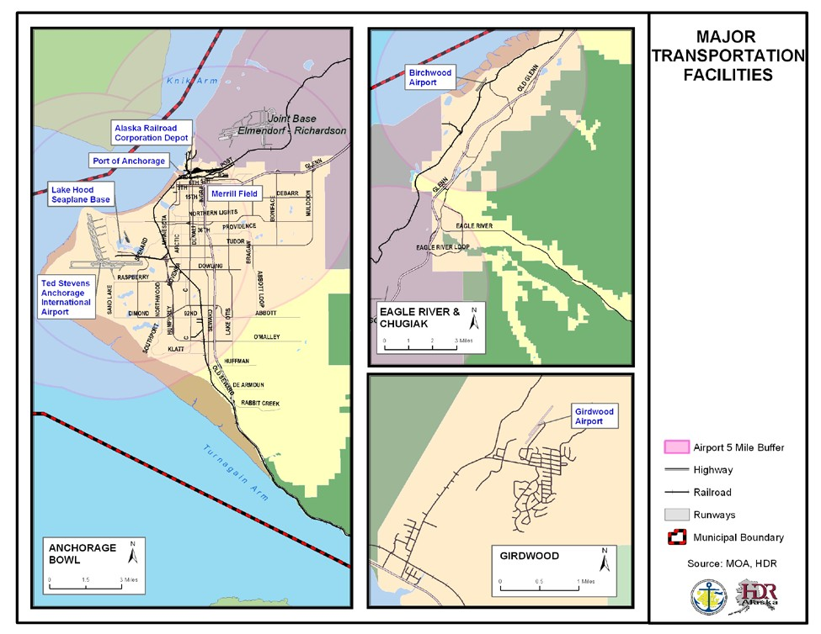

Historic Events
From January 1, 2004 to December 14, 2009, there were 70 reported aircraft accidents/incidents within the MOA (National Transportation Safety Board, 2010). Most of the accidents/incidents were minor; only 3 of the 70 accidents involved fatalities.

On May 27, 2011, a small plane crashed shortly after takeoff from the Birchwood airport. The crash killed the five people on board. The crashed caused the closure of the ARRC tracks for several hours.

On June 29, 2010, a cargo plane crashed shortly after takeoff on Elmendorf Air Force Base. The crash killed all four crew members on board. The crash also damaged the ARRC’s main rail line and a parallel siding, forcing train traffic to be suspended until repairs could be made.

On June 2, 2010, a plane crashed just after taking off from Merrill Field resulting in one fatality and four people seriously injured. The plane crash occurred during rush hour near a busy intersection (7th Avenue and Ingra Street). Traffic in the downtown area was disrupted for several hours due to road closures.

On September 22, 1995, an E-3B Airborne Warning and Control Systems (AWACS) jet carrying a crew of 24 crashed just after takeoff from Elmendorf Air Force Base. The cause of the crash was due to bird strikes.

On August 24, 2013, an airplane was coming in to land at Merrill Field and was told to wait due to another plane on the runway. The plane continued over the runway at approximately 100 feet when it suddenly pitched to the left and crashed. It was determined that the plane had been starved for fuel due to the nose-high altitude during the go-around and the engines failed. Two people were killed in this accident.

On May 28, 2014, a Robinson R44 II helicopter collided with the ground and caught fire while conducting practice flights for an external load project that was coming up at the Birchwood Airport. The pilot was killed in the crash.

On July 2, 2014, a plane crashed at Merrill Field killing the pilot after undergoing maintenance and modifications over the course of several years. The elevator controls had been misrigged and were in the opposite locations resulting in the reversal of control inputs. Witnesses stated that the airplane climbed steeply in an extreme nose-high attitude until it pivoted and descended straight to the ground.

On August 6, 2015, two people were missing after a Piper PA-18-150 plane crashed into the Knik Arm off the Birchwood Airport. The airplane was located and recovered, with extensive damage. The two occupants were never recovered and are presumed deceased.

On December 21, 2015, a small airplane lost engine power after taking off from Girdwood and landed on a highway bridge. No one was injured or killed.

On December 29, 2015, a Cessna 172 was destroyed and the pilot lost his life when the plane collided with an office building in downtown Anchorage.

The worst crash in Anchorage occurred on November 27, 1970. A DC-8-63F plane went off the end of the runway at TSAIA and was destroyed in a post-crash fire. The National Transportation Safety Board determined that the probable cause was that the plane was not traveling fast enough during takeoff. Of the 229 people on board, there were 47 fatalities (Embry-Riddle Aeronautical University, 1972).

Other aircraft accidents include:
  - An in-flight engine separation on March 31, 1993
  - A collision between two aircrafts at TSAIA on December 23, 1983
  - A crash during landing on December 4, 1978; five of the seven people on board were fatally injured.

According to the Minerals Management Service’s Alaskan Shipwreck online database, there have been approximately 19 marine accidents since 1900. The actual number of accidents is likely to be different because not all accidents are reported and because the location description may not be detailed enough to determine if the accident with within the MOA limits. Reported accidents include:
  - A ship ran into the dock at the Port of Anchorage and damaged a 30-ton section of dock on February 10, 1972
  - A ship ran into the Port of Anchorage dock on July 22, 1974 and damaged the pier
  - A strong wind pushed a ship onto the mudflats on April 19, 1982
  - A ship ran into the dock on March 17, 1985 and damaged part of the dock

Motor vehicles accidents are typically small-magnitude events, some with fatalities, but of no impact to the entire community. According to the 2013 MOA Annual Traffic Report, in 2013 there were 4,283 accidents, including 13 that involved fatalities. In the past, there have numerous accidents that resulted in roadway closures for several hours, but there have been no accidents that resulted in a disaster declaration.

According to the Federal Rail Administration database, there were 4 train accidents in the MOA from 2000 to 2009, with no fatalities.

Likelihood of Occurrence
Most airplane accidents are likely to involve general aviation aircraft. However, it is unlikely that a general aviation aircraft could cause a citywide emergency. However, the presence of large planes over the developed portion of the city makes a large crash a possibility.

Marine, road, and rail accidents that result in a citywide emergency are also possible; however, the likelihood is considered low.

Vulnerability
The entire MOA is vulnerable to a transportation accident and is shown in Table 4.32. In general, the areas closer to a transportation route are more vulnerable than areas further away. A major transportation accident could have an impact on the local economic if it results in a long-term shut down of that transportation mode.

QQ. Table 4.32 Parcels Vulnerable to Transportation Accidents
Land Use | # of Parcels | Taxable Value (Land) | Taxable Value (Buildings) | Total
Residential | 75024 | 8526159300 | 17756156200 | 26282315500
Commercial | 4065 | 2568664400 | 4512337400 | 7081001800
Industrial | 2597 | 1494944600 | 1907337000 | 3402281600
Institutional | 1035 | 1215398400 | 1554183700 | 2769582100
Open Space | 44 | 24995700 | 503000 | 25498700
Transportation | 664 | 0 | 0 | 0
Other | 562 | 377462100 | 36697800 | 414159900
Vacant | 228 | 0 | 0 | 0
Total | 84219 | 14207624500 | 25767215100 | 39974839600
Source: MOA GIS, 2016

In subsequent updates of the plan, additional research should be conducted to identify the areas vulnerable to each mode of transportation. For example, areas underneath the flight path for one of the airports would be more vulnerable to an airplane crash than other parts of the MOA.

4.2.7 AIR POLLUTION
Plug In @ 20F
The MOA’s Department of Health and
Human Services has a Plug In @ 20F campaign that encourages people to use an engine block heater when temperatures are 20F or below to reduce engine wear and to reduce carbon monoxide emissions from cold starts.
Air pollution is the introduction of chemicals, particulates, or biological materials that can cause harm or discomfort to humans or other living organisms or damage to the natural environment, into the atmosphere. Air pollution comes from different sources, including industrial processes, vehicles, etc.

The U.S. Environmental Protection Agency (EPA) has set air quality standards for:
  - CO
  - Ozone
  - Sulfur dioxide
  - Nitrogen dioxide
  - Airborne lead
  - Particulates (PM10 and PM2.5)

There is no national standard for other substances that may cause air pollution.

In the MOA, the most likely sources of an air pollution disaster are volcanic ash and wildfire
smoke. An air pollution disaster may also occur due to a fire or other event causing the release of toxic chemicals (Morris, 2010).

Location:
Every parcel in MOA has the potential to be affected by air pollution. Different parts of town may be affected by different events depending on the source of the pollution and the wind conditions. The location of volcanic ash fall is described in section 4.1.8. Wildfire smoke could be the result of a wildfire in the MOA, or neighboring communities including the Matanuska Susitna Borough and the Kenai Peninsula Borough. The location of hazardous materials is described in section 4.2.4.

Likelihood of Occurrence
According to the MOA’s EOP, air pollution events occur every one to four years but tend to have negligible impacts. The likelihood of air pollution resulting in a disaster declaration is considered low.

Anchorage currently meets the standards for all six pollutants that have EPA standards. PM10 levels sometimes approach federal standards. The MOA periodically issues health advisories when air pollution levels reach or are predicted to reach unhealthy levels. In Anchorage, PM10 concentrations tend to be higher during breakup in late March and early April and during freeze-up in late October and early November. Concentrations are typically lowest in mid- summer and mid-winter.

Historic Events
The Anchorage Bowl area was identified as having high levels of CO in the early 1970s. The National Ambient Air Quality Standards (NAAQS) for CO were violated every year from 1972 to 1994 and in 1996. In 1998, the EPA declared Anchorage a serious nonattainment area for CO. Anchorage has since attained compliance with the NAAQS and was designated a maintenance area in 2004. Although Anchorage has had previous (in 1996) violations of the national standard for carbon monoxide, no event has been substantial enough to result in a disaster declaration.

Anchorage has exceeded NAAQS related to natural events, including volcanic eruptions and wind storms. After the August 1992 eruption of the Mt. Spurr volcano, the NAAQS for PM10 were exceeded 18 times between 1993 and 1995. Wind storms in March 2001 and March 2003 also resulted in violations. As these were largely the result of natural events, the EPA has not considered them when evaluating the Anchorage Bowl’s PM10 attainment status.

Other PM10 violations have resulted from maintenance of road sand and unpaved roads and parking lots. The MOA and the SOA have modified their road maintenance practices to reduce PM10 emissions.

Eagle River was designated a PM10 nonattainment area as the result of air quality violations between 1985 and 1987. A PM10 control plan was developed to address this situation. As most of the PM10 was the result of unpaved roads, the plan emphasized paving or surfacing gravel roads. This effort was considered a success, as no violations have been measured since October 1987. Eagle River is now considered in compliance with the PM₁₀ standard.

Vulnerability
Every parcel in MOA could be vulnerable to air pollution (Table 4.33). The built environment has the potential to be impacted by a significant volcanic ash fall event. The built environment has less potential to be impacted by wildfire smoke or toxic gases. However, all MOA residents have the potential to be impacted. In general, the most vulnerable people are those with lung conditions including asthma, the elderly and children.

RR. Table 4.33 Parcels Vulnerable to Air Pollution
Land Use | # of Parcels | Taxable Value (Land) | Taxable Value (Buildings) | Total
Residential | 75024 | 8526159300 | 17756156200 | 26282315500
Commercial | 4065 | 2568664400 | 4512337400 | 7081001800
Industrial | 2597 | 1494944600 | 1907337000 | 3402281600
Institutional | 1035 | 1215398400 | 1554183700 | 2769582100
Open Space | 44 | 24995700 | 503000 | 25498700
Transportation | 664 | 0 | 0 | 0
Other | 562 | 377462100 | 36697800 | 414159900
Vacant | 228 | 0 | 0 | 0
Total | 84219 | 14207624500 | 25767215100 | 39974839600
Source: MOA GIS, 2016

4.2.8 COMMUNICATIONS FAILURE
A communications failure is the interruption or loss of communications systems including transmission lines, communications satellites, and associated hardware and software necessary for the communications system to function. A communications failure may be the result of an equipment failure, human acts (deliberate or accidental) or the result of another hazard event.

When a communications failure occurs, it can have a wide range of affects. A failure that results in a small delay in response times by emergency service providers might have a minimal impact on the community in general even though it may be problematic to individuals who require those services. A failure of the 911 system or an emergency warning system has the potential to impact the entire community.

Location
All parts of the MOA have the potential to be impacted by a communications failure.

Likelihood of Occurrence
The likelihood of a large-scale extended communications failure is low. However, small scale failures with a short duration are frequent.

Historic Events
Communication failures in the MOA have been limited to small scale outages associated with equipment failures or natural events such as severe weather storms and mainly affecting landline and cellular telecommunication capabilities.

There have been no failures of the 911 system in the MOA since the late 1990s. Backup systems are in place so when the APD dispatch is unable to answer 911 calls, the calls are directed to the AFD. In the past 5 years, there have been 3 instances where the back-up system has been activated. Two of these events were caused by human error which the third event was caused by a computer failure (Kurtz, 2010).

On May 19, 2002, the APD dispatch and the 911 center was evacuated due to a fire/air conditioning overheating which resulted in Halon being discharged (Roberts, 2010).

Vulnerability
Anyone who relies on technology such as telephones, are somewhat vulnerable to experiencing some type of communications failure. Interruptions in day to day communications would create problems for businesses, public agencies, citizens, and emergency services. The most common problems would range from minor inconveniences of our citizens to loss of production and revenues for businesses. Emergency services could face more serious consequences, as nonexistent communications failure could escalate what would have been a minor emergency into a disaster situation.

4.2.9 INFECTIOUS DISEASE
Infectious diseases (sometimes called communicable diseases or transmissible diseases) are diseases caused by pathogenic microorganisms such as bacteria, viruses, parasites or fungi. When they are easily spread from person to person they can cause disaster situations.
Examples of infectious diseases include influenza, avian influenza (“bird flu”), malaria, meningococcal meningitis, small pox, and tuberculosis. An infectious disease outbreak may occur as the primary event or may be a secondary event to another disaster. Common examples of infectious diseases in the MOA include tuberculosis and pertussis (“whooping cough”).

Location
The entire Municipality has the potential to be impacted by an infectious disease event. An infectious disease may be more likely to spread in areas where more people come into contact with each other.

Likelihood of Occurrence
A likelihood of major infectious disease outbreak is considered rare. The likelihood of an infectious disease event would depend on the disease. For example every year, some percentage of the population is affected by influenza. If it is a mild strain, the severity of the epidemic is less than if it was a stronger strain of the virus. Factors that contribute to the emergence and spread of infectious disease include population increase and migration/travel.

History
There are no known infectious disease outbreaks in the MOA in recent years that have resulted in a disaster declaration. Even though there has been a lack of community-wide events, the MOA experiences small scale outbreaks on an annual basis. However, there are people treated for an infectious disease annually. For example, influenza is typically seen in Anchorage every year with cases of H1N1 and seasonal influenza being found in 2009. In 2006, 41 people with active tuberculosis were reported in the MOA (State of Alaska Epidemiology, 2007). Four of these patients died.

Vulnerability
There would be little threat to the natural or built environment from an infectious disease event. In general, members of the community with compromised immune systems, and the elderly and very young children are more vulnerable. Those populations with poor access to health care may also be at increased vulnerability. Different populations may also be more vulnerable to different types on infectious diseases. For example, people 65 and older are typically affected by seasonal flu but this age group was less affected by the H1N1 virus than younger adults and children (US Department of Health and Human Services, 2010). In a large event, the capacity of the health care system may become overwhelmed and negatively impact the ability to treat patients efficiently.

4.2.10 FOOD/WATER CONTAMINATION
Food and water contamination refers to food and water that has been spoiled because it contains microorganisms (such as bacteria or parasites), chemicals, or other contaminants that make it unsafe for human consumption. Contamination can be unintentional (for example through improper handling or storage), or intentional. This section will discuss unintentional contamination with intentional contamination being discussed in a future plan update.

Location
Food and water contamination has the potential to occur everywhere in Anchorage but different areas may be impacted differently depending on the contamination. For example, contamination of the Municipal water supply is unlikely to affect areas that still rely on wells.

Vulnerability
The built environment has a low vulnerability to food and water contamination but people are vulnerable. The populations most at risk are those with weakened immune systems such as the elderly. Conferences, special events, and other activities that involve food service to large numbers of people are of more concern because of the potential for larger numbers of people being infected. The MOA’s vulnerability to food and water contamination may increase as parasites, bacteria, etc. become more resistant to pesticides. In addition, new parasites and bacteria continue to be identified.

A food and water contamination event may occur as the result of another disaster. For example, an event that disrupts electrical service may lead to food being improperly refrigerated. Individuals who consume the improperly stored food may become ill as a result.

History
There are no known food or water contamination events that have resulted in a disaster declaration. However, there have been mild events impacting relatively small numbers of people. In recent years, one of the largest incidents occurred in 2008 when approximately 99 people became ill from the campylobacter bacteria. Health officials were able to determine that the illness was the result of eating contaminated peas from a local farm (State of Alaska Epidemiology, 2008).

4.3 HUMAN/SOCIETAL
These events are the result of deliberate human acts. The following human/societal hazards will be addressed in a future update:

4.3.1 ATTACK
4.3.2 CIVIL DISTURBANCE
4.3.3 TERRORISM
4.3.4 WMD: BIOLOGICAL, CHEMICAL, NUCLEAR

CHAPTER 5 MITIGATION STRATEGY

The purpose of this chapter is to document the MOA’s mitigation strategy, which is based on the findings presented in the preceding chapters. This chapter is divided into the following sections:
- Hazard Mitigation Goals and Objectives
- Hazard Mitigation Strategies
- Action Plan

The goals, objectives, and action items in this chapter are intended to guide everyday activities and provide a long-term hazard mitigation approach for the MOA to follow. The intent is that these goals, objectives, and action items will be incorporated into future MOA plans, policies, and projects. The goals are broad statements about what the MOA wants to achieve in terms of hazard mitigation. Objectives identify how the MOA will achieve those goals. The Action Plan items are specific actions that will be taken or projects that will be built to implement this mitigation plan.

A review of the goals and objectives done as part of the plan update has determined that the goals and objectives from the 2005 plan remain valid, with minor changes.

5.1 GOALS AND OBJECTIVES
Goal 1: Education/Coordination: Develop coordinated and proactive public policies, emergency plans and procedures, and educational programs that minimize the risk to the community from natural, technological, and human/societal hazards and disasters.
(From Anchorage 2020, LRTP, Housing & Community Development Consolidated Plan, Work Force & Economic Development Plan)
Objective 1.1 Increase coordination among Municipal departments.
Objective 1.2 Educate individuals and businesses about hazards, disaster preparedness, and mitigation.
Objective 1.3 Increase coordination between hazard mitigation goals and existing and future plans, including the incorporation of effective hazard mitigation strategies into the Capital Improvement Program.
Objective 1.4 Coordinate with the Alaska Division of Insurance.
Objective 1.5 Educate public officials, developers, realtors, contractors, building owners, and the general public about hazard risks and building requirements.
Objective 1.6 Partner with Municipal Departments and other agencies serving vulnerable populations to minimize harm in the event of an emergency.
Goal 2: Land Use/Planning: Develop an urban place that functions in harmony with its natural setting and is mindful of its natural technological and human/societal hazards.
(From Anchorage 2020, LRTP, Housing & Community Development Consolidated Plan)
Objective 2.1 Continue to provide for floodplain management to protect residents and property from the hazards of development in floodplains.
Objective 2.2 Land use regulations shall include new design requirements that are responsive to Anchorage’s climate and natural setting.
Objective 2.3 Use environmentally and conservation-friendly materials in mitigation projects whenever possible and economically feasible.
Objective 2.4 Adopt and enforce public policies to minimize impacts of development and enhance safe construction in high hazard areas.
Objective 2.5 Integrate new hazards and risk information into building codes and land use planning mechanisms.

Goal 3: Emergency Management: Create and maintain a community where people and property are safe.
(From Anchorage 2020, LRTP, Housing & Community Development Consolidated Plan, Work Force & Economic Development Plan)
Objective 3.1 Develop mechanisms in advance of a major emergency to cope with subsequent rebuilding and recovery phases.
Objective 3.2 Consider the secondary effects of disasters, such as hazardous waste and hazardous materials spills, when planning and developing mitigation projects.
Objective 3.3 Minimize increases in hazard vulnerability.
Objective 3.4 Ensure compliance with the Emergency Planning and Community Right-to-Know Act of 1986.
Objective 3.5 Improve road connectivity for evacuation purposes.
Objective 3.6 Promote disaster contingency planning and facility safety among institutions that provide essential services such as food, clothing, shelter, and health care.
Objective 3.7 Improve disaster warning systems.
Objective 3.8 Promote appropriate hazard mitigation of all public and privately owned property within the Municipality of Anchorage including, but not limited to, residential units, commercial structures, educational institutions, health care facilities, public gathering places, and infrastructure systems.
Objective 3.9 Promote mitigation of historic buildings.
Objective 3.10 Promote post-disaster mitigation as part of repair and recovery.

Goal 4: Protection of Public/Critical Facilities: Make MOA-owned facilities as disaster- resistant as feasible.
Objective 4.1 Encourage a structural review of new facilities.
Objective 4.2 Consider known hazards when siting new facilities and systems. Objective 4.3 Perform structural retrofitting of existing structures.
Objective 4.4 All public facilities should have a pollution prevention plan. Objective 4.5 Incorporate non-structural mitigation into existing buildings.
Objective 4.6 Implement mitigation programs that protect critical Municipal facilities and services and promote reliability of lifeline systems to minimize impacts from hazards, to maintain operations, and to expedite recovery in an emergency.
Objective 4.7 Create redundancies for critical networks such as water, sewer, digital data, power, and communications.
Objective 4.8 Formalize best practices for protecting systems and networks.

Goal 5: Support Wildfire Mitigation.
Objective 5.1 Support the AFD Wildfire Strategic Plan.
Objective 5.2 Promote FireWise homes through the concepts in Firewise Alaska; landscaping and vegetation management; structure protection through preparedness; building design, siting, and construction material; and homeowner awareness.
Objective 5.3 Promote vegetation management in greenbelts and parks to limit fire spread. Objective 5.4 Maintain the wildfire risk model.
Objective 5.5 Maintain and develop additional water resources.

Goal 6: Information: Ensure information is easy to access and up to date.
Objective 6.1 Convert all hazard maps to GIS format. Objective 6.2 Identify hazards not already mapped.
Objective 6.3 Map all currently unmapped regulated flood-prone areas. Objective 6.4 Update drainage studies.

Goal 7: Economy/Business: Maintain Anchorage’s (and the State’s) economic vitality
Objective 7.1 Partner with private sector, including small businesses, to promote structural and non-structural hazard mitigation as part of standard business practice.
Objective 7.2 Educate businesses about contingency planning citywide, targeting small businesses and those located in high-risk areas.
Objective 7.3 Partner with private sector to promote employee education about disaster preparedness while on the job and at home.
Objective 7.4 Minimize economic loss.

5.2 IMPLEMENTATION
5.2.1 STRATEGIES
The MOA will implement the mitigation measures identified in this plan by using the comprehensive plan, Capital Improvement Plan, and other hazard mitigation tools they have at their disposal.

While there are many different ways to mitigate hazards, not all are appropriate for all situations. Each situation must be evaluated in order to decide what activities are the most appropriate. General strategies that can be used to mitigate hazards include:

Structural Features
Structural features are designed to control the hazard and restrict the exposed area. The construction of a structure such as a dam, levee, or avalanche deflection wall can lessen the impact of a hazard event. Structures are most appropriate to protect existing development. Structures can be incorporated into new development, but this should be discouraged in hazard-prone areas. The following departments can implement this strategy:
  - PM&E
  - Public Works

Land Use Planning
Land use planning can guide development away from hazard-prone areas. Planning is more effective at protecting future development. The responsibility for land use planning is with the Planning and Development Services Department.

Zoning
Zoning ordinances regulate development by dividing a community into areas and by establishing development criteria for each area. They may restrict certain uses in hazard- prone areas or add restrictions such as minimum elevations. Zoning is more effective with future development. Zoning can:
  - Prevent new development in hazard-prone areas
  - Preserve or establish low densities in hazard-prone areas
  - Control changes in use and occupancy of structures in hazard-prone areas
  - Establish performance standards
  - Require special use permits

P&DS and the Planning and Zoning Commission have the primary responsibility for zoning in the MOA.

Subdivision Regulations
Subdivision regulations govern how a parcel of land can be subdivided into two or more smaller parcels. It is better to incorporate mitigation measures into subdivision regulations before a parcel of land is developed. These regulations are better at protecting future development than existing development. P&DS and the Platting Board administer the MOA’s subdivision regulations.

Capital Improvement Plan
A Capital Improvement Plan (CIP) is used to guide major public expenditures for physical improvements over a given period of time. These expenditures can be used to mitigate existing and future development. For example, funds could be used to retrofit an existing structure, build a new levee, or purchase property. The lack of investment in infrastructure in hazard-prone areas may also act to restrict development, as it is too costly for a private developer to build the necessary improvements. All municipal departments have input into the CIP, but the Office of Management & Budget is the coordinating department.

Open Space Preservation
Open space preservation is a tool to keep existing open spaces in hazard-prone areas from being developed. This prevents putting more people and facilities at risk. Typically, a municipal government will acquire the property from a private property owner. The property then becomes zoned as open space, which limits the future development of the property.
Property that is already government-owned can also be preserved as open space. Open space is usually managed by the Parks & Recreation Department.

Acquisition
Acquisition involves purchasing property in high-risk areas and demolishing any structures on it to prevent the structure from being damaged during a hazard event. The structure is demolished to ensure that it is not re-used in the future. This technique is appropriate for mitigation of existing structures. It can also be used to buy vacant land in high-risk areas to prevent development from occurring. Many departments would be involved in the acquisition of property and structures.

Relocation
Relocation is similar to acquisition, except that any structures on the property are relocated out of a hazard-prone area. The structure may be relocated to a different parcel or within the same parcel. This technique is also more appropriate for existing structures. Many departments would be involved in the relocation of structures.

Building Codes
Building codes are a compilation of laws, regulations, ordinances, or other statutory requirements adopted by a government legislative authority relating to the physical structure of buildings. They establish minimum requirements regarding the construction of a structure to protect public health, safety, and welfare. They apply to new buildings as well as those undergoing significant renovations, which makes building codes helpful in protecting new and existing development. Enforcement is essential in order for building codes to be an effective hazard mitigation tool. It is also less expensive and easier to incorporate mitigation measures into new structures than it is to retrofit existing ones. P&DS is responsible for administering the building code in Anchorage.

Insurance
Insurance provides funding to rebuild a structure and replace its contents after a hazard event. Insurance is appropriate for mitigating existing structures. The problem with insurance is that it can make it easier to rebuild in a hazard-prone area, thus creating a repetitive loss situation. Because municipal governments such as the MOA are typically self-insured, this strategy is used more by private property owners. The Risk Management Department is responsible for ensuring the MOA’s insurance needs are met.

Education
Education involves teaching the public about potential natural hazards, the importance of mitigation, and how to prepare for emergency situations. It is used to inform residents, business owners, visitors, etc. about the hazards in the area and what they can do to protect themselves and their property. Examples include real estate disclosure, homeowner wildfire reduction publications, and training. Many departments within the MOA can undertake education activities, including OEM, the Mayor’s Office, AFD, and P&DS.

5.3 ACTION PLAN
The action plan consists of specific activities or projects that will be used to implement the goals and objectives of this hazard mitigation plan. The action items are categorized by the hazard being addressed with action items addressing more than one hazard being grouped in a multi-hazard category. The action plan contains many items that have no funding sources identified. The timelines are dependent upon obtaining funding. If and when funding becomes available, more specific timelines will be established. This list is in the early stages of development and will be updated as needed. For each item, several characteristics are listed, including:
  - Purpose: Why this item is included in the action plan
  - How Identified: How the action item was identified
  - Coordination Organization : The primary organization to implement the action item
  - Objective: The objectives being implemented
  - Status/Timeline: What stage the project is at or the target start date
  - Priority: The priority of the project as determined by the process established in Appendix G (Departments have not begun to use this tool and priorities will be included in the next version of the mitigation plan.)
  - Cost: The estimated cost of the project (if known)
  - Potential Funding Sources: Possible sources of funding (if known)
  - Hazard : The hazard being addressed (for multi-hazard action items only)

Multi-Hazard

Action 1. Identify department responsible for coordinating hazard mitigation activities.
  - Purpose: As department staffing levels, resources, and responsibilities change over time, the MOA should review which department is responsible for the hazard mitigation plan.
  - How Identified: Planning Team
  - Coordinating Organization: All departments
  - Objective: 1.1
  - Hazard: All
  - Status/Timeline: Ongoing
  - Priority: High
  - Cost: Staff time
  - Potential Funding Sources: General revenue

Action 2. Review composition of departments represented on the hazard mitigation planning committee.
  - Purpose: As departmental responsibilities change and additional hazards are incorporated into this plan, the list of departments should be reviewed to ensure the appropriate departments are represented in the hazard mitigation planning process.
  - How Identified: Planning Team
  - Coordinating Organization: Dependent on the results on Action 1
  - Objective: 1.1
  - Hazard: All
  - Status/Timeline: Ongoing
  - Priority: High
  - Cost: Staff time
  - Potential Funding Sources: General revenue

Action 3. Review and update prioritization strategy (in Appendix G). Upon completion, prioritize action items.
  - Purpose: Prioritizing the projects will help the MOA make decisions regarding how to allocate the resources available for hazard mitigation activities.
  - How Identified: Consultant
  - Coordinating Organization: Dependent on the results on Action 1
  - Objective: 1.1, 1.3
  - Hazard: All
  - Status/Timeline: Ongoing
  - Priority: To be determined
  - Cost: Staff time
  - Potential Funding Sources: Current funding

Action 4. Hold semi-annual meetings of the hazard mitigation committee.
  - Purpose: To discuss hazard mitigation related items on a regular basis
  - How Identified: From 2011 Plan
  - Coordinating Organization: Dependent on the results on Action 1
  - Objective: 1.1
  - Hazard: All
  - Status/Timeline: Ongoing
  - Priority: High
  - Cost: Staff time
  - Potential Funding Sources: General revenue

Action 5. The MOA shall develop a program to educate the community on the various methods of making structures and their contents more disaster-resistant, which would include workshops, literature, and public safety announcements.
  - Purpose: To educate people about hazard mitigation
  - How Identified: From 2011 Plan
  - Coordinating Organization: All departments
• Objective: 1.1, 1.2, 1.5, 7.1, 7.2, 7.3, 1.4, 5.1, 5.2
  - Hazard: All
  - Status/Timeline: Staff resources unavailable and unable to implement until a funding source is found.
  - Priority: To be completed
  - Cost: To be determined
  - Potential Funding Sources: To be completed

Action 6. Continue the Emergency Watch Program.
  - Purpose: To continue educating residents on basic emergency response strategies
  - How Identified: from 2011 Plan
  - Coordinating Organization: OEM
• Objective: 1.2, 1.5, 3.8
  - Hazard: All
  - Status/Timeline: Ongoing
  - Priority: To be completed
  - Cost: To be completed
  - Potential Funding Sources: Current funding or apply for FEMA grant

Action 7. Develop a recovery plan.
  - Purpose: To identify how hazard mitigation can be incorporated into the re- construction of the MOA after a hazard event
  - How Identified: From 2011 Plan
  - Coordinating Organization: To be identified
• Objective: 3.1, 3.10, 4.2
  - Hazard: All
  - Status/Timeline: Staff resources unavailable and unable to implement until a funding source is found
  - Priority: Low
  - Cost: To be completed
  - Potential Funding Sources: apply for FEMA grant

Action 8. Acquire updated air photos or LiDAR information for the entire MOA
  - Purpose: To allow more accurate information analysis.
  - How Identified: PM&E
  - Coordinating Organization: to be identified
  - Objective: 1.1, 2.1
  - Hazard: All
  - Status/Timeline: Ongoing
  - Priority: To be completed
  - Cost: to be completed
  - Potential Funding Sources: to be determined

Action 9. Identify necessary warning system improvements.
  - Purpose: To provide improved warnings to the residents of Anchorage
  - How Identified: From 201 Plan
  - Coordinating Organization: OEM
  - Objective: 3.7
  - Hazard: All
  - Status/Timeline: Ongoing
  - Priority: To be completed
  - Cost: To be completed
  - Potential Funding Sources: Current funding, although grants and other funds may be needed to implement the improvements

Action 10. Utilize essential strategies to implement public safety policies 98, 99, and 100 of Anchorage 2020 – Anchorage Bowl Comprehensive Plan (9-10-02 public safety amendments; AO 2002-119). Essential strategies include emergency management plan, public safety plan, design for public safety, public facilities site selection criteria, and geohazards management.
  - Purpose: To establish plans for emergency management and public safety levels of service, and to better integrate hazard mitigation into other Municipal plans and regulations
  - How Identified: From 2011 Plan
  - Coordinating Organization: OEM/APD/AFP/P&DS
• Objective: 1.3, 2.2, 2.4, 2.5
  - Hazard: All
  - Status/Timeline: 5-10 years
  - Priority: To be completed
  - Cost: To be completed
  - Potential Funding Sources: To be determined

Action 11. Continue to require new and renovated MOA buildings to go through the FM Global Engineering Review.
  - Purpose: To ensure MOA buildings are as disaster-resistant as feasible
  - How Identified: From 2011 Plan
  - Coordinating Organization: Risk Management
  - Objective: 6.1, 4.8
  - Hazard: All
  - Status/Timeline: Ongoing
  - Priority: To be completed
  - Cost: To be completed
  - Potential Funding Sources: Current funding

Action 12. Develop siting requirements for facilities built with Municipal funds.
  - Purpose: To minimize increases in vulnerability
  - How Identified: From 2011 Plan
  - Coordinating Organization: M&O
• Objective: 4.2, 3.3, 3.2, 4.8
  - Hazard: All
  - Status/Timeline: Staff resources were unavailable to complete this action item. The time to complete this action is dependent on the availability of staff resources.
  - Priority: To be completed
  - Cost: To be determined
  - Potential Funding Sources: Current funding

Action 13. Replace, retrofit, or construct new fire stations as listed in the AFD’s 2009-2015 Strategic Plan.
  - Purpose: To ensure the availability of emergency responders and their equipment after a hazard event
  - How Identified: AFD Strategic Plan
  - Coordinating Organization: AFD
• Objective: 4.6, 4.7, 4.3
  - Hazard: All
  - Status/Timeline: 95% completed
  - Priority: To be completed
  - Cost: Depends on project
  - Potential Funding Sources: Possible Capital Improvement Bond Issue.

Action 14. Replace, retrofit, or construct new police stations as listed in the APD’s Strategic Plan.
  - Purpose: To ensure the availability of emergency responders and their equipment after a hazard event
  - How Identified: APD
  - Coordinating Organization: APD
• Objective: 4.6, 4.7, 4.3
  - Hazard: All
  - Status/Timeline: Ongoing
  - Priority: To be completed
  - Cost: Depends on project
  - Potential Funding Sources: Possible Capital Improvement Bond Issue.

Action 15. Complete the Port of Anchorage modernization.
  - Purpose: The port expansion will include modern infrastructure and systems, making it more hazard-resistant than the existing port.
  - How Identified: Port of Anchorage
  - Coordinating Organization: Port of Anchorage
• Objective: 3.3, 3.8, 4.2
  - Hazard: Earthquake, extreme weather, hazardous materials, transportation accident
  - Status/Timeline: This project is ongoing and is expected to be completed between 2015 and 2020. The actual completion date will depend on a variety of factors, including the availability of funding.
  - Priority: To be completed
  - Cost: Approximately $750 to 800 million
  - Potential Funding Sources: Federal appropriations and grants, State grants, Port profits, revenue bonds

Action 16. Prepare 1 or 2 grant applications that can be submitted to DHS&EM when funds are available.
  - Purpose: Developing grant applications in advance will allow adequate time to collect the necessary information and will allow the MOA to apply for grants that have short deadlines.
  - Coordinating Organizations: All departments
• Objective: 1.1, 3.8, 4.3, 4.5,
  - Hazard: All
  - Status/Timeline: to be determined
  - Priority: To be determined
  - Cost: to be determined
  - Potential Funding Sources: Current funding

Action 17. Create a volcanic ash recovery plan.
  - Purpose: Ash can remain a hazard even after the initial events, because clean-up efforts can cause ash to become airborne. A plan that identifies the appropriate recovery methods can help ash be properly disposed of in a timely manner.
  - How Identified: DHSS
  - Coordinating Organization: DHHS
• Objective: 1.2, 1.5, 3.1, 7.4
  - Hazard: Air pollution, volcanic ash
  - Status/Timeline: Dependent on staff availability
  - Priority: Low
  - Cost: Staff time
  - Potential Funding Sources: To be determined

Action 18. Obtain GIS data used to create the seismic landslide hazards maps from the USGS Report titled “Maps showing Seismic Landslide Hazards in Anchorage, Alaska.”
  - Purpose: To make the data more accessible
  - How Identified: Consultant
  - Coordinating Organization: P&DS
  - Objective: 6.1
  - Hazard: Earthquake, ground failure
  - Status/Timeline: 1 year
  - Priority: To be determined
  - Cost: Less than 1 week of staff time
  - Potential Funding Sources: Current funding

Earthquake

Action 19. Pursue funding to seismically retrofit MOA-owned facilities that will be needed during and after a hazard.
  - Purpose: To limit the amount of damage caused by an earthquake
  - How Identified: From 2011 Plan
  - Coordinating Organization: M&O
• Objective: 3.9, 4.3, 2.3, 4.8
  - Status/Timeline: Ongoing
  - Priority: To be completed
  - Cost: Depends on facility
  - Potential Funding Sources: General funding, bonds, grants

Action 20. Install gas shut-off valves in MOA-owned public facilities used in response/recovery efforts.
  - Purpose: To reduce the possibility of gas leaks after a hazard event
  - How Identified: From 2011 Plan
  - Coordinating Organization: M&O
  - Objective: 4.3, 4.6
  - Status/Timeline: Ongoing; several MOA facilities have already been retrofitted.
  - Priority: To be completed
  - Cost: To be completed (approximately $5,000 to $7,000 per facility)
  - Potential Funding Sources: General funding, bonds, grants
  - Status/Timeline: 1 year
  - Priority: To be completed
  - Cost: Under $100,000
  - Potential Funding Sources: General funding

Action 21. Repair the Port of Anchorage pilings under Terminal I as necessary.
  - Purpose: The pile thickness underneath Terminal I is below standard and could fail during an earthquake.
  - How Identified: From 2011 Plan
  - Coordinating Organization: Port of Anchorage
  - Objective: 7.4
  - Status/Timeline: Ongoing. This action will no longer be needed when the Port expansion is complete.
  - Priority: To be completed
  - Cost: Between $1 and $2 million annually
  - Potential Funding Sources: Existing funding

Action 22. Continue to identify municipal fire stations, police stations, emergency facilities, and other facilities that need to be seismically retrofitted or rebuilt to current seismic standards.
  - Purpose: To ensure the availability of emergency responders and their equipment after a hazard event
  - How Identified: From 2011 Plan
  - Coordinating Organization: M&O
• Objective: 4.6, 4.7, 4.3
  - Status/Timeline: Ongoing
  - Priority: To be completed
  - Cost: To be completed
  - Potential Funding Sources: Possible Capital Improvement Bond Issue; seek grant funding from FEMA mitigation grant programs or other outside source as needed

Action 23. Continue and expand seismic monitoring instrumentation of buildings, other major structures, and free field sites throughout the Municipality, and establish funding support for locally based monitoring and data analysis from these instruments.
  - Purpose: To obtain data that will help determine if buildings and other major structures located throughout the Municipality can safely withstand earthquake shaking intensities that can vary depending on underlying soil conditions. Data obtained through this effort could provide the basis for mitigating potential building damage or casualties/injuries through local amendments to the International Building Code.
  - Coordinating Organizations: UAA, P&DS
  - Objective: 2.5
  - Status/Timeline: To be determined
  - Priority: High
  - Cost: To be completed
  - Potential Funding Sources: To be identified

Action 24. Incorporate the action items identified in the Downtown Seismic Risk Assessment into the All-Hazards Mitigation Plan.
  - Purpose: To help ensure the action items identified in this assessment are coordinated with other MOA activities
  - How Identified: Consultant
  - Coordinating Organization: P&DS
• Objective: 1.3, 2.4, 3.3
  - Status/Timeline: Within 1 year of the Seismic Risk Assessment being completed
  - Priority: High
  - Cost: Under $10,000
  - Potential Funding Sources: Current funding

Wildfire

Action 25. Review existing zoning to determine if additional wildfire mitigation measures could be incorporated.
  - Purpose: To help incorporate wildfire mitigation measures into future development
  - How Identified: From 2011 Plan
  - Coordinating Organization: P&DS/AFD
• Objective: 1.3, 2.2, 2.4, 2.5, 5.2
  - Status/Timeline: Staff resources unavailable and unable to implement until a funding source is found
  - Priority: To be completed
  - Cost: To be completed
  - Potential Funding Source: To be determined

Action 26. Conduct fire-wise home assessments.
  - Purpose: Conduct firewise home assessments to enable homeowners in certain parts of the MOA to obtain insurance.
  - How Identified: From 2011 plan
  - Coordinating Organizations: AFD
• Objective: 1.5, 2.4, 3.8, 5.2
  - Status/Timeline: ongoing
  - Priority: Medium
  - Cost: Varies by year
  - Potential Funding Sources: Federal grant

Action 27. Maintain the wildfire risk model.
  - Purpose: To ensure the risk model is using the most current information
  - How Identified: From 2011 Plan
  - Coordinating Organization: AFD
  - Objective: 5.4
  - Status/Timeline: Ongoing
  - Priority: To be completed
  - Cost: To be completed
  - Potential Funding Sources: Current funding

Action 28. Continue and maintain vegetation management.
  - Purpose: To limit the amount of fuel available for wildfires
  - How Identified: From 2011 Plan
  - Coordinating Organization: AFD
  - Objective: 5.3
  - Status/Timeline: Ongoing
  - Priority: To be completed
  - Cost: To be completed
  - Potential Funding Sources: Current funding

Action 29. Develop additional water resources for wildfire response purposes.
  - Purpose: Developing additional water resources would assist in fighting wildfires.
  - How Identified: From 2011 Plan
  - Coordinating Organization: AFD
  - Objective: 5.5
  - Status/Timeline: Ongoing
  - Priority: To be completed
  - Cost: To be completed
  - Potential Funding Sources: To be completed

Flood

Action 30. The MOA shall continue to apply floodplain management regulations for development in the flood plain and floodway.
  - Purpose: To continue to minimize vulnerability to flooding
  - How Identified: From 2011 Plan
  - Coordinating Organization: PM&E
  - Objective: 2.1
  - Status/Timeline: Ongoing
  - Priority: To be completed
  - Cost: Included in the PM&E Watershed Management Budget
  - Potential Funding Sources: Current funding

Action 31. The MOA shall continue to utilize the FEMA Flood Insurance Rate Map to define the special flood hazard area, the floodway, and the floodplain.
  - Purpose: To define the special flood hazard area, the floodway, and the floodplain in a consistent manner
  - How Identified: From 2011 Plan
  - Coordinating Organization: PM&E
  - Objective: 2.1
  - Status/Timeline: Ongoing
  - Priority: To be completed
  - Cost: Included in the PM&E Watershed Management Budget
  - Potential Funding Sources: Current funding

Action 32. Annually review and amend, as appropriate, a list of potential flood mitigation projects such as culvert replacement, channel rehabilitation and property acquisition.
  - Purpose: To identify sites the MOA would like to consider purchasing
  - How Identified: From 2011 Plan
  - Coordinating Organization: PM&E
  - Objective: 2.1, 2.3
  - Status/Timeline: Part of ongoing activities
  - Priority: To be completed
  - Cost: Staff time
  - Potential Funding Sources: Current funding

Action 33. Annually identify and prioritize FIRMs that need to be updated.
  - Purpose: Because all the FIRMs cannot be updated simultaneously, having a prioritized list would tell the city what to update when resources are available.
  - How Identified: From 2011 Plan
  - Coordinating Organization: PM&E
  - Objective: 6.3
  - Status/Timeline: Ongoing
  - Priority: To be completed
  - Cost: Staff time
  - Potential Funding Sources: General revenue, FEMA grant

Action 34. Update the Flood Insurance Study.
  - Purpose: To update information about the flooding hazard in the MOA
  - Coordinating Organizations: PM&E
  - Objective: 1.2, 2.1
  - Status/Timeline: to be completed in early 2021
  - Priority: To be determined
  - Cost: under $20,000
  - Potential Funding Sources: Current funding

Action 35. Convert the local vertical datum to a national standard vertical datum
  - Purpose: To reduce Municipal-wide flood hazard threat.
  - How Identified: by FEMA
  - Coordinating Organization: PM&E
  - Objective: 2.1.3.1.3.8
  - Status/Timeline: To be completed
  - Priority: Medium
  - Cost: To be determined
  - Potential Funding Sources: Federal Grant

Action 36. Annually review the list of drainage studies that need updating.
  - Purpose: To identify which drainage studies need to be updated and the order in which they should updated
  - How Identified: Modification of Action 35 from 2005 Plan
  - Coordinating Organization: Watershed Management
  - Objective: 6.4
  - Status/Timeline: Ongoing
  - Priority: To be completed
  - Cost: To be completed
  - Potential Funding Sources: Current funding

Avalanche

Action 37. Update snow avalanche mapping for Chugiak/Eagle River, Anchorage Bowl, and Turnagain Arm/Girdwood.
  - Purpose: Utilize aerial photography, mapping, fieldwork, and analysis to update snow avalanche hazard maps that were produced in 1982 and to add snow avalanche areas that were not mapped in the 1982 project
  - How Identified: From 2011 Plan
  - Coordinating Organization: P&DS
• Objective: 2.5, 6.1, 6.2
  - Status/Timeline: To be determined
  - Priority: To be determined
  - Cost: To be determined
  - Potential Funding Sources: To be determined

Dam Failure

Action 38. Map estimated dam inundation areas within the Municipality and evaluate alternative methods to mitigate the potential risk of a dam failure in these areas.
  - Purpose: To assess and recommend alternative methods to mitigate the risk of dam failure on residents and structures located within estimated dam inundation areas
  - How Identified: From 2011 Plan
  - Coordinating Organization: PM&E/P&DS
  - Objective: 6.1, 6.2
  - Status/Timeline: A GIS layer for the Lake O’ the Hills Dam is available. An electronic version of the Eklutna Lake dam inundation area 1 year.
  - Priority: To be completed
  - Cost: 1 week of staff time (may be less if the GIS layer can be acquired from the firm that developed the inundation area map)
  - Potential Funding Sources: Current funding

Action 39. Retrofit the Lake O’ the Hills Dam.
  - Purpose: The Lake of the Hill Dam does not meet current standards. It needs to be upgraded to reduce the chance of a dam failure.
  - How Identified: From 2011 Plan
  - Coordinating Organization: PM&E
  - Objective: 4.3
  - Status/Timeline: In progress. The Lake O’ the Hills homeowners association has funded improvements to the dam. Construction work has begun and is scheduled to be completed in 2011.
  - Priority: To be completed
  - Cost: To be completed
  - Potential Funding Sources: Privately funded.

Hazardous Materials

Action 40. Identify all MOA facilities that need an industrial storm water pollution prevention plan (SWPPP).
  - Purpose: To manage storm water runoff
  - How Identified: From 2011 Plan
  - Coordinating Organization: PM&E
  - Objective: 4.4, 2.3
  - Status/Timeline: 5 years
  - Priority: To be completed
  - Cost: Staff time
  - Potential Funding Sources: Current funding

Action 41. Continue to comply with Right to Know Act.
  - Purpose: To remain in compliance with the Emergency Planning & Community Right to Know Act.
  - How Identified: From 2011 Plan
  - Coordinating Organization: AFD/ LEPC
  - Objective: 3.4
  - Status/Timeline: Ongoing
  - Priority: To be completed
  - Cost: Staff time
  - Potential Funding Sources: Current funding

Air Pollution

Action 42. Continue to support DHHS’s air pollution monitoring, prevention, and education programs.
  - Purpose: To reduce the potential for a community-wide air quality emergency
  - How Identified: DHSS
  - Coordinating Organization: DHHS
  - Objective: 3.3
  - Status/Timeline: Ongoing
  - Priority: To be determined
  - Cost: Depends on program
  - Potential Funding Sources: Current funding

Action 43. Create an inventory of respite centers to be used during an air quality emergency.
  - Purpose: To identify MOA facilities with strong ventilation systems that can be used by people trying to get out of the smoke/air during an air pollution emergency
  - How Identified: DHSS
  - Coordinating Organization: DHHS
  - Objective: 1.6, 3.8
  - Status/Timeline: Dependent on staff availability
  - Priority: Low
  - Cost: Staff time
  - Potential Funding Sources: Existing funding

Infectious Disease

Action 44. Continue the Communicable Disease Reporting and Screening program.
  - Purpose: To reduce the potential for a community-wide infectious disease outbreak
  - How Identified: Consultant
  - Coordinating Organization: DHHS
  - Objective: 1.6, 3.3
  - Status/Timeline: Ongoing
  - Priority: To be determined
  - Cost: To be determined
  - Potential Funding Sources: Current funding

Action 45. Identify ways to have information on reportable infectious diseases reported to DHSS in a timelier manner.
  - Purpose: To be better able to address an infectious disease outbreak in its early stages and reduce the potential for it to become a community-wide event
  - How Identified: DHSS
  - Coordinating Organization: DHHS
  - Objective: 1.2, 1.6
  - Status/Timeline: Current resources are not adequate to pursue this action except on a small-scale.
  - Priority: To be determined
  - Cost: To be determined
  - Potential Funding Sources: Additional funding would be required.

Action 46. Continue the Tuberculosis Control Program.
  - Purpose: To help prevent the spread of tuberculosis in the MOA
  - How Identified: DHHS
  - Coordinating Organization: DHHS
  - Objective: 1.6, 3.3
  - Status/Timeline: Ongoing
  - Priority: To be determined
  - Cost: To be determined
  - Potential Funding Sources: Current funding

Action 47. Continue the Immunization Clinic.
    - Purpose: To help prevent outbreaks of infectious diseases
    - How Identified: DHSS
    - Coordinating Organization: DHHS
    - Objective: 1.6, 3.3
    - Status/Timeline: Ongoing
    - Priority: To be determined
    - Cost: To be determined
    - Potential Funding Sources: Current funding

Food and Water Contamination

Action 48. Continue to support DHHS’s food safety & sanitation program.
    - Purpose: To reduce the potential for a community-wide food & water contamination event
    - How Identified: Consultant
    - Coordinating Organization: DHHS
    - Objective: 3.3
    - Status/Timeline: Ongoing
    - Priority: To be determined
    - Cost: To be determined
    - Potential Funding Sources: Current funding

In the past several years, several of the action items identified in the 2005 Plan have been completed or other activities have occurred that make the action item no longer applicable. Table 5-1 summarizes action items from the 2005 plan that are not being included in this update.

CHAPTER 6 PLAN MAINTENANCE

6.1 PLAN ADOPTION
The Municipality of Anchorage’s Assembly will be responsible for adopting the Anchorage All-Hazards Mitigation Plan Update.

Prior to being adopted, the department responsible for the plan will submit it to the State Hazard Mitigation Officer (SHMO) at DHS&EM for review and approval. The SHMO will then submit the plan to the FEMA Region X for review and pre-adoption approval. The plan will be adopted for approval by the Anchorage Assembly. FEMA will then grant full approval of the plan and the MOA will be eligible for Hazard Mitigation Grant Programs funds.

6 .2 MONITORING AND EVALUATION
The Anchorage All-Hazards Mitigation Plan, like all plans, requires periodic review to ensure that it remain up to date, reflects current information, and still meets the goals of Anchorage. The MOA Hazard Mitigation Planning Committee will review the plan annually and after every federally declared disaster. The review will determine if there have been any significant changes in the Municipality that affect the Plan. If it is determined that significant changes have occurred, the plan will be amended in order to remain current.

Issues that may be addressed during the evaluation include:
- Are new or different goals, objectives, and action tasks needed?
- Are there any implementation problems?
  - Not enough funding?
  - Conflicts with other goals?
  - Is the plan achieving the desired result?
- Should other hazards be addressed?
- Do we have new information that should be incorporated?
- Does the prioritization of tasks/goals reflect current priorities?

6.3 UPDATING
This plan is intended to be a “living” document that will help inform all interested parties about the MOA’s natural hazard mitigation policies and projects. It will be reviewed and updated on a regular basis. The mitigation strategies identified will act as a guide for MOA departments in determining projects for which to seek FEMA and other mitigation funds from outside sources.

6.3.1 ANNUAL REVIEW
The Responsible Department will oversee an annual plan review to make sure that all information is current. The review and update process is as follows:

- The MOA Hazard Mitigation Planning Committee will meet to consider:
  - Progress made on plan recommendations during the previous 12 months;
  - Mitigation accomplishments in projects, programs, and policies;
  - Status of mitigation projects included on the MOA’s CIP list;
  - New mitigation needs identified;
  - Cancellation of planned initiatives, and the justification for doing so; and
  - Changes in membership to the Committee.

The meeting should occur approximately four months before FEMA PDM grants are due, to allow the MOA enough time to develop a grant application should they wish to apply.

- The Responsible Department will request input from other departments and outside entities not represented on the MOA Hazard Mitigation Planning Committee on issues listed above. A special effort will be made to gather information on non-capital projects and programs important to mitigation.

- The Responsible Department will make “minor” changes to the Plan, such as updates to the CIP, without seeking outside approval.

- “Major” changes—those related to new policies or recommended projects—will go through a more formal review process, including a possible review by the MOA Hazard Mitigation Planning Committee.

- To allow for ongoing public input, the Responsible Department will post the plan permanently on the MOA’s website along with contact information that will encourage people to submit questions or comments.

6.3.2 FOLLOWING A MAJOR DISASTER
If disaster warrants Presidential Disaster Declaration, the Responsible Department will convene the MOA Hazard Mitigation Planning Committee within 2 months of the declaration date. For other events, the Responsible Department will determine if the committee should meet. Because recovery can be a long process and the full impact of a disaster may not be known for many months, this initial meeting may need to be followed by additional meetings over time.

The annual update process described above will also be used following a major disaster. However, post-disaster deliberations will also consider the following:
- “Lessons Learned” from the disaster, and what new initiatives should be added to the plan to help reduce the likelihood of similar damage in the future
- Follow-up needed on items relevant to mitigation from any after-action reports produced by the Municipality
- Integration of mitigation into the recovery process

6.3.3 FIVE YEAR UPDATE
Every five years, the plan will be updated and re-submitted for adoption to the MOA Assembly. Prior to this, the Responsible Department will use the following process to make sure all relevant parties are involved:

  - Follow steps 1 and 2 of the Annual Review process (Section 6.3.1).

  - Incorporate all relevant issues raised via the forums identified.

  - Hold public meetings and meetings with identified groups of interested parties and outside organizations to gain input and feedback.

  - Integrate relevant feedback and circulate revised plan to the Hazard Mitigation Committee.

  - Upon incorporation of the Assembly’s comments, the revised plan will be submitted to the Alaska State Hazard Mitigation Officer for their review. The plan will be updated based on their comments.

  - The revised plan will then be submitted to FEMA for review. The plan will be updated based on FEMA’s comments and re-submitted to FEMA if necessary to obtain a Criteria Met/Plan Not Adopted determination.

  - Submit the plan to the MOA Assembly for adoption by resolution.

  - Submit the adopted plan to FEMA.

The next five-year update process should begin in 2020, with Assembly Adoption occurring in 2021.

6.4 CONTINUED PUBLIC INVOLVEMENT
Before the Assembly approves the plan, it will be presented to the public. A public meeting will be held and a 30-day comment period provided before the plan is presented to the Assembly. However, because the plan is a living document, public involvement in the plan should be encouraged at all times. The MOA website will have a page devoted to the Anchorage All-Hazards Mitigation Plan. This page will have the most recent approved plan, a method of providing feedback on the plan, and notices about plan activities such as updates.

REFERENCES
Alaska Climate Research Center. “Alaska Climatology – Temperature.” Available at http://climate.gi.alaska.edu/Climate/Temperature/. Accessed on November 17, 2003.
Alaska Climate Research Center. “Average Minimum Temperature (°F), 1971-2000.” Available at http://climate.gi.alaska.edu/Climate/Temperature/min_temp.html. Accessed on November 17, 2003.
Alaska Climate Research Center. 2000. “Average Temperature (°F), 1971-2000.” Available at http://climate.gi.alaska.edu/Climate/Temperature/mean_temp.html. Accessed November 17, 2003.
Alaska Department of Environmental Conservation. 2009. “Annex J: Radiological Response Procedures.” Available at http://www.dec.state.ak.us/spar/perp/plans/uc_draft/Annex%20J%20Rad%20Respon se%20 (Pub%20Review%2009).pdf Accessed March 9, 2010.
Alaska Department of Natural Resources. “Chugach State Park.” Available at http://www.dnr.state.ak.us/parks/units/chugach/. Accessed October 8, 2003.
Alaska Department of Natural Resources. “Forestry Assignments.” Available at http://www.dnr.state.ak.us/forestry/assigmnt.htm. Accessed March 29, 2004.
Alaska Department of Transportation & Public Facilities. 2006. “Lake Hood and ANC General Aviation Master Plan.” Available at http://www.dot.state.ak.us/anc/business/generalAviation/GAmasterPlan/8- 06MasterPlan.pdf
Alaska Department of Transportation & Public Facilities. 2009. “Seward Highway to Glenn Highway Connection: Origin-Destination Analysis Technical Memorandum.” Available at http://highway2highway.com/documents/Technical%20Reports/Origin%20Destinati on%20Analysis%20Tech%20Memo%20FINAl%20092209.pdf
Alaska Volcano Observatory. Undated. “Glossary.” http://www.avo.alaska.edu/downloads/glossary.php#V Accessed December 1, 2010.
Albanese, Sam. 2010. National Weather Service. Telephone Conversation.
Albanese, Sam. 2010b. National Weather Service. Personal Communication. December 9, 2010.
American Avalanche Association. 2002. “Snow Avalanche: their characteristics, forecasting and control.” Available at http://www.avalanche.org/moonstone/forecasting/snow%20avalanche%20their%20c haracteristics,%20forecasting%20and%20control.htm
Anchorage Visitor and Convention Bureau. 2010. “Largest Cruise Ship to Date Docks in Anchorage Today.” Available at http://www.anchorage.net/2752.cfm, Accessed November 19, 2010.
Anchorage Visitor and Convention Bureau. Undated. “The Economic Impact of Tourism on Anchorage.” Available at http://www.anchorage.net/library/SellingtheBigWildLife_acv175.pdf. Accessed November 19, 2010.
BC Ministry of Employment and Investment. 1993. “Landslides in British Columbia.” Information Circular 1993-7. Produced in cooperation with the B.C. Ministry of Health, the B.C. Ministry of Transportation and Highways, the B.C. Ministry of Environment, Lands and Parks, the B.C. Ministry of Forests, the B.C. Provincial Emergency Program, and with the assistance of the Geological Survey of Canada.
Cyberspace Snow and Avalanche Center (CASC). “Accident Report: South Fork of Eagle River, Alaska.” Prepared by Kip Melling. Available at http://www.csac.org/incidents/2001-20/20020328-alaska.html. Accessed on October 9, 2003.
Cyberspace Snow and Avalanche Center. “Air National Guard rescues climber injured in Chugach Park avalanche.” Original article from the Anchorage Daily News. Available at http://www.csac.org/Incidents/2003-04/20031111-Alaska.html. Accessed on October 9, 2003.
Cyberspace Snow and Avalanche Center. “Avalanche Incident” Available at http://www.csac.org/incidents/1990-00/20000201-Alaska.html. Accessed on October 9, 2003.
Cyberspace Snow and Avalanche Center. “Avalanche lets loose at Alyeska; no one buried.” Original article from the Anchorage Daily News. Available at http://www.csac.org/Incidents/1999-00/20000125-Alaska.html. Accessed on October 9, 2003.
Cyberspace Snow and Avalanche Center. “Crow Pass Avalanche Fatality.” Prepared by Doug Fesler and Jill Fredston. Available at http://www.csac.org/incidents/1997-98/Alaska- 112397.html. Accessed on October 9, 2003.
Cyberspace Snow and Avalanche Center. “Eagle River Avalanche Kills Two Men.” http://www.csac.org/incidents/2001-02/20020331-Alaska.html Accessed October 9, 2003.
Cyberspace Snow and Avalanche Center. “Flat Top Mountain Avalanche Accident.” Prepared by Doug Felser and Jill Fredston. Available at http://www.csac.org/incidents/2000-01/20001111-Alaska.html. Accessed on October 9, 2003.
Cyberspace Snow and Avalanche Center. “Slide kills railroad employee – Bulldozer blasted into Inlet.” Original article from the Anchorage Daily News. Available at http://www.csac.org/Incidents/1999-00/20000201-Alaska.html. Accessed on October 9, 2003.
Cyberspace Snow and Avalanche Center. Available at http://www.csac.org/incidents/1998- 99/19990213-alaska.html. Accessed on October 9, 2003
Davis, T. Neil. 1980. “Lake George Breakout.” Available at http://www.gi.alaska.edu/ScienceForum/ASF4/414.html. July 28, 1980. Accessed on
November 14, 2003.
Day, Jennifer Cheeseman. 2001. “National Population Projections.” U.S. Census Bureau, Population Division and Housing and Household Economic Statistics Division. January 18, 2001. Available at http://www.census.gov/population/www/pop-profile/natproj.html. Accessed on January 27, 2004.
Eli. 2003. “Wild Land Fuel Behavior.” May 13 2003. From Alpha Disaster Contingencies.
Available at http://www.alpharubicon.com/prepinfo/firebehavioreli.htm. Accessed July 21, 2004.
Embry-Riddle Aeronautical University. 1972. Aircraft Accident Report. Available at http://libraryonline.erau.edu/online-full-text/ntsb/aircraft-accident-reports/AAR72- 12.pdf
Environmental Protection Agency. 2000. “The Emergency Planning and Community Right- to-Know Act” Office of Solid Waste and Emergency Response (5101) EPA 550-F-00-
004. March 2000. Available at http://www.epa.gov/swercepp/factsheets/epcra.pdf. Accessed August 18, 2004.
ERI International. 2002. “Draft Comprehensive Emergency Management Plan.” Prepared for MOA OEM. October, 2002.
Federal Aviation Administration. 2010. “Calendar Year 2009 All-Cargo Landed Weight.” Available at http://www.faa.gov/airports/planning_capacity/passenger_allcargo_stats/passenger/ media/cy09_cargo.pdf. Accessed on November 19, 2010.
Federal Emergency Management Agency (FEMA). 2009. Flood Insurance Study: Municipality of Anchorage, Alaska Anchorage Division Volume 1 of 2 Community Number 020005V001. September 2009.
Haeussler, Peter. 2010. United States Geologic Service. Telephone Conversation. March 29, 2010.
Harding-Lawson Study “Geotechnical Hazards Assessment.” H-LA job No. 5502.009.08. 1979. HDR Alaska, Inc. 2002. “Virgin Creek Floodplain Study.” Prepared for Dowl Engineers and
MOA Heritage Land Bank. August 2002.
Institute of Social and Economic Research. 2009. “Economic and Demographic Projections for Alaska and Greater Anchorage 2010-2035.” Available at http://www.iser.uaa.alaska.edu/Publications/EconDemProjectionsAnchorage_v4.pdf
International Volcanic Health Hazard Network (IVHHN). Unknown. “The Health Hazards of Volcanic Ash: A guide for the public.” Available at http://www.ivhhn.org/images/pamphlets/Health_Guidelines_English_WEB.pdf Accessed on February 22, 2011.
Jibson, R.W., and Michael, J.A., 2009, “Maps showing seismic landslide hazards in Anchorage, Alaska: U.S. Geological Survey Scientific Investigations Map 3077.”, Available at URL http://pubs.usgs.gov/sim/3077
Kenedi, Christopher, Brantley, Steven, Hendley James, and Stauffer, Peter. 2000. “Volcanic Ash Fall – A “Hard Rain” of Abrasive Particles.” USGS Fact Sheet 027-00. Available at http://www.avo.alaska.edu/pdfs/fs027-00.pdf
Kurtz, Karen. 2010. Anchorage Police Department, Dispatch. Telephone Conversation.
December 17, 2010.
Mason, Owen et al. 1997. “Living with the Coast of Alaska.” Part of the Living with the Shore Series. Duke University Press.
Mears, Arthur I. 1982. “Anchorage Snow Avalanche Zone Analysis.” Prepared for MOA. September 1982.
Mears, Arthur I. , Doug Fesler, and Jill Fredston. 1993. “Snow Avalanche & Mass-Wasting Hazard Analysis: Glacier/Winner Creek Area, Alaska.” Prepared for Municipality of
Anchorage. August 1993.
Medred, Craig. “Rescuers Find Body of Crow Plass Skier.” Originally published in the Anchorage Daily News. Available at http://www.sarinfo.bc.ca/Library/Rescues/CrowPass.AK. Accessed on October 9, 2003.
MOA. “Commercial Areas and Transportation Master Plan, Girdwood Alaska.” Assembly Ordinance AO No. 2000-124(S). Adopted February 20, 2001.
Municipality of Anchorage (MOA). 2006. “Chugiak-Eagle River Comprehensive Plan Update.” Available at http://www.muni.org/Departments/Planning/Documents/FINAL- Feb7.pdf.
Municipality of Anchorage (MOA). 2008. “Community Wildfire Protection Plan.” Available at http://www.muni.org/Departments/Fire/Wildfire/Documents/CWPP_lowres_Jan8- 08.pdf.
Municipality of Anchorage (MOA). 2009. “Gas Contingency Planning.” Available at http://www.muni.org/Departments/Mayor/Energy/Documents/Brochure.pdf
Municipality of Anchorage (MOA). 2010a. Port of Anchorage web site. Available at http://www.muni.org/departments/port/pages/default.aspx.
MOA. 2010b. Wildfire Mitigation web site. Available at http://www.muni.org/Departments/Fire/Wildfire/Pages/AnchorageWildfireProgram.a spx. Accessed on March 10, 2010.
Municipality of Anchorage. 2007. “Anchorage Indicators Neighborhood Sourcebook.
General Demographic Indicators.” Prepared by Susan Fison, Fison and Associates.
National Park Service. 1998. “Weekly List: 1998”. Available at http://www.nps.gov/nr/listings/Weekly_Register_List_1988.pdf
National Transportation Safety Board. 2010. “Aviation: Accident Database and Synopses.” Available at http://www.ntsb.gov/ntsb/query.asp
Neal, Christina, Murray, Thomas L., Power, John A., Adleman, Jennifer N., Whitmore, Paul M., and Osiensky, Jeffery M. “Hazard Information Management, Interagency Coordination, and the Impacts of the 2005-2006 Eruption of Augustine Volcano.” In The 2006 Eruption of Augustine, Volcano, Alaska.
Power, J.A., Combs, M.L., and Freymueller, J.T., editors. U.S. Geological Survey Professional Paper 1769.
Pierce County, WA web site. 2002. “Energy Emergency.” http://www.co.pierce.wa.us/xml/abtus/ourorg/dem/EMDiv/HIVA/energy.pdf
Power, J.A., Coombs, M.L., and Freymueller, J.T., eds., 2010, The 2006 eruption of Augustine Volcano, Alaska: U.S. Geological Survey Professional Paper 1769, 667 p., 1 plate, scale 1:20,000, and data files.
Randall, Cotton K. 2003. “Fire in the Wildland-Urban Interface: Understanding Fire Behavior.” University of Florida, Institute of Food and Agricultural Sciences. Available at http://edis.ifas.ufl.edu/fr138. Published January 2003. Accessed July 21, 2004.
RWDI. 1998a. Phase I Technical Memorandum for the Anchorage Area-wide wind speed study Anchorage, Alaska. Project Number 98-362-4. Prepared for the Municipality of Anchorage. December 1998.
Roberts, Mark. 2010. State of Alaska Division of Homeland Security and Emergency Management. Personal Communication. December 12, 2010.
RWDI. 1998b. Phase II Technical Memorandum for the Anchorage Area-wide wind speed study Anchorage, Alaska. Project Number 98-362. Prepared for the Municipality of Anchorage. December 1998.
Scott, Carven A, Shaune E. Baines, and J.P. Papineau. 2004. NOAA/NWS Weather Forecast Office, Anchorage, Alaska. “March 12-13th ‘Bora’ Windstorm across much of South- central Alaska.” Available at http://ams.confex.com/ams/pdfview.cgi?username=70170 Accessed December 8, 2003. Abstract for the 20th Conference on Weather Analysis and Forecasting/16th Conference on Numerical Weather Prediction, to be held Jan 11-15, 2004 at the Washington State Convention & Trade Center, Seattle, WA as part of the 84th American Meteorological Society Annual Meeting.
Scott, WE and McGimsey, RG, 1994 Character, mass, distribution, and origin of tephra-fall deposits of the 1989-1990 eruption of Redoubt Volcano, south-central Alaska, Journal of Volcanology and Geothermal Research, v. 62, p. 251-272.
Shackelford, D. C., 1978, Augustine: in Annual report of the world volcanic eruptions in 1976 with supplements to the previous issues, Bulletin of Volcanic Eruptions, v. 16, p. 53-55.
Sokolowski, Thomas J. undated. “The Great Alaskan Earthquake & Tsunami of 1964.”Available at http://wcatwc.arh.noaa.gov/64quake.htm. Accessed on March 8, 2011.
State of Alaska Epidemiology. 2007. Bulletin No. 18. Available at http://www.epi.alaska.gov/bulletins/docs/b2007_18.pdf. Accessed on August 26, 2010.
State of Alaska Epidemiology. 2008. “Bulletin No. 20.” Available at http://www.epi.alaska.gov/bulletins/docs/b2008_20.pdf. Accessed on August 26, 2010.
Swanson, S. E., and Kienle, J., 1988, The 1986 eruption of Mount St. Augustine: field test of a hazard evaluation: Journal of Geophysical Research, v. 93, n. B5, p. 4500-4520.
U.S. Army Corps of Engineers (USACE). 2002. “The U.S. Army Permafrost Tunnel. Available at http://www.crrel.usace.army.mil/permafrosttunnel/1g2_Permafrost.htm. Accessed on August 16, 2004.
U.S. Department of Health and Human Services. 2010. “Seniors (Adults 65 Years and Older) and the Flu.” Available at
http://www.flu.gov/individualfamily/seniors/index.html. Accessed August 26, 2010.
  - Forest Service. “The Setting and Planning Background: Chugach National Forest.” Available at http://www.fs.fed.us/r10/chugach/forest_plan/setting_doc.pdf. Accessed October 8, 2003.
UAA Justice Center. Summer 2009. “A look at Homelessness in Alaska.” Alaska Justice Forum. Vol. 26, No. 2. Available at http://justice.uaa.alaska.edu/forum/26/2summer2009/b_homelessness.html Accessed on April 8, 2011.
USGS. 2009. “Volcanic Ash: Effects on Water Supply and Mitigation Strategies.” Available at http://volcanoes.usgs.gov/ash/water/index.html. Accessed February 22, 2011.
USGS. 2009a. “Volcanic Ash: Effects on Power Supply and Mitigation Strategies.” Available at http://volcanoes.usgs.gov/ash/power/index.html Accessed on February 22, 2011.
Vonderheide, David. 2003. National Weather Service, Anchorage Office. Telephone Conversation. October 6, 2003.
Wallace, K.L., Neal, C.A., and McGimsey, R.G., 2010. “Timing, distribution, and character of tephra fall from the 2005-2006 eruption of Augustine Volcano”, chapter 9 of Power, J.A., Coombs, M.L., and Freymueller, J.T., eds., “The 2006 eruption of Augustine Volcano, Alaska.” U.S. Geological Survey Professional Paper 1769, p. 187–217 and spreadsheet
Wallace, KL, and Schaefer, JR. 2009. “Timing, distribution, and character of the tephra fall from the 2009 eruption of Redoubt Volcano, Alaska – a progress report”. Eos Trans. AGU, 90(52), Fall Meet. Suppl., Abstract V43A-2220
Wallace, KL, Kaufman, DS, Schiff, CJ, Kathan, K, Werner, A, Hancock, J, Hagel, LA. 2010. “I: Preliminary tephra-fall records from three lakes in the Anchorage, Alaska area: advances towards a regional tephrochronostratigraphic framework.” Abstract V11D- 2325, presented at 2010 Fall Meeting, AGU, San Francisco, Calif., 13-17 Dec.
Waythomas, C. F., and Miller, T. P. 1999. “Preliminary volcano-hazard assessment For Iliamna Volcano: U.S. Geological Survey Open-Fire Report OF 99-373.” 39 p.
Waythomas, C. F., and Miller, T. P. 2002. “Preliminary volcano-hazard assessment for Hayes volcano, Alaska: U.S. Geological Survey Open-File Report OF 02-0072.” 33 p.
Waythomas, C. F., and Nye, C. J. 2002. “Preliminary volcano-hazard assessment for Mount Spurr Volcano, Alaska: U.S. Geological Survey Open-File Report OF 01-0482.” 46 p.
Waythomas, C. F., and Waitt, R. B. 1998. “Preliminary volcano-hazard assessment for Augustine Volcano, Alaska: U.S. Geological Survey Open-File Report OF 98-0106.” 39 p., 1 plate, scale unknown.
Waythomas, C. F., Dorava, J. M., Miller, T. P., Neal, C. A., and McGimsey, R. G. 1997. “Preliminary volcano-hazard assessment for Redoubt Volcano, Alaska: U.S. Geological Survey Open-File Report OF 97-857.” 40 p., 1 plate, scale unknown.
Wesson, Robert L., Boyd, Oliver S., Mueller, Charles S., Bufe, Charles G., Frankel, Arthur D., Petersen, Mark D. 2007. “Revision of time-Independent probabilistic seismic hazard maps for Alaska: U.S. Geological Survey Open-File Report 2007- 1043”.
West Coast and Alaska Tsunami Warning Center. 2005. “Tsunami Potential and Response for Augustine Volcano Events.” Available at http://wcatwc.arh.noaa.gov/Augustine/AugustineWeb.htm. Accessed on November 22, 2010.
Western Regional Climate Center. “Alaska Climate Summaries.” Available at http://www.wrcc.dri.edu/summary/climsmak.html. Accessed on November 24, 2003.
Wildlandfire.com “Introduction to Wildland Fire Behavior.” Available from http://www.wildlandfire.com/ppt/s190-1.ppt. Accessed on July 21, 2004.

1 The Emergency Planning and Community Right-to-Know Act “establishes” requirements for Federal, State and local governments, Indian Tribes, and industry regarding emergency planning and “Community Right-to-Know” reporting on hazardous and toxic chemicals. The Community Right-to-Know provisions help increase the public’s knowledge and access to information on chemicals at individual facilities, their uses, and releases into the environment. States and communities, working with facilities, can use the information to improve chemical safety and protect public health and the environment” (EPA, 2000).
Hazard information is from various federal, state, public, and private sources and is for planning purposes only. The information should not be used for purposes it was not intended for including permit applications or for construction.
Information was taken with permission from Anchorage 2020: Anchorage Bowl Comprehensive Plan, the Girdwood Area Plan, and the Chugiak-Eagle River Comprehensive Plan Update.
Approximately 9,000 residents from the Matanuska-Susitna Borough also commute into the Anchorage Bowl (Department of Transportation & Public Facilities, 2009). Approximately 9,000 residents from the Matanuska-Susitna Borough also commute into the Anchorage Bowl (Department of Transportation & Public Facilities, 2009). Approximately 9,000 residents from the Matanuska-Susitna Borough also commute into the Anchorage Bowl (Department of Transportation & Public Facilities, 2009).
There are other APD substations in the MOA. They are not listed here because they are not staffed facilities.
Lane miles refer to a way of measuring a roadway based on its length and the number of lanes it has. A two lane street that is one mile long has two lane miles
The Wendler Building does not appear on the National Park Service’s National Register of Historic Places Database. However, the weekly register listing for 1988 states this property was entered in the National Register (National Park Service, 1998).
Adapted from Eli, 2003 and wildlandfire.com
Flooding types are not exclusive categories and a flood event could have elements of multiple types of floods.
General aviation refers to non-military flying except scheduled passenger airlines (Department of Transportation & Public Facilities, 2006).
The Emergency Planning and Community Right-to-Know Act “establishes” requirements for Federal, State and local governments, Indian Tribes, and industry regarding emergency planning and “Community Right-to-Know” reporting on hazardous and toxic chemicals. The Community Right-to-Know provisions help increase the public’s knowledge and access to information on chemicals at individual facilities, their uses, and releases into the environment. States and communities, working with facilities, can use the information to improve chemical safety and protect public health and the environment” (EPA, 2000).

