Girdwood ADUs (Current->Proposed)
Accessory dwelling units. Except as set forth below, the generally applicable Accessory Dwelling Unit regulations contained in subsection 21.05.070 D.1., Accessory dwelling units (ADUs) shall apply. The regulations set forth below shall apply in addition to those contained in subsection 21.05.070 D.1. except, in case of conflict, the regulations below shall govern.
i. Maximum number of accessory units. Except as provided in subsection ii., below, only one accessory dwelling unit, as defined in section 21.05.070 D., shall be allowed on any single-family residential lot. The accessory dwelling unit may be a rental unit.

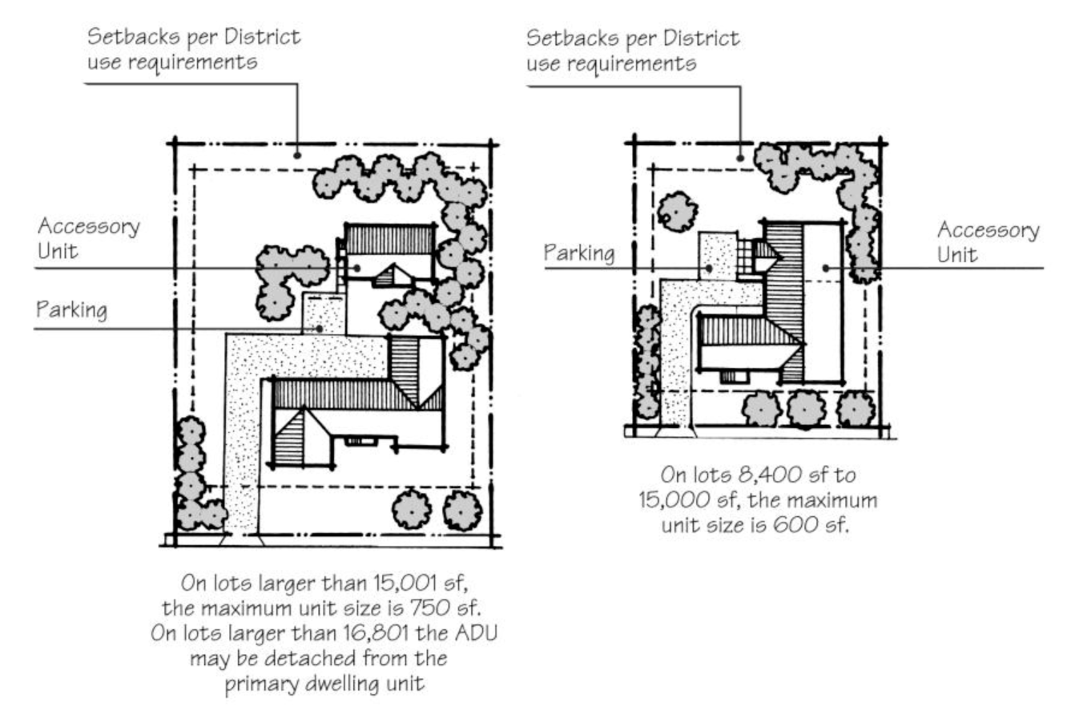
iii. Location. An accessory dwelling unit shall be on the same lot as the primary dwelling unit. An accessory dwelling unit shall be attached to the single-family dwelling unit; if the lot is at least 10,400 sq. ft., the accessory dwelling unit may be detached from the primary dwelling unit.

iv. Maximum square footage. There is no minimum square footage for an accessory dwelling unit. The maximum square footage for an accessory dwelling unit is 900 sq. ft., on a lot; provided, however, that in the gRST-1 and gRST-2 districts, the maximum square footage for an accessory dwelling unit is 750 square feet on a single-family residential lot. The accessory dwelling unit shall not, however, exceed 75 percent of the gross floor area of the primary dwelling unit.
v. Floor area ratio; density. The floor area of the accessory dwelling unit is included, along with the floor area of the primary dwelling unit, in calculating the floor area ratio on the lot, but the accessory dwelling unit is not included in calculating the average density for a new single-family subdivision.
vi. Parking. In addition to the parking requirements for the primary dwelling unit, one off-street parking space shall be provided for each accessory dwelling unit of 600 sq. ft. or less, and two off-street parking spaces shall be provided for an accessory dwelling unit larger than 600 sq. ft.
vii. Owner occupancy. Either the principal dwelling or the accessory unit on any site shall be occupied by the owner of the principal dwelling or owner of the lot where the accessory unit is located.
viii. Architectural compatibility. An accessory dwelling unit, whether attached to or detached from the primary dwelling unit, shall be compatible in style and materials with the primary dwelling unit.
ix. New accessory dwelling unit where single-family dwelling unit already in existence. A new accessory dwelling unit to be constructed on a lot with an existing single-family dwelling unit shall conform to all development and dimensional standards in the applicable zone district regulations.
x. The ADU shall have no more than two bedrooms.
xi. Setbacks. An ADU shall not encroach into any required setback. Detached accessory units taller than 15 feet shall not make use of the side and rear setback flexibility in note 2 of Table 21.09-5.
xii. Utilities. To the extent allowed by law and utility tariff, the ADU shall be connected to the water, sewer, gas, and electric utilities of the single family dwelling unit. However, lots with on-site water or septic systems may have a separate water and/or septic system for the ADU.

