Date: December 16, 2016
To: Kyle Kelly, MOA Girdwood Service Area Manager
Through: D. Michael Rabe, PE - CRW Engineering Group, LLC
From: Rebecca Campbell, PE, PTOE - CRW Engineering Group, LLC
Project: Girdwood Cemetery
Project No: CRW#10131.07
Subject: Girdwood Cemetery Feasibility Study
Tract D, Girdwood Elementary Subdivision

Introduction
The Municipality of Anchorage (MOA) has identified Tract D, Girdwood Elementary Subdivision (project site) as a potential location for the Girdwood Cemetery. The project site, shown on Figure 1, is described as Tract D Girdwood Elementary School Subdivision; Parcel No. 075-031-34; SEC 8, T10N, R2E, SM; USGS Map Seward D-6; N60.97° W149.13° (NAD83). The location is along Crow Creek Road approximately 1 mile east of the Alyeska Highway. The subject property is located within the Glacier Creek watershed.
The Girdwood Board of Supervisors and Girdwood Cemetery Committee have developed a general vision statement for the cemetery that involves maintaining natural features of the existing land to every extent practicable, with burial sites interspersed in the natural environment. The cemetery would also function as a recreational area with unpaved walking paths capable of conversion to cross country skiing trails in the winter months, drawing upon the existing unofficial and unmaintained trails crisscrossing the subject property. Additional conceptual designs include the use of GPS coordinates to identify burial sites rather than formal headstones to minimize environmental disturbance
CRW Engineering Group, LLC (CRW), in cooperation with Restoration Science & Engineering, LLC, Shannon & Wilson, and DOWL HKM have been retained by the MOA to review the feasibility of locating a cemetery on the project site. A review of existing geological conditions, wetlands, archeological features, applicable building codes, and nearby utilities was completed as part of this effort. A map summarizing this research is shown in Figure 2.
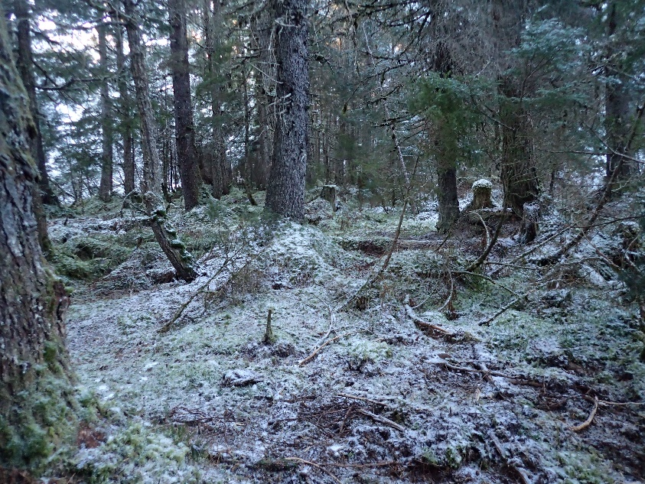
Site Description
Photo 1 - Project Site
Tract D, Girdwood Elementary Subdivision encompasses approximately 22 acres of gently sloping terrain. The lot is an irregular triangle shaped parcel. Neighboring properties include Raven Glacier Lodge to the west of the proposed site and Chugach State Park to the north and east. The Beaver Pond Trail maintained by the MOA parallels California Creek on the southwest side. Crow Creek Road delineates the property to the southeast. Crow Creek Road is the only access point to the site and approximately 725 feet of the lot fronts the road. The parcel is currently under consideration of transfer from the Heritage Land Bank (HLB) to the Girdwood Service Area.
Existing easements on the parcel include ten foot telephone and electric easements on the south side fronting Crow Creek Road and along the western lot line. A creek maintenance easements runs along California Creek, twenty five feet each side of the ordinary high water mark (OHW.) Further title research is recommended for any additional lot restrictions.
California Creek runs north/south bisecting the property. California Creek is an anadromous stream that supports chum, coho, chinook, pink and sockeye salmon. The property provides suitable habitat for moose, black and brown bear, lynx, red squirrels, marten, porcupine, hawks, owls, ravens, spruce grouse, Steller’s jay, and several species of resident and migratory songbirds. Nine species of migratory bird, including the bald eagle, are present within the project area. Due to the small footprint of the proposed cemetery which seeks to maintain natural features with minimal tree removal and vegetative disturbance, the project is not anticipated to affect migratory birds.
Vegetation in the area is predominantly needle leaf forest covering a dark but relatively open understory with few herbaceous species including sorrels, ferns, mosses, and liverworts. Alders occur in higher density near California Creek and the unnamed drainages traversing the subject property. The vegetation is typical of coastal mountainsides in Southcentral Alaska. Such vegetation communities support wildlife species associated with forested areas in Southcentral Alaska. No significant changes to vegetation are expected at the site due to the development of a cemetery. The cemetery development would be designed in concert with the natural site features. Only minor cutting or filling is anticipated.
Slopes within the project area average 5% to 10% based upon LIDAR imagery, posing few challenges to development. The project area increases in slope as it moves from east to west and south to north into the Chugach Mountains, with slopes of up to 20% at the property edge. The property slopes towards Crow Creek Road and drainage is conveyed overland southwest across the site to California Creek and to the road ditch system on Crow Creek Road. There is no existing storm drain on the project site or along Crow Creek Road. There have been reports of flooding on the site.
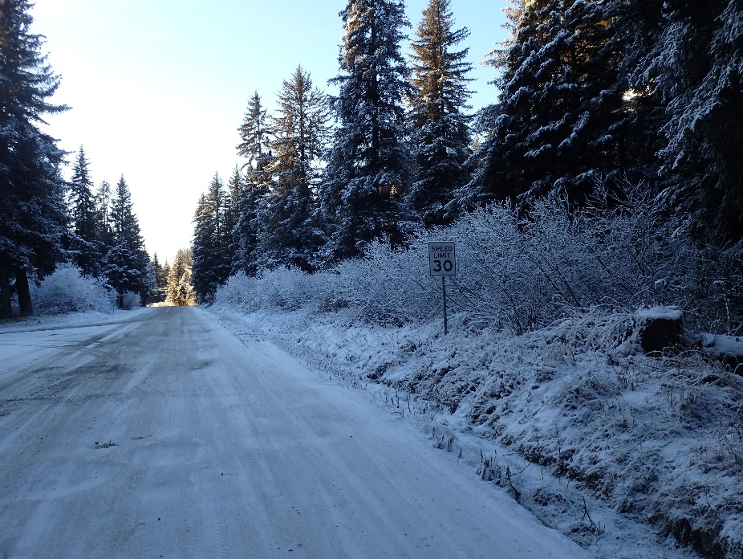
Avalanches are common in the Girdwood Valley. In areas where natural vegetation is still largely intact, avalanche paths can generally be easily seen. Several visible avalanche paths are located in the area the south of California Creek. The project area is located over 1000 feet from the nearest zone of moderate avalanche hazard (as mapped by HDR, Inc. 2004) defined as a 1% to 10% annual occurrence.
Photo 2 – Crow Creek Road at Project Site –Facing South
Crow Creek Road has a posted speed of 30 mph. The road is classified as a minor collector in the MOA Official Streets and Highways Plan. The road is paved for a portion of the project site and is unpaved north of the project site. Sight distance for the site should be adequate. However, additional clearing may need to occur during driveway construction to ensure visibility. Crow Creek Road is owned and maintained by the State of Alaska. As such, any driveway connecting the site to Crow Creek Road will require a State of Alaska driveway permit.
Code Study
Title 21, Chapter 9 of the MOA Municipal Code provides development guidelines and requirements for any new construction within Girdwood.
Tract D, Girdwood Elementary Subdivision is zoned GR5. Under GR5 zoning, a cemetery is an allowed use, but only under a Conditional Use Permit. The Conditional Use Permit requires site plan approval from the MOA Planning and Zoning Commission. As part of the site plan approval, the developer must provide public notice and solicit input from the community. Lot setbacks established under zoning GR5 include a 25’ front setback, 15’ side setback, and a 20’ rear setback. No development including parking is allowed in the setback area.
A twenty five foot stream setback from the ordinary high water mark (OHW) of an identified stream (Title 21.07.02 Natural Resource Protection) is also required. This setback should overlap with the creek maintenance easement on California Creek. Additionally, a ten foot setback is required from the edge of each side of above-ground drainage ways and ephemeral channels. No disturbance in the stream or drainage setbacks are allowed except for trails, utilities and roadways that are perpendicular to the drainage way or stream and do not impact the natural flow characteristic of the stream.
A wildlife Management Corridor is also required along California Creek in accordance with Title 21.07.02. The Wildlife Management Corridor is a 200’ setback from each side of the OHW of California Creek. In this area, all trash receptacles shall be bear resistant. Additionally, trails, driveways and drainage ways shall be designed to accommodate wildlife. Trail locations will require coordination with the Alaska Department of Fish and Game.
Under Title 21, Chapter 9, off-street parking will be required for the cemetery. This parking must be paved and have appropriate lighting. The amount of off-street parking spaces must be determined through a parking study based on the amount of burial space within the cemetery and will require coordination and approval of the MOA. If over twenty parking spaces are provided, interior parking lot landscaping will also be required. Under GR5 zoning, two driveways are allowed along Crow Creek Road with a maximum width of 24’ each. The driveways must be paved with asphalt or concrete.
Snow storage is required for the parking, trails and driveway areas. Snow storage must equal twenty percent of the area used for parking, driveways and trails.
The 2004 Crow Creek Neighborhood Land Use Plan, through multiple community meetings and guidance from the municipal zoning authority, identified multiple goals for the area in which the subject property is located. These goals included responsible development to the service of Girdwood and Anchorage residents that maximizes the preservation of natural features, minimized impacts to recreational and natural resources, further expansion of the local trail system, and coordinated delivery of infrastructure. The proposed action is consistent with community goals and needs identified in the 2004 land use plan, while servicing a gap in local services for burial and honoring of the deceased.
On-Site Utilities
Anchorage Water and Wastewater Utility provides water and sewer service to Girdwood. The project site is within the AWWU service area; however, water and sewer utilities are not currently located near the site. The closest water and sewer mains are located on the Girdwood School site, approximately 500 feet from the project site. AWWU currently has no plans of extending water service along Crow Creek Road (AWWU Water Master Plan 2012). AWWU has long term plans to extend sewer service along Crow Creek, though nothing in the immediate future (AWWU Wastewater Master Plan 2014). A well and septic system should be considered for the site due to the expense of extending water and sewer utilities to the site.
Chugach Electric Association (CEA) provides electrical service to the Girdwood community. CEA has underground electrical facilities on the northwest side of Crow Creek Road. The line ends just south of the project site. Alaska Communications Systems (ACS) provides telephone service to the Girdwood community. ACS has an underground telecommunications line that runs on the northwest side of Crow Creek Road. This line ends just south of the project site.
Enstar Natural Gas Company (ENSTAR) provides natural gas service to the Girdwood community. An existing underground 2” plastic gas main runs along the northwest side of Crow Creek Road. This line stops just south of the project site.
Geotechnical Investigation – Shannon & Wilson, Inc.
A geotechnical investigation was performed by Shannon & Wilson in November of 2016. See attached geotechnical report for more detail on this investigation. Four bore holes were analyzed as part of the report. In general, the borings encountered a surficial layer of organic material (approximately 2’ thick) overlying granular soils and over consolidated glacial till. Fines content in the granular soils ranged from 6% to 14%. Groundwater encountered ranged from 2 feet below the existing ground surface to 12 feet below the existing ground surface.
Based on the existing subsurface conditions, conventional shallow, heated foundations would be appropriate for building construction. New roads and pathways will require an improved structural section due to the fine contents. The structural section would vary from 2 feet to 5 feet on pathways, driveways, and parking lots. Structural fill will need to be clean, granular soil free of organic material and non-frost susceptible. Structural fill should meet the MOA requirements for Type II material. Due to the depth of groundwater, dewatering for construction of foundations and utilities is anticipated.
The site was also traversed for evidence of surface water. The largest area of surface water observed was along the north edge of the parcel. Evidence of ponding was also observed in low lying areas across the site. These areas are likely intermittently inundated with surface water and are dependent upon rainfall events.
Research was performed on potential borrow sites in Girdwood. There are no known high volume sources for clean, NFS material in the Girdwood valley. Imported material typically comes from either Anchorage or State of Alaska owned borrow sites along the Seward Highway. In the past, waste material in Girdwood is either used for fill on private properties are trucked to the Anchorage area.
Environmental Investigation – Restoration Science & Engineering, LLC
An Environmental Investigation and Preliminary Determination of Wetlands and Waters was completed by Restoration Science & Engineering, LLC in November of 2016. See attached Preliminary Determination of Wetlands & Waters.
California Creek is an anadromous stream that supports chum, coho, chinook, pink, and sockeye salmon. (RSE 2016). Fish tend to avoid spawning in glacially fed, braided streams because those channels are unpredictable and frequently shift. The most significant fish spawning in the Girdwood Valley occurs in California Creek. There is a significant fish milling area at the confluence of California Creek and Glacier Creek. (MOA 2010). The extent of salmon use in the segment of the creek that flows through the property is unknown.
Under the National Wild and Scenic Rivers Act (1968), selected rivers in the United States are preserved for possessing outstandingly remarkable scenic, recreational, geologic, fish and wildlife, historic, cultural, or other similar values. Rivers, or sections of rivers, so designated are preserved in their free-flowing condition and are not dammed or otherwise impeded. California Creek is not listed as a Wild and Scenic River.
Local residents have voiced concerns regarding formaldehyde leachate from embalmed bodies migrating toward California Creek. Embalming is only required if a body is transported across state lines, and the more common embalming agent is formalin which carries nominal environmental risk compared to formaldehyde. (Veteran’s Affairs 2016). Leachate potential is minimal. The Girdwood cemetery may employ an engineering control such that embalmed bodies would be placed further from California Creek. All burial sites would have a minimum distance from waterways as established by federal and local law.
Potential jurisdictional waters were identified on the property include California Creek, four small streams, and a pond occupied by a small excavation. Several drainage ways were identified on the property that are believed to be intermittent streams since they lack a discernible bed and bank. Wetlands were not found within the property. Based on evaluation of existing soils, vegetation, and hydrology, wetlands were not found within the project site.
Floodplains– Restoration Science & Engineering, LLC
Review of the Federal Emergency Management Agency (FEMA) Flood Rate Insurance Map (FIRM) indicates the project area is in Zone D, an area in which flood hazards are undetermined, but possible. A 2004 study by HDR Inc. used a combination of existing MOA flood mapping and field delineation based on vegetation characteristics and topographic features. The most significant flood plain within the project area is located along the west bank of California Creek, on the southernmost extent of the subject property.
Although much of the existing Girdwood commercial district is contained in a similar flood zone, new development—including burials—should be excluded from known and probable flood prone areas. Burials will not be permitted within the 100-year flood plain, which is located across California Creek from the primary proposed access. Burials conducted outside the 100-year flood event zone are not considered to pose a risk of dislodgement. The FIRM and HDR maps are included in the Environmental Feasibility Study.
Groundwater– Restoration Science & Engineering, LLC
The geotechnical borings encountered groundwater between 5 and 20 feet below ground surface. Those areas with shallow groundwater are not considered eligible for buriable space. Only one (1) boring advanced demonstrated groundwater at 5 feet below ground surface. Selection of burial sites would require temporary installation of groundwater piezometers to document the fluctuation of groundwater across seasons, and selection of those areas where groundwater is not shown to rise above 6 feet below ground surface.
The subject property is shown on the Alaska Drinking Water Protection (DWP) map as being located directly outside of a Zone A (groundwater travel time of several months) and Zone B (groundwater travel time of 2-years) DWP area within the Chugach State Park. The subject property is not located within a drinking water protection area.
A single subsurface water right was identified to the west of the subject property, at the approximate location of the Raven Glacier Lodge. The owner is identified as Knapp Laurence. A corresponding record was not identified within the Alaska Well Log Tracking System (WELTS). The WELTS database did not identify wells within ½ mile of the subject property.
No contaminated sites monitoring wells were identified within ½ mile of the subject property on the Alaska Department of Environmental Conservation (ADEC) database.
Local residents have noted that protection of the area’s water sources should be considered. Piezometers will be required at the subject property to determine seasonal fluctuations at various locations on the property. Areas exhibiting shallow groundwater properties will not be eligible for burial but may be within the cemetery’s recreational area without incurring adverse impacts. Appropriate engineering controls would need to be utilized during construction to ensure no long-term adverse effects to groundwater. Based on standard modern burial practices, it is unlikely that embalming fluid or other decomposition byproducts would be released into the soil and/or groundwater. Modern embalming fluids are markedly less toxic as the primary active ingredients are no longer arsenic-based. (Veteran’s Affairs 2016). Additionally, as the majority of Alaskans elect for cremation or columbarium placement, the potential for leachate commensurately decreases as no embalming fluids are used.
Cultural – DOWL HKM
The Crow Creek area has played an important part in Girdwood history, and a key role in the area’s early resource development. The cultural resources likely to exist in the area include materials left from Crow Creek’s days as a mining hub. Additionally, a number of historic mining and tiehacking trails run through the area.
In 2016, DOWL HKM conducted a basic review of the Alaska Heritage Resource Survey and did not identify previously recorded cultural sites in the tax parcel. More detailed surveys are forthcoming once identification of the lead agency for the cemetery development is identified. As development moves forward in specific locations, detailed surveys will identify any resources the areas may contain. As these are identified, proper procedure will be followed, in accordance with historic preservation laws, to assure that significant materials and sites are preserved and/or documented.
Findings
Based on the results of this study, the site appears to be feasible for a new cemetery. Approximately 7 acres of the 22 total acres on site are suitable for development due to creek and setback requirements, and the need to maintain existing drainage paths. This area is outlined on Figure 3. Additional areas of the 22 acre site may be developable, but will require additional permitting efforts including possible MOA criteria waivers.
Groundwater should be investigated further as it will limit placement of burial sites. It is recommended that parking and trails be located where the groundwater is an issue. Surface drainage issues have been reported, and the site will need to be regraded to mitigate this issue.
Dependent on the number of grave sites and the size of the columbarium, 7 acres should provide more than 50 years of burial space at the current death rate.

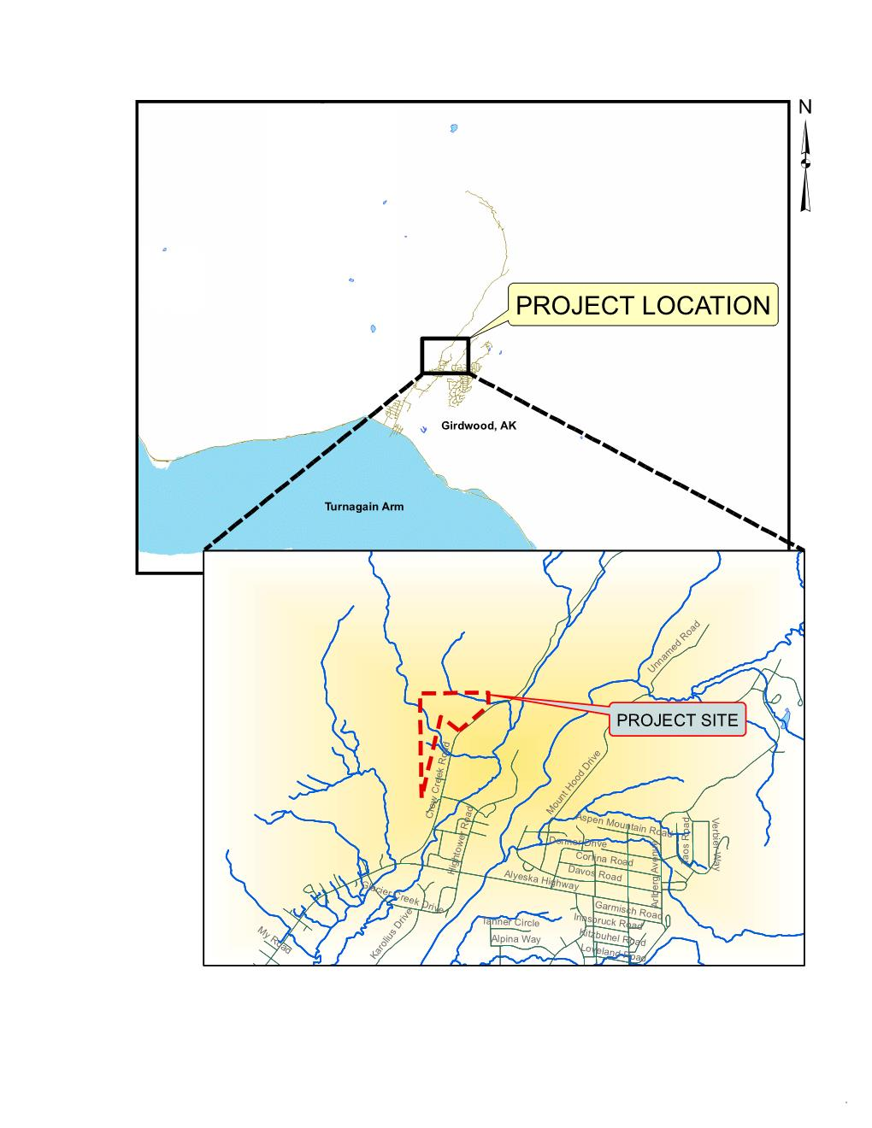
Figure 1 – Location Map

