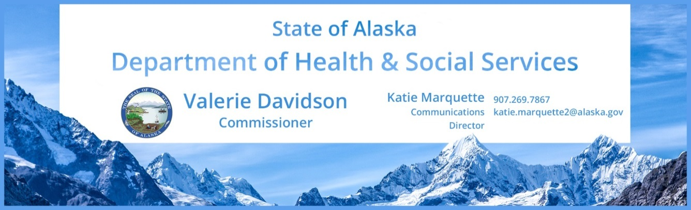
FOR IMMEDIATE RELEASE

Contact: Elizabeth Manning, 907-269-4541, elizabeth.manning@alaska.gov

PSA Campaign: Alaska has high rates of STDs
Radio: Run immediately, through August 31

STD_highrates.mp3 (30 seconds)
Did you know Alaska has some of the highest rates of STDs in the country and half of all sexually active, young people in the U.S. will get an STD by the time they are 25? Alaskans are even more at risk due to our ongoing outbreak of gonorrhea AND a new outbreak of syphilis. Often these infections have with NO symptoms at all. Talk to a public health professional and your partners. Get tested. Get treated. For more information, visit std.dhss.alaska.gov. Brought to you by the Alaska Department of Health and Social Services and this station.

STD_youngpeople.mp3 (30 seconds)
Half of all sexually active, young people in the U.S. will get an STD by the time they are 25. Alaska is having outbreaks of syphilis and gonorrhea. Anyone who has oral, anal, or vaginal sex with an infected person can get an STD. Protect yourself and your partners. Get tested. Get treated. For more information, visit std.dhss.alaska.gov. Brought to you by the Alaska Department of Health and Social Services and this station.

STD_infertility.mp3 (15 seconds)
Sexually transmitted disease can make you infertile. So learn how to protect yourself and the baby you may want to have someday. For more information, visit std.dhss.alaska.gov. Brought to you by the Alaska Department of Health and Social Services and this station.

STD_notification.mp3 & STD_notification_jazz (30 seconds-same PSA/different music)
Person 1: What’s this? This has to be a joke.
Person 2: What, baby?
Person 1: Um, it’s a text from the health department. It says they have an important health message for me!
Person 2: I hear there’s an outbreak of STDs. You should really get that checked out, and then we should talk.
Person 1: OK
If you receive a message from the health department, talk to them and learn more. You may have a sexually transmitted disease. Learn more at std.dhss.alaska.gov or for more about the reporting system, dis.dhss.alaska.gov. Brought to you by the Alaska Department of Health and Social Services and this station.

# # #

